Cheap public space and the art of negotiation
- strategies for the provision of publicly accessible space through the private
sector, and a proposal of how to communicate, compare and appraise their impact

Abstract:
One of the issues regarding public space is unsurprisingly of financial nature: it is expensive. This relates not only to the acquisition of land and the construction of infrastructures, but also to their maintenance and occasional renovation. In a situation in which there are - on the one hand - deepening budget issues, and on the other hand increasing expectations expressed by a well-informed public opinion, local authorities continue to invent mechanisms through which public space, or publicly accessible space can be provided by the private sector. In some cases, the land is given over to the public, in others it remains in private ownership. These strictly quantitative requirements of space as land surface are supplemented by qualitative measures including a notion of use, like access to strategic view points, sports facilities, rights of way, waterways or investment in public art. Depending on local market conditions and prevailing political paradigms, cities can insist on certain features in return for the granting of building permits, or - more frequently - offer incentives for owners to embrace their ideas or propose their own ones. How do these mechanisms work, what are the issues for implementation and how to
evaluate their impact on the creation of public realm? The authors present several options, and explore the opportunities of informed global comparisons through the experimental conception of an internet-based search and analysis tool.

1. Introduction:
The importance of public space for our society has been acknowledged for long time, even though many causalities still have to be better examined. It is considered to be beneficial for our health, for social interaction and also economic value. The latter statement holds however only true, if the calculation is made in the long term and on the scale of a whole district or community. For a single landowner, things can look differently. This fact has crucial consequences, making intervention by the public sector necessary or highly desirable. The paper therefore focuses on the options for public space provision that disburden the state or city exchequer from the simplest and most expensive way of reserving land for public use: its direct purchase and development.

In terms of methodology the authors first establish a theoretical framework for the different categories of intervention, and then review place-specific strategies and their physical implementation. Finally, they present the prototype of an internet-based database and research tool that is meant to communicate and compare such measures, and their impact on society.

It goes without saying that the relationship to public space varies enormously from one culture to another, and from one period to another. It is hence important to clarify that it lays not within the scope of this paper to dwell on these cross-cultural questions. It lays also not within its scope to comment on the relevance of public space issues compared to other, locally more urgent problems of the built environment. In this respect it might be worth mentioning that the authors’ perspective is the one of scholars living and working in the developed world. The chosen case-studies often include an element of city-marketing that could bear decadent traits for citizens of poorer countries, where the benefits of public space might be a question of basic hygiene and political empowerment rather than a summer night’s hipster barbecue boon. The documentation of the gradation between physical necessity, locational advantage, political sales argument, place of political interaction and tourist gimmick - in the form of tangible examples rather than theoretical disquisitions - might however be one of the study’s useful byproducts, and an alternative way to come up to the topic’s high complexity.

As a matter of fact, the attempt to procure knowledge through the ordered, but only rudimentarily informed representation of numerous case-studies, is the work’s actual motivation. On the one hand committed to the use of technology, but on the other hand realizing the problematic of providing normative judgment through computational tools that work with quantitative rather than qualitative parameters, the authors decided to conceive the beginnings of a research and information tool that can be understood as a mixture of GIS (Geographic Information System), specialized social network and image catalogue. To a certain extent, it acts as a specialized search engine, and explores - like many other ongoing research or commercial projects - the opportunities to apply features of the last two decade’s internet revolution also to the realm of the built environment. The simple concept consists hence not that much in the exploration of new scientific ways of decision-taking, based on optimized methods to appraise success, but on the procurement of greater clarity through cross-linkages of different types of data, including feed-back of existing or future users. The project’s thesis is that greater success and sophistication of future interventions can be achieved through raised legibility and transparency of existing ones, an essentially basic educational agenda. Only the long-term use of such tools, and the analysis of a multitude of parameters for thousands of case-studies will show, if computation really helps to empirically prove new causalities and “spatial laws”, an endeavor that still appears naive in view of its inherently political character.

2. Discussion:
2.A. The different categories of public space provision - a short review:
We would like to assign these categories to two major groups, relating to the physical situation of the space on the one hand, and the type of provision strategy on the other. This allows for numerous permutations, of which we will describe only a selection. In view of the multitude of possible parameters this division might appear simplistic and arbitrary - a reproach that could not be easily dismissed -, but it correlates the two spheres that the authors find most appropriate for the examination of their thesis.
For the purpose of this short and somehow theoretical categorization we do not differentiate between “genuine public space” and publicly accessible private space. We also make abstraction of a related quality, the question if a space is enclosed or not. An important clarification should also be made through our focus on pedestrian spaces, assuming that vehicular infrastructures do not respond to the same social demands. The majority of our examples are projects that have been created in an existing urban fabric, and are not the result of large-scale masterplanning. This can be explained through the fact that large-scale plans - and their share of public space provision - tend to be the result of dedicated, and very political, stakeholder negotiations. This paper, in contrast, explores different options of systematized approaches in the form of policies, regulations and incentive programs.

Please find hereafter a concise explanation of the different forms of physical situation and type of provision strategies. In this list we marked those strategies that found also application in the online tool. The subsequent table identifies specific case-studies as combinations of these two attributes and conditions, which in turn get briefly explained in a short paragraph at the end of the chapter.

Physical situation of a newly-created publicly accessible space:
- open land within the urban fabric, not directly attributed to an individual building (a square or park in the classical understanding)
- setback spaces between the street and a building
- in the center of a block or building ensemble (courtyard type)
- within or underneath a building (skydeck or pilotis type)
- leading through a building or private lot (“right of way” type)
- on top of a building
- along a special geographic feature, usually waterways or hills
- extension of existing sidewalks (street widening)
- public space as, or linked to a new infrastructure (bridge or pedestrian bridge)
- “imaginary” space, as a visual extension of public space (on private inaccessible land)

Type of provision strategy:
- deliberately provided by public or private landowners*
- implemented by the city through land purchase (based on preemptive rights or not)
- implemented through private owner, based on place-specific code stipulations*
- implemented through private owner, based on amenity-related laws*
- implemented through public or private owner, based on laws of ecological preservation*
- implemented by the city, but financed through voluntary participation of private developers in schemes that allow for bonus development capacity in return for financial contributions
- implemented by private owners, based on voluntary participation in incentive schemes*
- implemented by the city, based on public pressure through protestation and informal appropriation
- implemented by partnerships, through the re-organization of scattered spaces

 | open land | setback | courtyard type | part of building / ensemble | right of way | on top of building | geography-based | street widening | infrastructure related | visual / imaginary
Deliberately provided |  | Seagram Building |  | London - Broadgate |  | Yokohama Ferry Terminal
land purchase |  |  | Pro Eixample
place-specific law |  |  |  |  |  |  |  | Paris Street Alignment 1807
amenity-related  law |  |  |  |  | HK Skyways
ecological law | Potsdamer Platz
financed through bonus
incentive scheme |  | NYC POPS
protestation | Tempelhofer Feld
re-organization | London - Marble Arch

In some cases we added within the descriptions to the issue of space creation the one of space activation. In many communities, the problem is not the total amount of public space in terms of surface, but its actual use. If a space is not able to accommodate a simple set of human activities, including relaxation, its actual value can become negative, attracting in the worst case criminal activities.

Broadgate, London:
This redevelopment of a former train station is a good reminder of the simple fact that public space is also a necessary condition for the creation of real estate value, and not just a liability and cost. The developer’s winning answer for a tender by British Rail was able to propose a better financial offer than its competitors, because it was the only one to imagine the creation of a new district rather than an oversized big box. Almost as important as the provision of the spaces - legally still in private ownership - was the decision to beautify and activate them through the installation of dedicated art pieces. Many municipalities have understood these benefits of public art, and have elaborated financial mechanisms for their increased emergence. One example is Singapore’s Public Art Tax Incentive Scheme which motivates private entities to donate, adopt or display public art.

Seagram Building, New York City:
Mies’ decision to step back from Park Avenue and to create a plaza between the sidewalk and the building was motivated by the desire to elevate a strictly vertical facade. According to the New York building code from 1916, the positioning on the lot boundary would have forced him to implement several set backs in the building section in order to allow - despite high-rise construction - for a sufficient light level on the city’s sidewalks.

POPS incentive program, New York City, example Citigroup Center:
Since 1961, following the example of the Seagram Building, and the architect’s deliberate decision to step back through the creation of a public space, the City of New York has offered incentives for developers to provide privately owned public spaces (POPS). In return for the provision of these spaces, higher floor-area-ratios are granted. Despite the program’s undoubtable success, it also epitomizes the crucial fact that quantitative requirements do not always produce the same qualitative effect. Over the years, in order to raise the space’s average quality, the program’s legal and design requirements have been several times updated.

New York City Waterfront Framework:
A city gains in attractivity and specificity in taking profit of its natural geographic features. This happens particularly often around and along water features, may they be rivers, sea shores or lakes. New York City is just one example among many, where public access and special requirements for waterfront lots have been anchored into the zoning plan. Since 1993 landowners have to follow a set of rules that vary according to situation, development density and program. Up to 20% of the lot surface have to be built and maintained as public open space. Currently, due to rising sea levels and an increased risk of flooding, some of these rules are in the process of modification, trying to reconcile a vision of active street frontages with a need to raise the buildings’ ground level datum.

Public right-of-way through skyways / Hong Kong:
Due to its particularly high population density, an extensive public transport system, the humid climate and a large amount of shopping malls, Hong Kong features an impressive and highly complex network of publicly accessible circulation spaces. Though rarely designed with seating or any other relaxation facilities, everyday use by the population does not necessarily differ from the one observed in outdoor spaces. Ownership can both be private or public, but in some cases it is based on government zoning variances that require mall owners to keep parts of their premises constantly open to the public in order to allow for convenient access to the metro stations. This is for example the case for the IFC Center, which links the Central Ferry Piers with Hong Kong Station. The terms are still favorable for the private parties, as the skyway network channels masses of commuters into their commercial developments.

French street alignment law of 1807 ((counter)-example rue Rambuteau):
It is often assumed that Baron Haussmann’s works between 1853 and 1870 as a planning director for Emperor Napoleon III marked a new generation of city-making, in which the mostly medieval fabric of Paris was modernized and beautified. Many ideas however - like the widening of existing streets - originated half a century earlier, but failed in implementation due to financial and legal issues. A good example can be given by the effort in 1807 to establish for all French municipalities over 2000 inhabitants a street alignment plan, through which new and renovated developments had to step further back from the street. In most cases, the law’s effect was degradation rather than linear street widening. This logic was quickly acknowledged, and masterplanned projects like Rue Rambuteau (1834-38) in Paris are first examples of more ambitious interventions in which the city steered a successful, but resource-consuming process of acquisition and reconstruction.

Potsdamer Platz, Berlin:
Urban projects in Germany have to be the object of an ecological impact study. It has to be proven that a redevelopment of land does not only not harm the environment, but also - due to the relative character of such statement - that the post-development state is not worth than the pre-development one. In order to balance the by definition harmful consequences of building, compensatory measures are often necessary. These usually appear in the form of green spaces. Due to the position on previously empty land - the “dead zone” on and around the former Berlin Wall - the Potsdamer Platz redevelopment is a particularly complex example of this policy. In order to allow on the one hand for the creation of urbanity and density in the city’s historic center, and on the other hand for the development of an economically viable project, the compensatory provision of green spaces had eventually to be lowered, and its majority was implemented outside the project boundaries for the creation of Gleisdreieck Park.

International Ferry Terminal, Yokohama:
This building is considered to be a particularly successful example of how infrastructural projects can relate to - and even create - public realm. The terminal’s roof structure is not only accessible, but is part of a complex circulation network, in which interior and exterior spaces are closely interlinked. An obvious, but important advantage of making the top of a building accessible is the fact that public space can be offered without acquisition of additional land.

Pro Eixample, Barcelona:
The joint-venture between the City of Barcelona and several Catalan Banks endeavors to soften the shortcomings of one of the 19th century most prominent urban plans. Initially intended to remain green, the courtyards of the square-shaped blocks have in most cases been overbuilt as one-story extensions of the retail or restaurant spaces of the perimeter constructions. In a time-consuming, expensive and legally complex effort, Pro Eixample tries to scoop out the block interiors in order to create green and publicly accessible spaces. The Jardin de la Torres de les Aigues is a well-known example of this strategy.

Tempelhofer Feld, Berlin:
Tempelhof Airport, famous for the airlift organized by the allies during the Russian blockade of 1948 and 1949, was closed in 2008. As a temporary use during the establishment phase of a redevelopment proposal, the entire former runway and surrounding open spaces were opened to the public, and received overwhelming turnout. In May 2014 an independent association forced the city to organize a referendum that proposed to keep the site in its current state and to declare the site unsuitable for building. It was won by a large majority and stopped plans to build a new library and new apartments. As many public space projects are the result of public initiatives and political pressures, it could be argued that this example does not represent a separate category. It seems however to symbolize a new stage of citizen emanzipation, one that promises to exponentially increase through the combination of digital governance and social media.

Marble Arch, London:
In 2002 the Mayor of London started the “100 Public Spaces” program. Many of these projects, only partly implemented due to a change of leadership in 2008, were re-organizations of existing spaces rather than new creations. The proposal for the area around Marble Arch - at the junction of Oxford Street, Hyde Park and Park Lane - intended to create a vast new plaza in reconfiguring street, park and sidewalk spaces. The challenge of this type of project lies not only in funding and traffic management, but also and predominantly in the art to align the interests of a multitude of private and public stakeholders, in this case the Crown, Transport for London, English Heritage, London Underground, the Portman Estate and the Grosvenor Estate.

Parc Monceau, Paris:
Created in the second part of the 18th century as a private park by the Duke of Chartres, it was purchased by the city of Paris in 1852. The following real-estate enterprise by the Pereire Brothers altered and diminished its form and size, adding town palaces and luxurious apartment buildings along its western, southern and eastern boundaries. Interesting is the fact that public and private green spaces abutt, sometimes - like a ha-ha - indistinguishably from a visual point of view. The park hence appears larger than it actually is. Assuming that public spaces often include inaccessible areas, this is a remarkable feature. A related and far more common type of such strategy are zoning requirements regarding the front yards of residential plots. In providing design guidelines for private owners, the city explicitly uses private land for the beautification and visual extension of public streets.

Amenity-related public spaces: Example playgrounds in Berlin (public and private ownership):
Like many other German municipalities, Berlin adopted (in 1979) a law that advises its districts to build a sufficient amount of children playgrounds. The aim is to provide an average of approximately 1 m2 per inhabitant.
In addition, the building code requires all new residential developments with more than six apartments to include a private playground of at least 50 m2 surface, based on a minimum of 4 m2 per unit. Buildings with more than 75 units have to realize a design that satisfies also the needs of older children. If it is impossible or highly restrictive to implement this legal demand on site, the owners can circumvent it through a fee payment to the city. In most cases, these private playgrounds are not publicly accessible, also due to issues of insurance and responsibility. Some municipalities however, like Potsdam, currently discuss an amendment that would force all of the spaces to become publicly accessible.

This case-study is thought-provoking, because it materializes the fact that the need of public space also depends on the provision of private space within the communities. It also raises the question to what extent social exchange in a communal space differs from the one that occurs in a more open and potentially more diverse public frame.

2.B. Presentation of the tool - a new type of public space database:
A prototype of internet-based database was constructed together as by-product of the paper. The goal of the database is, not only a comprehensive presentation of the projects that has been explored by authors, but a research tool that has the possibility of evolving into a collaborative efforts of establishing a worldwide “cheap public space” database with the user participations from every corner of the global internet.

The database (figure 2.1) was constructed based on the Google Map API platform with the capabilities of utilizing Google’s collection of basemaps as well as street views.
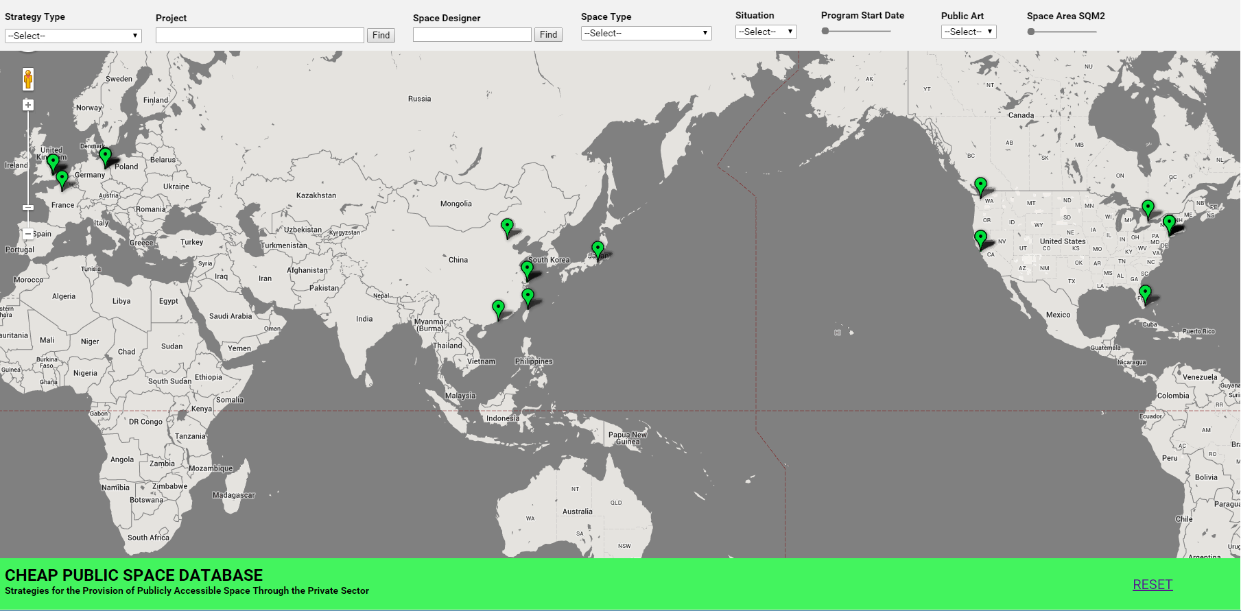
Figure 2.1 The “Cheap Public Space Database” Interface

A zoom-in view will be created when clicking on any green markers on the map. Each marker represent a project that was studied by authors.
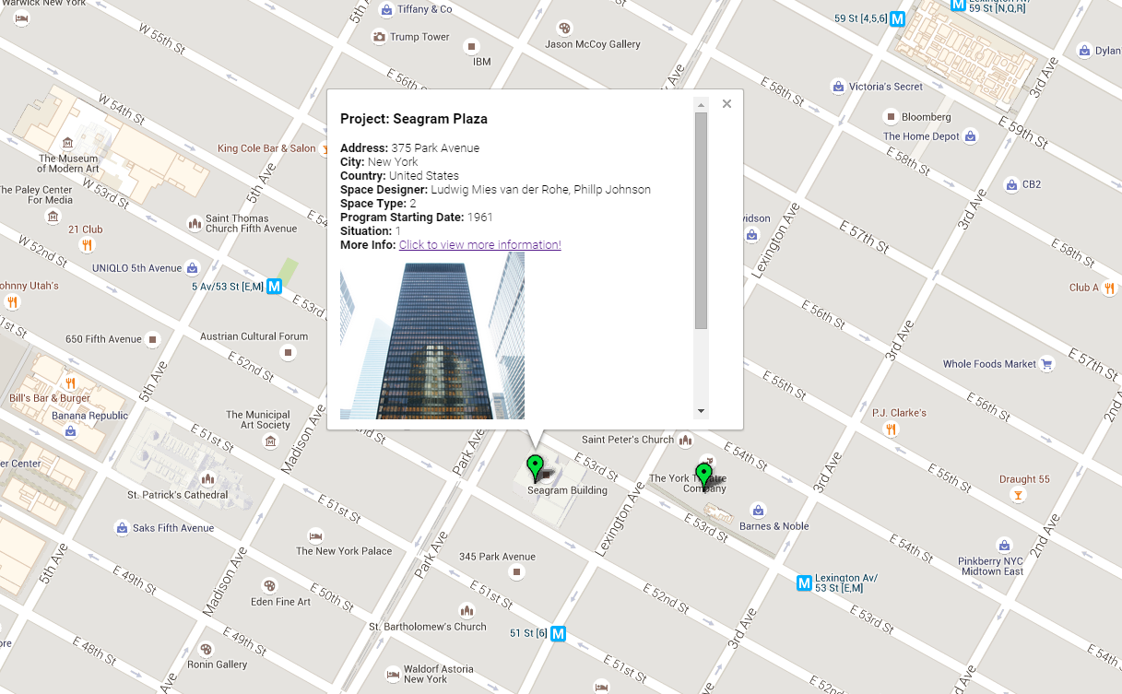
Figure 2.2 The Individual Project Information Window

The Google Streetview feature can be further utilized to allow users to inspect the space in detail.
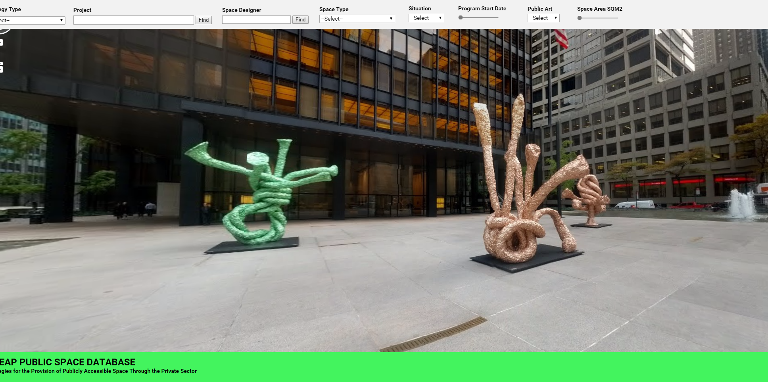
Figure 2.3 Google Streetview of Seagram Buidling, New York City, USA
The interactive bar on the top of the database provides the user with multiple search capabilities in regards to the varied parameters of each case studies. Website user can, for example, inquire the cases via “Strategy Types”, “Project Name”, or “Program Start Date”.
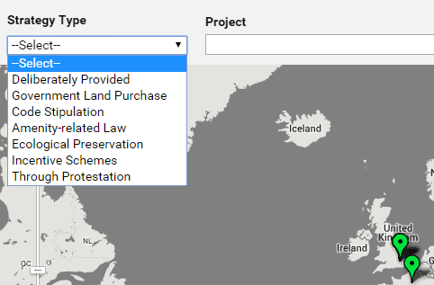
Figure 2.4 Search via different “Strategy Type”

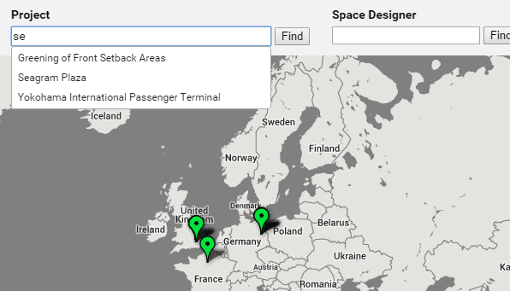
Figure 2.5 Search via different “Project Name”

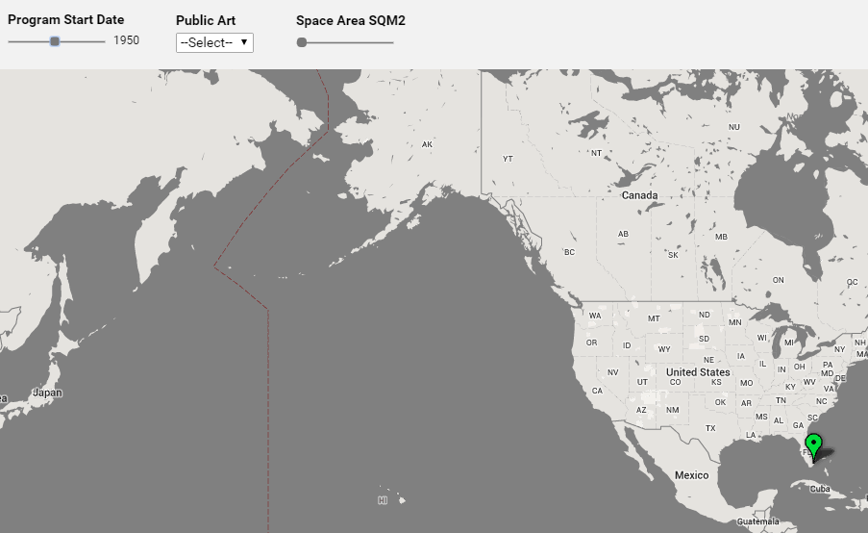
Figure 2.6 Search via different “Program Start Date”

As the first prototype, the database is subject to further development to serve the potential of additional functionalities that mentioned above. Future Ideas include a database that allows user to input and enrich the “Cheap Public Space” database and review the data, and a database that displays and compares the real estate information of the project.

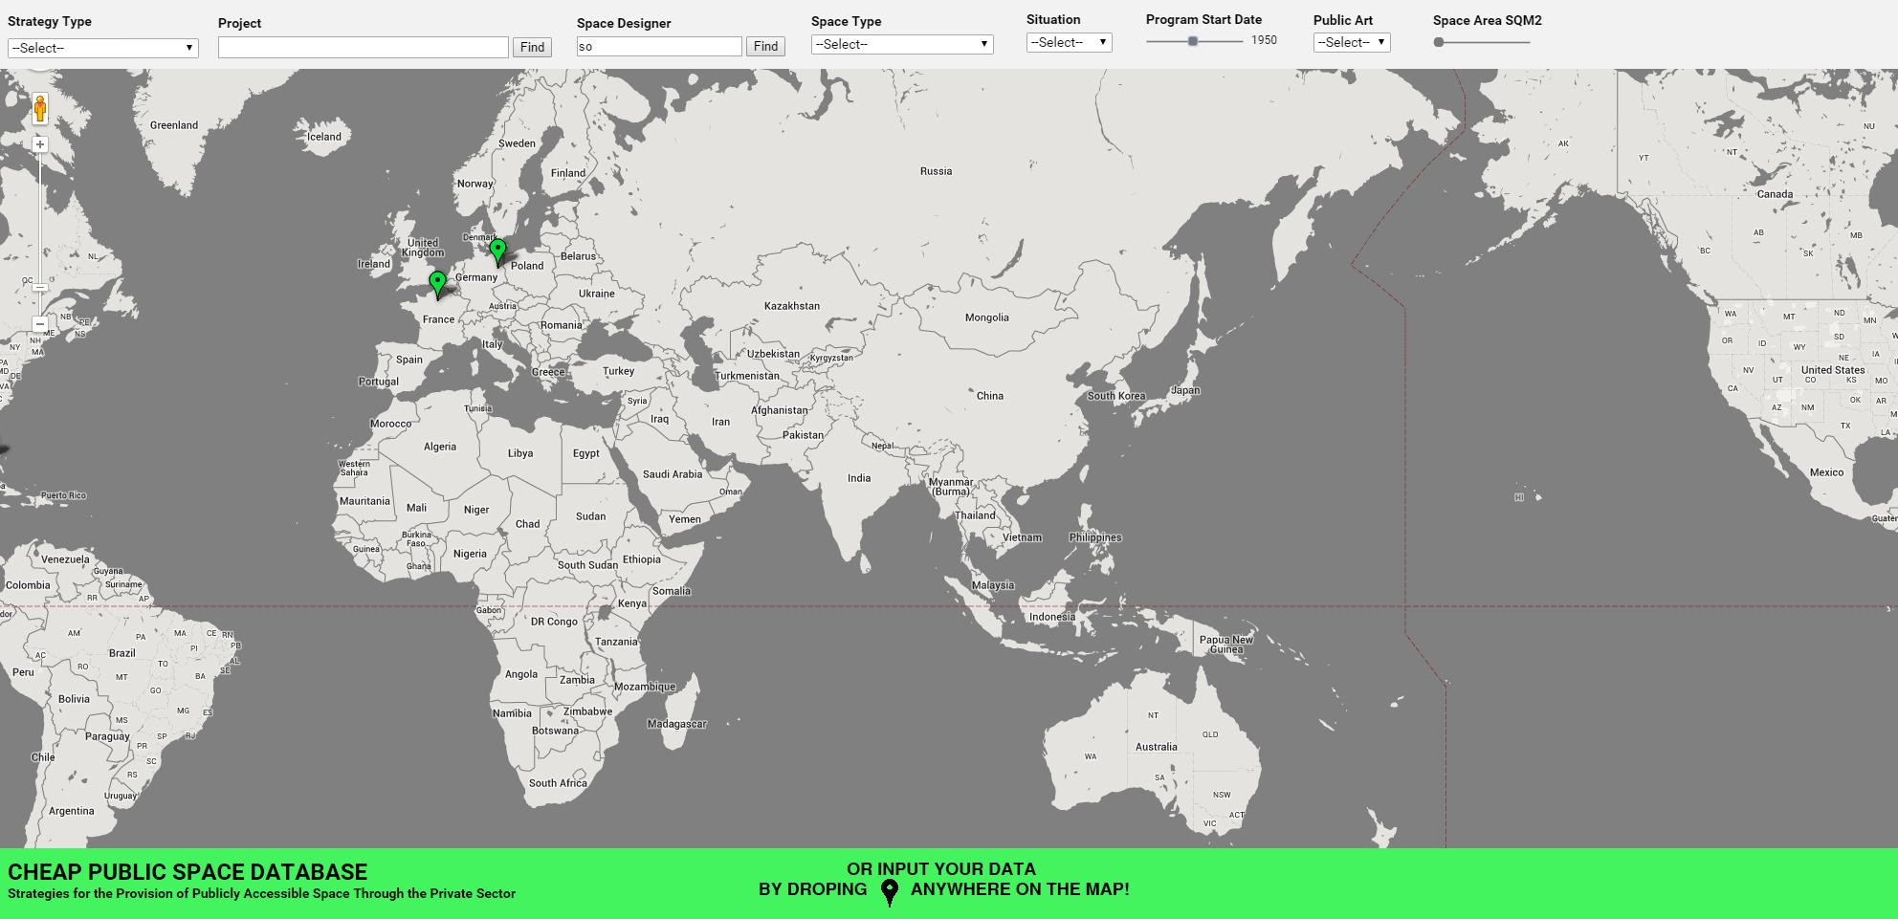
Figure 2.7 Database Input System
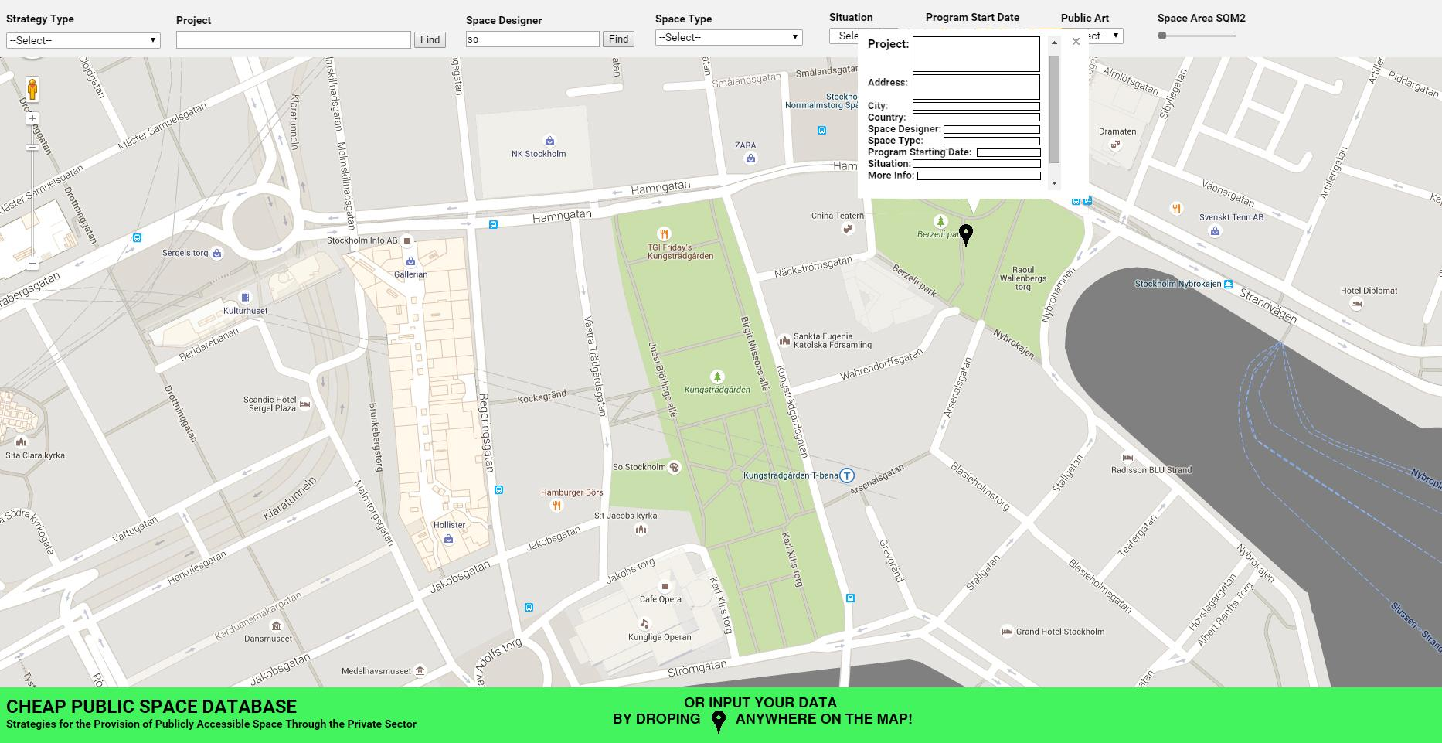
Figure 2.8 Database Input System 2

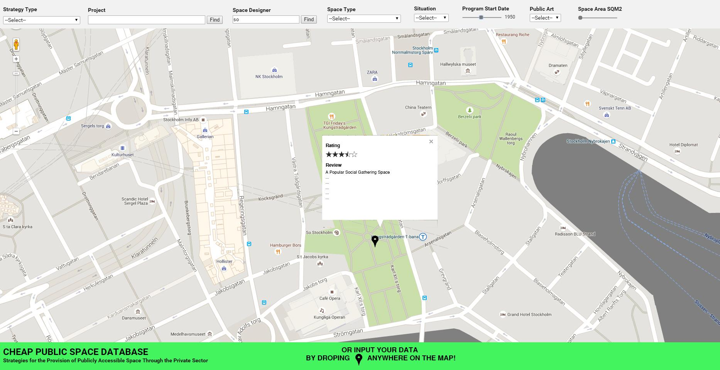
Figure 2.9 Database Review System
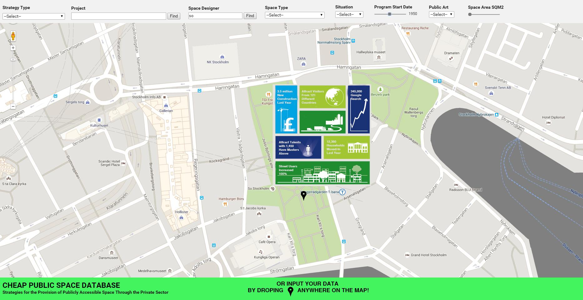
Figure 2.10 Real Estate System

3. Conclusion:
In the main part of this paper the authors developed a case-study based taxonomy of public space provision, and a proposal of how to transform and extend it into a searchable, online database. As has already been mentioned, such an endeavor - the initiation of a process rather than the discussion of a thesis - excludes at this early stage the writing of a conclusion. Meaningful results can only be expected, once the database comprehends a critical mass of case-studies that allows not only for a generally enriching user experience, but also - despite the implausibility of empirical proof - for the detection of potential links and causalities. In the longer term it could become clear which initiatives have been the most popular with the users, which ones with the developers, and to what extent they had an impact on local real-estate values. Average costs and sizes could be calculated, and potentially - through the addition of parameters - a link established between type of incentive and type of political regime. It will have to be seen, if the perceived correlations within an ever growing mass of metric information point to genuine functions, stochastic systems or, possibly, nothing of scientific value.
In the short and middle term the database can act as a reference tool for city planners who would like to get an understanding of current best practice. The difference with a written book lies not only in the amount of data, but also in the tool’s interactive nature. Feed-back, for example in the form of “likes”, allows to add a democratic element in a field that still struggles to combine academic research and the input of the end-user as the key client. The project’s flaws, also and especially in this context, might hence point to a source of future conflict, when social media and the public’s growing expectations for the built environment will considerably raise the pressure on decision-takers. On the background of often still diminishing budgets - and a phenomenon that can be called the disappearance of the client-expert -, public leaders will have to perform a balancing act between the fulfillment of public desires on the one hand, and the parallel request of hyper-efficiency on the other. Metrics can be used for both, sensibly and pointlessly.

A similar ambivalent judgment could be made about the decision to perform so consistently global and cross-cultural comparisons: on the one hand they are insightful and thought-provoking, on the other hand they can be deliberately misinterpreted, and eventually turn against the interests of local populations.

A last point shall be made regarding the proposal’s obvious need of support through the collaboration of different academic entities and potentially contributing individuals. It shall not only be taken literally, in the form of an appeal to join our team, but is also symbolizes the change of research methodology that occurred over the last two decades. The move towards longer-lasting projects, interdisciplinary research constellations and maintenance-intensive internet tools has burst traditional academic frameworks. This is a great opportunity, but it necessitates funding streams that differ from the ones conceived for the production of books.

References:

- to be added

