Title Enhancing security by instating the “shared” space as negotiator between private and public spaces.
Subtitle Places & placemaking a comparative between a rural and urban setting.
First Author Arch. Ir. Michiel Smits, Ph.D candidate
Institute Technical University Delft, The Netherlands
Address Faculty of Architecture and the Built Environment, Room: 01.East.760, Julianalaan 134, 2628 BL Delft
Phone +31610810674
Email m.w.m.smits@tudelft.nl

Keywords: Security, privacy, spatial organisation, collective space, the role of architect, housing design

Abstract
Exponential population growth has forced many rural inhabitants in the developing countries to move to the cities. According to UN Habitat, in most cases the search for better opportunities is the main motivation to urbanize (2012, p.35). Thousands of new “informal” houses are built every day around the world to accommodate these people. Due to the lack of land, financial capacity and planning these areas become highly densified housing districts. To an outsider they might seem vibrant and full of life, but reality of slum dwellers is harsh (UN Habitat, 2012, p.35). According to Raleigh (2015, p.90) the number of crime increases in urban areas, while decreasing in rural. The scarcity of social and spatial organization in slums is leading to degradation of the standard of living and security (UN Habitat, 2012, p.33). One of the main reasons for this seems to lie in the relation between private, semi-private and public space, which are investigated in this article. They derive from cultural traditions and living habits of each community represented by their type of communal organisation (Habraken, 1988).

Introduction
According to Habraken, type as a body of implicit knowledge coherently folded into a shared image, introduces the notion of communal non-designed production (Habraken, 1985). In other words, the type explains how spaces have been organised by individuals and their community and how the relations between private and public have been defined through social consensus (Habraken, 1988; Rapoport, 1969). This represents the extent of security and privacy for the place making as well as for the welfare of children. As a result they can be in a safer outdoors due to the connection to private spaces. Regarding this concept, two case studies (rural - Mt. Elgon and urban - Mathare) in Sub-Saharan Africa have been taken into consideration. Their further exploration and the comparison describes how spatial sequences of private and public space have been embodied. The matters of security and privacy in traditional setting are compared to how they are shaped in contemporary practices. The outcome intends to clarify a possible different role for the architect in the design of collective and public spaces regarding the spatial configuration of housing design.

Global Urbanization of the poor
With a roughly 65% of the world population with an income below $2,000 per year, currently over 4 billion people are at the financial Bottom of the Pyramid (BoP) (Prahalad & Hammond, 2002). According to UN Habitat nowadays over 70% of Single-Family Housing (SFH) worldwide, is built informally and often by the inhabitants themselves (UN-Habitat, 2013). Roughly 60% of the BoP SFH inhabitants are located in informal neighbourhoods (UN-Habitat, 2013), commonly identified as slums. Although effort is being made to understand slum conditions and solutions, little attention is paid on the causes leading to their creation. Global urbanization figures estimate that 60% of world population will live in cities by 2030 (Cohen, 2006). With African being under the most significant shift from rural to urban in the contemporary world (Raleigh 2015).

Namely the rapid and shear size of the slums will impose a great danger to the general well-being of the urban BoP.
Although help organizations do engage in slum problems, they often lack help of urban planners and architects (Burton, 1987). This does impose a problem in the role of the commercially working planners and architects particularly how they can be of help to the underprivileged in need of SFH, without patronization, decline of self-reliance or self-organization. This article intends to state a position and role for commercial working planners and designers engaging in the urbanization process of the BoP in hope to offer them and their children a safe and healthy living environment in cities.

Community of practice
For centuries SFH inhabitants established continuity between tradition and renewal of the African vernacular archetype (Habraken, 1988, p.3). This is still the case today and could be of great significance for developing this culture towards the built environment for urban practices. Comparison of the informal SFH around Kenya shows similarities in construction and material usage (see figure 1). The group of self-constructing SFH can be divided roughly in two categories, namely: rural and urbanized context. Rural areas are: SFH located in a remote, low density context, and urban areas are SFH located in city, in a high density context (Raleigh 2015). External features of the rural (left images figure 1) and urban SFH (right images figure 1) demonstrate significant resemblance in morphology, construction methodologies and often also materials.

Inhabitants’ self-reliance towards their built environment
This analogy indicates the continuation of the vernacular tradition, taught from father to son, which is comparable to a Community of Practice (CoP) - a group of people who share a common concern a set of problems or interest in a topic and who come together to fulfil both individual as well as group goals (Wenger, E., McDermott, R. & Snyder, W., 2002). The community being mostly self-reliant to their built environment a need for architect in the realization of the houses could be argued, both rural and urban. The culture, social patterns, and shared preferences of a people are articulated in the archetype (Habraken, 1988).

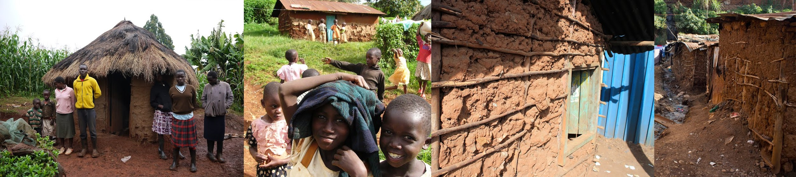
Figure 1: Left images - the Mt. Elgon case; right images the Mathare (Nairobi)

Spatial negotiation, communication and thresholds
To better understand similarities and differences between the “rural” and “urban” communities of practice, two case studies are investigated. The rural is located on Mt. Elgon (North-West Kenya) and the urban in Nairobi (Mathare). The orientation and communication of the private and shared SFH spaces in relation to the public space are of key importance (Smits, 2014). Looking at the spatial quality in the rural case we can identify a spatial negotiation (between the private and public space) enabled by the existence of a “shared space”. It has multiple functions varying from an open-air living room to laundry, cooking and meeting place. This semi-enclosed space does have a communication with the public territory, but acts as a security buffer. Below an overview of these three types of spaces (private, shared and public) are analysed and explained in relation to safety and security.

Individual/private space
The images below show the two case studies: in figure 2 a SFH located on Mt. Elgon, and in figure 3 a SFH located on Mathare (Nairobi). Comparing both cases morphological similarities are observed such as: dimensions, layout/usage, materialization and construction. Especially the usage division made inside the SFH (private/semi-private) reveals similarities - a thin line (often of cloth) is used to make a light and flexible separation between the private functions (sleeping, storing and changing clothes) and more public usages (receiving visitors, eating, cooking and washing). This enables the inhabitants to obtain great flexibility of the interior. It is of great importance considering customs such as taking people in (children and adults; family, friends and acquaintances) to the SFH. In the Mathare case this is a bigger challenge due to the spatial constraints having only one structure available for all usages, while in the Mt. Elgon case usages are spread over various structures (figure 4). An essential difference between both cases is revealed: in the Mt. Elgon SFH typology the program is spread over a larger area (building and plot), in the Mathare case the different functions are compressed into one SFH unit. According to Hall, below certain amount of square meters per person in house (varied culturally), the increase (double) of social and physical pathologies may occur (1990, p.172), thus the spatial densification correlates with the criminality.
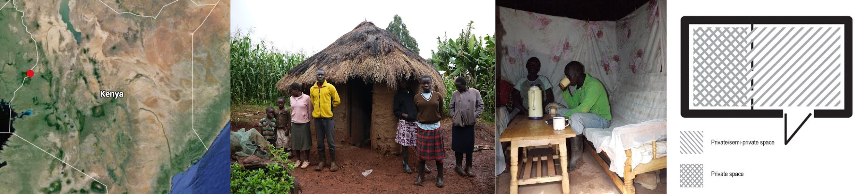
Figure 2: From left to right: map Kenya with location(Mt.Elgon), the inhabitants, indoor livingroom and morphology (private & semi-private spaces)
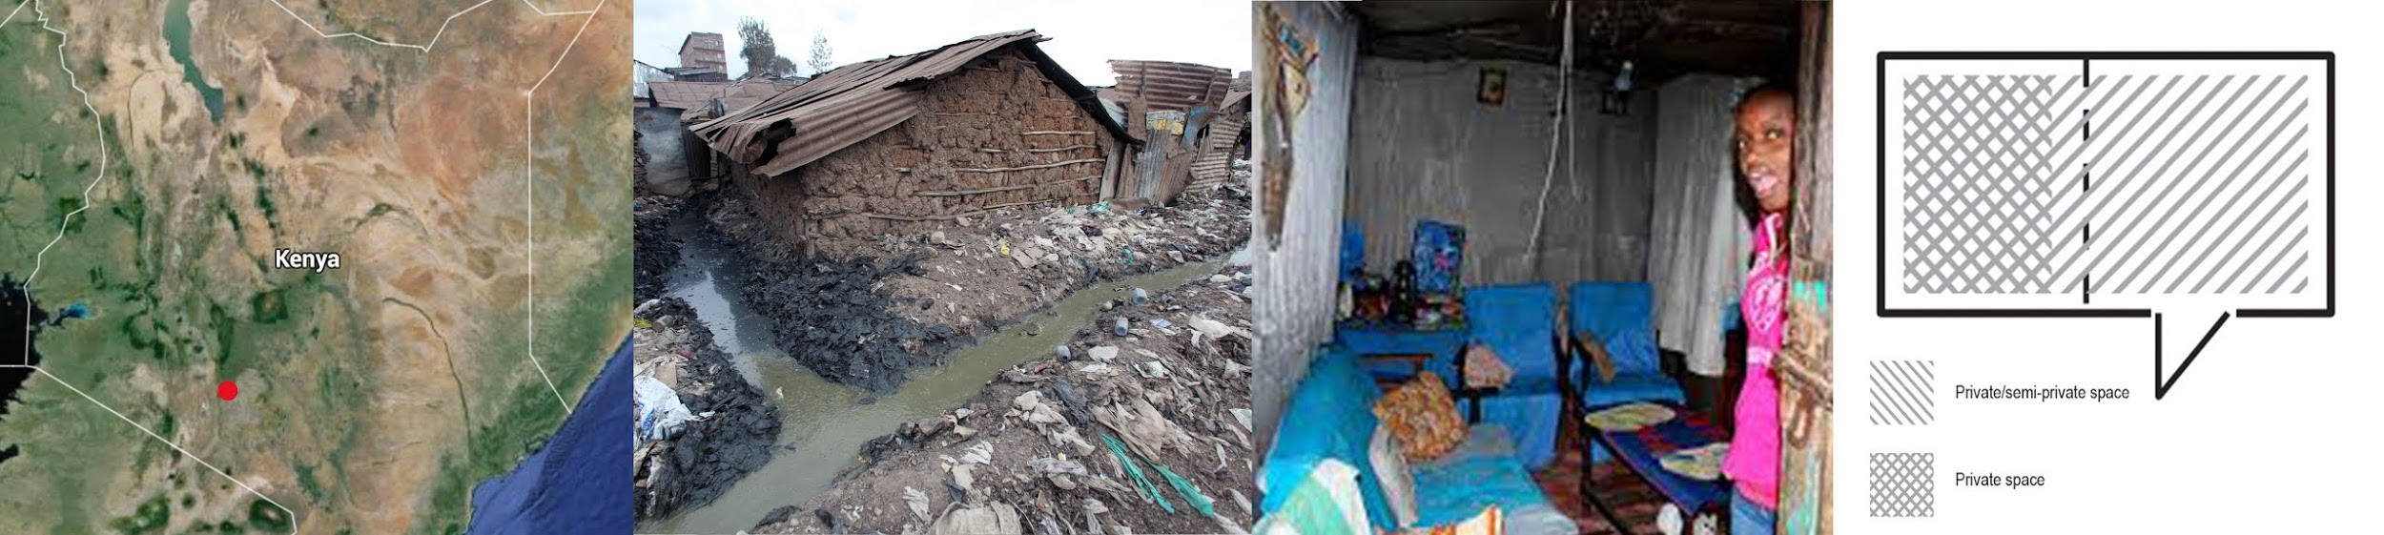
Figure 3: From left to right: map Kenya with location(Mathare), the inhabitants, indoor livingroom and morphology (private & semi-private spaces)

Moreover many private usages such as laundry, personal hygiene or cooking on Mt. Elgon are performed in the perimeter around the SFH, while in the slums these are often performed inside. The Mt. Elgon case indicates that a sense of security enables inhabitants to perform private and semi-private (Hall, 1990) usages in the perimeter of the dwelling. The Mathare SFH lacks the land and feeling of safety due to the physical distance between private and public usages. According to Hall (1990) there is a direct relation between physical distance, level of private/public and if it is socially desirable (figure 4). As a consequence this influences the sense of security in and around the Mathare SFH.
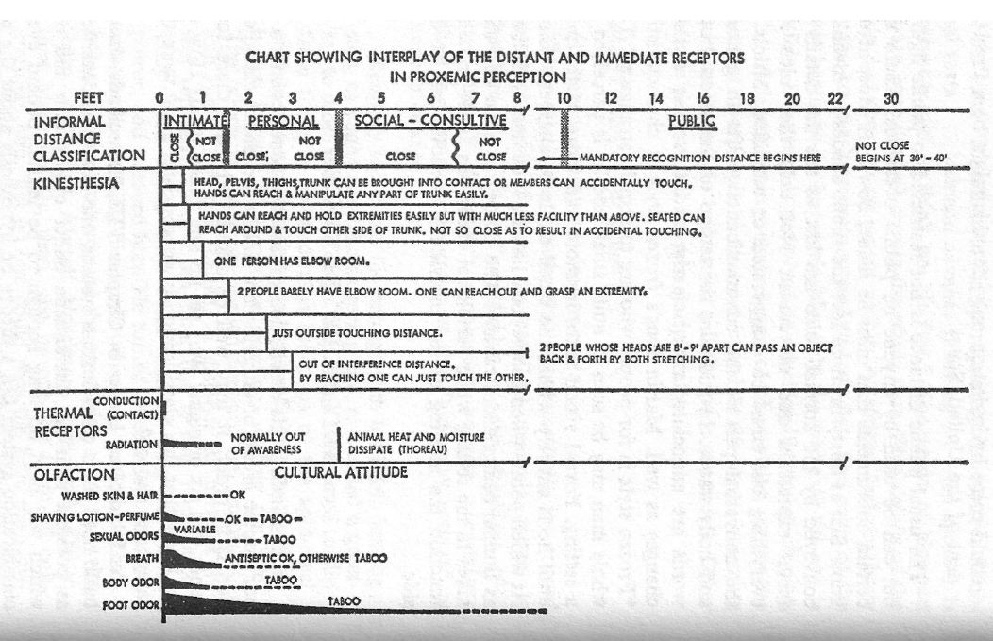
Figure 4: Hall index, we should add pictures or problematic tendency (rural urban on the right)

Due to the spatial compression undesirable usage is forced inside thus it is assumed the inhabitant spends there more time. The inhabitants of the Mt. Elgon case spend less time inside the dwelling, engaging more in the public space. The morphology of both cases seems to be highly similar, hence the conclusion follows: the problem lies in the context of the SFH. In particular the loss of shared space seems to be an important cause, as there is no space left for individual private usage (washing and sanitation) or for shared space, in the Mathare case.

Shared space
The shared space terminology is derived from the analysis of the Mt. Elgon case. The SFH compound perimeter (often low fenced) is an informal zone that enables various usages and more importantly establishes communication with the public space. This area is owned by the family, but due to the low perimeter fence and many possible entrances, easy to access by visitors (figure 5). This passage is offered via small informal infrastructural network connecting to the main public space. In daily life this means that neighbours, friends and family often stop by for a chat or for a shared activity (cooking, washing, etc.). With a simple “hodi?” (May I come in?) people are welcome to enter. Because of this unofficial, low barrier between the public and private space and high amount of common activities this zone has been identified as a “shared space”.
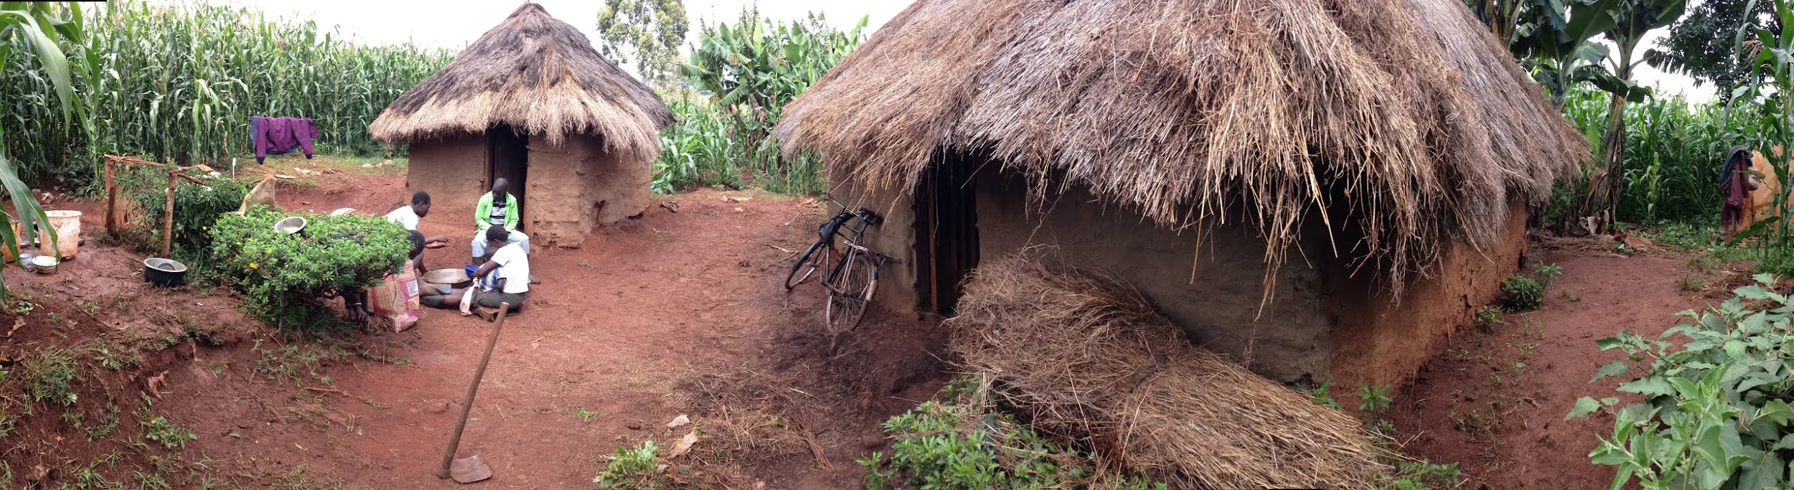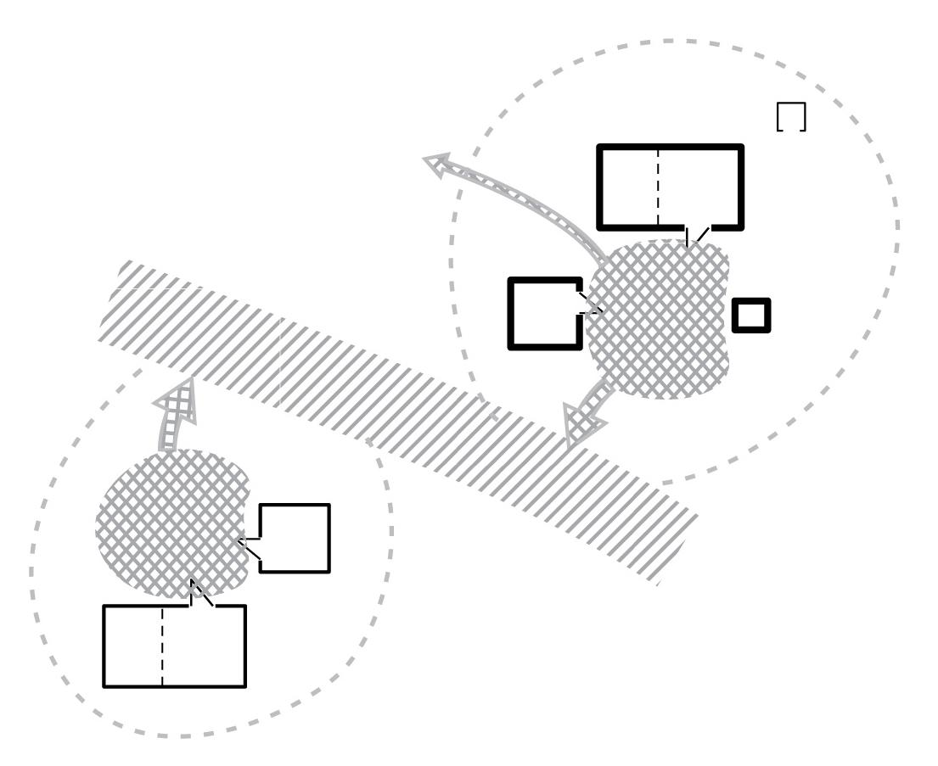
Figure 5: Left; shared space in the Mt. Elgon case, right; scheme of connectivity between shared and public space.

It seems to be a vital informal negotiator between the private and public space. However in the urban case, it is minimized and often not existent. As a consequence most SFH activities have moved inside, leading to a more private living. In the rural context most of the family life and an intrinsic part of communal life is spent outside, in Mathare it is now behind closed doors. In this article the lost shared space in community is perceived as the elemental problem to the decreased sense of security. Due to the loss of spatial awareness as well as decreased communication between private and public life, the feeling of safety declines. It strongly relates to the lack of communal organization and largely unknown social conditions. Common values and principles are unknown, creating a state of individualism opposing community sense obstructing contemporary built environment practices (Habraken 1984). This could be solved by the commonly owned, but publicly accessible shared space. Figure 6 shows the spatial conditions and relations in the Mathare case. The little shared usages (sitting, chatting, washing, etc.) in front of the SFH indicates rural practices, but they now collide/interfere with the public space.
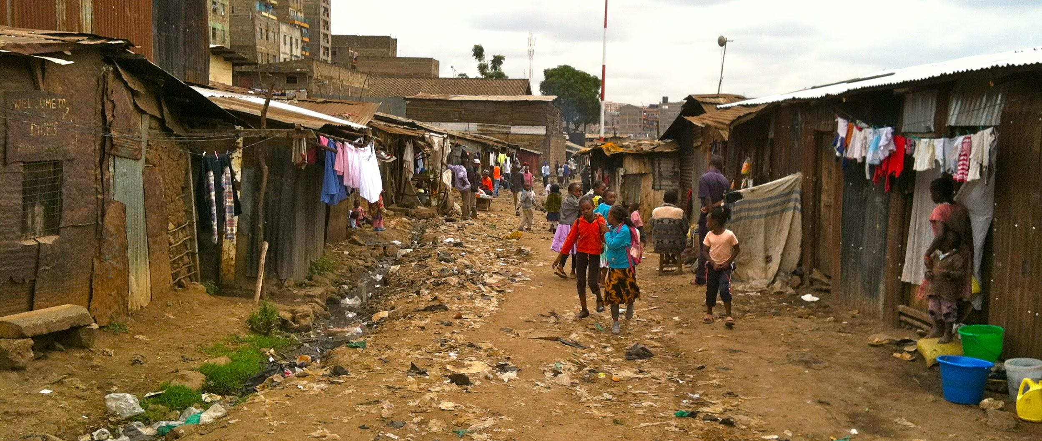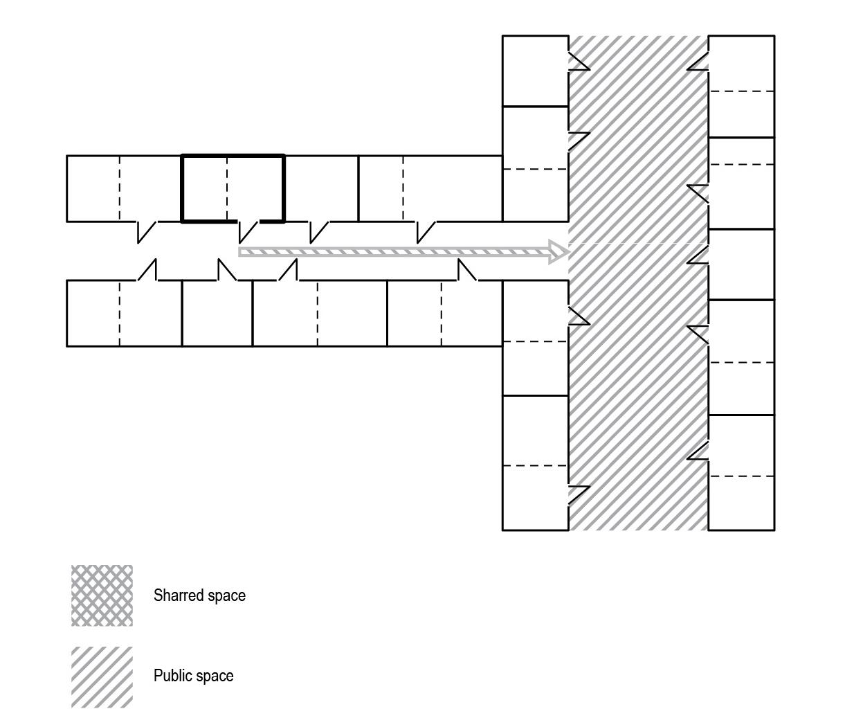
Figure 6: Left; “public/shared” space in the Mathare case, right; scheme of connectivity in the shared/public space.

Public space
Physically the loss of shared space results in the diminished distance between private and public space. Due this shrinkage , anything happening in the public realm has a direct impact on the private space. The type of activity can vary, but is strongly connected to the type of public space. To compare the public space of the two cases, three main types of public space (see figure 7) are distinguished: necessary activities, optional/social activities and leftover space (Gehl, 2011, p.9). Three tendencies in the organization of the SFH compound in relation to their type of public space can be inferred from the rural case: firstly all SFH connect directly to a shared space and connect via informal paths to the main infrastructure, secondly most compounds next to public space have sufficient distance from it, thirdly unused spaces are equally shared for growing crops. Moreover the community board and chairman is supervising the overall organization of the families and public realm. In case of alterations or disputes they negotiate and arrive at solutions, therefore sustaining communication between the individual and the community.
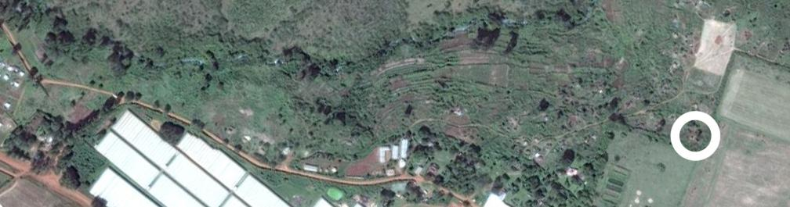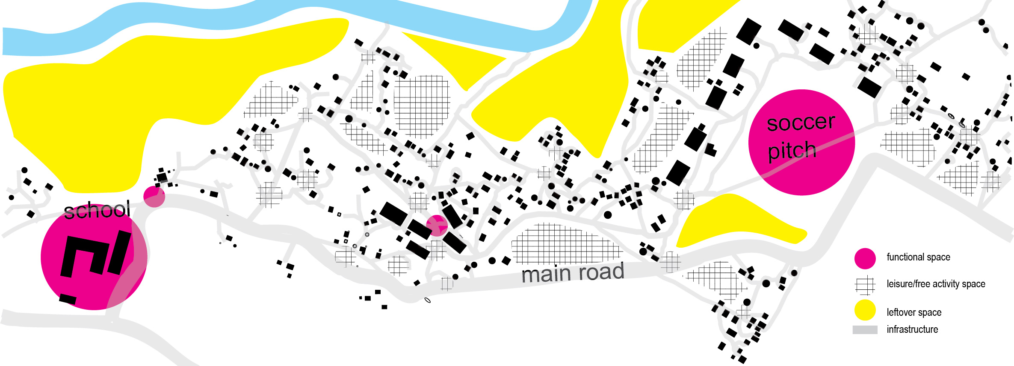
Figure 7: Top; Google Map picture of the Mt.Elgon case area, Bottom; Map of informal settlements and type of spaces in the case of Mt. Elgon

Opposite tendencies are observed in the urban case. Firstly most SFH are connected directly to the public space, secondly slum SFH does not have sufficient distance from the public space. Unused spaces are scarce and in most cases used for sanitation or garbage disposal. While in the rural case study trespassing is easy to spot (paths leading over the shared space could only be used when inhabitants are there), the absence of shared space disables or diminishes the mediation between the public and private. This means that the people passing by the dwelling are actually moving in the area that from tradition was perceived as shared space (Alexander, 1977).

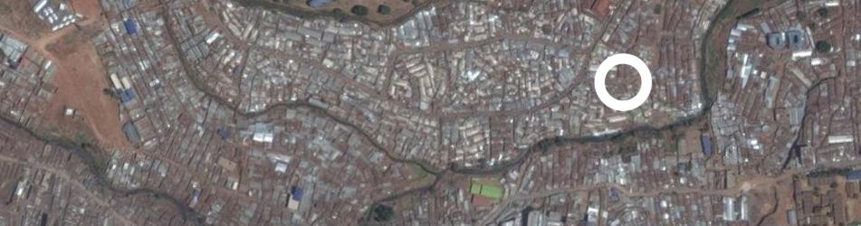
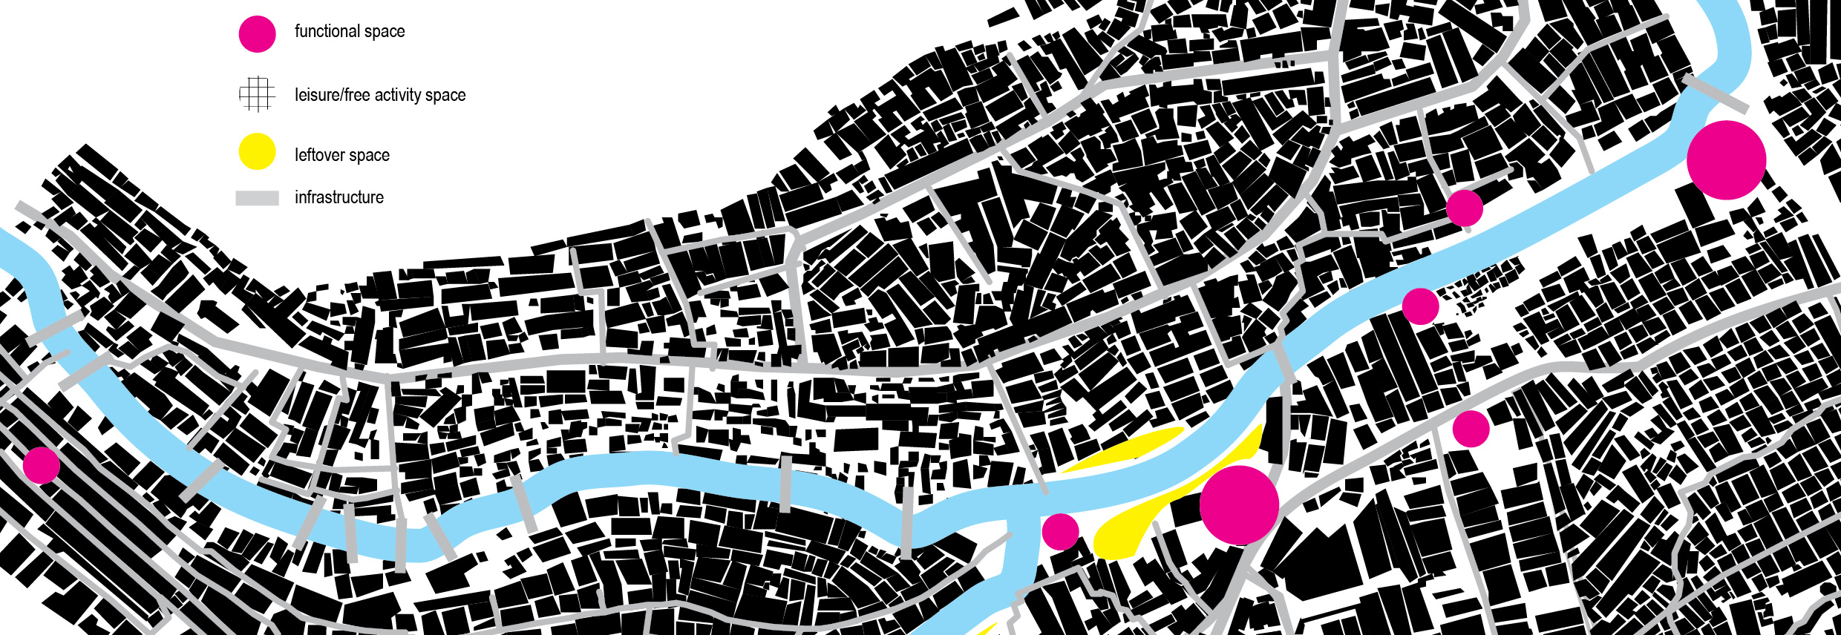
Figure 8: Top; Google Map picture of the Mathare case area, Bottom; Map of informal settlements and type of spaces in the case of Mathare.

According to Gehl (2011) optional activities in the public realm are vital to a good physical living environment (figure 9). Therefore, by providing shared space room will be given for optional activities enabling social and household activities in and around the house (UN Habitat, 2013, p.15). Due to the lack of communal organization and spatial planning, the slum community is unable to force any changes towards their shared and public space.

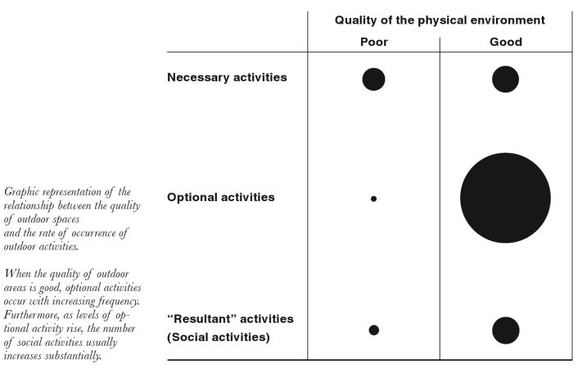
Figure 9: Diagram showing type of outdoor activities in relation to the quality of the environment (Gehl).
Lack of (spatial) organization
In the rural case the SFH inhabitants are owners of the private and shared space, together with their neighbours and community they decide where and how the various spaces connect/intertwine with the public space. Although there is no formal “system” a continuous transition from private to shared space and from shared to public space can be observed. In most slums there is little communal regulation, here the board and chairman are replaced by a complex informal network of owners and renters (SDI & Pamoja trust, 2007). Due to the lack of space there is no or little shared space and ownership is often temporal (renting). This constant flux of transition is difficult to organise as a community and seems to play a vital role in the disturbances on a local level. The lack of security often points towards the lack of community sense, which is not the case in most house owned neighbourhoods.

It can be questioned whether changing parts of the public space to shared space causes an increase the sense of community. In slums there lies a different problem. Due to the lack unused public spaces, there is little chance for optional activities. A spatial change can only be made with community activation planning and a reappointment of an organizational system. In the rural case this consist of a board and chairman. They act as negotiators between, individual and community, public and private, safety and criminality, etc. Therefore there is a need of a social and spatial negotiator among the urban poor, but it remains unclear who could play this role.

Role of the architect in spatial and social negotiation
To explain the possible negotiating role for the planner and architect, the case of the Huruma project executed by Italian NGO called Cooperazione Internazionale (Coopi), together with the Pamoja Trust is presented. These organisations are lead mainly by urban planners and architects, working on informal settlements around the world. The Huruma Slum Upgrading Project intended to support community-led process activated for the upgrading of the informal SFH in Huruma. The ambition behind the process was to actively involve residents in all stages of the project. Furthermore one of the goals was to strengthen the inhabitants’ skills (construction) so they could give a meaningful contribution to their own development. In three consecutive field missions (2007, 2008 & 2009), the planners firstly analysed the slums and completely mapped the existing situation together with the inhabitants. Secondly made suggestions and discussed them with the inhabitants, thirdly developed a general masterplan. Over the period of three years planners and architects looked together on the current problems in the dwellings and formulated multiple possible solutions on every problem e.g. the of lack of land and the constant need of morphological expansion were solved by vertical construction. Moreover, current construction practices were analysed and together with the inhabitants simple, cheap and lightweight constructions were pinpointed (Habitat in development).
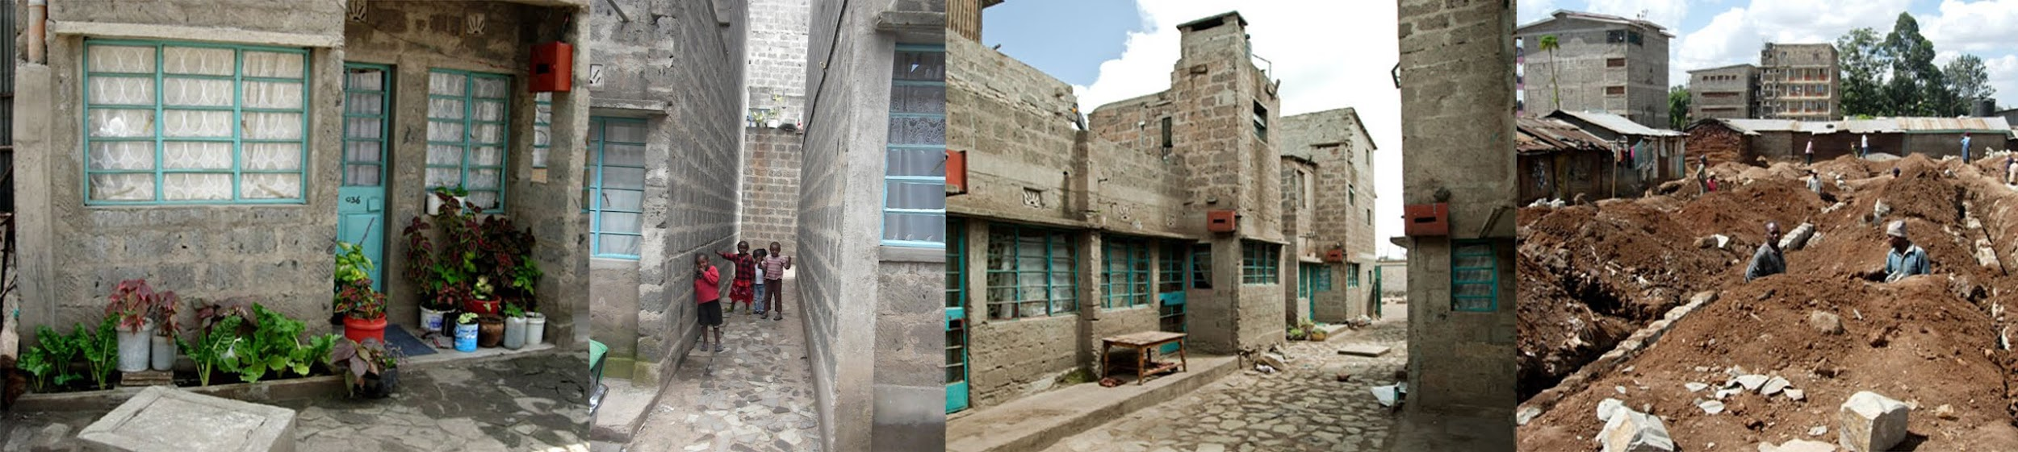
Figure 10: Pictures of the Huruma project, author: G. Steenput, E. van den Veyver & http://www.habitatindevelopment.org/kenya.html
The most valuable solution of the Huruma project seems to lie in the way the masterplan was made - together with the inhabitants. Although little of the rural organismal morphology can be recognized here, there seems to be a qualitative and intertwined private, shared and public space. More importantly due to home tenure and communal efforts, a new community rose from the remains of the Huruma slums. It enabled children to grow up in a safe and healthy environment despite surrounding the chaos of a slum. This example shows that planners and architects can play a vital role in co-creation with the urban poor to improve their living environment and sense of security. Statistics derived from the Huruma project reveal that for a global slum upgrading assignment hundreds of planners and architects are needed.

According to Atkinson & Kintrea (2001), there is a direct relation between the level of poverty and the chances (job opportunities, education level, etc.) one can obtain. If we strive towards equality, we should start offering safe and healthy environment for the urban poor. For the planner and the architect this means that the solution does not lie in building for an inhabitant, they will have to built together with the inhabitants and their community.

References
Alexander, C., (1977), A pattern language,
Atkinson, R. & Kintrea, K., (2001), Disentangling Area Effects: Evidence from Deprived and Non-deprived Neighbourhoods, Urban Studies, November 2001, 38: 2277-2298, doi:10.1080/00420980120087162
Burton, I., (1987) Report on reports: our common future, environment: science and policy for sustainable development, vol. 29, iss. 5
Cohen, B., (2006) Urbanization in developing countries: Current trends, future projections, and key challenges for sustainability, Technology in society 28, 63-80, Washington
Gehl, J. (2011) Life Between Buildings: Using Public Space, Island Press, London
Habraken, J.N. (1985), Appearance of form, Awater Press, Cambridge, Massachusetts
Habraken, J.N. (1988), type as a social agreement, Asian congress of architects, Seoul
Hall E.T.,(1990) The hidden dimension, Anchor Books Editions, New York
Habitat in development, (viewed 06-2015) Huruma slum upgrading, http://www.habitatindevelopment.org/kenya.html
Prahalad, C.K. & Hammond, A., (2002), Serving the world’s poor, profitably, Harvard business review
Raleigh, C. (2015). Urban Violence Patterns Actors Across African States. International Studies Review 17, 90–106
Rapoport, A., (1969) House, form and culture, prentice-hall, Englewood cliffs
Pamoja Trust & Shack/Slum Dwellers International, (2009), The Nairobi Inventory, Nairobi, Available at: http://www.homelessinternational.org/client_files/doc_docs/rep NairobiSlumInventory _ Final_Apr09.pdf
Smits, M.W.M., (2014) Social changes and spatial transition of informal settlements in sub-saharan communities, FoP II, Buenos Aires.
UN-Habitat (2012) Streets as Tools for Urban Transformation in Slums: A Street-Led Approach to Citywide Slum Upgrading, UN-Habitat Working Paper, Nairobi
Wenger, E., McDermott, R., Snyder, W. (2002), Cultivating Communities of Practice: A Guide to Managing Knowledge, Boston, MA: Harvard Business School Press, 2002).

