**Future of Places III** - Stockholm June 29- July 1, 2015.

Martin Scoppa, PhD. Postdoctoral Fellow SUTD/MIT. Massachusetts Institute of Technology

**Title:**

**STREET CONNECTIVITY INDICES IN URBAN GROWTH PLANNING. A CASE FOR CONTEXT DRIVEN URBAN EXPANSION IN SOLO, INDONESIA.**

**Abstract**

Over the past years a large number of studies focused on the importance of connectivity of street networks. In the US, where much of this literature has been produced, research transcended the academic boundaries and currently assists policy making in numerous cities (APA, 2006; Handy et al., 2003). This practical use of street connectivity research rests, largely, in that it framed the debate regarding a possible transition from auto-oriented urban growth, towards more compact, healthier, and cleaner cities. More recently, UN Habitat has placed streets in the world’s urban agenda, providing a basis by which to initiate the discussion on street connectivity in the developing world. However, this paper argues that informing policy in these countries requires that connectivity research focuses on the specifics of each context, contributing to effectively address objectives relevant to each case.

In consequence, this paper focuses on the application of common connectivity indicators used in practice (such as block sizes, and street and intersection densities) to outline, and potentially frame, a discussion that informs policy in a developing country context. Using Solo, Indonesia, as an example, this paper investigates, first, the performance of this city’s street network given key objectives such as walkability, public and private motorized transportation, emergency access, and general aspects related to quality of life. Second, using this detailed quantitative summary, we identify connectivity indices that could contribute to more efficiently plan Solo’s expansion. Particularly, we explore which of the existing conditions should be preserved, and which would need to be changed, in planning for street connectivity in its future growth. Data for this study was obtained during a recent survey of streets and land use conducted in Solo.

In a scenario of rapid urban expansion, where some cities might even triple their footprint within a thirty year framework, street connectivity measures are singularly important. They assist in planning a rational framework for connectivity development that is contextually appropriate.

**Introduction**

The discussion of street connectivity has grown substantially in the past decade. It has now reached the agenda for research and planning in developing countries, with several publications by UN Habitat addressing streets, street networks, and urban expansion (UN Habitat 2012, 2013, 2015). However, the discussion regarding the overall suitability of measures of connectivity used in developed countries, to measure and characterize connectivity in the developing world, is still lacking. More specifically, while the measures developed, mostly, in the US context were designed to address this country’s concern about urban sprawl -i.e., the growth of the suburban areas characterized by large blocks and an overall lack of streets, their ability to inform urban form policy in other contexts still needs further scrutiny. Particularly, the application of measures of connectivity in cities in developing countries where the characteristics of the street layouts are likely to emerge from different historic and cultural processes, and where the concerns of planners and city officials might have other agendas than sprawl and overreliance on private motorized transportation, requires further study. While suburbanization patterns with low connectivity characteristics can be increasingly found in the developing world, such as the new cities in the outskirts of cities like Cairo, or developments in the metropolitan area of Buenos Aires of the last 15 to 20 years (see images below), cities’ street networks across the world do not present, consistently, the characteristic features of these types of developments.

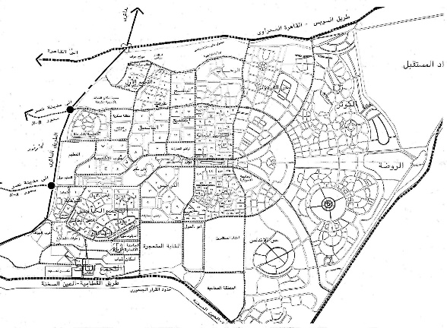 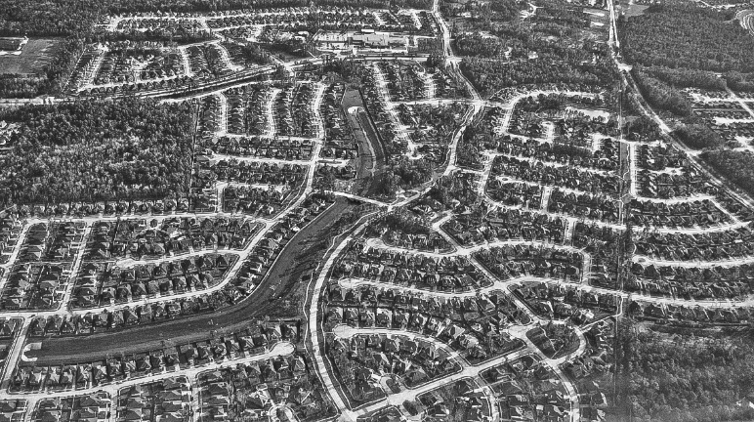

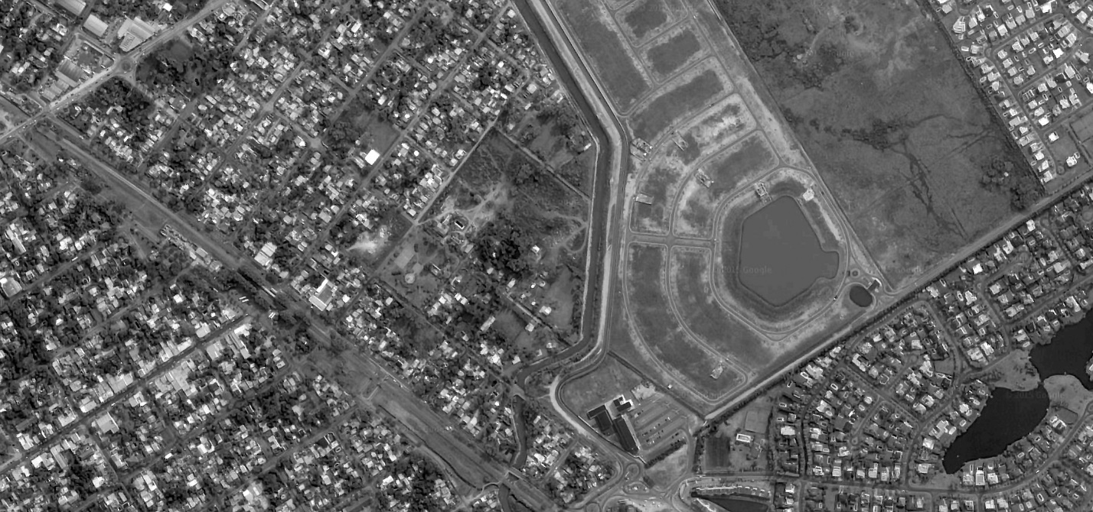

Figure 1- Top left, New Cairo. Top right, US suburban development typically associated with “sprawl”. Bottom image shows, on the left half, the traditional grid layout of metropolitan Buenos Aires streets. On the right, new ‘sprawling’ subdivisions at different states of consolidation.

As a result, the indicators currently used, and which are useful in identifying low connectivity patterns marked by high number of cul-de-sacs, a lack of streets, and large blocks, might not be as useful in other contexts. More specifically, current indicators are particularly useful in highlighting differences in connectivity, when contrasting development patterns such as the noted peripheral sprawl, and the inner city grids characteristic of prewar development in the US; still, they might not be as effective in highlighting connectivity differences in other cases. Thus, the question remains regarding the ability of these street connectivity indicators in describing street network patterns where variations between inner city and the expanding periphery, are not so starkly in contrast. Moreover, these indicators might not be adequate in addressing, first, planning issues that are of concern in developing countries, and second, the characteristics of street networks that develop informally -i.e., without responding or adhering to regulations regarding road widths or land subdivision.

In this paper we study the characteristics of the street network of Solo, Indonesia, as a case by which to investigate the values that connectivity indicators take in this context. Through a comparative analysis between Solo’s street connectivity properties, a planned street network of regular blocks, and a typical suburban street pattern, we outline a preliminary agenda for further research.

**What is connectivity? The methodological framework and the discussion in the US.**

Connectivity is defined by the American Planning Association (APA, 2006) as the quantity and quality of connections. This definition, rests on the role of streets networks in their fundamental function of connecting spatially separated places, enabling movement from one place to another. These definitions, while applicable to the general role of streets in cities, acquire a specific dimension in the discussion that has been, and still is, of interest in the US.

In this country, the concern over the lack of streets and the low connectivity in suburban areas is related, to a large extent, to the high prevalence of motorized trips generated by this type of urban growth. That is, the effect on travel mode choice of a large number of urban dwellers who rely, mostly, on private automobiles for transportation. This situation, in turn, raises concerns about the high consumption of fossil fuels, the noxious effects of automobile use on air pollution and carbon emissions, the loss of productivity by time lost in traffic, and also, to a lack of physical activity with consequent health problems. In other words, the discussion of connectivity is fundamentally linked to the reevaluation, not exempt of criticism, by planners, urban designers, and architects, of the forms of urban development that emerged after WWII, and their consequences on urban life and urban sustainability. From this premise, a large number of studies have focused on aspects of urban form and their relationship to walkability, travel behavior, health and well-being, as well as purely morphological categorizations (see for example Cervero and Kockelman, 1997; Frank, Engelke, 2001; Southworth and Owens, 1993).

Street connectivity has been measured using a variety of indicators. However, the large majority is designed to contrast the situation in the older centers, and the expanding suburbs. A thorough summary of these indicators has been provided by Dill (2004), who reviewed several key studies produced in the US. Among the measures cited by this author, we find measures such as block sizes and maximum block sides’ length, as well as measures of density. These latter are, the density of streets in linear units per area, the density of intersections per area, and the density of blocks per area. Additional measures reviewed include ratios of road segments (parts of streets between intersections) to nodes (intersections themselves). In the case of density measures, the prevailing theory indicates that higher values are associated to higher connectivity: higher density values are indicative of higher numbers of alternative paths between origins and destinations, and would involve shorter travel distances between them. All these, factors that encourage walking or non-motorized transportation. Expectedly, higher densities of streets, or blocks, or intersections, per unit of area, are positively and highly correlated to block sizes. Additional indices, such as Pedestrian Route Directness (PRD) has been used to compare the efficiency of connections, as networks that provide more direct paths between a given origin and potential destinations reduce the length of routes, also encouraging walking. The amount of research that has applied these indices has been substantial, but, we must emphasize, was guided by a clear theoretical framework regarding the planning of future urban growth in America.

In sum, we find that in these studies there is a very clear underlying motivation for addressing connectivity. Thus, the indicators developed have been especially useful in their ability to address the specific concerns of US planners and researchers. The results of several years of continuous research and a vast number of publications have derived in the application of connectivity regulations in many cities. But what is the situation in places where land development does not follow these same patterns? What do these indicators describe, and how can they help in addressing issues that can be tackled through connectivity research? As a way to initiate this discussion, the following section presents a quantitative summary of street connectivity indicators in Solo, and present them side by side with values characteristic of a regular grid and a typical suburban street layout.

**Quantification Solo’s street network properties.**

As a starting point we describe the characteristics of Solo’s street network, based on a quantification of the commonly used indices identified in the previous section. At this time, we focus on these indices, given their success in transcending the boundaries of academic research. In other words, unlike other network connectivity indices that are perhaps more discriminating, as they address urban street structures based on centrality metrics (Crucitti, Latora, Porta, 2006; Porta et al., 2009), or accessible street density and street alignment (Peponis, Bafna, Zhang, 2008; Scoppa, Peponis, 2015), these indices have the advantage of having been implemented in regulatory frameworks. However, we should note that ongoing research is currently focused on the application of this more sophisticated measures of connectivity to case study cities such as Solo.

The summary of Solo’s street connectivity indices is presented in Table 1. This summary result from the analysis of the central parts of the city, covering an area of approximately 7.5 km2, where a detailed survey of the streets was conducted. For further reference, the values obtained are compared to a regular grid, such as the ones found in cities throughout Latin America, the US, Canada, and Australia, and a typical suburban pattern. In this study the grid used for reference is that of the City of Buenos Aires, whose blocks have approximately 100 meters sides. The suburban pattern used is located in Decatur, DeKalb County, Georgia, USA. Decatur is approximately 15 minutes away, by car, from downtown Atlanta.

|  |  |  |  |  |
| --- | --- | --- | --- | --- |
|  | **Indicator** | **Solo** | **Grid** | **Suburban** |
| General characteristics of the networks | Total Area (km2) | 7.48 km2 | 7.48 km2 | 7.48 km2 |
| Street network length | **155.5 km** | 120.7 km | 19.39 km |
| Total blocks | **681** | 215 | 59 |
| Total Intersections (nodes) | **1203** | 544 | 259 |
| Total segments (links) | **1986** | 1072 | 332 |
| Blocks | Block sides (average) | **78.3m** | 112.6m | 273.5 |
| Average block size | **1.12 ha.** | 0.92 ha. | 2.05 |
| Densities | Block density | **91.04/km2** | 28.7/km2 | 7.88/km2 |
| Street density | **20.7 km/km2** | 16.1 m/km2 | 2.59 km2 |
| Intersection density | **239 u./km2** | 73 km2 | 44 km2 |
| Intersections | Nodes value 4 (%) | 21% | **73%** | 6% |
| Nodes value 3 (%) | **71%** | 21% | 59% |
| Dead ends / value 1 (%) | **8%** | 4% | 35% |
| Proportion of choice nodes to dead ends. | 12.6 | **23.5** | 1.91 |
| Link to nodes ratio | 1.65 | **1.98** | 1.28 |
| Street widths/ Area | Area dedicated to streets | 14% | **28%** | Not available |

***Table 1*** *–* Values obtained over equal areas of 7.48 km2. This area encompasses the central districts of Solo where a detailed surveyed was conducted. Numbers in bold indicate more favorable values.

As can be observed in the summary presented in Table 1, several indicators stand out in Solo in comparison to a regular grid of blocks whose sides approximate 100 meters, and with the suburban layouts that have generated so much research.

In terms of street lengths, the network of Solo is about 20% longer than the grid, and about 12 times longer than that of the suburban layout. As a result, the number of blocks in Solo increases to about three times the number of blocks in the grid, and more than 10 times the number of blocks of a typical suburban layout. The number of intersections and road segments (the portion of roads between intersections) is also strikingly higher in Solo compared to the grid and the suburban layout.

Further results indicate that Solo’s blocks have, on average, short sides, although not remarkably different from those of the grid. In other words, it could be argued that the 30 meters difference between blocks sides’ lengths in these two cases, is not significant at the scale at which cities are planned or walked. When looking at the two dimensional measure, average block size, we find that Solo has larger blocks than the regular grid. However, in this case, this difference is attributable to the presence of large tracts of land in the central area surveyed, corresponding to the Kraton Surakarta (the Sultan’s Palace), and the Dutch colonial fortress Fort Vastenburg. We should note that the median block size in the study area of Solo is 0.67 hectares while Buenos Aires’ is 0.95.

When looking at the densities of streets, intersections, and links, Solo stands out again with significantly higher values than either the grid or the suburban layout. Considering that, in theory higher densities signify higher connectivity and would effectively support walking and biking, the layout of Solo outperforms the two other layouts studied.

However, important differences surface when observing in detail the type of intersections found in Solo, as compared to the two other layouts. Of particular interest is the prevalence of nodes of value three (T intersections), whose 71% value approximates it to the 59% of the suburban layout, while also showing a doubling of the percentage of dead ends compared to the regular grid. This prevalence of T intersections could impact route directness, requiring frequent turns, further complicating navigation and wayfinding.

Finally, a striking difference is found in terms of area dedicated to street. Expressed as a percentage, the area dedicated to streets in Solo approximates 14%, which is only half of the area found in the grid. While in the grid studied streets widths average 17 meters, the average width of streets in Solo is only 6.8 meters. These two values are typical: the low percentage of Solo is noted by UN Habitat as characteristic of developing countries with unplanned street networks (UN Habitat, 2013, p.109), while 28% is close to the values found planned cities in developed nations, and cities where planning has been more consistently enforced (UN Habitat, 2013, p.108). Unfortunately at this point data on the width of streets in the suburban layout was unavailable.

In sum, Solo’s street network presents characteristics of what could be considered outstanding connectivity according to block sizes and, consequently, the density of streets and the density of intersections. However, two areas warrant further analysis. These are, first, the prevalence of T intersections, which could impact through traffic, reduce the efficiency –directness- of potential paths, and could complicate navigation and wayfinding. Second, and perhaps more fundamentally, the lack of streets that are wide enough to accommodate all modes of transportation, particularly public and private motorized modes, points to one of the most significant challenges of urban expansion: the costs involved in developing roads, and additionally, utilities infrastructure. However, we should note that these results are focused on the quantification of connectivity properties. The ability of the indicators to address planning issues, particularly those related to a more efficient growth, are outlined in the following section.

**Discussion of Solo’s quantitative indices and identification of areas for further research.**

The quantitative descriptions introduced allow us to better understand the characteristics of a street network whose properties differ significantly from a planned regular grid and a typical suburban layout. If we follow the concerns frequently expressed regarding the impact of street networks in building more livable cities, where streets network design encourages alternatives to driving (particularly walking and cycling), provide efficient routes, and support a multiplicity of urban activities, it is possible to outline the areas in which Solo’s layout should, in theory, perform well, and where the potential challenges lie.

In terms of *walkability*, Solo has a highly dense network of streets, resulting from a structure of small blocks. This would provide for a high number of alternative paths between origins and destinations –i.e., higher quantity-, as well as the potential for following more efficient and direct routes between start and endpoints of trips –i.e., the quality of connections-. However, as earlier noted, a notable feature of the type of street networks in the city of Solo, is the prevalence of T intersections (nodes of value 3). This characteristic might present a challenge that requires further research to be properly addressed. In other words, the impact of the “misalignment” of consecutive parts of roads and streets, requires further study in order to understand its real impact in terms of its effect on walking and overall access throughout the city. It has been noted that turns have incidence in the cognitive load required to navigate a street network, a factor that has led to the study of urban street structures according to direction changes (Hillier and Hanson, 1983; Hillier 1996; Peponis, Bafna, Zhang 2008). Whether this represents a challenge to the overall walkability of this environment, or a challenge to the integration of neighborhoods to their surrounding areas, still needs further research. Initial results from the analysis of businesses locations in the streets of Solo indicates that these tend to locate, overwhelmingly, on the wide and long streets that structure and distribute traffic across the city. However, studies of connectivity addressing street alignment (measured by direction changes), and potential for concentrating through traffic (betweenness centrality), have been found to be important contributing factors. As this research progresses, and the impact of street alignment is progressively clarified, we expect to contribute to a richer discussion regarding walkability in this context.

A second area of concern when addressing street connectivity is *motorized traffic*. As noted, the dense street network of Solo and its land subdivision structure of small blocks results in a high quantity and quality of connections. This means, in turn, many alternative paths and efficient routes that link potential origins and destinations. However, for motorized traffic, the limiting factor is related to the lack of adequate widths for the movement of vehicles larger than motorcycles in every single one of the city streets. Once again, the concern over lack of connectivity in street networks that is addressed by a large number of studies in the US, notes that highly connected street networks would permit the dispersal of traffic, provide alternative routes, and consequently reduce congestion and many of its negative impacts (economic, environmental, and overall sustainability of urban traffic systems). On the other hand, as a negative side, it is noted that allowing through traffic traversing residential areas might affect perceived good qualities of neighborhoods, such as safe and quiet streets, with consequent effects on property values. In the case of Solo, the potential for traffic dispersal is severely hampered by the lack of appropriate widths, as would the potential for planning efficient and wide-covering public transportation, and emergency vehicles access into the inner areas of residential neighborhoods. Typical connectivity measures, such as those listed in the first four subgroups in Table 1, fail to account for this factor. The inclusion of area dedicated to roads is a fundamental metric to consider, and one that has been timely introduced by UN Habitat in its 2013 report.

**Discussion – Moving forward**

In this paper we quantified and compared the characteristics of Solo’s street connectivity to two distinctive urban patterns. We find the comparative study to be particularly useful as it clarified how connectivity indicators, used in research addressing many of the concerns of current planning, perform in this particular urban environment.

The overall prevalence of small blocks, and consequent high values of street, intersections, and block densities, indicate that Solo’s network would be particularly apt for accommodating non-motorized movement. The quantity and quality of connections, as measured by indicators currently in use, is higher than in the typical grid and the suburban layout. It has been noted however, that road misalignments are frequent and that further research is required to better understand the impact of this element in the overall connectivity performance of this network.

A second factor that has been found to be particularly important is the area dedicated to streets. In other words, while Solo’s network is particularly dense and could, in principle, contribute to disperse traffic and alleviate congestion –with all the positive effects that this would bring- many of the city streets are currently not apt for carrying motorized traffic. Further, the lack of appropriate widths has impacts not only on the distribution of private motorized transportation, but also for public transportation and emergency vehicle access. The introduction of an indicator addressing the area dedicated to streets is of particular importance in this context and UN Habitat timely discussion of this factor should be consistently considered in street connectivity research.

Overall, the street structure of Solo could be summarized as being dense, with frequent misalignments, and strongly hierarchical. There are many streets, paths will require frequent turns, and motorized traffic cannot be accommodated on all streets. In planning for its expansion it would be important to recognize these factors. Incorporating them into the urban regulatory framework, however, would require further study. Still, we know that street densities can be regulated, that the type and quantity of intersections can also be regulated, and so can be the area dedicated to streets. Where should these values lie? At this point we can only speculate that comparative studies such as this can further clarify the options available for cities such as Solo. Balancing competing interests, such as walkability and motorized traffic distribution and access, as well as the budgetary constraints involved in road building, should be carefully considered when planning the city’s expansion.

In closing, it is important to note that researchers have developed sophisticated connectivity indices that are singularly insightful. Particularly in terms of their ability to identify variations in urban street structure, movement patterns, and the distribution and location of land uses. The challenge that these indicators meet, lies in the difficulties involved in translating their values into regulatory recommendations. Still, this challenge could be considered as an opportunity to explore ways by which this research can be more effectively incorporated into the city planning process. The increasing use of GIS and web mapping services can certainly contribute to this.

**References**

Angel, Shlomo. *Making room for a planet of cities*. Cambridge, MA, USA: Lincoln Institute of Land Policy, 2011

American Planning Association. *Planning and urban design standards*. John Wiley & Sons, 2006.

Cervero, Robert, and Kara Kockelman. "Travel demand and the 3Ds: density, diversity, and design." *Transportation Research Part D: Transport and Environment* 2, no. 3 (1997): 199-219.

Crucitti, Paolo, Vito Latora, and Sergio Porta. "Centrality measures in spatial networks of urban streets." *Physical Review E* 73, no. 3 (2006): 036125.

Dill, Jennifer. "Measuring network connectivity for bicycling and walking." In *83rd Annual Meeting of the Transportation Research Board, Washington, DC*, pp. 11-15. 2004.

Frank, Lawrence, Peter Engelke, and Thomas Schmid. *Health and community design: the impact of the built environment on physical activity*. Island Press, 2003.

Habitat, U. N. *State of the world's cities 2012/2013: Prosperity of cities*. Routledge, 2013

Habitat, U. N. "Streets as Public Spaces and Drivers of Urban Prosperity." *Nairobi, Kenya: United Nations Human Settlements Programme* (2013).

Habitat, U. N (2015). *Planned City Extensions: Analysis of Historical Examples*. Nairobi: UN Habitat, 2015.

Handy, Susan, Robert G. Paterson, and Kent Butler. *Planning for street connectivity: getting from here to there*. No. PAS Report No. 515. 2003.

Hillier, Bill, and Julienne Hanson. *The social logic of space*. Cambridge university press, 1984.

Hillier, Bill. "Space is the machine: a configurational theory of architecture." (2007).

Peponis, John, Sonit Bafna, and Zongyu Zhang. "The connectivity of streets: reach and directional distance." *Environment and planning. B, Planning & design* 35, no. 5 (2008): 881.

Porta, Sergio, Vito Latora, Fahui Wang, Emanuele Strano, Alessio Cardillo, Salvatore Scellato, Valentino Iacoviello, and Roberto Messora. "Street centrality and densities of retail and services in Bologna, Italy." *Environment and Planning B: Planning and design* 36, no. 3 (2009): 450-465.

Scoppa, Martin D., and John Peponis. "Distributed attraction: the effects of street network connectivity upon the distribution of retail frontage in the City of Buenos Aires." *Environment and Planning B: Planning and Design* 42, no. 2 (2015): 354-378.

Southworth, Michael, and Peter M. Owens. "The evolving metropolis: studies of community, neighborhood, and street form at the urban edge." *Journal of the American Planning Association* 59, no. 3 (1993): 271-287.