Future of Places III, Stockholm.

Managing the car in the historic built environment:

Giving places back to people

Ian Poole, BA (Hons) DMS MRTPI

Owner Director, Places4People Planning Consultancy, Ipswich, UK

**Abstract**

In 2003 the Council for European Urbanism declared that European cities were under threat from, amongst other things, a loss of regional and national cohesion, character and distinctiveness. The Council agreed twelve challenges for their organisation including:

* Degradation of public spaces;
* Public realm made from left over space;
* Car dominated transport;
* Indiscriminate road and street design; and
* Non-contextual guidelines and regulations in historic areas.

This problem is no more apparent than in many British historic towns and cities, as particularly highlighted by the English Historic Towns Forum for over 20 years and in many of its publications during that period. Despite an EHTF managed initiative to create pilot Historic Core Zones where the historic character of an area takes precedent over the demand of the car driver, little has changed since these problems were highlighted. As the United Kingdom’s economy shows signs of strong recovery following the recession at the end of the last decade, there remains little prospect of an upturn in investment in the quality of the public realm.

Various reports have been published in the UK over the last 20 years on the degradation of the public realm in historic cities, the contents of which form the background to this paper. I also examine one particular Historic Core Zone project and briefly convey findings of my Travel Scholarship that examined good practice in European historic cities where there is evidence that the historic environment has been improved to ensure that the local distinctiveness of the historic built environment takes priority.

**INTRODUCTION**

When we think of the historic cities across Europe we often think of landmark buildings, like Tower Bridge in London, the Eifel Tower in Paris or the Coliseum in Rome. However, the ability to admire those and all the other historic buildings in towns and cities is only possible by the space that surrounds them, providing the ability to view them as a whole, or in glimpses along streets and across squares. While those buildings might provide a focal point in the view, the quality of the space around them is of equal importance to the context of the building and its setting. However, it is apparent that the streets and spaces in historic towns and cities are not always afforded the same priorities of investment and care as the buildings themselves. “The spaces between buildings are fundamental to our perception of what makes places special; the proportion of time and effort given to the consideration of the public realm in comparison to historic buildings is disproportionate” (Dadson, 1999). Many architects recognise this connection. Jane Jacobs wrote of it in her great book,The Death and Life of Great American Cities. “Think of a city and what comes to mind? Its streets. If a city’s streets look interesting, the city looks interesting; if they look dull, the city looks dull” (Jacobs, 1993).

The streets and squares of our historic towns and cities, and therefore the spaces surrounding our historic landmarks, are often older than the buildings themselves. Buildings burn down; streets don’t. Even with major regeneration schemes the street pattern often remain because that’s where all the services are located and too move them is too difficult.

When thinking about the importance of spaces, their function is fundamental to their design. Many will serve more than one role, perhaps depending on the time of day, the season or the date. But, in general terms, city streets and squares are places where:

* People walk, drive, cycle, are pushed or carried;
* Walls and floors merge into open air extensions of buildings;
* Trading takes place;
* People meet, talk, trade, entertain or are entertained;
* Access is obtained to buildings;
* Utilities and services are located (gas, water, sewers etc);
* Objects are stored, especially cars;
* Human interaction and social activity takes place;
* Battles are won and lost;
* Special events take place,
* You’ll find trees, walls, flower planters, traffic signs, railings, steps, water features, cafes and advertising hoardings; and
* The city’s art is displayed, either permanently or temporarily.

However, the continued enjoyment of these spaces for such purposes is not guaranteed. For example, the Council of European Urbanism declared at their Bruges Symposium in 2003, “European cities were under threat from, amongst other things, a loss of regional and national cohesion, character and distinctiveness” (CEU, 2003). The Council agreed twelve challenges for the newly formed organisation, and perhaps for everyone involved in the design and management of public spaces, including:

* Degradation of public spaces;
* Public realm made from left over space;
* Car dominated transport;
* Indiscriminate road and street design; and
* Non-contextual guidelines and regulations in historic areas.

The challenges that they set their organisation over ten years ago should probably be heeded by all involved in the design, management and maintenance of streets and spaces in historic cities across Europe.

**The Problem**

It is important to put these concerns about the challenges facing those that care for historic streets and squares into context. Historically, the streets and public spaces of our cities have served numerous roles in defining the character and distinctiveness of London, compared to Paris or Brussels or New York. They are the glue that bound the city together; the places where pageants and processions have always been held and the venue for social interaction, rebellion and change. But, as Gehl recognised “Just as it is possible through choice of materials and colours to create a certain palette in a city, it is equally possible through planning decisions to influence patterns of activities, to create better or worse conditions for outdoor events, and to create lively or lifeless cities”. (Gehl, 2001)

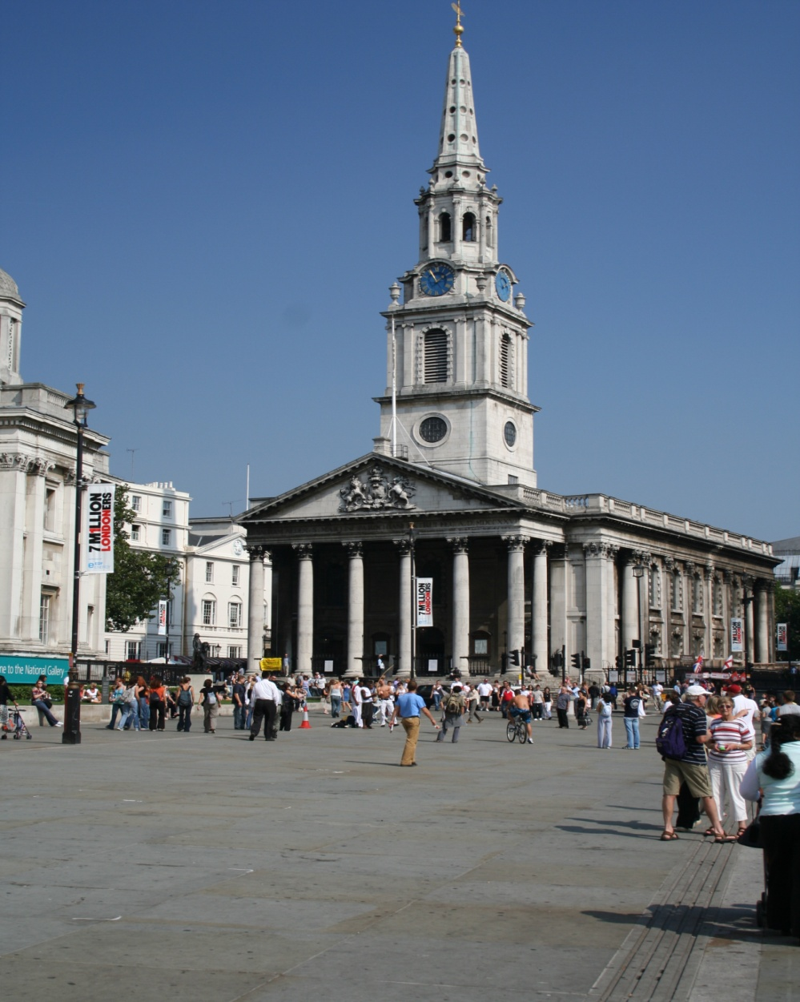

Trafalgar Square, London. Conditions conducive to enjoying the place

The public streets and squares of our cities have played a huge significance in the lives of so many. Nevertheless, it is apparent in the UK that the special qualities of these historic spaces are frequently ignored and vandalised by so many different operators who use the public realm without regard for others. By this I mean those that provide services in or through the streets. Their selfish disregard for others, including the historic environment, is destroying the very distinctiveness that can have such significant economic benefits and is having a knock on effect for the buildings that surround them.

The problem became apparent nearly ten years earlier than the Bruges Declaration when the English Historic Towns Forum published "Traffic Measures in Historic Towns: An Introduction to Good Practice" (EHTF, 1993). The authors highlighted that there was "conflict...between the requirements of UK traffic regulation law and the need to conserve the character and appearance of the historic environment" (cited in Traffic in Historic Town Centres. EHTF 1994). The Forum was especially concerned that, when compared with continental Europe, the UK approach lacked imagination and flexibility.

This lack of imagination and flexibility is demonstrated by the clutter and inconsiderate solutions to be found across UK historic cities, in particular relating to:

* The inconsiderate use of yellow lines indicating parking restrictions;
* The placement of traffic signs that obscured buildings;
* Narrow pavements not suitable for modern demands;
* Indiscriminate car parking;
* The disproportionate allocation of space;
* Standardised street furniture; and
* A lack of local distinctiveness

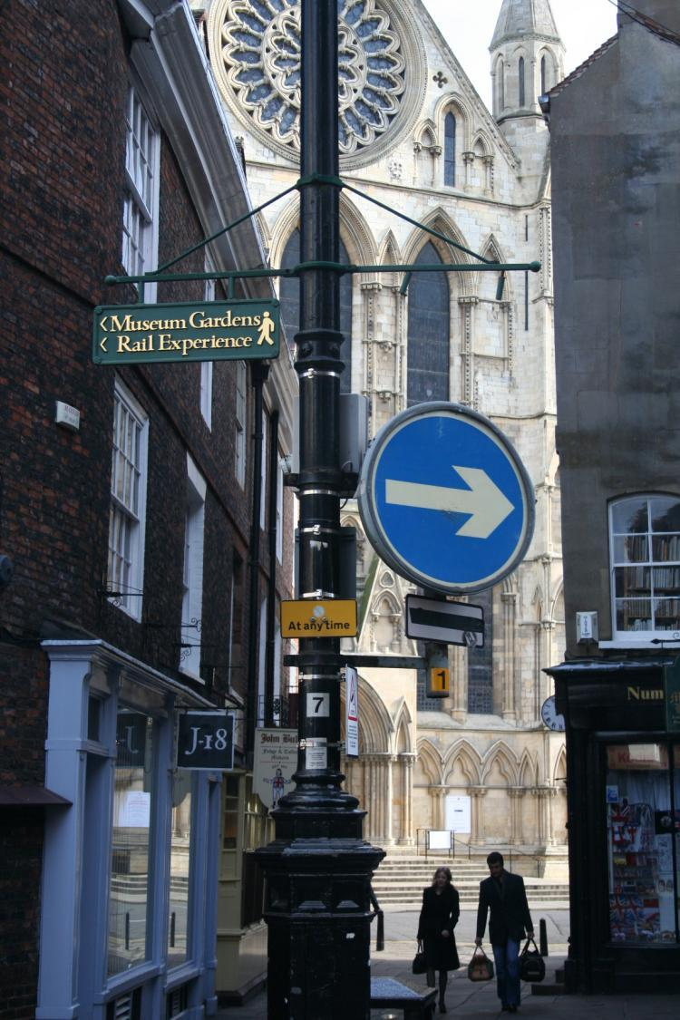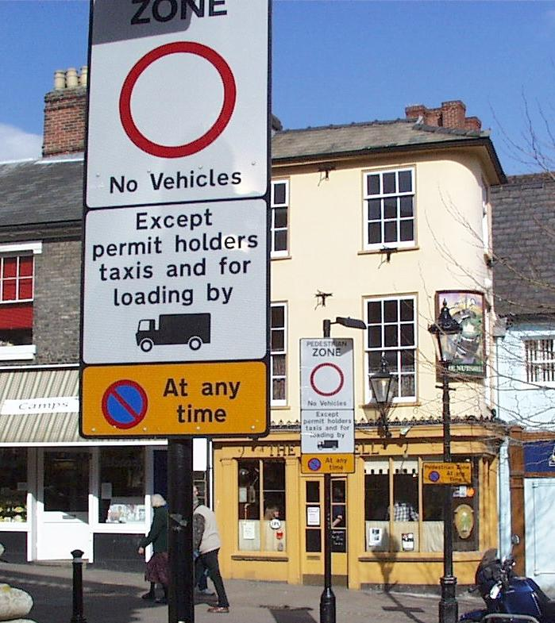

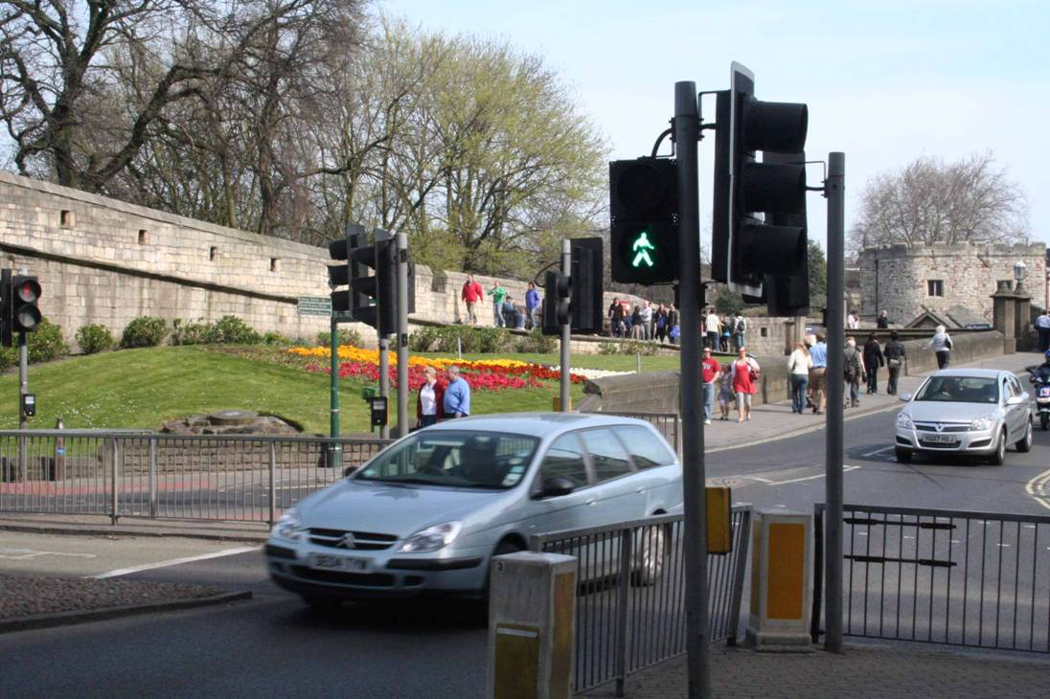

Examples of street clutter in the UK that obscure the historic qualities of place

**Historic Core Zones**

The Traffic in Historic Town Centres publication (EHTF, 1994) proposed the establishment of Historic Core Zones which would:

* Be central conservation areas and traffic control zones;
* Make special provision for controlling traffic speeds, parking, servicing and access;
* Give particular consideration for the number and design of signs and all physical traffic calming measures;
* Give priority to enhancing the historic environment; and
* Provide some recognition of the need for pedestrian priority.

In 1994 and with backing from the then Department of Transport, Department of the Environment, Transport Research Laboratory, English Heritage and the Civic Trust, the Forum sought bids from member towns to establish pilot Historic Core Zone. These bids were eventually sifted down to four pilot towns, namely:

* Bury St Edmunds
* Halifax
* Lincoln, and
* Shrewsbury.

In this paper I am focusing on the Bury St Edmunds Historic Core Zone project, for which I was project manager.

In response to the call for pilot projects, St Edmundsbury Borough Council, the local planning and highways authority for Bury St Edmunds, proposed a comprehensive approach to cover the oldest part of the historic market town. The pattern of streets date back to the 11th century and is characterised by a grid of narrow streets and squares adjoining the walls of the former abbey of St Edmund. They remain largely intact and struggle to cope with the demands of the present day. The issues identified in the town at the time were:

* Traffic speeds in the town centre;
* The use of streets in the historic core as short cuts across the town centre;
* The presence of unnecessary heavy goods vehicles;
* Congestion and conflict arising from motorists searching for elusive on-street parking spaces;
* An abundance of yellow lines and street signs;
* A lack of pedestrian space; and
* Parked cars detracting from and obscuring many of the unique buildings and monuments.

The Bury St Edmunds project sought to:

* Create a clearly identifiable zone within which it was obvious that special traffic measures applied;
* Introduce measures which were self enforcing wherever possible;
* Enhance the central conservation area, including the removal of unnecessary signs and road markings;
* Reduce the dominance and speed of traffic within the Zone;
* Create better access for public transport, pedestrians, cyclists and those with mobility restrictions; and
* Manage the demand for public car parking within the Zone.

The project resulted in four main schemes, namely

* The introduction of a 20 mph (32 kph) speed limit throughout the zone;
* Environmental enhancements in streets and squares;
* The use of traffic regulations to reduce the amount and size of traffic signs; and
* The combination of public art with traffic signs.

The 20mph zone was introduced without the normal practice of installing traffic calming measures, such as speed humps. This was possible due to the nature of the streets as it would be difficult to achieve average speeds higher than 20 mph. Introducing the restriction was more a psychological measure designed to deter motorists from entry to the area and thereby reduce the number of short cut trips.

The major physical works involved the implementation of environmental enhancements in streets and squares where the motor car was dominating the environment. The works in three secondary streets (St John’s Street, Hatter Street and Whiting Street) involved:

* narrowing the carriageway;
* widening pavements;
* reducing kerb heights;
* reducing the amount of parking;
* removing white and yellow carriageway lines; and
* reducing the amount and size of traffic signs.

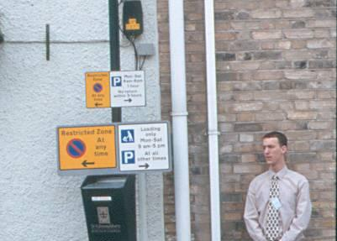

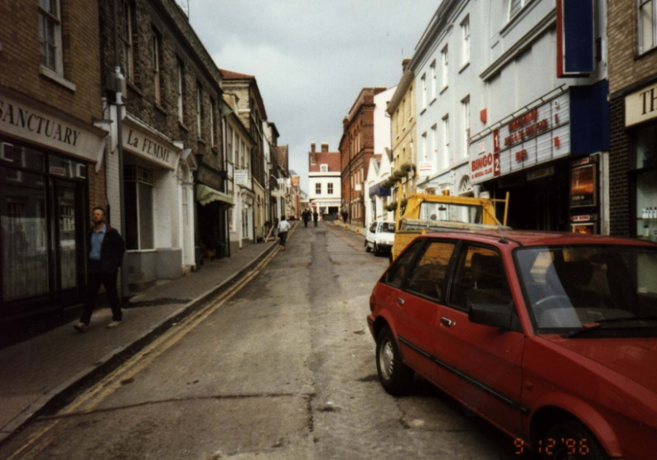

Hatter Street, Bury St Edmunds - Before improvement

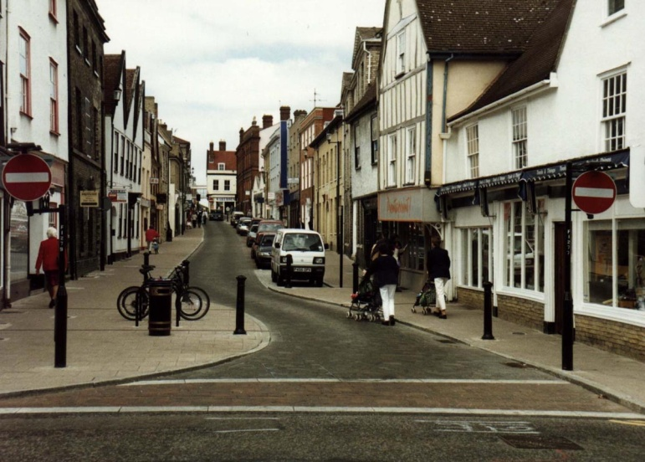

Hatter Street, Bury St Edmunds - After improvement

The outcome of these enhancements was a significant increase in the amount of pedestrian space and a reduction in traffic speeds due to the carriageway narrowing. These projects were monitored by the UK Transport Research Laboratory and published in Traffic Advisory Leaflet 13/99 (DETR, 1999).

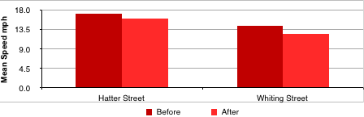

1Measured mean speeds before and after enhancement works (source: DETR, 1999)

The most significant investment involved major enhancements to Angel Hill, Chequer Square and Crown Street, the streets and squares immediately adjacent to the abbey grounds, Cathedral and surrounded by some of the most significant historic buildings in the town. Angel Hill in particular was dominated by parked cars and a through road where the considerations of the historic environment and pedestrians were secondary. This was certainly not befitting of one of the most important public squares in the UK and, prompted by local community concerns about its condition, the Historic Core Zone project delivered a substantial increase of pedestrian space, a minor reduction in the amount of car parking provision and considerable enhancements to the historic environment. The works were undertaken in 1999 and completed in early 2000.

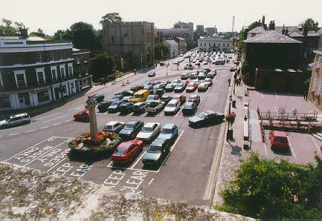

Angel Hill Bury St Edmunds - before intervention

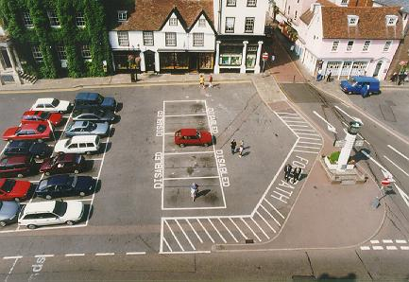

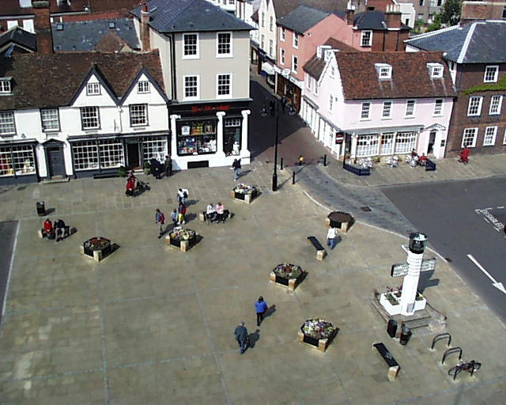

Angel Hill, Bury St Edmunds - Before and after

While not politically acceptable to remove the car from the square, through the loss of 10% of the parking spaces it was possible to achieve the creation of a new pedestrian space next to the Abbey Gate providing a link from the Abbey Gardens, a major visitor attraction, and the primary shopping streets. The pedestrian crossing in front of the Abbey Gate was designed as a "shared space" whereby the carriageway was narrowed, raised up to footway level and split to provide a central refuge for pedestrians. As a result of the merging of the "ownership" of this space, vehicle speeds reduced significantly and pedestrians are now able to claim the space and cross with ease.

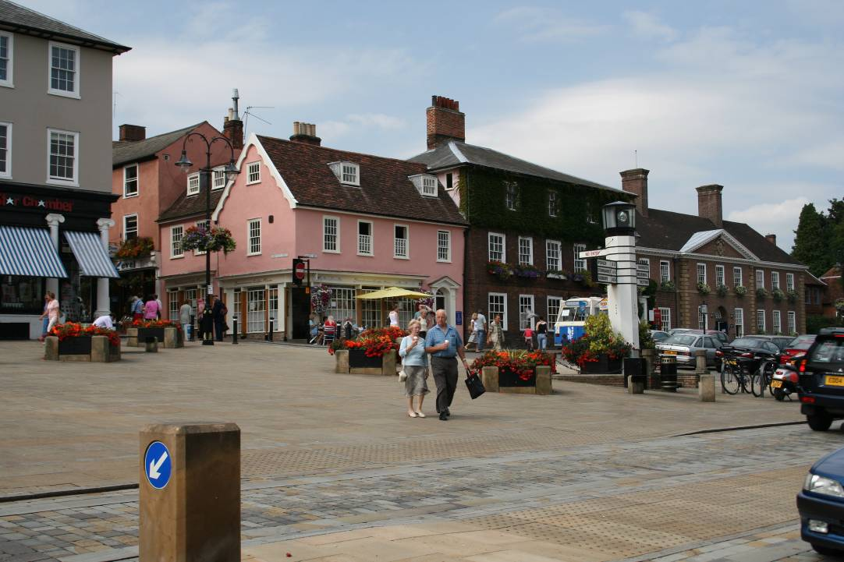

New pedestrian space and courtesy crossing

This element of the project also brought about the blending of traffic signs with public art. There was an acknowledgement that signs would be needed, especially at the entrance to the Core Zone and, rather than have the standard traffic signs mounted on posts, the project examined how signs could be made a feature of the area. Artists experienced in the delivery of art in the public realm were commissioned and they designed signs and a gateway feature that reflected connections with the local history and therefore complimented the distinctive features of the area.

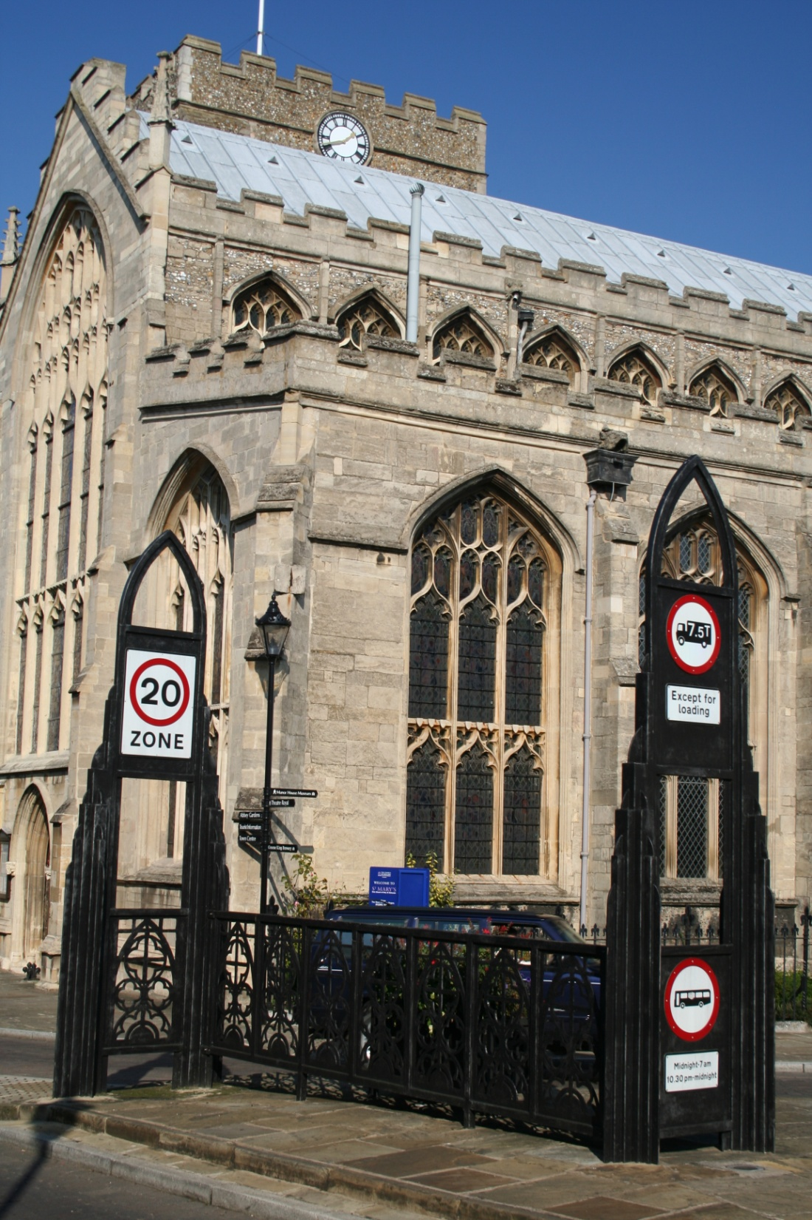

Some 15 years after the project was completed, the works remain in good condition and, because of the level of investment in high quality products at the time, have required little in the way of maintenance. This aspect is especially important because of the limited funding available in local authorities for maintenance and repairs to highways.

**Post Historic Core Zones**

In 2003 the English Historic Towns Forum published “Focus of the Public Realm” (EHTF, 2003) which highlighted the problems with having so many different organisations and bodies responsible for looking after various parts of the street scene. The report contained a table, reproduced below, to highlight the problem.

Of 23 elements in the street scene in the UK, only eight elements required approval under legislation to be installed. Compare this to the buildings that surround streets in conservation area, where often consent is required to undertake minor works to a protected building. The result is a degradation of our historic streets and spaces that results in clutter, a lack of co-ordination of street furniture, neglected and insensitive street furniture, pointless signs and lines. In the UK there is nobody in overall control of what happens to public spaces, unlike the owners of the buildings that surround them or, for that matter, the private spaces that are now occurring with more frequency in new developments.

The publication proposed an “agenda for action” that recommended every town had a Public Realm Strategy that would be adopted as supplementary planning guidance and contain a plan of action. The Forum also suggested that each town should designate one person that would co-ordinate what goes in the streets in order to improve their quality.

In 2006 English Heritage joined the campaign for a more sympathetic approach to the treatment of streets in historic urban areas. Their publication “Streets for All” (English Heritage 2006) noted that “co-ordinated action” was required to address the “proliferation of traffic signs, bins, bollards, guard rails and street furniture”. The government organisation (now Historic England) stated that “well designed, well ordered and well maintained streets are an expression of a confident and caring community”.

In 2008 the English Historic Forum published “Manual for Historic Streets” (EHTF 2008) which continued to highlight the lack of “constructive change” and that, despite the publications and campaigns, “mistakes continue to be made and the necessary investment is still not forthcoming” (Poole in EHTF 2008). It was also noted that “all historic towns and cities face a battle to overcome the clone image created by ‘designed for anywhere’ street furniture” (Poole in EHTF 2008). The standardisation of street furniture purchased out of a catalogue, the perceived lack of flexibility in the placement and size of traffic signs and the need to protect pedestrians from the motorist by creating fences between them continues to create unnecessary clutter and erode the special qualities and local distinctiveness that are so valued and cherished in historic towns.

The UK government started to acknowledge the problem in 2010 and in August 2010 both the Secretary of State for Communities and Local Government and the Secretary of State for Transport encouraged local authorities to remove unnecessary signs and street furniture that is “confusing motorists, obstructing pedestrians and hindering those with disabilities” (DCLG 2010).

Regrettably, and some 12 years on from the publication of Focus on the Public Ream and despite all the publications and encouragement, there remains little evidence of a wide scale improvement and change in attitude.

**Identifying Good Practice**

Despite the picture painted above, there are good examples of investment in streets and squares in historic towns and cities across Europe that demonstrates the important contribution that they make to their distinctiveness and attractiveness. In the United Kingdom, isolated pockets of investment are evident that has restricted the dominance of the car, and everything that goes with it, to the benefit of an improved environment in which the distinctive historic character is respected. The Lanes in Brighton, Exhibition Road in Kensington and Sheffield City Centre.

However, the pallet of good practice across Europe is much more varied and extensive. The remainder of this paper examines some of the examples from a travel scholarship that I was awarded in 2008 by the Commission for Architecture and the Built Environment (CABE). The purpose of the scholarship was to examine the management and maintenance of streets and squares in historic squares across Europe. I sought to understand the extent of the problem that the Council of European Urbanism had identified, to assess whether it was especially prevalent only in the UK and whether examples of a better balance between the conservation of the local distinctiveness of the historic built environment and the management of the car existed. In particular, I wanted to look at the design philosophy behind public realm improvement schemes, with an emphasis on:

* The people involved in the design process;
* The decision making process including public involvement;
* Reasons for choice of materials;
* The functionality and maintenance issues of the schemes;
* Funding arrangements;
* Issues around local distinctiveness; and
* Ongoing maintenance issues.

The scholarship involved visits to the following historic towns and cities in Belgium, Denmark, France, Germany, the Netherlands, Norway, Sweden and Switzerland, with interviews with council officers, architects and urban designers in a number of the cities.

|  |  |  |
| --- | --- | --- |
| **Belgium** | **France** | **Sweden** |
| Antwerp | Besancon | Kalmar |
| Gent | Bordeaux | Visby, Gotland |
| Mechelen | Dijon |  |
| Namur | Lyon | **Switzerland** |
| St Niklaas |  | Berne |
|  | **Denmark** | Biel-Bienne |
| **Norway** | Copenhagen | St Gallen |
| Trondheim | Odense | Zurich |
|  |  |  |
| **Germany** | **Netherlands** |  |
| Bamberg | Delft |  |
| Nurenburg | Drachten |  |
|  | S’Hertogenbosch |  |
|  | Utrecht |  |
|  | Zutphen |  |

I chose to spend between 1 and 3 days in each city to provide an opportunity to interview local “professionals” where possible and to spend time visiting the spaces at different times of the day in order to understand how they function when both busy and quiet. Despite trying to make contacts with project designers or city councils, it did not prove possible to interview anyone in France. However, I do not feel that this has impeded my study as I was able to make detailed observations of various projects in the four cities I visited.

In addition, I was fortunate to be invited to the Final Seminar of the EU funded Shared Space project that was taking place in Drachten in the Netherlands at the same time I was visiting the country.

**Assessing Good Practice**

In undertaking this research I decided to use the 12 quality criteria concerning the pedestrian landscape developed by Gehl, Gemzoe, Kirknaes and Sondergarrd in their book New City Life (Danish Architectural Press, 2006) as a framework for assessing projects as well as a visual assessment in terms of the relationship between the historic built environment and the management of motor vehicles.

|  |  |  |  |  |  |  |
| --- | --- | --- | --- | --- | --- | --- |
| **PROTECTION** |  | **1. Protection against traffic and accidents**   * Protection for pedestrians * Eliminating fear of traffic |  | **2. Protection against crime & violence (feeling of safety)**   * Lively public realm * Eyes on the street * Overlapping functions day and night * Good lighting |  | **3. Protection against unpleasant sense experiences**   * Wind * Rain/snow * Cold/heat * Pollution * Dust/noise/glare |
|  |  |  |  |  |  |  |
| **COMFORT** |  | **4. Possibilities for WALKING**   * Room for walking * Interesting facades * No obstacles * Good surfaces * Accessibility for everyone |  | **5. Possibilities for STANDING / STAYING**   * Edge effect / attractive zones for standing / staying * Supports for standing * Facades with good details that invite staying |  | **6. Possibilities for SITTING**   * Zones for sitting * Utilizing advantages: view, sun, people * Good places to sit * Benches for resting |
|  |  |  |  |  |  |
|  | **7. Possibilities to SEE**   * Reasonable viewing distances * Unhindered views * Interesting views * Lighting (when dark) |  | **8. Possibilities for HEARING / TALKING**   * Low noise levels * Street furniture that provide “talkscapes” |  | **9. Possibilities for PLAY / UNFOLDING / ACTIVITIES**   * Physical activity, exercise * Play and street entertainment * By day and night * In summer and winter |
|  |  |  |  |  |  |  |
| **ENJOYMENT** |  | **10. Scale**   * Buildings and spaces designed to human scale |  | **11. Possibilities for enjoying positive aspects of climate**   * Sun/shade * Heat/coolness * Shelter from wind/breeze |  | **12. Aesthetic quality / positive sense experiences**   * Good design and detailing * Good materials * Fine views * Trees, plants, water |

SOURCE: Gehl, Gemzoe, Kirknaes and Sondergarrd New City Life, 2006

It is impossible to describe the detail of all the projects visited in this paper but what follows is a summary of projects in some of the cities that were the main focus of my study.

**Zutphen, Netherlands**

This relatively small city of around 46,000 inhabitants is situated around 30 km north-east of Arnhem and is a Hanseatic city, one of a number along the River Ijssel, and the evidence of the merchants’ dwellings, businesses and medieval streets remain today. The historic centre is characterised by narrow streets leading into large spaces traditionally used for markets.

The city council has an ongoing commitment to investing in the streets to provide a high quality pedestrian environment while vehicles were allowed access, either unrestricted or at certain times of the day. Projects have not been restricted to the street surfaces, but have included help with shopfonts and signs and building shutters. One particular problem tackled was the display of goods and A-boards outside shop premises. This had the effect of creating spaces where it is easy to move around on foot or by bicycle and where vehicles are also allowed to enter, subject to certain restrictions. Particular attention to detail had been made to the needs of stall holders in the market area. For example, provision has been made in the surface for tying down stall awnings, which eliminates the need for heavy and unsightly weights. The use of local materials provides a sense of local distinctiveness and the city has recognised the importance of regulating shopfronts and street trading as well as investing in infrastructure.

**s’Hertogenbosch, Netherlands**

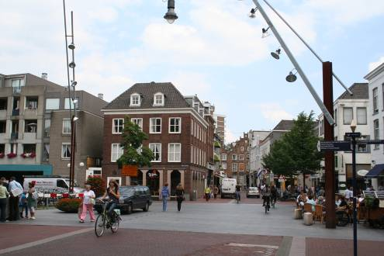

The city is located around 80 km south east of Amsterdam and is the capital of the region of North Brabant. It was granted city status in the 12th century and has always been heavily fortified by ramparts. A number of canals also traverse the city. After the second world war, the central government declared the city a protected townscape and, as a consequence, many of the historic elements have been preserved.

Investment in improving the public realm has been a key piece of work in the city since the preparation of a public realm strategy in the 1990’s. However, it was recognised that improvements could not be undertaken until appropriate measures to manage the flow of traffic through and around the city was in place. With this work completed, a comprehensive strategy was drawn up, involving Spanish architect, Beth Gali. Over the course of five years the streets of s’Hertogenbosch were reclaimed for pedestrians and cyclists in a €9 million project. The work is characterised by the bespoke street furniture including streetlights and cycle parking stands. The streetlights are very similar in design to those recently installed in Cork in Ireland where Gali has also worked.

**Bamberg, Germany**

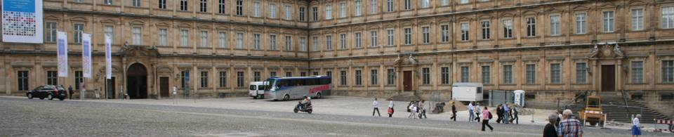

The city of Bamberg is a Bavarian town located approximately 60 km north of Nuremberg. It dates back to around the 11th century and the old part is listed as a World Heritage City, primarily because of its authentic medieval appearance. The Old Town ranks as Germany’s largest single architectural ensemble, extending over an area of 425 hectares and containing around 2,000 listed buildings.

Significant investment is taking place in the public realm of the Old Town, the city council recognising that this investment helps to promote investment in the buildings that surround the streets and squares. A number of details within the projects are worthy of note. In particular, in instances where streets were being made more pedestrian friendly, both rough and smooth finished surfaces of the same material was being used. The rough stones were used nearest the buildings, with a path of smooth stones approximately 1 metre wide down the centre to facilitate easier use by those pushing buggys, in wheelchairs, cycling or those that found it uncomfortable to walk on rough surfaces. In addition, in the large square known as the Domplatz, there are no road markings whatsoever other than aluminium discs approximately 100mm in diameter to illustrate the edge of the carriageway. No “give-way” markings exist either, but motorists are able to navigate their way around without apparent danger in a manner similar to the Shared Space initiative in the Netherlands.

Also of note was a large section of one-way street that bisected the old town and the relatively modern shopping area that was a signalled crossing. Rather than the crossing being the usual narrow width, a length of around 120 metres was the subject of control, due in part to the number of desirable crossing points across the street. The road and footway surfaces were the same, and the carriageway extent was delineated by white granite blocks.

**Odense, Denmark**

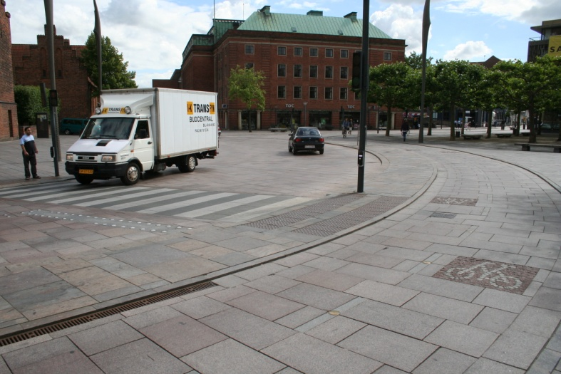

The city of Odense has a population of over 150,000 and is the third largest city in Denmark. It is the birth place of Hans Christian Andersen and draws a considerable number of visitors to view places of interest spread around the city centre.

Significant investment in public art has taken place across the city and a notable example of using art in a functional form was located at the northern end of Kongensgade, a pedestrianised shopping street that ran perpendicular to the city centre distributor road. In order to reduce the impact of the traffic noise, a water feature had been put in place and the noise of the splashing water helped to baffle the noise of vehicles in the street behind it.

In the more historic centre, a project had been implemented to reduce the impact of vehicles travelling in the vicinity of the cathedral and city square. Although a low kerb exists between the highway and pedestrian area, the surface for both is exactly the same material and there is a sense of having created a space through which vehicles are allowed to pass, rather than having a highway that separates the cathedral from the city square and shopping streets. Light controlled pedestrian crossings remain, but these are relatively well integrated into the street scene and the small lights do not detract from the surroundings. Particularly notable, was the street lighting outside the church that stood erect as sentinels to the main west door during the day and then turned to create a traditional form at night.

The investment in the public realm in Odense has arisen due to the recognition of how managing tourism can bring benefits to a city. This has been achieved through significant investment and the creation of a better balance between motorists and pedestrians. The use of public art for functional purposes, such as bollards and manhole covers has also provided an element of local distinctiveness that is often overlooked through the purchase of “off-the-shelf” examples found in other cities.

**Visby, Sweden**

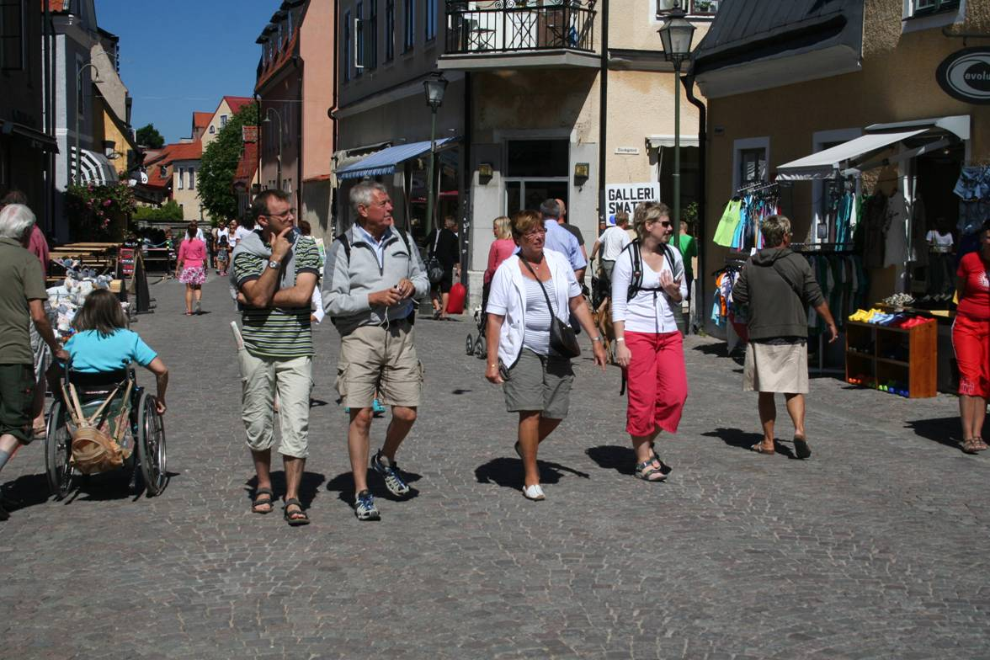

Located on the island of Gotland in the Baltic Sea, the walled city is a UNESCO World Heritage Site recognising that Visby was the main centre of the Hanseatic League in the Baltic from the 12th to the 14th century.

The narrow streets of the walled town are not able to cope with the modern day demands of the car let alone balancing these demands with those of pedestrians. A long term investment programme has been implemented to provide a more pedestrian friendly environment, without necessarily excluding the car, ensuring that quality of scheme rather than maximising the amount of improvement achievable is paramount. During the busy summer months the car is excluded from the centre, except for those with residents’ permits and this provides a better balance to manage the large influx of visitors to the city and Gotland during the summer holidays. During all periods, the streets are effectively “Woonerfs” or pedestrian zones, as is evident by the traditional Woonerf sign throughout.

The walled city has had to find an approach to manage traffic that recognises the different demands on it at various times of the year. The approach to ban all but essential traffic in the summer months appears to work very well and create a safe and friendly pedestrian environment.

**Kalmar, Sweden**

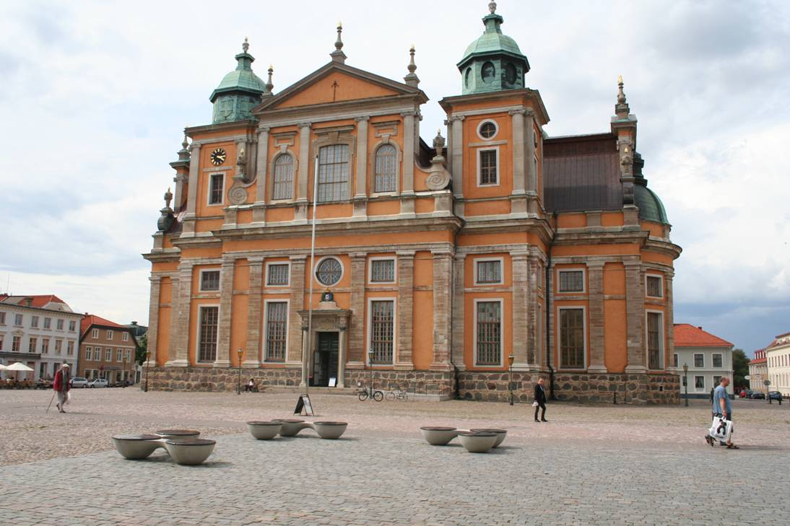

In the centre of the city is a square that has great historical and cultural importance for Kalmar. Stortorget, as it is known, was the location for religion, justice, education and administration. Today it is dominated by the Baroque cathedral which sits within the square and in the late 1990’s the municipality joined forces with the Swedish Public Art Council and a local amenity society and invited proposals for the renewal of the Stortorget. The aim was to recreate it as a flexible public space where people could meet and enjoy themselves and enjoy various activities and events. The implemented scheme has extended the original cobblestone paved areas, removed the definition of the roads around the square, created smoother pedestrian paths and introduced art features that use water to provide a link back to the days when the Stortorget provided wells as a source of water for residents. Unfortunately, these features have since failed. Modern lighting columns also feature as part of the project, effectively single steel poles with a coloured light at the top.

The implemented scheme has restored the historic character of the square and reduced the impact of the motor car. The car has not been banned from the square, but it is restricted to paths around the edge, defined only through the extensive use of steel bollards. The rough finish helps to reduce traffic speed and create a feeling that the car is intruding into an historic space. Prior to work commencing the Swedish government “listed” the square, therefore requiring a licence to undertake the renewal works. The use of local materials was also significant, as few places can boast that the source of the stones is the fields surrounding the city!

**Conclusions**

With the population of the World continuing to grow and more and more people living in cities, the potential competition for urban spaces will become more problematic without some form of regulation. As noted above, many of Europe’ cities streets have remained largely intact since they were created in medieval times. But in the last century the introduction of the motor car and the need for regulatory measures to manage it has resulted in degradation of the quality of spaces and the ability of pedestrians, in particular, to use them for both functional and social purposes.

The Historic Core Zones Project in the UK has demonstrated that it is possible to achieve an appropriate balance between the cart and the historic environment. Schemes in historic cities across Europe demonstrate a more concerted approach to minimising the impact of the car.

In the UK, the population of historic towns and cities are projected to grow considerably over the next decade. However, this growth is accompanied by severe real terms public expenditure cuts. Local authorities in England lost 27 per cent of their spending power between 2010/11 and 2015/16 (Joseph Rowntree Foundation, 2015) and difficult decisions are having to be made as to where to invest the reduced income. Statutory, people focused services such as health and education are those where, because of the direct correlation to the population is possible, investment is most focused. Maintenance of existing streets has to be funded from revenue income, namely the Council Tax. But local authorities are restricted on how much they can increase the tax without a referendum. Therefore, the likelihood of new and significant direct government investment in the historic public realm in the UK is, I believe, extremely low.

Despite the numerous calls for improvement and investment, including from the UK Government, the prospect for actual improvement and, to some extent, the maintenance of current spaces, does not look good.

**References**

Dadson, P., 1999 *Joined up conservation: the space between buildings.* Context 61, Institute of Historic Buildings. March 1999 www.ihbc.org.uk

Jacobs, J., 1993 *The Death and Life of Great American Cities.* Modern Library, February 1993

Council for European Urbanism, 2003 *Declaration of Bruges.* www.ceunet.org

Glasgow City Council, 2007 *Glasgow’s Tourism Strategy to 2016.* www.glasgowtourismstrategy.com

Gehl, J. Life between buildings, Using Public Space. Danish Architectural Press 2001

English Historic Towns Forum, 1993 Traffic Measures in Historic Towns: An Introduction to Good Practice

English Historic Towns Forum, 1994 Traffic in Historic Town Centres

English Historic Towns Forum, 2003 Focus on the Public Realm*.* www.historictownsforum.org

# Department for Communities and Local Government announcement “Our streets shouldn't be an obstacle course” 26 August 2010 <https://www.gov.uk/government/news/our-streets-shouldnt-be-an-obstacle-course>

Gehl, Gemzoe, Kirknaes and Sondergarrd. 2006 New City Life. Danish Architectural Press,

Joseph Rowntree Foundation. 2015 The cost of the cuts: The impact on Local Government and poorer communities