Can Shared Space contribute to the Future of Places?

## Introduction and history

The concept of Shared Space existed without a name for it already some years. Rethinking of what we are doing in the public realm was the main reason for making pilots where traffic rules were brought back to three basic rules. Stick to the right, give priority to the right and be careful. For these rules, you don’t need signs, lights and lines.

Over the past decades, traffic objectives and traffic legislation have determined the way in which public spaces were designed. This was meant to improve traffic flows and traffic safety. But it was at the cost of the quality of the public spaces and the living environment of people. And it was also at the cost of the personal conduct in public, and the professional capacities of those who are responsible for public spaces.

## The Idea.

In contrast to current practice, *Shared Space* strives to combine rather than separate the various functions of public spaces. By doing so, the quality of public spaces will be improved, and responsible behaviour will be evoked. So, when designing spaces, *Shared Space* relies on information from the surroundings to guide road users' conduct, instead of forcing them to strictly obey to traffic rules and signs. When there is a primary school, we don’t want to hide it behind fences and sign posts. Instead, we extend the school yard out into the street. We think that car drivers are not stupid. If they can see children playing in the streets, they will reduce speed and drive as careful they possibly could.

In the first year of the new Millennium, the name Shared Space was given by the London architect, Ben Hamilton Baillie[1]. An English name was needed, because the known Hans Monderman needed this for a presentation abroad about his non-conformist ideas on traffic and people in the public realm.

The late Hans Monderman, ([Leeuwarden](http://nl.wikipedia.org/wiki/Leeuwarden_%2528stad%2529), [19 November](http://nl.wikipedia.org/wiki/19_november) [1945](http://nl.wikipedia.org/wiki/1945) - [Ureterp](http://nl.wikipedia.org/wiki/Ureterp), [7 Januar](http://nl.wikipedia.org/wiki/7_januari)y [2008](http://nl.wikipedia.org/wiki/2008)) was a traffic engineer who was working on traffic safety.

He and some colleagues with him were thinking about traffic safety and their question was where engineering should end. Is there a limit to putting up more and more signs, traffic lights and separation of all modes of traffic in public space? Hans Monderman and his colleagues didn’t believe the behavioral effects of traffic signs couldn’t achieve a lasting and personalized road user behavior. People were and are still just communicating with the (traffic-) system. And this type of communication is a one-way communication. The system tell you what to do or not to do. There is no need to communicate with each other. A road should be a self-explaining road.

Hans Monderman and colleagues were working for the province of Fryslân and de municipality of Smallingerland they were able to convince politicians in some pilots to start reducing traffic measures rather than adding. The first one was in Oudehaske in the Netherlands, where a simple T-crossing in the center of the village with priority for the through going road, was changed into a T-crossing with priority from the right and the area of the crossing was lifted to the level of the sidewalks and all in the same type of pavement. This led to slower speeds and the feeling that this place was part of the village instead of a road through the village.

Hans Monderman developed the idea further and found a lot of understanding. Although he was able in charismatic speeches to convince people of the idea, it was still not enough – except for in few local areas– to turn it into a broader (international) movement. This took many more years. Now however, Shared Space is in the world of traffic engineers and urban designers a rather familiar concept.

## Backgrounds and research.

In the last century open public space has been more and more claimed for traffic, transport, roads and highways. Making larger and more infrastructure was an acceptable way of accommodating the need for car mobility. Living places became slowly split in parts with highways, communities were no longer built by people and social relations, but with bricks, concrete and tarmac. As motorized traffic became a predominantly place in our cities, place for people was squeezed to sidewalks and crossing of streets was designated to zebra’s.

Slowly we became aware of how the design of the public space was purely a way of making infrastructure (for cars). And as this traffic became more busy, dangerous and faster, rules were needed, guiding, and separating modes of traffic. All this was also consuming space, we lost the human scale. The famous American writer Jane Jacobs in the sixties of last century already observed it and warned us: *“There is no logic that can be superimposed on the city; people make it, and it is to them, not buildings, that we must fit our plans.” [2]*

A famous research done by Donald Appleyard[3], showed the influence of traffic volume in a street, on the interrelations of the people who lived there.

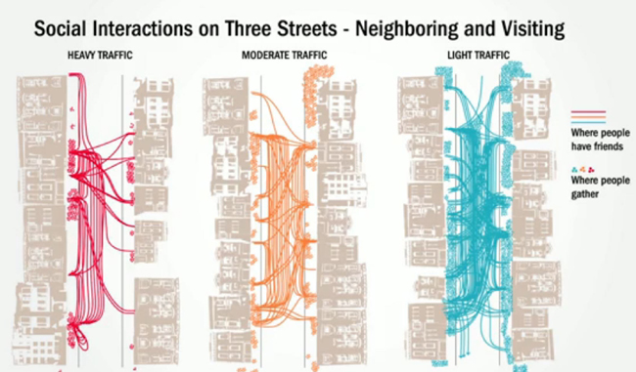

Figure 1.Relations are limited to one side of the street as traffic volumes grow.

At the end of the century, a step aside was made to rethink the system. Was there another way? A way to get out of the system, and the race, to keep ahead of the continuous need for space and speed. 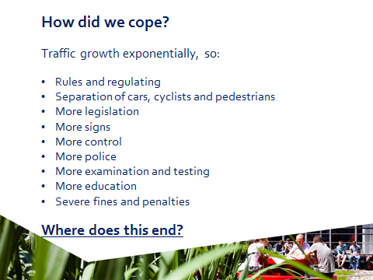

Figure 2. From a presentation, Pieter de Haan, Sydney, October 2014

It was only in the second decennium of the last century when the first traffic measure was introduced in The Netherlands. On both sides of the bridge over the Maas, the main river that connects the North and South of Rotterdam, a policeman was directing walking people to stick to the right:

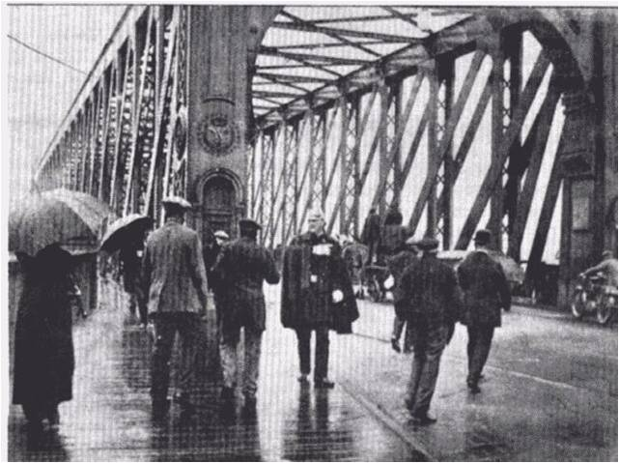

Figure 3. Stick to the right! Bridge in Rotterdam around 1924.

The late Hans Monderman (1945-2008) started In the City of Drachten (Netherlands) with some small pilots, where a radical change was made in how public space could be reclaimed for public. Traffic lights were taken out, no separation of walking, biking and driving, one level floor, no guidance and no traffic signs. Speeds slowed down, communicating between road users became possible and responsibility was in their hands, instead of for the road administrator. This project was monitored by the NHL University of Applied Sciences, department for Traffic Engineering.[4] Results showed slower traffic, less accidents, no serious accidents anymore and easier traffic flow, no queuing anymore and busses were able to cross faster this junction than before.

A long term evaluation, in Drachten and surroundings covering the opinions of policy, public, stakeholders and traffic data, regarding the experience with 15 years of shared space on 15 schemes, showed an overall convenience. Also a change in thinking about how public space and traffic can go together in a more human way. Traffic safety is much better and one of the main goals of Shared Space looks as achieved, there is quite a higher appreciation of the aesthetics of the public space. It’s more livable now. (*This study is only available in Dutch language*.)

The municipality of Drachten decided to make Shared Space a guiding principal in the policy for designing their public space.

These projects still function in the same way as they were designed and are part of the normal traffic and public space. The inner city ring is now reconstructed with more shared space junctions and the last junction with traffic lights will be reconstructed in the near future into a Shared Space environment. People get used to it and it becomes clear that Shared Space changes from experiment to normal.

## In search for a definition.

**Public space is all around us, a vital part of everyday**

**urban life: the streets we pass through on the way**

**to school or work, the places where children play,**

**or where we encounter nature and wildlife; the local**

**parks in which we enjoy sports, walk the dog and sit**

**at lunchtime; or simply somewhere quiet to get away**

**for a moment from the bustle of a busy daily life. In**

**other words, public space is our open-air living room,**

**our outdoor leisure center.**

The “traditional” traffic regulation becomes no more the rule but the exception. It will be only there applied where the situation makes it necessary. The conditions for this decision are still subject of research. More places in bigger cities to the biggest, i.e. London in UK are now realizing shared spaces.

It was time to come to a more precise definition, although defining a concept as shared space is also a bit against the concept. It says that it’s always a tailor made solution with respect for the surroundings, the history and the wishes of the users of the space.

Figure 4. Sir Stuart Lipton, Cabe

As s sort of definition we like to use:

*Shared Space is a way of thinking and a way of working, which helps improving the quality of public space. It includes a philosophy and set of principles for the design, management and maintenance of public spaces, based on the integration of various forms of human activity. It involves the entire process of planning, designing, decision-making and maintenance of public space, but also the related topics of deregulation, taking responsibilities and empowerment. Shared Space relies on and encourages durable alliances between researchers, teachers, students, practitioners, politicians from various work fields, who together with citizens and entrepreneurs to discover the pleasure and the added value of working in such networks and maintaining them.*

It’s too long for a definition, but we don’t want it to be a chapter in a handbook with guidelines.

Shared Space started with pilots, convincing and charismatic speeches and this lead to quite a lot of public attention for what was happening in a little part of The Netherlands.[5] It became clear that a concept to make it a reality needed a scientific fundament. Research, was needed and this could come from evaluations (see the first ones above and later on this kind of studies are continued and the results are still more or less the same.) and also from desk research[6], to see if in behavioral studies there can be found support or with experimental research[7]. Quite a lot has been done until now, but there are still questions and aspects that emerge and need to be answered. A PhD-study was done on the challenges in Shared Space for blind people by Else Havik.[8] They were feeling not unsafe in shared space places, but on some there were problems with orientation. This issue is tackled now with design suggestions to help blind and visually impaired people to find better their way through Shared Space.

## The Process.

The process of Shared Space has become more and more important. It’s even conditional for the success of a Shared Space project.

As said before, Hans Monderman was a traffic engineer and there was no other process than the engineering process. A problem was identified, the situation was surveyed and a solution was made. Than hearings and consultations started. Council decided and protests came.

In the Shared Space concept we understand that a traditional way of working is most times more contra productive and leads to standard solutions. Ones that have proven to work in other situations, so why not here? When it’s assumed that the public space is a space for everyone, that the place where people live, and linger is almost theirs, the role of the local government needs to be reconsidered. The public realm is as you can say mentally owned by the people. The place where they live is **their street, their square.** So what needs to be the role of the municipality regarding this other way of looking at the public space?

Shared Space adopted in the run of the years this point of view.

Local municipalities are most times planners. They have visions, they make policy and they make plans. Consultations and hearings were introduced in the last decennia. But a new view helps the governing authorities to adopt a new role. To be reluctant, to lean back and give the users of the public space their territories back. This is not always easy for them. People are more familiar with the role of the municipalities to make the plans and to be in control. *“He who pays the piper calls the tune”*. Protests are usual afterwards. Realization of the projects takes sometimes years of procedures, before they can start. But this is not the way in the Shared Space method. As soon as the public realizes that the public space is **their space,** with their problems and needs, they should be allowed to make **their solutions.**

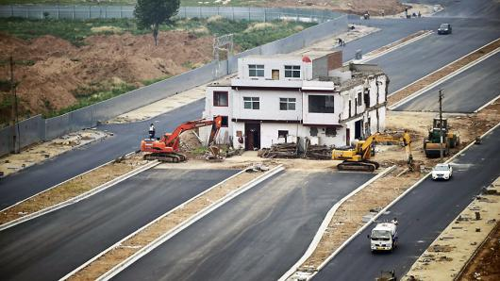

Figure 5 It's not my plan, just my house!

A project starts with blank sheets. Conditions are set by the governing authorities and they lean back awaiting the outcomes of the process to come up with solutions. Conditions can be in terms of time and money, facilities, expertise and most important support and trust. Off course the local people and road users that are involved in the process have a lot of expertise about 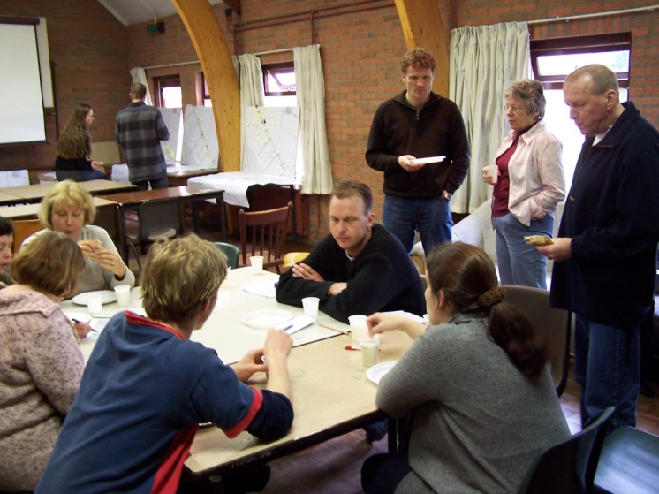the daily use of the space but can be facilitated with expertise from the municipality in this process.

Figure 6 shared space at work.

When Shared Space is claiming that the goal of it is to achieve a higher quality of the public realm, than the local users are pre-eminently the ones that are able to say what this quality means for them.

The process makes the solutions as the solutions of the people themselves and therefore these solutions will be more sustainable and encounter less objections afterwards. It takes time to be invested in the beginning but gains time in the phase of realization and thereafter.

One of the Shared Space projects is an example of this way of working.

A junction of two quite busy roads with high speeds was dangerous. A standard roundabout was the standard solution of engineers. The people from the village started with making something that was in their eyes better. The municipality gave the conditions, workgroups began from scratch, with help from experts and became also important data. The result was a square, rather peculiar in situations like this. Nothing was ruled, everyone needed to find its way on that place. The municipality adopted this plan and it was realized. From a rather non-place, now it was a place with identity. It became even a name: Ons Dorpsplein,(Our Village square.)

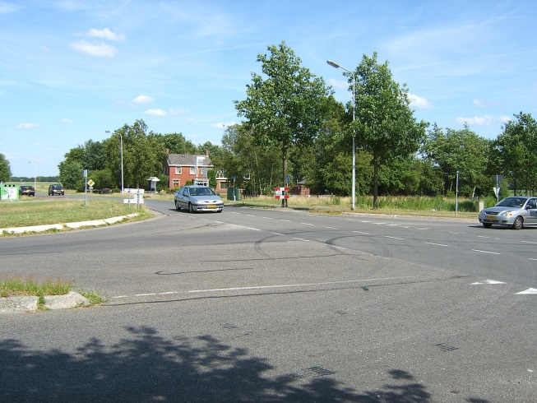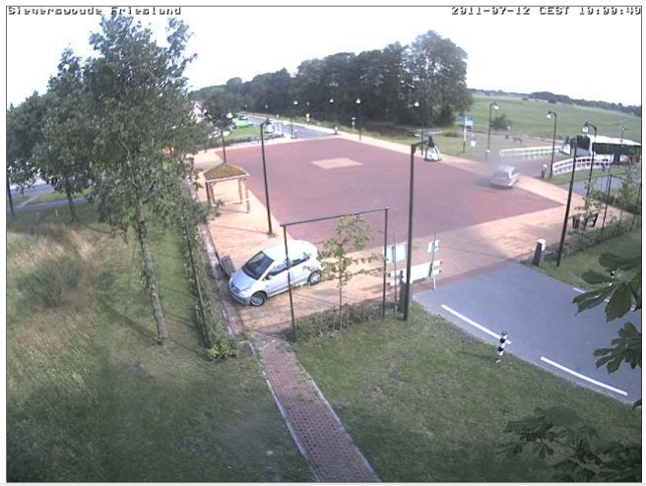

Figure 6. Siegerswoude Before Figure 7. Siegerswoude After

Evaluations after 5 years now show no accidents anymore! The place now is more attractive and other functions than being just a traffic place are started.

This place now is famous. A lot of (international) attention, not only for the solution, but also for the process.

## The Future of Places.

Shared Space started in small villages, cities and neighborhoods. Slowly the step was made to bigger places and higher traffic volumes. But still it’s, not a solution for cities as a whole. The smaller parts, which can be identified, or can get a (new) identity are the most suitable ones. This means that the scale of the cities doesn’t matter, it’s more the possibility to assess places and gather the users of those places together to make something out of it that leads to a higher quality. To change it from a traffic place into a place for people.

As we saw in the 2013 Habitat conference Future of Places in Stockholm, the governmental influence on solutions in the public space is less as cities grow, because the distance between decision makers and the public is getting big. Shared Space is always a local solution, always tailor-made, there is no standard. It’s a way of looking at the needs and possibilities of the place and the people. All places look different because the design depends, but it’s the same for the human scale, for the harmonized speeds and the fact that the place serves not only mobility but a lot more activities.

So we can conclude that Shared Space, although it started in small towns and villages, it’s success is not dependent on the scale of the city. Big western cities have already Shared Space schemes and the next phase is to find out whether it suits also in other cultures. Or is it a viable conclusion that in those other cultures Shared Space already (or still) exists?

Future of Places looks at big world cities. In my opinion in these cities (democratic) control decreases over the more detailed situations in boroughs and districts. Now municipalities of those mega cities live with the illusion of governance. The ideas of Shared Space, certainly the way the process that is used to make places, places of the people themselves, could contribute to the Future of Places.

Pieter de Haan

The Netherlands January 2014

Psychologist at

Knowledge Center Shared Space

www.nhl.nl/sharedspace

[p.de.haan@nhl.nl](mailto:p.de.haan@nhl.nl)

1. RECONCILING PEOPLE, PLACES AND TRANSPORT, December 17, 2001, Ben Hamilton-Baillie Director (Sustainable Transport and Urban Design)
2. # THE DEATH AND LIFE OF GREAT AMERICAN CITIES,1961, Jane Jacobs, Published September 10th 2002 by Random House (first published 1961)

  
3. THE VIEW FROM THE ROAD, 1965 by [Donald Appleyard](http://www.amazon.com/s/ref=dp_byline_sr_book_1?ie=UTF8&field-author=Donald+Appleyard&search-alias=books&text=Donald+Appleyard&sort=relevancerank) (Author), [Kevin Lynch](http://www.amazon.com/s/ref=dp_byline_sr_book_2?ie=UTF8&field-author=Kevin+Lynch&search-alias=books&text=Kevin+Lynch&sort=relevancerank) (Author), [John R. Myer](http://www.amazon.com/s/ref=dp_byline_sr_book_3?ie=UTF8&field-author=John+R.+Myer&search-alias=books&text=John+R.+Myer&sort=relevancerank) (Author)
4. THE LAWEIPLEIN, EVALUATION OF THE RECONSTRUCTION INTO A SQUARE WITH ROUNDABOUT. Nhl –Hogeschool Leeuwarden 2007.
5. IT TAKES SHARED SPACE TO CREATE SHARED UNDERSTANDING, Publication Shared Space Institute, 2007
6. THE PSYCHOLOGICAL BASIS OF THE SHARED SPACE PROJECT, Pieter de Haan, 2010.
7. NEUE FORMEN DER VERKEHRSBERUHIGUNG, Ivan Katsarov PhD thesis, Technischen Universität Wien Fakultät für Bauingenieurwesen
8. WAYFINDING AND ACCESSIBILITY FOR VISUALLY IMPAIRED PEOPLE, PhD study by Else Havik 2012, Groningen University, department of Psychology.