**URBAN NETWORKS OF PLACE: THE CASE OF HYDERABAD,**

**TELANGANA STATE, INDIA**

Dr.Sridevi Rao, Landscape architect,

Sridevi Associates,

83, Whisper Valley, Raidurg,

Hyderabad, Telangana State, India 500008.  
Email: sridevirao_dr@yahoo.com

**ABSTRACT**

The Government of India has announced plans for building 100 Smart Cities. The Paper attempts to understand where public open spaces figure in the evolving process of a City. In this context, the public garden or urban park occupying a large piece of prohibitively expensive urban land seems like an unsustainable proposition. The case of Hyderabad, a 425 year old city, is examined for the associations of public open spaces in fulfilling aspirations of its citizens. Variations between the intended and actual use occur since planners provide for a predetermined range of activities in a uniform setting. Historically, ideology or perceptions about the linkages between natural and built components have contributed to the way in which open spaces were distributed and used. Representative examples of prominent natural features and activities around these features indicate trends in the use of open spaces because of their local significance. The imageability of Hyderabad is inextricably linked with these natural features, which are settings for experiences and activities which are the crux of public open spaces redeeming it of ‘municipal sterility’. This aspect forecasts a future where natural features within the city are linked to recreation. Based on the case study there is a third dimension of open space quality that appears to enrich recreation or environmental value. This quality is cultural which can be recognised as culturecentric. The appreciation of place that such public open spaces embody seems to not only link the cultural memory of a city through its users but also its ecological memory. Perhaps the imageability of a Smart City would also be innately recognised by its citizens through its natural features more than any other urban component.

**Urban Networks of Place: the Case of Hyderabad,**

**Telangana State, India**

The Smart City in India is expected to contribute positively to active and passive recreation in the public realm to a smart citizen with greater leisure. Since cities are about building sustainable communities, survival and aspiration, though related to work, are also not unrelated to the cultural aspect of how Indians perceive public open space. This cultural aspect should be encouraged by the design and distribution of public open spaces in the Smart City.

Among the physical components that facilitate urban development, public open space is singularly responsible for improving urban quality – environmentally, physically, and culturally. At city scale, town planners often perceive open spaces as green wedges, ‘lungs’ or walkways that may also take the form of a greenbelt joining town and country. Within the urban fabric, there is an attempt to create a pattern based on the equitable distribution of open space types such as the tot lot, neighbourhood, district and regional parks (the latter may form part of the greenbelt). Therefore, the planner-administrator generally visualises open space as a green space with recreation as the assigned use. There is an emphasis on the physical and environmental role of public open space, as a formative response to improve urban quality and the health of the community.

Functionalism, which laid the groundwork for our loss of traditional space, became obsessed with efficiency and depends on ornament, metaphor and style to provide user satisfaction. Thus, such spaces could no longer accommodate physical or social diversity, and therefore were no longer truly urban. Non-conforming activity was banned and variety was excluded. Zoning operates under normative assumptions about human welfare and happiness. As a response to social hygiene, holistic planning models have sterilised the messy vitality that is the essence of urbanism. Whatever could not be drawn on plan was omitted

(Zunick, 1995, Gallion, Eisner & Jellicoe 1963). As Mumford (1963) commented, this 'denial of tradition' may have led to the emphasis on the role of open spaces as physical or environmental entities where the assigned use for recreation was also manifested in uniformity in terms of standards, play equipment and, open space types.

Recreation is understood as a response to the elements that define an open space. It is thus that an open space is defined as a recreational resource. The implied flexibility in this explanation advocates putting aside existing definitions and typologies of recreation or open space types which are culturally restrictive often requiring enforcement of assigned use. In the broadest sense, the explanation also acknowledges the impact of the attitudes of the local community, towards the natural and built landscape and subsequent quality of the open space.

This fact is evident in Indian cities, in the building of temples and mosques in urban areas or in cultural uses. This does not mean that religious institutions alone are formatively appropriate to fulfill user needs; but that their formative components such as a water source, tree or a hillock or rock-face and their suitable definition fulfill user comfort levels more effectively. Shrines as defining elements appear to fulfill one cultural aspect without taking away from the fact that open space basically exists as a product of the built and the natural component. This in turn gives rise to the cultural component.

**Public Open Space**

There are other aims relevant to developing countries, which are emphasised in the UN Conference on Human Settlements (‘*Human Settlements*’ 1976):

Public parks should be created from slum improvement schemes and attempts should be made to maintain historically valuable architectural landmarks and surrounding areas as recreational places. Public parks along existing canals, open spaces and small recreation places should be provided in crowded areas such as central business districts of the city. The urban authorities should show the capacity to control urban services, to control environmental pollution, aesthetic development and environmental sanitation and improve basic conditions of health. Efforts are needed to protect and identify areas of historical, cultural, scientific and recreational value.

There have been attempts to restore traditional values and meaning to urban open space. Indicative of this need are: open space as opposed to filled space; hard space, dystemic space or enclosed space as opposed to soft space or proxemic space and Venturi's emphasis on the ''Genius of the Place'' and his description of exclusive and inclusive spaces. In 1929, Sitte's disciples practiced the Emperical-Picturesque. That is, the natural component contributed to the distribution of open spaces and to town planning itself. This contribution was based on precedent found in existing villages and towns ‘adapted to our customs, climate, and soil and has acquired the environment of naturalness….’ It was Gordon Cullen who coined the phrases the ‘human factor and the physical factor.’ The former included “…those conditions of happiness or sadness, fulfilment or despair, which arise from total human relationship.” The latter was the “actual shape and arrangement of the urban environment, the mould into which mankind is poured.” Cullen saw an Integration Chain consisting of human activities and a Space Chain of physical environments. It was in the New Town of Maryculter (1974) designed by Gosling, Cullen and Donaghue, that design responded to a place. Maryculter was never built but showed an evolution in planning thought which emphasised the association of built and natural components in creating cities and in influencing the distribution, form, and use of open space (Broadbent, 1990).

Yet, all the above and many recent explanations perhaps fit the qualitative aspects of open space form where the patterns in recreation or use, as an indication of the perception of the user, never changes; nor is their function as an urban component amid changing contexts, evident.

**Change in Context**

A study by Forrester (1969)attributed the changes in city development to the influence of industry, housing, and the consequent ‘population mix,’ which are managerial-professional, labour, and the unemployed. These categories emphasise the relevance of the population mix as an economic category and not as a socio-economic category. The former does not consider the influence of inherited cultural factors or historical factors on city development and the community. The latter is a product of history such as education, caste, religion etc., which has a bearing on the lifestyle of a user, especially in India. This is one reason why any mismatch in the planning and use of open spaces cannot be explained as an extension of Forrester's theory. Though it examines the changes that an urban area undergoes as it develops, the theory is based on a hypothetical contemporary city.

This brings into focus the tot lot outside the dwelling, as the primary accessible openspace in contemporary planning which is also presumably most familiar to the user. The issue of the universal form of the community space, which is usually implemented as a tot lot in residential landuse, is examined. The separation of work place and residence to mitigate the ill effects of the industrial revolution also led to the separation of recreation due to division of time into work and non-work (King, 1976). The beginnings of landuse led to mass housing where recreation and social infrastructure was the focus, away from industrial centres. Development in the nineteenth century in Bourneville (1879), and Port Sunlight (1887), were preceded by multiple housing in seventeenth century France. The urban square appears to have been the predecessor of the tot lot in that housing was located around it. Mumford (1963, pp.396-397)focusing on its uses suggests that it was initially a parking lot for coaches. Gardens within the square in the eighteenth century were landscaped according to prevailing styles. This concept was refined in the New Towns built after the Second World War where the more relevant concept to this, referring to public open space, was within the framework of the housing or the Radburn Plan (in New Jersey, USA, 1929). In 1956, the National Recreation Association in the USA suggested that “the play lot or block playground should be within walking distance of majority of homes” (Laurie, 1975, p.50).

The above synopsis of the origins of the tot lot when seen in the context of the colonial development in India in the 18th and 19th centuries does not find any parallel till 1928 in Hyderabad as planned by the City Improvement Board, and in the late 1820’s in Trevelyanpore as Bentincks’ Square, located west of Shahjahanabad in Delhi. The Deputy Resident, Trevelyan planned such a layout but did not implement it. Otherwise recreation was mainly restricted to the individual dwellings and their compounds and after the 1820’s British wives and children lived in Hill Stations (King, 1976, p.202)**.** Between 1911 and 1947 “government accommodation for official civil representatives of the colonial power for indigenous lower status assistants” took the form of single storey, quadrangular terraces facing a central square (King, 1976, p.250).

During the colonial period, recreation was mainly visible as a team game. The aged lived at ‘Home’ (England) or were dead and the children also lived at ‘Home’ or in the ‘Hills’. Thus, the need for the tot lot did not then manifest itself in the present form. As is generally believed, exposure to ‘metropolitan’ (English) urban forms and culture alone are not the causes for the persistence in the continuation of the tot lot even today. In fact, local planning convention may be reason itself for the standardised routine of its planned form and a ‘green’ agenda.

The case of Hyderabad illustrates the role of city development on the distribution of open spaces, which indicates that the growth of a city provides an impetus separate from contemporary planning conventions that consider static contexts.This appears to be dependent upon the location and association of natural components and built components.

**The Case of Hyderabad**

Hyderabad was established in 1591 AD by Muhammad Quli Qutb Shah and remained under the rule of the Qutb Shahi dynasty until 1687 when Mughal emperor Aurangzeb conquered the sultanate, and the city became part of the Deccan province of the Mughal Empire. Hyderabadis the capital of the Indian state of Telangana. It is located on the banks of the Musi River in the Deccan Plateau in southern India. The city has an area of 650 sq. km.with a population of 6.8 million. The following images show some prominent monuments.

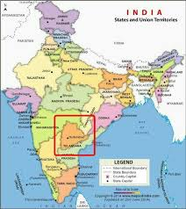 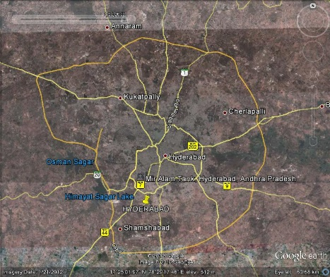

Figure Location of Hyderabad Figure 2 Hyderabad showing major road network

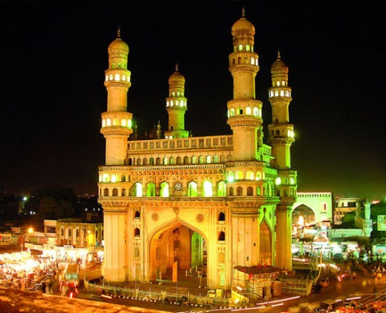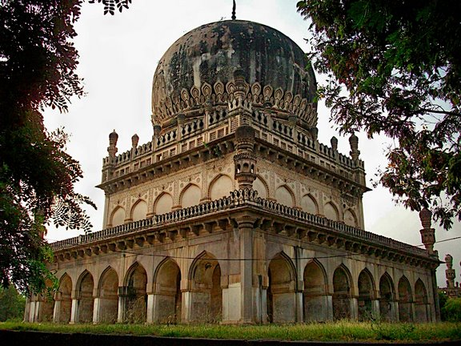

Figure Charminar Figure 4 Qutb Shahi Tombs

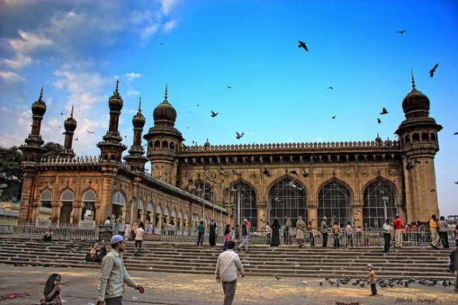 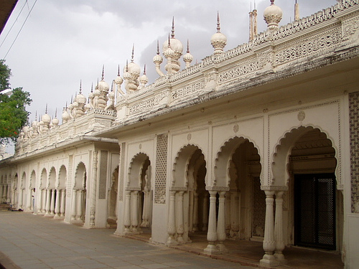

Figure Mecca Masjid Figure 6 Paigah Tombs

**The Setting for Nature in Hyderabad: the location of public open spaces**

In Hyderabad, the natural features form the setting for experiences and activities which are the crux of public open spaces. Representative examples are from different areas of Hyderabad and their formations. The following figures show their setting in the city. Activities around these features though unrelated in some cases, are facilitated by the administration because of the location and prominence of the natural feature. The imageability of Hyderabad is inextricably linked with these natural features.

**Legacy of the Deccan Region - Deccan Rock Formations.**

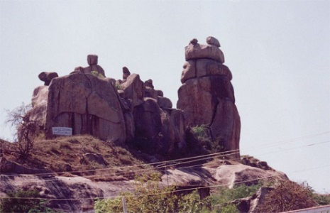 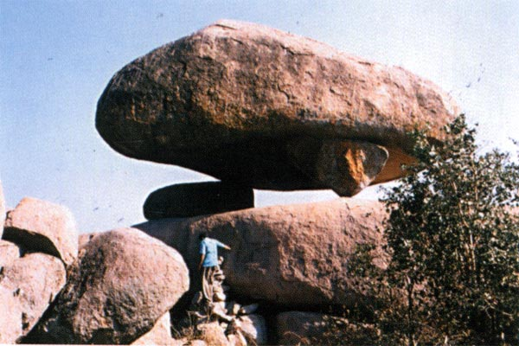

Figure Sentinel rock near Moulali, Hyderabad Figure Mushroom Rock, Central University of Hyderabad

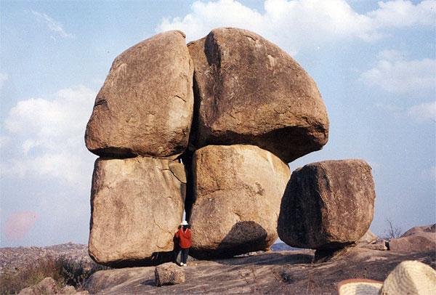 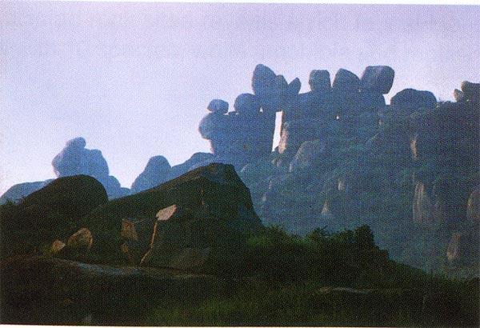

Figure Patther Dil Rock, Gachibaoli, Hyderabad. Figure 10 Rock Park Hillock, Old Bombay Road, Hyderabad

**Golconda Fort.**

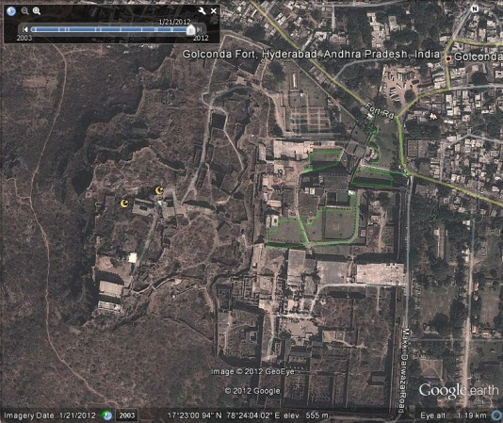

Figure Location of Golconda Fort

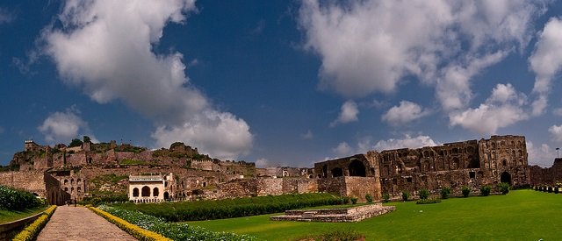 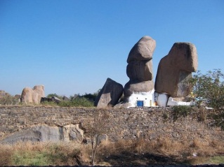

Figure View of the Fort Figure 13 Ancient shrine within the Fort

attracts 2, 00, 000 visitors on certain festival days.

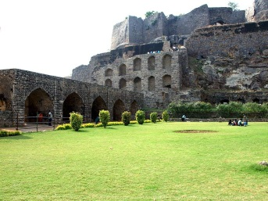 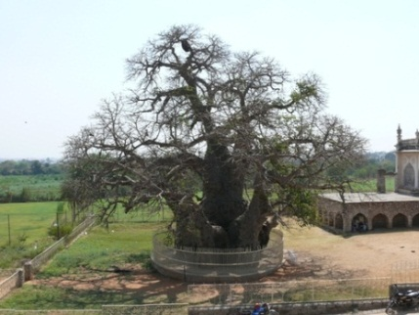

Figure View within the Fort Figure 15 the Baobab Tree within the Fort

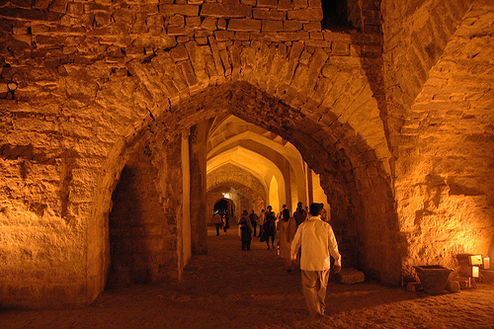

Figure Interior of a part of the Fort

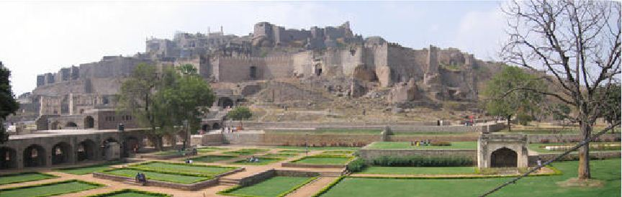 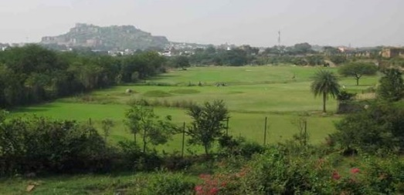

Figure View of the Fort Gardens Figure 18 Recreational facilities such as this

Golf Course has the Fort as a backdrop

**Moula Ali Hillocks.**

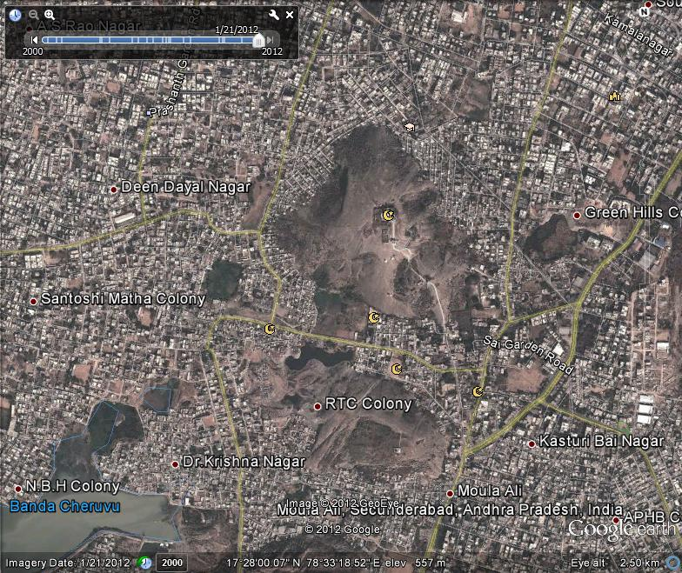 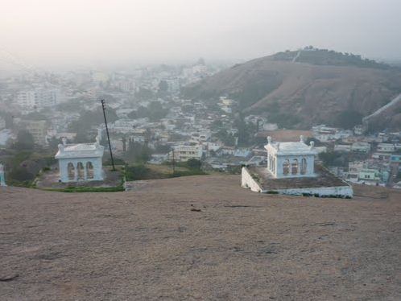

Figure Location of the Hillocks of Moula Ali, Figure 20 View of the City from the

Hyderabad hillock of Moula Ali

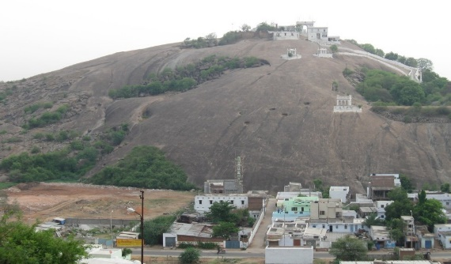 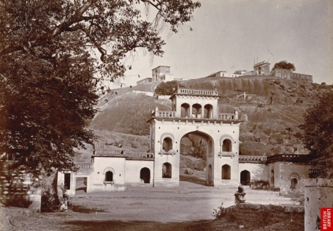

Figure View of the hillock Figure 22 Gateway to the Hillock

**KBR National Park, Hyderabad.**

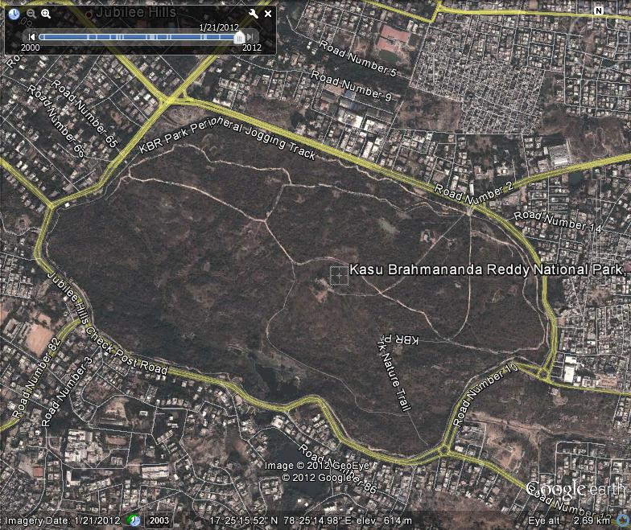

Figure Location of KBR Park, Hyderabad

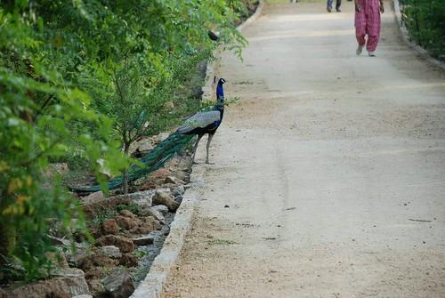 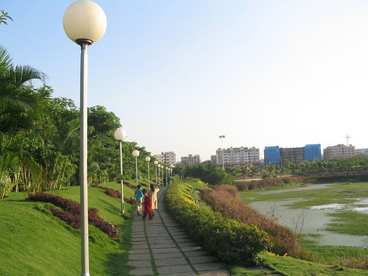

Figure Provision of walkway to experience Figure 25 view of the walkway which surrounds

native flora and fauna the park extends upto 7km.

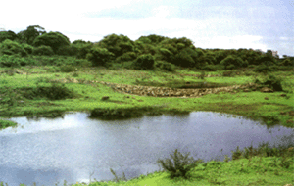

Figure View within the park

**Lakes in Hyderabad**

Hussain Sagar Lake

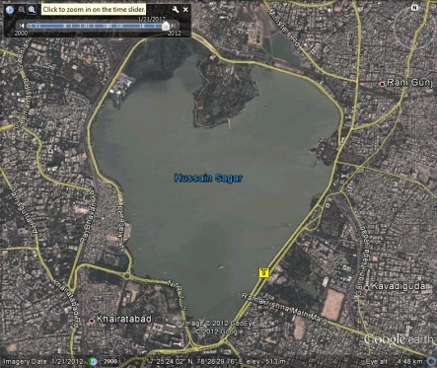

Figure Location of Hussain Sagar

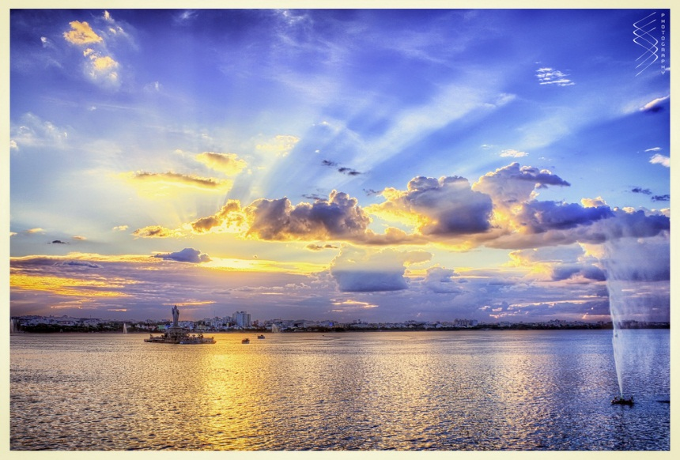

Figure View of the Lake

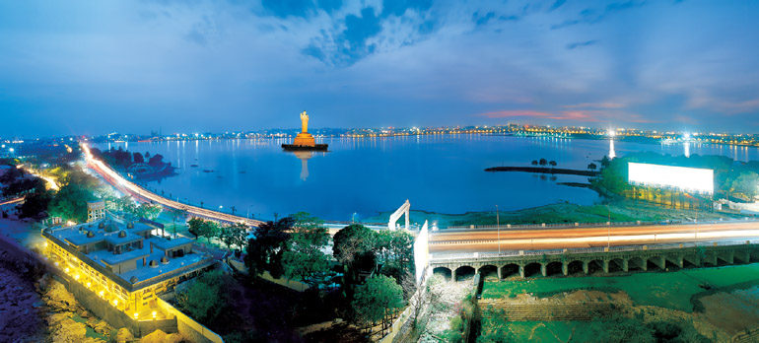

Figure View of the Lake

Mir Alam Tank Lake

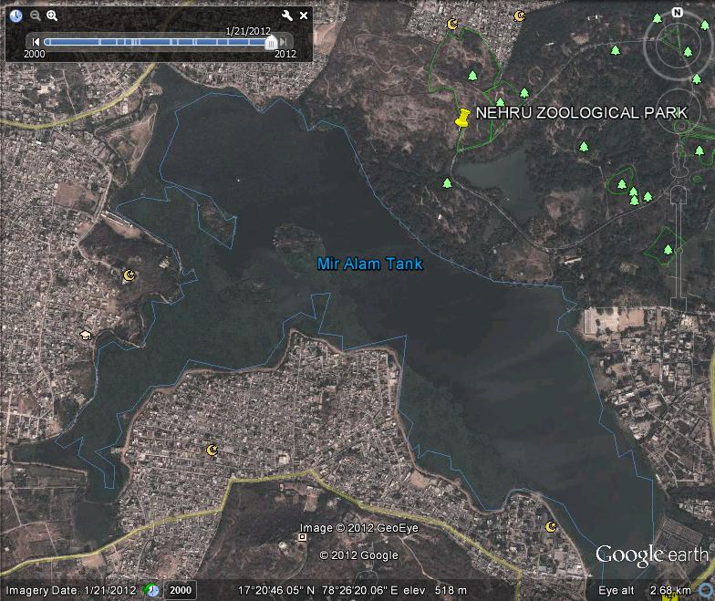

Figure Location of Mir Alam Lake

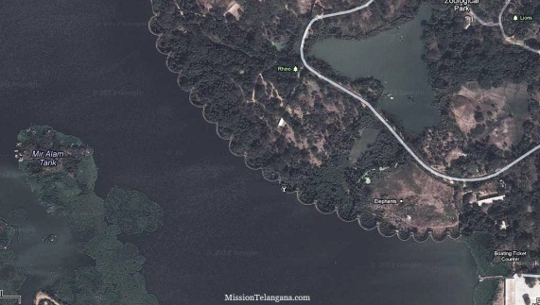

Figure View showing Weir of the Lake

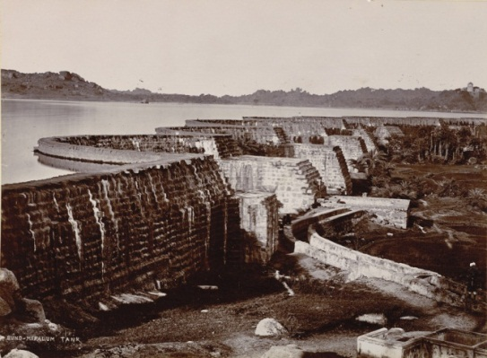

Figure View of the Weir

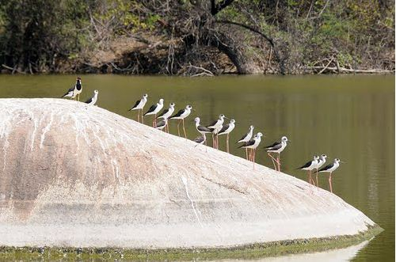

Figure Birdlife at the Lake

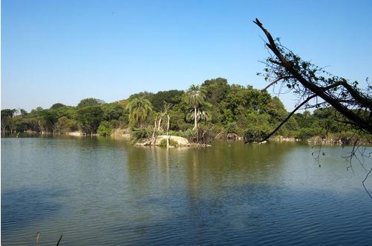

Figure The Lake is the water source for the Nehru Zoological Park located on its shore

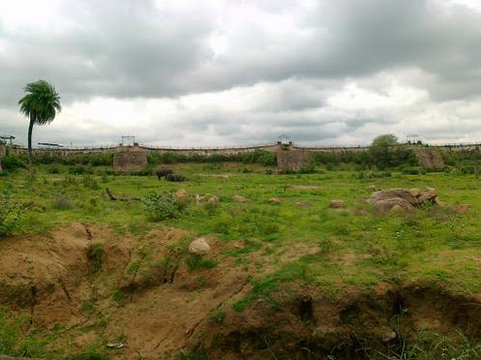

Figure Other side of the Weir serves as a resting place for elephants

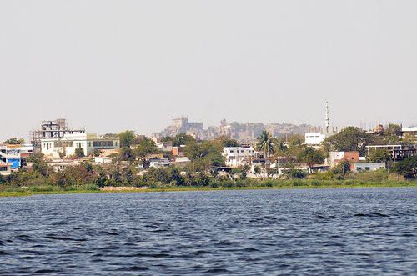

Figure View of Golconda Fort from Mir Alam Lake

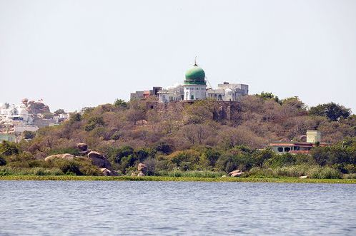

Figure View of the mausoleum of the builder Mir Mahmood Shah

Durgam Cheruvu Lake

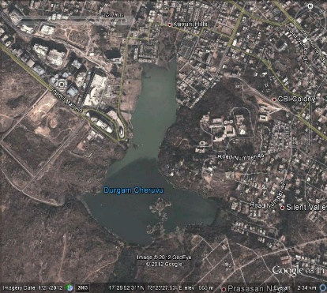

Figure Location of Durgam Cheruvu Lake

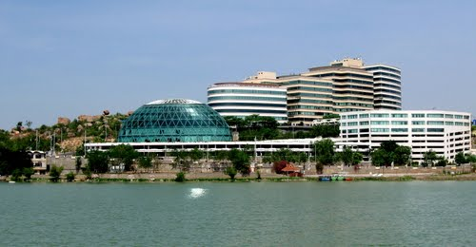

Figure Contemporary buildings form the backdrop for the lake

**The Distribution of Public Open Spaces in Hyderabad: Urban Networks of Place**

The significance and sustainability of public open spaces over centuries amid changing urban contexts appears to be related to the components that determine the distribution of open spaces. Public open spaces have evolved wherever the natural, built or cultural components were distributed.

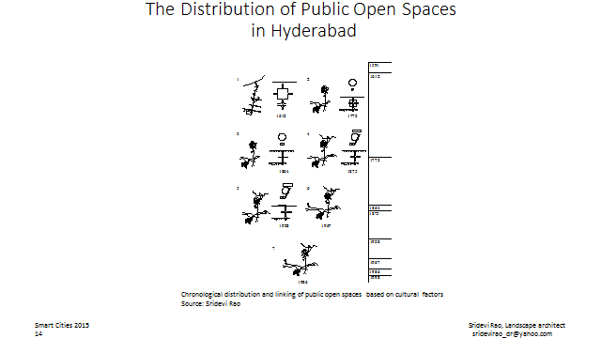

Figure 40 Chronological distribution and linking of public open spaces in Hyderabad based on cultural factors such as festival routes and shrines and prominent natural features

Chronological distribution and linking of public open spaces based on cultural factors is illustrated through festival routes to shrines. These shrines are interlinked to natural features. An illustrative description of the processional festive route linking Charminar and Moula Ali is described (Naqvi, 1993).

Koh-e-Moula Ali is located at Malkajgiri, 16km. northeast of Hyderabad (Figures 19-22). This Ashur Khana was built in 1578 during the reign of Ibrahim Qutb Shah. It is built on a hillock that is 670m. in height. It has an impression of Hazrat Alis’ right hand over the stone. There is a story regarding this Ashur Khana. The Ashur Khana is distinguished from other buildings because of the painting of the fairy horse and a lion over the walls at the entrance. The horse is said to have carried Prophet Mohammad to heaven and the lion represents Hazrat Ali who has the title Sher-e-Khuda. The significance of the link between Charminar and Moula Ali is described below.

As a pious devotee of Hazrat Ali, Yaqub used to pray every Thursday night in his garden at Lallaguda near the hillock. On the seventeenth day of the month of Rajab, he dreamt about the impression of Hazrat Alis’ hand on the top of the hillock and found that it was true, the next morning. He informed his king about this and he visited the shrine. Thus, Moula Ali became a pilgrim centre for people belonging to all religions.

The buildings, arches, houses, mosques, naqar khana and gardens are spread all over the hillock. These were built during the Qutb Shahi and Asaf Jahi periods. The stairs now in use were built by Asaf Jah VII. The tomb of two ardent devotees, Chanda Bai and Raj Kunwar Bai are also located on the hillock. The only source of water on the hillock is the Neem Baoli. Two Naqar Khanas were built by two nobles, Raja Rao Rambha and Raja Chandulal. There are many baradaris or pavilions built by the nobles during the reign of the Asaf Jahis. The main Ashur Khana has a large courtyard.

For more than four hundred years pilgrims of all religions have offered nazr consisting of coconuts and flowers. They consisted of bairagi, Brahmin, gosin, marwari, irani, turani, rummi, shammi, Arab and ajmi sects. Sheep are sacrificed here. The food is cooked and served to the people there. Tribals also pay homage here. The thirteenth and seventeenth Rajab (name of the month) is respectively the birthday and urs (death anniversary) of Hazrat Ali. They are celebrated in a grand manner even today. The ruler was a part of the ceremony and procession. During the urs, perfume and sandal paste is offered at Moula Ali. Descriptions of celebrations during the Asaf Jahi rule are available as described in the following paragraphs.

There were a number of inns to house those who arrived on the tenth Rajab itself to take part in the celebration on the seventeenth Rajab. The sweet vendors and fruit sellers took care to establish their place in the bazaar. From the fifteenth day, the number of people increased. Tents were pitched in all open spaces. The road from Charminar to Moula Ali was lit with lamps. On this road, five thousand horses, camels and carts used to carry food grains, dry fruits, fruits etc. for the shops at Moula Ali. Even to this day this festival route links Charminar and Moula Ali.

Administrative contribution to facilitate user comfort and activities is evident in the figures shown in previous sections. City development acts as a catalyst for the introduction of elements by the planner that enhance the inherent attraction of the formative components of the open space. Historically, the close association of natural and built components gave rise to the cultural component of public open space. However, today, the natural, built and cultural components together through the presence of elements that emphasise their inherent attraction to the user, define public open space as a recreational resource. Based on the illustrative case of Hyderabad there is a third dimension of open space quality that goes beyond recreation or environmental value. This quality is cultural which can be recognised as culturecentric.

Perhaps public open spaces are sustainable not as unchanging works of art but with flexible uses that consider location or the context as determined by the landuse. For example, Hussain Sagar (Figure 27-29) has functionally changed from an agricultural tank, to providing drinking water and is now a recreational resource. Today, the lakes’ significance is enhanced due its location within the built up area of the city.

**The Contemporary Park**

Today if the urban park has to be planned for flexibility and not designed as a work of art it ceases to answer the classic definition. The function of the urban park or public garden, separate from its town planning connotation as an oasis of green that offered the experience of an environment that rejuvenated the urban dweller, may now be possible only in the geographical assets in our cities viz., the river, the boulder formations, within urban forests and urban lakes. Similarly experiences that infuse the user with nostalgia, tradition and give meaning to the contemporary context are to be found in these sites. Planners accommodate these trends in perception by defining these areas as recreational resources. The setting for Smart cities carries an ecological memory and, a cultural memory through its citizens, which can perhaps be enhanced through associations and not necessarily through physical links, to form a network of places.

**REFERENCES**

Zukin, Sharon (1995). The Culture of Cities. London, Blackwell Publishers.

1. Gallion, Arthur.B, Simon Eisner, N.Jellicoe (1963), Urban Pattern, City Planning and Design. London, D.Van Nostrand and Company Inc. First published 1958. Pp.388.

Mumford, Louis (1963). The City in History: its Origins, its Transformation, its Prospects. London, Secker and Warburg.

‘Human Settlements' (1976). *National Reports: Summaries and Reference Guide.* UN Conference. London, Pergamon.

Broadbent, Geoffrey (1999). Emerging Concepts in Urban Design. London, Van Norstrand Reinhold (International).

Forrester, W.Ray (1969). Urban Dynamics. Massachusetts, Massachusetts Institute of Technology Press.

King, Anthony.D. (1976). Colonial Urban Development: Culture, Social Power and Environment. London, Routledge and Kegan Paul.

Laurie, Michael (1975). An Introduction to Landscape Architecture. New York, American Elsevier Publishing Company.

Naqvi, Sadiq (1993). Muslim Religious Institutions and their Role under the Qutb Shahis. Hyderabad, Bab-ul-Ilm Society.

Rao, Sridevi (2007) ‘Open Space Typology: an indicator of urban sustainability’ presented at the *International Conference on Conservation and Management of Landscape in Conflict Regions* held at Birzeit University, Palestine. Nov 29-Dec. 30, 2007.