Making Successful Urban Places:
An A Posteriori Critique of the Area Ex- Fiat in Florence
(Section successful Urban Places)

Giovanna Potestà
PhD Architect

Author Note
Giovanna Potestà, has consulted the development of the area from 1998 to 2008, when it reached a partial completion. From 2009 to 2014, she served as Assistant Professor at Kuwait University.
Correspondence concerning this article should be addressed to Giovanna Potestà, email: giovannapotesta@gmail.com

Abstract
The development of the area ex- Fiat in Florence constitutes one of the biggest urban transformation occurred in Italy in the last 30 years. The area, occupied by production buildings of the FIAT Society, was part of the industrial district planned in the 1930s. After WWII, the city enlarged dramatically and the new buildings engulfed the production compound. In the 1970s started to be clear that the production of car components needed a different location and the area transformed into a piece of city.
In the 1980s, a series of alternating political administration at the Municipality level championed different architects and different Master plans. The final choice fell on the Master Plan designed by Leon Krier. I have followed the development phases of the areas from within, being a consultant architect for the developer. Considering the complexity of the overall scenario, the results achieved by the plan are highly appreciable. The area is much more vibrant and livable, than before and this spirit affect positively also the neighboring zones. People walk, lounge and gather in the newly created public spaces. The overall quality of urban space is good. Never the less is my opinion that the quality of the designed space might had been furtherly improved. Some slight changes in the shape and dimension of the blocks, width of the streets and links between different zones of the plan, might have increased the quality of the urban space and consequently the well-being of residents and users.

Historical Background
The area interested by the Master Plan designed by Leon Krier is located in the north-west periphery of the city of Florence, close to the airport. The north-west periphery of Florence is the only part of the metropolitan area not surrounded by hills. The plain to which Novoli belongs runs without topographic discontinuity from Florence to Pistoia. Due to the easy building conditions, this part of territory appears nowadays as a continuous built stripe loaded to the road system connecting the two cities.
The building development of Novoli happened rapidly, with few rules and mostly by private initiative of speculators. High-rise buildings pop up without correspondences; streets are narrow and confused, while the open space, that is largely available (Krier, 1995), represents more a barrier to a fluid social space, than an enjoyable opportunity. In the 1950s and 1960s, the period of the Italian Industrialization, big apartment buildings collected newcomers from the countryside. The buildings provided a suitable accommodation for the night, but most of the services were still located in the consolidated city. Novoli was for a long time stigmatized as a dorm-neighborhood (in Italian quartiere dormitorio), as a not attracting place. Many causes determined the poverty of the urban space. Surely the lack of a clear street pattern, the odd orientation of the buildings, the lack of defined public spaces, shops, district services, just to mention a few. Yet the big compound of the FIAT factory worsened the situation obstructing the internal circulation between the two main routes, via di Novoli and viale Guidoni. In the period between the two wars, FIAT Company along with few others started a production in the area. An industrial plan for the area dated to 1917 but had not really took further development. (Giovannini and Potestà, 2004). The industrial plan confided in the flat topography of the terrain and in the proximity to the rail system. At that time, the city was still far from Novoli and a massive expansion was not predictable. Actually not many factories decided to install their production in the marshy land in the north-west periphery of Florence, but the contingency of the imminent war pushed FIAT Company to establish a production of airplanes in Novoli. The area was strategic because next to the military airport. Florence was also much more suitable than Turin, whose proximity to France augmented the risk of being bombed.
After World War II the Italian cities attracted the rural forces searching for work in the growing factories. FIAT plant in Novoli converted its production from airplanes to tracks and then mechanical pieces. In the 1970s the FIAT area was fully engulfed in the urban built environment and 1980s FIAT Company decided to relocate the production. The FIAT area was considered a priority problem to solve in the draft of new City Plan published between 1985 and 1986 (Giovannini and Potestà, 2004) (figure 1).
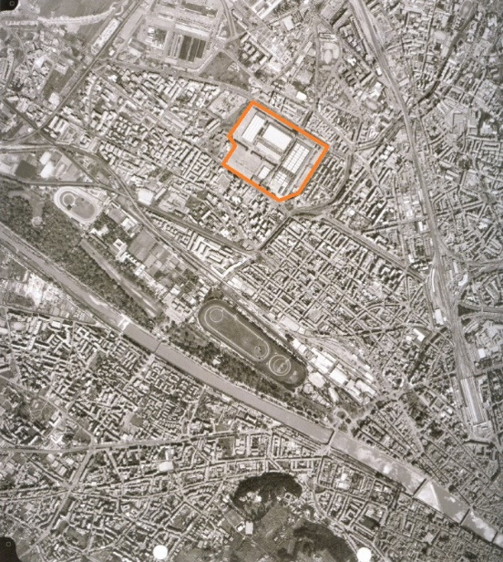
Figure 1: The area FIAT in Novoli, 1990.

In 1985, FIAT Company invited a group of planners and architects, leaded by Lawrence Halprin, in order to design a development of the area. The plan provided by Halprin and the others, drawn in three different workshops between 1985 and 1988, focuses on a big green park in the center of the area. Buildings designed by several international firms and hosting different functions raise up all around the green landscape. The architecture of the plan does not deal with the surrounding built neighborhoods. It manifests a reflexive attitude looking at the park as magnet of the composition. This scheme is highly criticized by a part of Florentines who do not recognize a familiar spirit of urban composition in the draft of the project. The opponents to Halprin’s project defend the European tradition of dense cities against the American tradition of big urban parks and spread built context. When the administration of the City changes, the Halprin plan is dismissed in favor of a solution that is considered more suitable to embody the principals of the European urban tradition. The selected architect is Leon Krier, rigid supporter of historicist models. In 1993 Krier designs a plan aimed at recreating the dense urban fabric of the traditional city (figure 2).
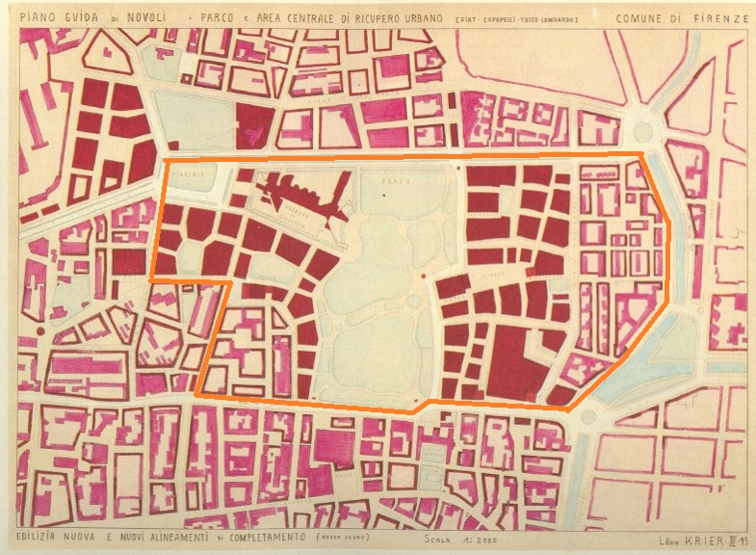
Figure 2: The master plan by Leon Krier.
The Master Plan: a Theoretical perspective
Leon Krier and his brother Rob base much of their theory on the Camillo Sitte’s ‘The Art of Building Cities’(1889). Sitte explains how the medieval city of Southern Europe represent a privileged model. He emphasizes the beauty of narrow streets, curved patterns and irregular piazzas, manifesting interest in the romantic appeal of the organic threading from a visually perspective. The same romantic fashion for the unpredictability of the dense urban space of medieval Europe informs the thinking of Krier brothers.
According to Leon Krier the city is composed by smaller micro cities, the quartiers, with a particular identity and livability. Each quartier, whose area is around 30 hectares, will be characterized by a square in the center. The square is a center, geographically and conceptually, attracting the functional and social life of the quartier. The quartier is ‘a city within the city’.
Talking about the components of the urban fabric, Leon Krier attributes primary importance to the building block. ‘The building block (…) is the most important typological element in the composition of urban spaces’ (Krier, 2009).
He highlight small blocks, with many commercial fronts. Higher the number of streets, streets higher the social use of space. ‘Small blocks are the result of the maximum exploitation of urban ground caused by great density of activities, high cost of urban ground, etc., and that a great number of streets on a relatively small area correspond to the maximum length of the commercial façade’ (Krier: 2009).
Krier criticizes the Berlin blocks of the Nineteenth century because too big. In his drawings represents the standard Berlin block (300 x 100 meters) divided into four smaller blocks by crossing streets. Each block measures 45 x 140 m. He also provides a variation on the same theme, with a public square at the center, cropping off the four inner corners of the blocks (figure 3).

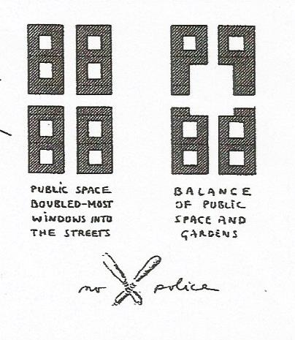
Figure 3: The transformation of the Berlin block operated by Krier

Consistently, the Master Plan of Leon Krier for Novoli replicates the principles of his theory. The area ex-FIAT is divided into three quarters, each of them measuring around 10 hectares. The central quartier becomes a green park, a residual heritage from the project of Halprin. Krier is not particularly fond of parks within the city, but the 12 hectares of green land was a mandatory input from the Municipality. Small building blocks with an array of streets form the other two quartiers. The project of the Justice Palace, inserted in the former plan, survives as an archeological monument not related to the rest. Residential building blocks range from 50 x 140 meters (similarly to the block obtained from the partition of the Berlin mega block) to very small blocks (30x50 meters). The buildings, according to the plan, should not exceed four floors high. A mezzanine serves as a storage while the first floor, the piano nobile of Italian aristocratic palace, is intended for offices. Apartments occupy the upper floors. In the plan, Krier creates a functional system of streets, defining commercial the streets (the ones with porches), car way streets and regular pedestrian streets. An underground garage serves each building separately. Despite not giving strict indications about typologies, Krier is very precise in defining the morphological rules for the facades of the building blocks. I report here some of the rules:
- ‘Facades openings present vertical proportion. They can be square or rectangular with horizontal proportion when the surface of the opening is less the 1 square meter’.
- ‘External walls are bearing walls with a strong differentiation between the areas of ground floor/mezzanine and the upper floors’.
- ‘Openings in the upper floors do not occupy more than 1/6 of the surface of the façade’.
- ‘Openings in the ground floor and mezzanine do not occupy more than 1/3 of the surface of the façade’.
- ‘Openings in a portico do not exceed ½ of the front and are vertical. Glass openings are divided into a minimum of four vertical panels and into two openable doors’.
- ‘In the upper floors vertical openings sits on horizontal stripes minimum 15 cm high’.
Krier indicates also useable and not useable materials, defines roof inclination and colors of building components. The intent is to recreate a spirit of the place with materials, forms and colors that belong to the Florentine tradition. Krier is convinced that this strict morphological asset constitutes the physical background for the flourishing of urban communities based on ideals of fraternity, social activism and economic productivity. The urban community does not exceed the limits of the quartier (Krier, 1995, 2009).
In 1995 the Municipality of Florence and FIAT Company approve the plan by Krier setting the conditions for the immediate starting of the works.

The implementation: from Theory to Reality
The first step towards the implementation of the plan included the demolition of the old industrial buildings and the decontamination of the soil. The Municipality took charge of the main infrastructural services. I started my consultancy as architect and urban designer in 1998. Between 1995 and 1998, I had worked in the office of Adolfo Natalini, the designer of the compound of the University buildings. The three University Faculties along with the Administration Office and the Library were among the first buildings to be completed. Grouping the University buildings in the North East side of the area contravened the initial rules of the plan, but an adjustment seemed a necessary solution. In fact, the University would not have accepted buildings dislocated in different parts of the area, preferring a campus-like solution.
A big part of the works in the initial phase included the making of the underground parking. Krier had displaced isolated car parking under each building, but since the beginning, this solution presented some limits. The already existing population density joined to the forecasted affluence of residents and commuters pushed the developer to ask for a variation of the plan. The variation provided the area with a long strip of underground parking, flanking the area of the central park and connecting the traffic roads running along the north and south edge of the area. In fact designing an isolated garage under each building has shown to be not an easy task. Each building necessitated a ramp whose inclination responded to national rules. In many cases, the ramp took almost the entire surface of the underground area leaving no space for cars. Grouping more units together and making them connected through an underground link circumvented the problem.
Krier has applied in the plan the principles of horizontal and vertical zonings. According to this idea, buildings with similar functions do not stay next to each other. The vertical zoning represents a further mixing of functions. In each building in fact, diverse functions locate at different floors. Commercial activities easily fit at the ground floor, while placing offices at the first floor of each building resulted not easily manageable. Usually big companies wants an headquarter designed according to their needs. Putting together the requirements of the clients, the rules by Krier along with city and national rules required a lot of effort.
In the initial phase, all the architects participating to the design of the buildings obliged to the rules by Krier. A so strong codification anticipated somehow the result, and many architects felt restricted by the impositions. Some others interpreted the rules with a defying naïveté that irritated part of the general opinion. The first tranche of buildings reached the completion when New Urbanism started to be less fashionable. Many professionals and common citizens saw in the raising architecture of the Krier plan an unreasonable hymn to an artificial past.
The criticism convinced the developer to ‘refresh’ the style of some buildings. Three architecture celebrities of the 1990s designed three buildings: Zaha Hadid, Odile Deq and Carme Pinos. The marketing strategy pacified the opponents to the Krier architecture, but opened new problems of feasibility. In fact, the deconstructivist interpretation of the three archi-stars did not fit the Krier rules. The solution took the form of a compromise: a variation master plan modified certain criteria of the Krier master plan while contemporarily the three architects reviewed their projects.
Despite all the polemics, the plan reached 2/3 of its completion in 2008. At that time, most of the east quartier and the entire park were completed. The global financial break down affected also the development of the area and works stopped (figure 4).
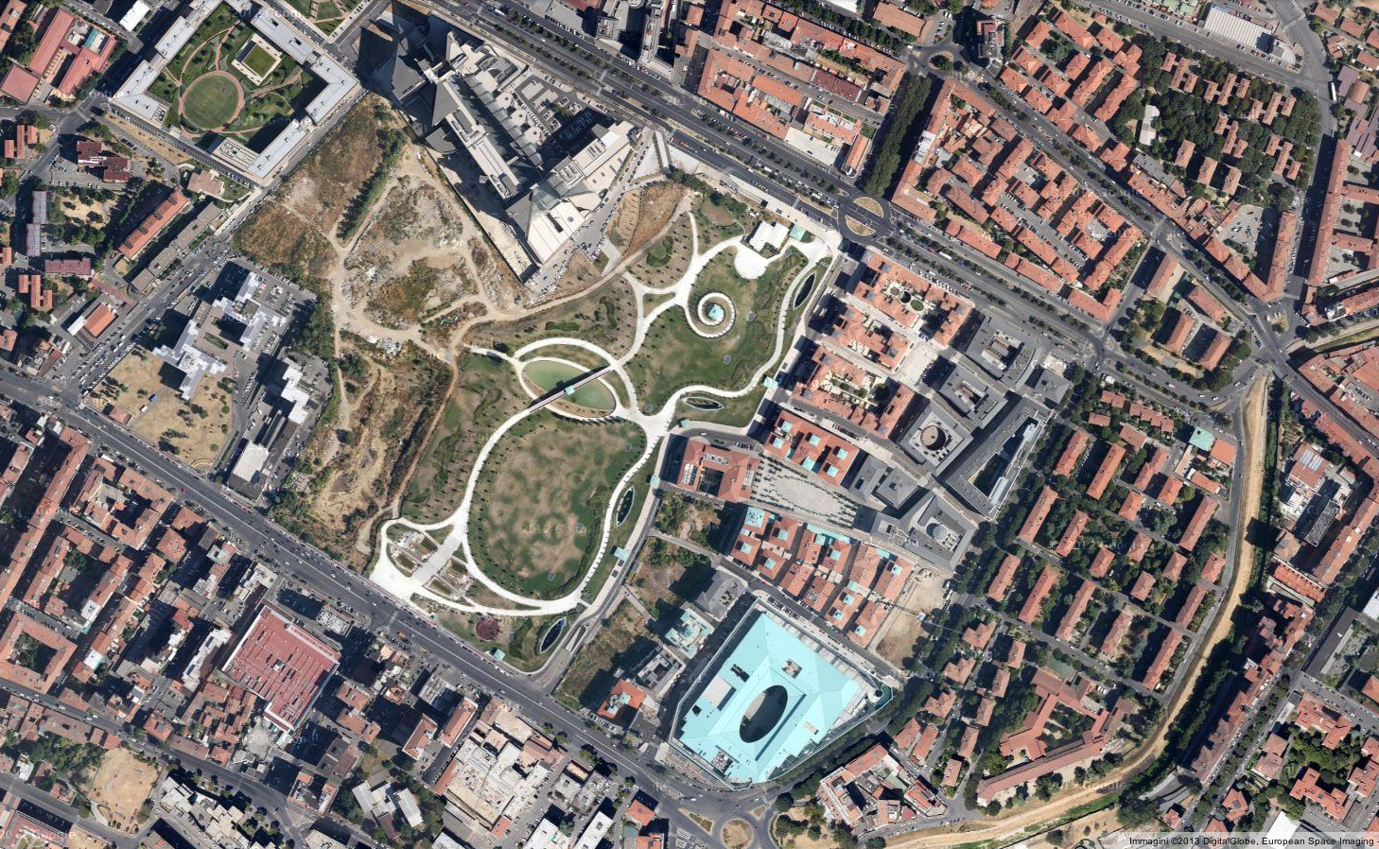
Figure 4: The area as it is today.

Beyond the strictness of the rules, the completion of the buildings of the Krier plan presented other issues. The larger blocks could accommodate in a proper way lined apartment buildings, facing each other by a court of 20-25 meters. It was instead difficult to design apartment steaks of four floors around the perimeter of a block of 30 x 50 m. The semi-private space inside the block, where people of Mediterranean tradition store domestic tools, wash clothes and put them to dry, measured something like 8 x 28 meters that is a dimension not acceptable by local rules and by practical rules of proper ventilation, lightening and privacy. Reducing the body of the building was a possibility, even though penalizing in terms of proper internal distribution and commercial revenue. The other possibility, usually the one adopted, left one side of the block unbuilt. In this case, the internal court is visible from the street, losing the character of domestic discretion dear to Florentines (figure 5).

Figure 5: The small size of the blocks does not allow proper court space.

The coincidence between block and building is part of Krier’s thinking (2009). It is therefore not an accident occurred in the plan for Novoli. In my opinion, this aspect of urban theory is susceptible to a more convincing conceptual elaboration. A block rarely coincides with a building. The building-block exposes all the sides to the public space. Creating a hierarchy between main front and back front is not possible. Residential buildings work better when offer a formal façade to the public street and a less formal side to a private or semi-private space. ‘A block consists of many buildings’ (Mikoleit and Purckhauer, 2011).
Multiple buildings confer variety to the area, making the block visually interesting.

The size of an urban block contributes to the success of a neighborhood
Nowadays most of the buildings of the plan for Novoli are completed and operaing. Three Faculties of the University of Florence, Economics, Law and Political Sciences relocated in the area. Many offices opened here their headquarters and commercial activities of different kind spread in the ground floor of the buildings. A supermarket with other medium size stores and a movie theater stand in the southeast side of the area. Coffee places in the piazza serve local residents and students from the University. Walking in the area is in general a pleasant experience (figure 6).

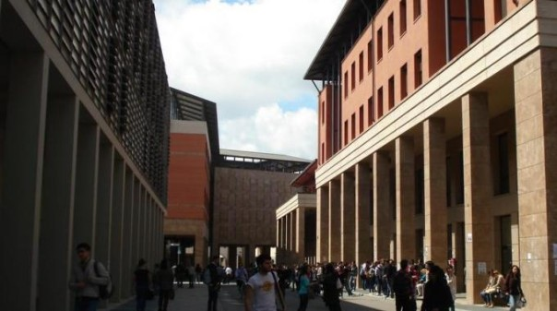
Figure 6: A street view of the area ex-Fiat in Novoli.

Most of the criticism addressed to the development involves stylistic aspects of the plan. Just a minimal part of critiques addressed the quality of space and the livability in the area. Supporters and detractors of Krier usually debated about the properness of an architecture claiming the idealization of the past.
We have already mentioned the duality between the Halprin plan and the Krier plan. The former, with the green park in the center, embodied the ideal of a city close to nature, not regimented in a rigid grid. The latter symbolizes the dense historic city of Southern Europe, with an urban fabric that is compact and readable. Interesting enough, both the plans, even if so different, qualify as ‘organic’. In fact, they refuse regular streets and orthogonal corners. The Halprin’s scheme dilates the usual public space of the European city, while the Krier’s plan condenses the generic block of the European city into micro blocks. The look of architecture is very different. The architects involved in the Halprin workshop proposed mega-buildings, randomly arranged around the park. Krier, on the other side, plays with micro-buildings, linking their type to a not well-specified period of the Florentine tradition. Both the plans, the one by Halprin and the one by Krier, are very referential, relating more to their artificial microenvironment than to the surrounding built reality. Whereas the plan by Halprin tries to initiate a new trend, the plan by Krier tries to recuperate a traditional trend. For this reason, it offers an easier ground to critique. I just want to mention briefly the ethical problems that such an experiment of historicism may pose. The resuscitation of a medieval Florence is not a practicable experience. Environmental conditions that generated its form evolved. Demographic, traffic, commercial and business relations, living conditions, parking needs, are just few of the problems that demand a different attention from the one that stimulated the growth of the medieval city. In this sense, whatever is new may benefit of doubt benefit, whatever claims a revival is open to criticism. If we think of places as places for people (Gehl, 2001) and not just places for tourists, it is implicit that replicating the conditions of a reality that has already proved to be unsuitable for locals is a defying operation. This is partially the case of the master plan for Novoli. The medieval revival intertwines with the revival of different periods of the supposed local past with an approach that, despite the intentions, is more sentimental that philologically correct.
We may extend the analysis on the ethical rightness of the stylistic citation of models and types as defined by the rules of the master plan for Novoli. In this context it would be just a matter of philosophy. I think that purity of form may not affect the quality of space and the grade of satisfaction of inhabitants. I am interested here in pointing out the urban design problems that, if treated differently, may have added quality to the project.
Probably that less complacence in a romantic past, in this case medieval Florence, may have brought to the design of even better space for people. Early medieval Florence started its expansions on the ashes of the Roman city. The diffused typology among craftspeople was the row house. Craftspeople represented the bulk of the urban population. Their income in the first period of urban growth was generally similar and similar were their housing conditions. The normal house untill the 14th century is the row house (Fanelli, 1973). Initially the row house took advantage of the residual foundations of the Roman block. Small units lined up in a row, each of them spanning for a width of around 3 meters and reaching a length of 12 meters with additional 6 meters for the orchard. The small plan dimension of the row house demanded for a sectioning of the Roman block (70 x 70 meters), generating sub-blocks (35 x 70 meters) (figure 7).
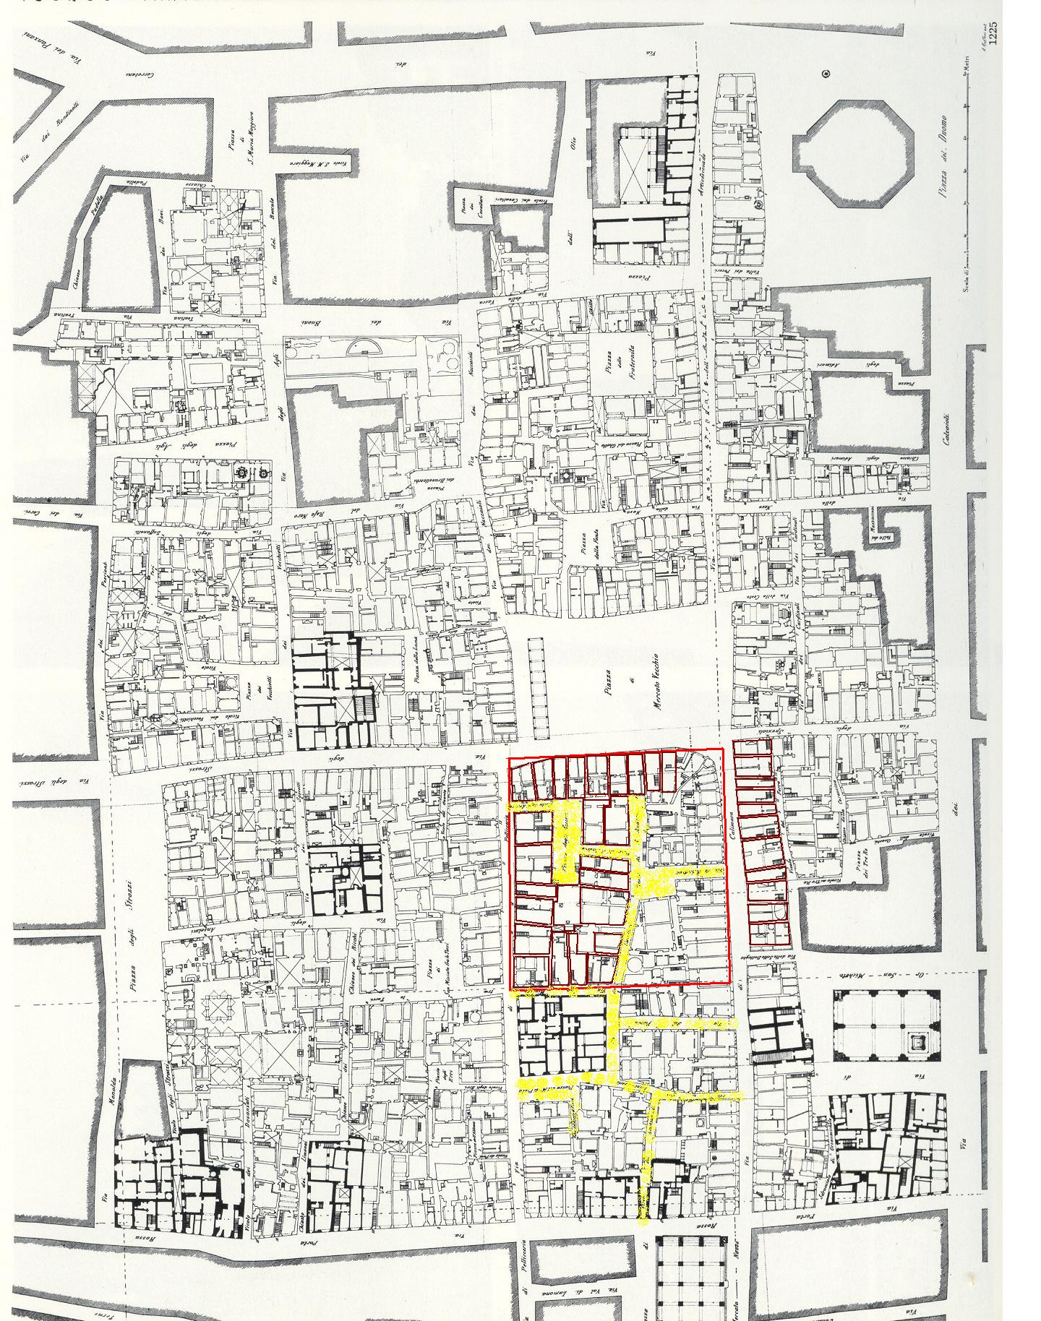
Figure 7: Row houses in the subdivided Roman block. Florence.
The medieval block of 35 x 70 meters and sometimes smaller, resulted functional to the row house. Many of the row houses still existing in Florence changed over time and floors added one above the other, although substantially the internal space did not change. The distribution is basic. One room occupies the street front and one room the back front facing the yard. In between can be located one room or two without windows or opening on a shaft.
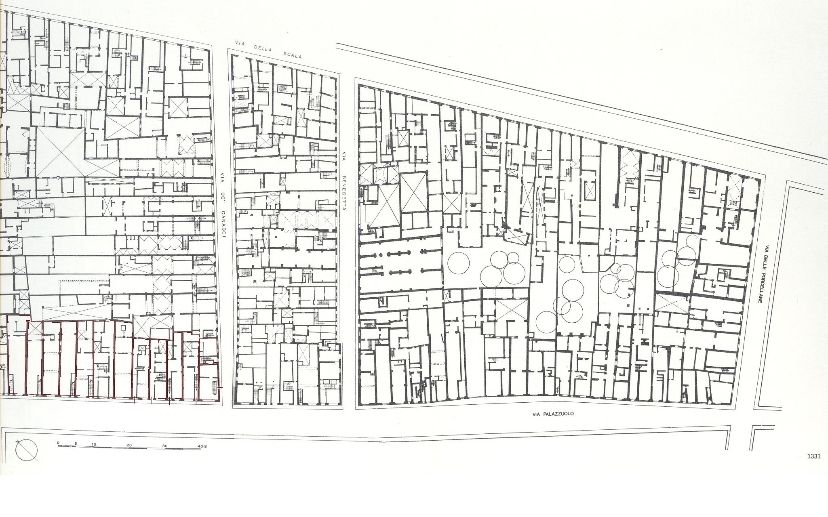
Figure 8: Medieval blocks of row-houses.
This model is historically very fascinating but realistically not suitable to modern living habits. Nowadays people who inhabit row houses seldom can afford different housing types. Medium class people usually prefer to reside in apartment buildings with a common staircase serving two or more apartments for floor. Despite the pronouncement in favor of a medieval city, the apartment building steak is also the typology used within the urban blocks of the Novoli plan.
Retracing an historical transformation of residential types in Florence, we may set the 13th century as a time line in which the economic conditions of some citizens improved. Few rich merchants could afford to build houses with higher comfort. Over time some of the row houses transformed into apartment buildings, with a common staircase and one unit at each floor. Sometimes adjacent row houses were connected. The apartment building as a tested typology is contemporary to the birth of the bourgeois’ class. When Florence initiated its expansion on new land (13th century), the typology of the row house maintained its canonical façade measure, but often displaced on a longer block (Fanelli, 1973) (figure 8).
The block surrounded by steaks of apartment buildings is a relatively recent typology in Florence. It became the rule in the City planning for Florence capital, in the second half of the 19th century. The architect of the plan, Giuseppe Poggi, designed the extension of the city in the areas adjacent to the old city walls, contemporarily demolished and substituted by a boulevard ring. Apartment buildings of the Florence enlargement are four, five floors high, each steak facing the street and the internal yard.
The size of the block is variable but its width is rarely inferior to 60 m. The steak of the apartment building is normally 11-13 m thick. These measures implied a successful distribution of the layout of the apartment, considering that rooms’ size was usually larger than now. The court between the two sides of the block measured more than 30 meters, allowing decent ventilation, lightening and privacy respect. The expansion of 19th century Florence produced a piece of city that is very successful. Nowadays the areas developed by Poggi plan are among the most livable in the city and among the most expensive in the real estate market (figure 9).
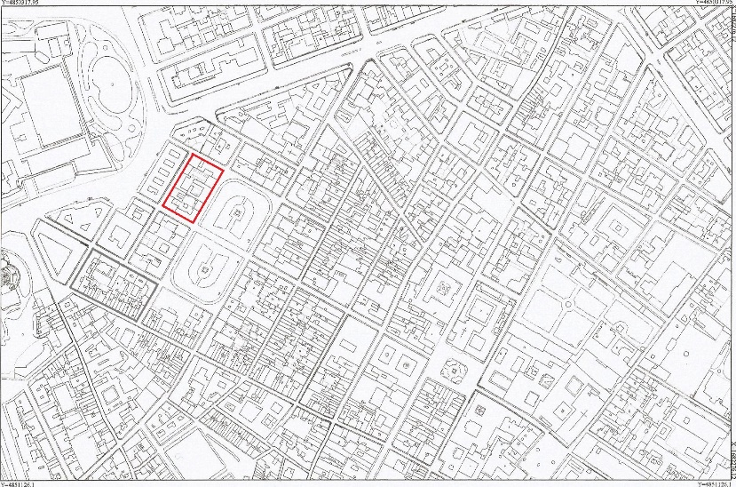
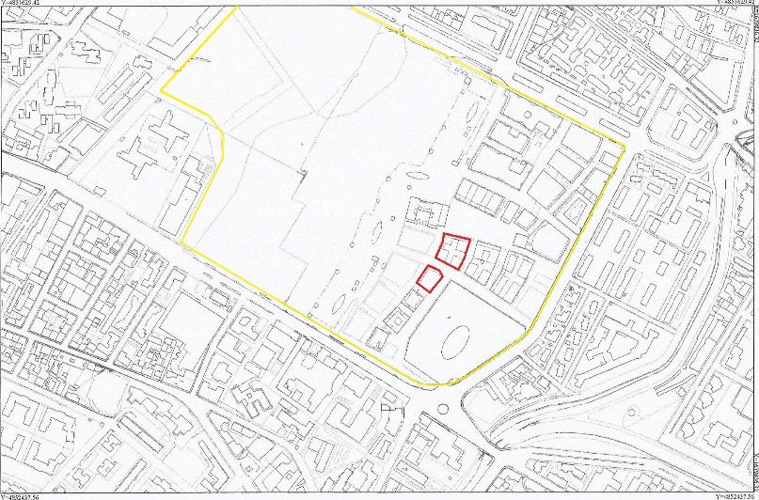
Figure 9: Left: Blocks of the late medieval expansion and blocks of the Poggi plan (in red).Right: Block of the Novoli Master Plan.
A first sight overview of urban blocks that proved to work well, both in the making of the court space, both in the making of the street space, would include several examples built in Europe between the 17th and the 21st century. The blocks of the Cerda plan in Barcelona and those the Craig plan in Edinburgh (18th century) are part of the list (Morris, 1996). The Cerda blocks have a square shape, the side 115 m long. The average Edinburgh blocks of the Craig’s city measure 180 x 70 m. In this case, the thickness of the urban house is compensated on the other side of the block by the reduced body of the service mews (Morris, 1996). In Vienna, an average block around the Ring measures 60 x 130 m. In Stockholm, the Building plan of 1876, destined to regulate the growth of low cost housing, defines blocks whose maximum height does not exceed five floors, while two internal courts flanked by inner lower steaks of houses, measure not less than 13 meters, that is approximately 1.2 times the width of the housing. The entire width of the urban block is 70 m (Zucconi, 2001).
Yet, it is a matter of fact that big blocks contribute lessening the attractiveness of a place as small blocks do. Jane Jacobs warned her readers from making too long blocks, explaining that long blocks, like the Manhattan blocks, impede the circulation of people, conveying the flux of pedestrian only in the main perpendicular street. The channeled flux of people, according to Jacobs, deprives the areas external to the main street from having their shops. She thinks as a reasonable solution cutting the Manhattan block with a small street in the middle and transforming it into two blocks. The Manhattan standard block is 240 m long. Cutting it into two parts would produce two blocks 115-120 m long. (Jacobs, 2000) (figure 10).
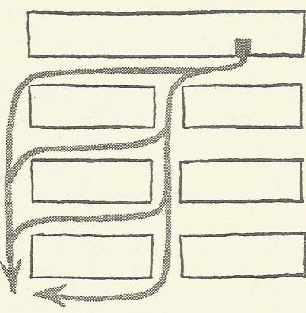
Figure 10: The subdivision of Manhattan block according to Jane Jacobs (Jacobs, 2000).
Conclusion
The present recollection of urban blocks and theoretical thinking represents a minimal part of the extremely vast array of samples of successful urban blocks making successful urban places. It is also evident that the mere dimensional aspect is just one of the variables that influence the fortune of an urban district. Nonetheless, certain dimensions recur in the most successful areas of western urban tradition.
A block whose short side ranges between 45 and 115 meters and whose long side ranges between 115 and 180 meters shows to be adequate to correspond expectations of dwellers inhabiting the blocks and pedestrian circulating at the ground level on the external perimeter. If the favorable conditions for pedestrians present a certain likeness in the consolidated western environments, climatic and cultural elements influence the dimensions of the internal yard. In the North European countries, where the climate is more rigid and privacy issues are determined more by behavioral attitudes than by physical proximity, the yard between two facing buildings tends to be smaller. The wideness of the internal space depends also on the typology of buildings and on the height of the front. Whereas too big blocks obstacle a consistent traffic of people, too small blocks constitute a limitation for the livability of dwellers. In addition, a tight net of streets too close one to the other disorient the pedestrians who are not able to identify landmarks of the area and physical references (Lynch, 2001).

References
Fanelli, G. (1973), Firenze Architettura e Città, Firenze: Vallecchi.
Gehl, J. (2010), Cities for People. Washington DC: Island Press.
Giovannini, Potestà (2004), San Donato a Novoli. Da area industriale a centralità urbana. Firenze: Polistampa.
Jacobs, J. (2000), Vita e morte delle grandi città. Torino: Edizioni di Comunità, pp. 168-69. Original title: The Death and Life of Great American Cities. New York: Random House, 1961.
Krier, L. (1995), Piano Guida per il recupero urbano di Novoli. Firenze: Comune di Firenze.
Krier, L. (2009), The Architecture of Community. Washington DC: Island Press.
Lynch, K. (1990), Progettare la città. La qualità della forma urbana. Milano: Etaslibri, pp. 303. Original Title: A theory of good city form, Cambridge: MIT University Press, 1981.
Lynch, K. (2001), L’immagine della città. Venezia: Marsilio, pp. 107-113. Original title: The Image of the City. Cambridge: MIT University Press.
Mikoleit, Purckauer (2011), Urban Code: 100 Lessons for Understanding the City. Cambridge: MIT University Press.
Morris, A.E.J. (1996), History of Urban Form before the Industrial Revolution. Bergen County, NJ: Prentice Hall, pp 240-241.
Sitte, C. (2013), The Art of Building Cities: City Building According to Its Artistic Fundamentals, Eastford, CT: Martino Fine Books. Original title: ‘Der Stadtebau nach seinen Kunstlerischen Grundsatzen’. Vienna, 1889.
Zucconi, G. (2001), La città dell’Ottocento, Roma-Bari: Laterza, p. 130.

