***A Tale of Two Main Streets: The Elements of Sustainable Placemaking as Seen Through the Evolution of Queen and Main Streets in Fredericton, New Brunswick, Canada.***

**Juan Estepa** ASLA, CSLA, CNU-A, Manager of Heritage and Urban Design, City of Fredericton, Canada. **Kenneth Forrest** MCIP, RPP, Director of Growth and Community Services, City of Fredericton, Canada.

**Abstract**

Fredericton, New Brunswick, Canada is an amalgamated city on Canada’s east coast. It is composed of the old historic city of Fredericton, located on the south side of the Saint John River and a number of towns and villages that developed on the north side of the Saint John River. The military planners that laid out Fredericton intended that Queen Street would be the community’s main street. Queen Street is a traditional 19th century North American ‘main street.’ It was recognized in 2012 as one of the great streets in Canada. Main Street, on the other hand, evolved from a rural road linking disparate farms into the ‘main’ street of the Village of Nashwaaksis on Fredericton’s north side. With suburban residential development, Main Street was rapidly transformed during the post-war boom into an automobile-centric, suburban commercial strip.

The City of Fredericton recently completed long-range urban design plans for both Queen Street (Fredericton City Centre Plan) and Main Street. These plans and their associated public processes have provided City planning staff with a unique opportunity to compare and contrast the divergent placemaking trajectories of these two main streets. It has led to a better understanding of how differing political, social and economic conditions have profoundly affected the quality of these streets as urban spaces.

This comparative approach has proven to be a strong analytical tool for both the public and private sectors in Fredericton as the community considers how to maximize the public benefits of having two main streets. The urban design plans each provide a compelling vision that has captured the imagination of residents and elected officials. The plans will guide capital investment and programming over the next twenty years in an effort to ensure that both streets see more of the best of times rather than the worst of times.

**Key Words**: main streets, places, placemaking, public process, urban spaces, sustainability

**Introduction**

The City of Fredericton is the capital of the Province of New Brunswick, located on the east coast of Canada. Situated along the banks of the Saint John River with a rapidly growing population of 56,000 in the city and 105,000 within the metropolitan area (based on the 2011 census), Fredericton is a cultural, educational, and information technology centre. The city has the highest percentage of residents with post-secondary education and highest per capita income in the province.

In recent years, Fredericton’s quality of life and economic potential have been recognized by being named a Cultural Capital of Canada (2009) and by earning top spot as a Micro American City of the Future, according to *Foreign Direct Investment Magazine* (2013).

The City of Fredericton is the product of the 1973 amalgamation of the old historic city of Fredericton, located on the south side of the Saint John River, and the adjacent towns and villages located on the north side of the Saint John River, as well as those communities located along its pre-1973 eastern and western boundaries. Queen Street continues to be the traditional North American ‘main street’ of downtown Fredericton and in 2012 was recognized by the Canadian Institute of Planners as one of the great streets in Canada. Main Street, on the other hand, was transformed during the post-World War II boom from a rural road linking disparate farms into the ‘main’ street of the Village of Nashwaaksis on the north side. Main Street is now an automobile-centric, suburban commercial strip. It is searching for a new identity in an environment where big-box retail is becoming more dominant yet the demand for more dense residential and mixed-use development is increasing.

As a result of the amalgamation of 1973, Fredericton is unique in the province of New Brunswick in that it is the only city to have two Business Improvement Areas (BIA).[1] Downtown Fredericton and Business Fredericton North are the two BIAs and each is focused on their respective “main” street – Queen Street and Main Street.

In 2013, the City of Fredericton, in collaboration with Downtown Fredericton and Business Fredericton North, initiated processes to develop new long-range urban design plans for both Queen Street (Fredericton City Centre Plan) and Main Street. The fact that these two urban design processes took place concurrently provides a unique opportunity to reflect upon Fredericton’s two “main” streets. Specifically, their divergent placemaking trajectories provides some insight into how the public and private sectors need to work together to implement the visions for both Queen and Main Streets.

**Historical Foundations**

From their very beginnings, Queen and Main Streets were set on different courses in terms of their placemaking potential. While military considerations determined the origins of both streets, the *genius loci,* or ‘spirit of the place,’ were different in each instance, with echoes lasting to the present day.

The settlement of the present City of Fredericton began in 1783 with the arrival, after the American Revolution, of the United Empire Loyalists. The new town, soon to be the provincial capital of New Brunswick, was laid out on the south bank of the Saint John River in a gridiron pattern that would be typical of British colonial settlement in British North America. With streets sixty-six feet wide, at right angles to each other, and blocks divided into eighteen lots, sixty-six feet wide and 165 feet deep, this new town plat gave credence to the claim that Fredericton is one of the oldest ‘planned’ cities in the British Commonwealth (see Figure 1) (Squires, 1980; and City of Fredericton, n.d.).

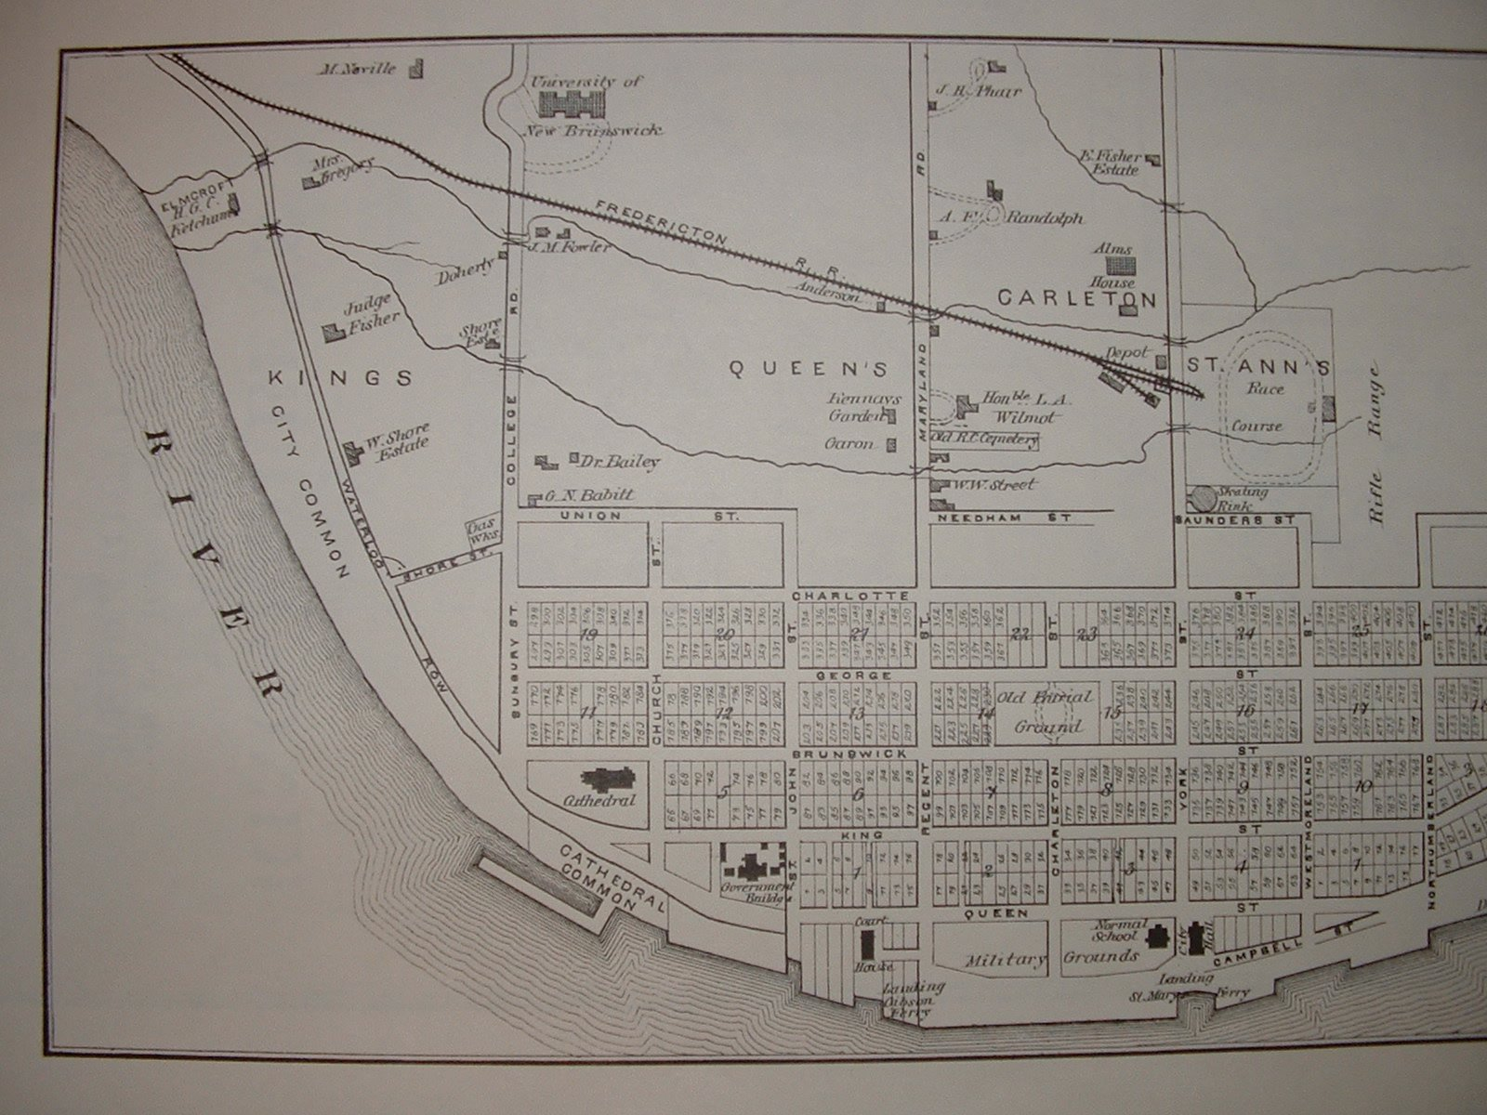

Figure 1. Map of Fredericton showing original Town Plat with Queen Street at bottom (Halfpenny, 1878)

With the establishment of a military garrison between the Saint John River and Queen Street and the preponderance of soldiers, Queen Street quickly became the commercial hub of the new town. In fact, the military presence in Fredericton was so important that military personnel outnumbered civilians for the first forty years of Fredericton’s existence. The influence of the British military garrison would persist until 1869, when the last regiments left after Canada’s Confederation, to be replaced by the Canadian military (which occupied the site until the First World War). Much of the social and cultural character, as well as physical landscape of Queen Street (and Fredericton) was defined by the military.

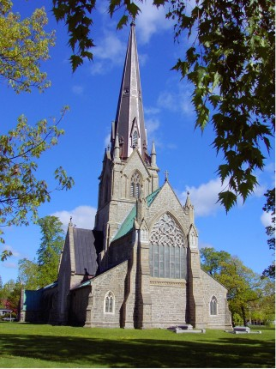

Figure 2. Christ Church Cathedral

The 19th and 20th centuries would see additional developments that would have lasting influences upon Queen Street. One of the most significant is Christ Church Cathedral (and the associated Cathedral Green) constructed between 1845 and 1853 at the east end of Queen Street, which not only led to the incorporation of Fredericton[2], but would also become an integral part of the City’s spiritual and social fabric (see Figure 2) (City of Fredericton, 2012). This cultural landmark was followed by other significant civic and cultural institutions distributed along the length of Queen Street, including: the York County Court House (1858), Fredericton City Hall (1876), the Provincial Normal School (1876), the Provincial Legislative Assembly (1882), the Old Post Office and Customs House (1882), the Old Post Office (1913), the New Brunswick Liquor Commission (1940), the Government of Canada Building (1950), the Beaverbrook Art Gallery (1959), and the Playhouse (1964), to mention just the most significant of the institutional buildings.

In addition to these institutional and architectural landmarks, there were cultural and public realm amenities along Queen Street that contributed significantly to its character. These include: the public green spaces (the Cathedral Green, Officers’ Square, and the forecourt in front of the Provincial Normal School), the public plazas (Barrack’s Square, Phoenix Square), fountains (Three Graces, Temple Fountain and City Hall Fountain), and statues/public art (Robbie Burns, Temple Lion, Lord Beaverbrook and Freddie “The Nude Dude”).

By the mid 20th century, there was no doubt that Frederictonians and visitors alike saw Queen Street as the pre-eminent street in Fredericton with a rich legacy in history, physical features, and social and cultural amenities looking confidently towards the future.

Nashwaaksis,[3] much like Fredericton, was settled with the arrival of the United Empire Loyalists after the American Revolution. However, unlike Fredericton, there was no intention of laying out a town or city. Like much of the north side of the Saint John River, the future Nashwaaksis was divided into sections reserved for Loyalist Regiments of the British Army. It was felt that if regiments were settled together, along with their officers, that a military force could be raised quickly in the event of an American invasion. Soon other settlers joined these Loyalists; however, Nashwaaksis was not initially self-sufficient and had to import its food and other provisions.

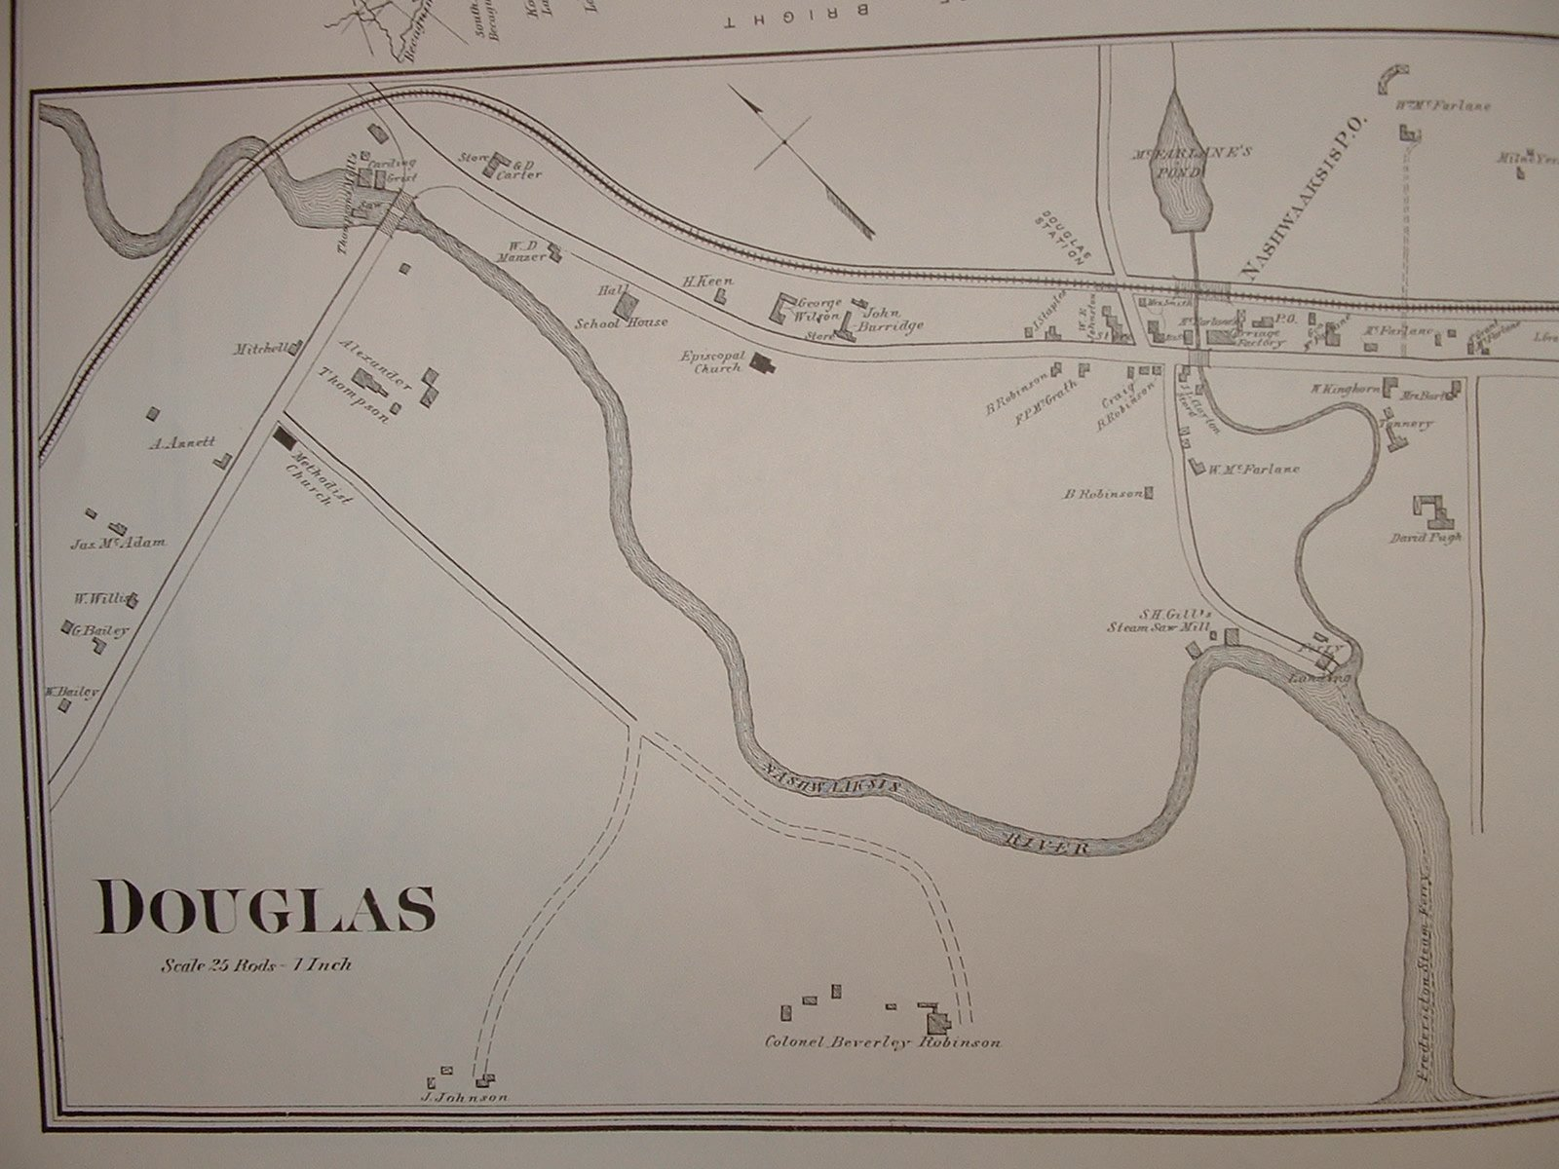

Figure 3. Map of Douglas/Nashwaaksis, Main Street at top centre (Halfpenny, 1878)

By the 19th century Nashwaaksis was home to a beer factory, grist and lumber mills, as well as a cheese factory. The emerging village was mostly dependent on sheep husbandry, farming, the timber trade, a mill (from the 1880s to 1905), and a foundry until 1933 (See Figure 3) (City of Fredericton, n.d.).

Until the post-World War II era, Main Street remained a sleepy, village road fronted by farms, houses and the odd general store, with a strong and memorable rural sense of place.

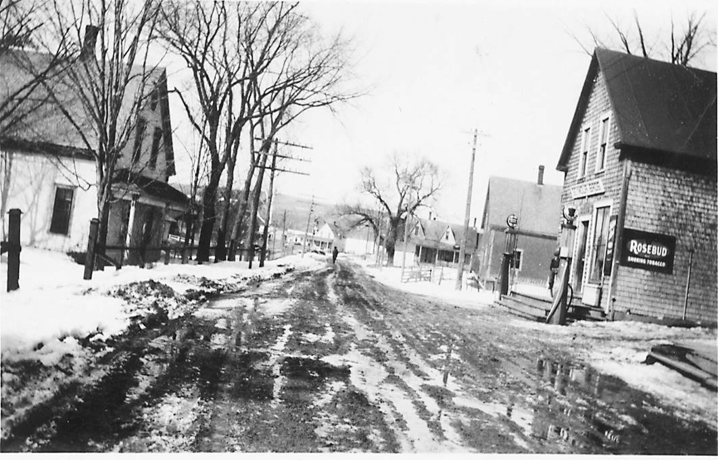

Figure 4. Pre-1950s view of Main Street

**Post-War Growth**

The post-war era saw tremendous changes in both Fredericton and Nashwaaksis that significantly impacted both Queen and Main Streets. The change in the case of Main Street was transformational. Following the creation, in 1950, of a Town Planning Commission and the adoption of “town planning” principles[4] (Town Planning, 1950), the following decade witnessed an explosion of development in Nashwaaksis such that by 1961 it was the fastest growing community in New Brunswick (Dunlop, 1961). Fueled by a housing shortage in Fredericton and the inexpensive land available in nearby Nashwaaksis, the new suburban population began to transform Main Street from a rural village main street to a modern commercial main street with shops and amenities for a automobile driving customer. Predictably, most of these new residents in Nashwaaksis commuted to Fredericton for work, making it primarily a bedroom community.

While not quite as dramatic as Nashwaaksis, Fredericton also experienced a strong post-war era of growth and development, primarily in the growth of the suburbs south of the original town plat. Queen Street continued to be the commercial heart of Fredericton and it experienced significant development with the construction of a number of key institutional buildings, including: the Beaverbrook Hotel (1949), the Government of Canada Building (1950), the Beaverbrook Art Gallery (1959), and the Playhouse (1964).

Overall, the post-war era brought increased prosperity for Fredericton, and the city was recognized by *Towns and Cities Magazine* as the 1961 City of the Year. Among the top reasons for the award was the strength and quality of Fredericton’s “main business section,” as well as the Beaverbrook Art Gallery, one of the finest small-city art galleries in Canada, which is located prominently on Queen Street (Reasons Why Fredericton is City of the Year, 1961).

**Amalgamation and the Growth of Suburbia**

Nineteen seventy-three was a milestone year for Fredericton. Not only did it celebrate its 125th anniversary of incorporation, but it also amalgamated with its neighboring communities on both sides of the Saint John River, growing in both size and population.[5] This was a period of substantial growth and urbanization[6] that continued throughout the 1970s. Most of the growth was due to the maturing post-war baby-boomers having families which created not only a demand for housing but also generated robust retail activity (City of Fredericton, n.d.).

Both Queen and Main Streets benefited from this growth but not in the same way, and from a placemaking perspective with radically different longer-term consequences. Main Street continued on its suburban strip mall trajectory in terms of its built form which was confirmed in the late 1970s when the Main Street Business Improvement Area[7] requested, and received, a highway commercial zoning designation for Main Street. Queen Street has, by and large, maintained its pedestrian-scale built form and public realm, despite some damage to its historic urban fabric due to increased automobile usage within and through the downtown.

Since the 1980s, both Queen and Main Streets have experienced serious challenges to their status as commercial/retail high streets with the development of commercial strip retail and regional malls at the periphery of suburban Fredericton, a situation that has only deteriorated with the advent of ‘box stores’ and ‘power centers’ at the expanding edge of suburbia.

The respective BIAs for Queen and Main Streets, in partnership with the City of Fredericton, have invested heavily in public realm improvements along both streets in an effort to enhance their attractiveness to shoppers, with mixed results. Main Street has seen no lasting impact from this public realm investment as it has proven inadequate to overcome the overwhelming sense of ‘placelessness’ of an automobile dominated public realm. Main Street continues to underperform as it struggles to find itself in a changing demographic and retail landscape (see Figure 5).

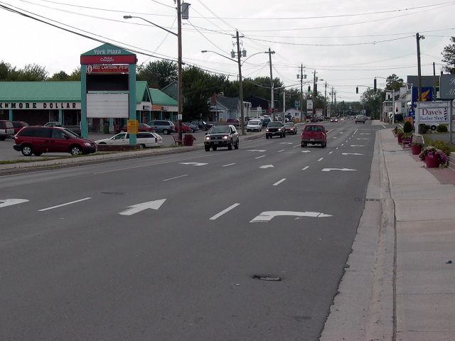

Figure 5. Main Street (2015)

Queen Street on the other hand was able to parlay its public realm investments into renewed strength, after narrowly averting a potentially disastrous urban renewal scheme.[8] Coupled with a comprehensive tourism strategy that focused on Queen Street’s rich cultural infrastructure, it helped revitalize downtown Fredericton, while also garnering national recognition as one of Canada’s great streets, according to the Canadian Institute of Planners (2012). The unique concentration of institutional uses on the north side of Queen Street in combination with a thriving retail and service sector on the south side of the street combines urban energy and sophistication with architectural elegance and a high quality public open space. The street is Fredericton’s natural gathering place as evidenced by the large number of events and festivals hosted in the spaces adjacent to the street or on the street itself. It is this rich mixing of use that has helped to immunize the commercial success of Queen Street against the competition provided from suburban retail development (see Figure 6).

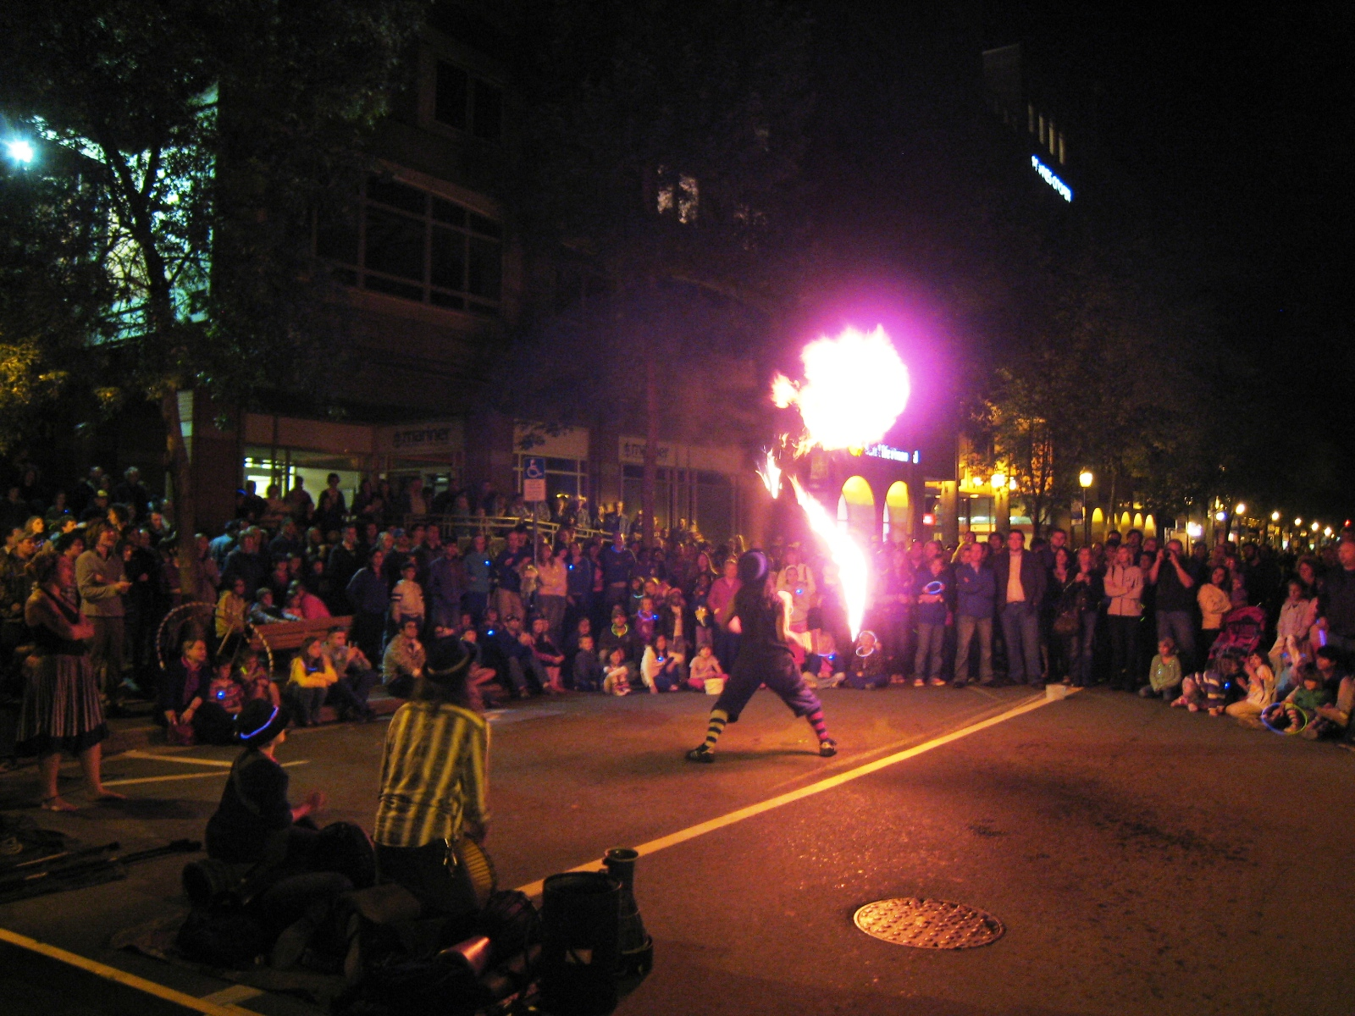

Figure 6. Queen Street during the Harvest Jazz and Blues Festival

**A New Vision for the Future**

It is against this backdrop that the City of Fredericton, in partnership with Downtown Fredericton and Business Fredericton North, initiated concurrent processes in 2013 to develop long-range urban design plans for both Queen (City Centre Plan) and Main Streets.

Over the course of a 2-year period, private sector planning consultants were engaged to work in partnership with City staff to develop urban design plans.[9] The plans were not undertaken using the process most typically used in North American urban planning. In Fredericton’s case, the existence of two “main” streets is a unique condition. City staff recognized from project conception that each urban design plan would require a customized place-making process that truly engaged the community.

In the case of the City Centre Plan, the planning team created many opportunities for true community engagement. The planning team established a temporary downtown storefront to become the “heart” of the planning process. Community consultation was also brought to the street through one-on-one interviews undertaken during one of the city’s largest music festivals. At the festival, citizens were asked to reimagine the downtown while in the place and while immersed in a celebratory atmosphere. The over-arching philosophy of the place-making process was that the vision for the downtown would be most compelling when the design process included citizens. The urban storefront became the design studio for the project and was a place where citizens and professional urban designers came together to dream, think, and sketch the future of Queen Street and the City Centre (see Figure 7).

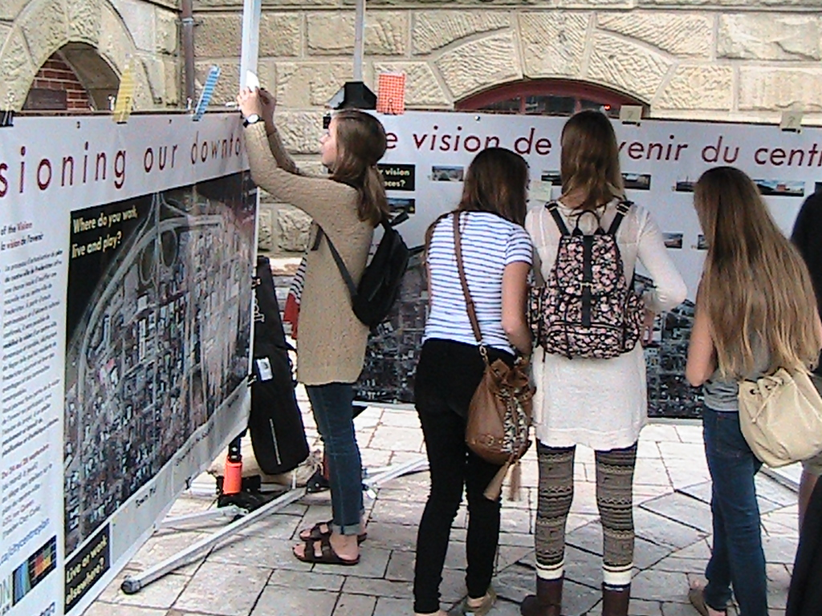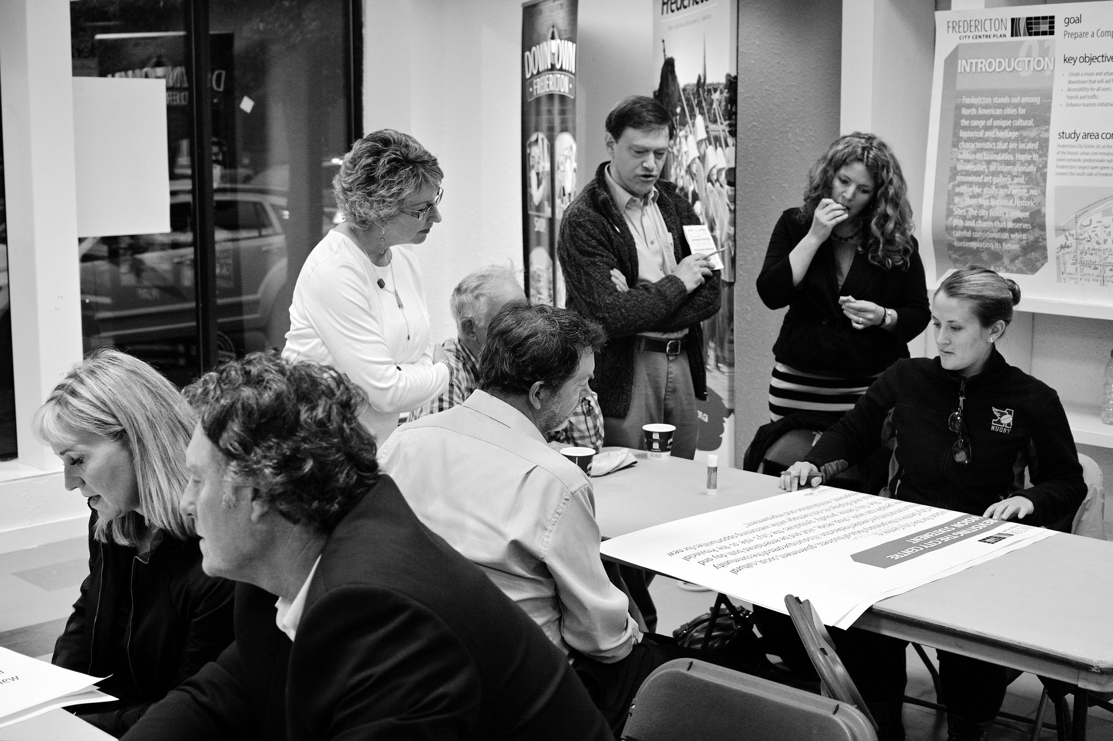

Figure 7. Community consultation on Queen Street and in the storefront urban design studio

The findings of the Queen Street (City Centre Plan) public and stakeholder consultation were quite revealing. When asked to take a fresh look at the existing vision for the area respondents stated that:

* The vision needs to emphasize the sense of place, and be readily identifiable as a place for everyone; and,
* The vision cannot be generic and it must be uniquely suited to the place (City of Fredericton, *Fredericton City Centre Plan,* 2015).

In imagining the future for Queen Street the following themes emerged, with participants favoring the following:

* More programming along the street;
* A preference for more small-scale and active public spaces;
* Development that is mixed-use and small-scale; and,
* More residential and mixed-use development at the west end of Queen Street (City of Fredericton, *Fredericton City Centre Plan,* 2015).

When asked what are the most important things about Queen Street that they felt should be preserved, enhanced, or introduced, participants identified the following:

* *Circulation* – Improve access to the Saint John River. Enhance non-vehicular transportation options (such as biking and walking);
* *Built Form* – Respect existing heritage, especially when it comes to new development. Retrofit buildings that present a blank face to the street. Insist on a higher standard of architecture;
* *Land Use* – Preserve green space and open space. Remove parking or make it more adaptable to other uses. Activate land uses with retail, an improved market or recreational facilities; and,
* *Streets and Open Space* – A more pedestrian focus. Eliminate surface parking lots. More trees, lighting and public art (City of Fredericton, *Fredericton City Centre Plan,* 2015).

Informed through the public consultation, the following vision and transformative strategy will guide the future growth and development of Queen Street and Fredericton’s City Centre:

With its rich cultural history at its foundation, the City Centre will reflect Fredericton’s status as a capital city and will be the vibrant heart of business, government, learning, social, cultural and tourism activities.

The City Centre will build upon its success and become a place defined by excellence in design, innovation and stewardship.

The Saint John River will once again be a defining and integrated feature of the City Centre.

It will be a place that inspires and excites both residents and visitors.

Above all, it will be a unique place – a place that captures the essence of Fredericton and its values, a place that is both proud and welcoming to all. (City of Fredericton, *Fredericton City Centre Plan,* 2015).

A key transformative strategy flowing from the new vision was the identification of Queen Street as a ‘cultural corridor.’ Queen Street will be a key organizing element for cultural, arts, and heritage attractions. It will become the visual and physical axis and connector across the downtown. There is also an opportunity to further enhance Queen Street as a mixed use pedestrian-priority cultural corridor that can be transformed into festival open space as and when required (City of Fredericton, Fredericton *City Centre Plan,* 2015).

In the case of the Main Street Plan, residents of Fredericton had less interest in establishing a new vision for the street. This lack of interest is most likely a result of the dominant suburban uses on the street which leaves residents with a more business-like relationship with the public space. In lieu of keen public interest in the physical form of the place, the planning process was designed to create a collaborative relationship with the business owners on the street through a close working relationship with the business improvement association. The staff and executive members of Business Fredericton North (the relevant BIA) worked with City staff and the consultants to shape the design process. This relationship facilitated the creation of a series of design models which provided options for the conversion of Main Street into a more urban and people-focused environment.

In lieu of direct citizen involvement in the place-making process, a more traditional open-house style public consultation was used to ensure that there was community awareness of the planning process. Social media was also used as an effective way of communicating with citizens in the Main Street planning process. The success of the social media investment is attributed to the view that people were less likely to feel enough passion for the future of the street to attend planning and urban design meetings and charettes. The platform of social media provided a quick and convenient way of interacting with the planning process.

Despite the differences in process used to develop each urban design plan, many of the residents and stakeholders of Main Street expressed similar issues and concerns as those expressed in the Queen Street consultation. The public engagement process for the Main Street Urban Design Plan revealed the following as the top priorities that the plan needed to address:

* *Lack of Identity* – While many considered Main Street to be “prosperous” in a commercial sense, residents felt that the street lacked a positive identity. Many felt that this was due to the auto-oriented nature of the street and its architecture;
* *Lack of Integration* – There is an abundance of natural and built features adjacent to Main Street that need to be better integrated, including: the riparian environment of the Saint John River and the Nashwaaksis Stream, recreation facilities, the trail system, neighboring residential areas, and a host of family services offered on Main Street;
* *Pedestrian Considerations* – Parking and vehicular traffic dominate every facet of life on Main Street. There needs to be more pedestrian-friendly environments and more multi-modal transportation options; and,
* *Lack of Animation* – Main Street lacks positive opportunities for entertainment and socialization in the evening after the businesses are closed (City of Fredericton, Main Street, 2015).

In order to address the priorities identified above, area residents and stakeholders arrived at a consensus around the following guiding principles that would form the basis of the new vision for Main Street:

* Support the businesses and organizations that shape our sense of community and improve our health and well-being;
* Create a safe, convenient and comfortable place to live, work and recreate;
* Encourage healthy lifestyle choices such as active transportation, living close to work and school, and participation in recreational pursuits;
* Support the arts, culture and diversity to make our community vibrant; and,
* Create a view toward sustainability that values natural systems, the rivers, greenery and minimizes the impact on the environment from development (City of Fredericton, Main Street, 2015).

In essence, these principles provide a comprehensive strategy for ensuring that the built form and public realm are redeveloped in a manner that also establishes Main Street as a desirable and vibrant place in which to live, work, shop, and recreate.

This led to the creation of a new vision for Main Street that aims, “to transition Main Street from a highway commercial area to a true “main street,” identified by the community as the Fredericton North commercial business area which serves as both a destination and a place to live and work.” (City of Fredericton, *Main Street*, 2015). In other words, the design solution involves transforming the automobile-centric suburban condition to a mixed-use, activated street with street fronting buildings and a people-oriented series of public and private spaces (see Figure 8).

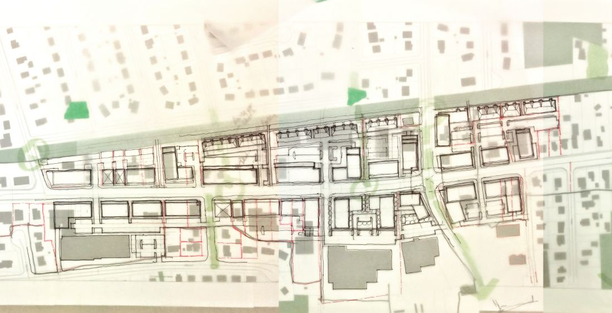

Figure 8. Overlay concept sketch of Main Street at future build-out

Change will happen slowly but the plans prepared for both Queen and Main Streets provide clear direction with respect to how each street will evolve and transform as redevelopment occurs over the next 15 to 20 years. At the heart of both visions is a community-based placemaking process that, as stated by the Project for Public Spaces, “is focused on the local community’s assets, inspiration, and potential, and will result in the creation of quality public spaces that contribute to people’s health, happiness and well being” (2015).

**Lessons for Successful Placemaking**

Creating a unique sense of place for main streets requires both passion and diligence amongst those in a position to effect positive change. The new visions for Queen and Main Streets in Fredericton, New Brunswick, Canada chart a bold and exciting course for these important public spaces. The following is a summary of some of the lessons learned through these planning processes that may prove useful as communities work to create better places in the future:

* Successful plan preparation and implementation requires a customized bottom-up planning process that includes citizens, businesses, and community organizations in every stage of the process. The planning process needs to be designed to “coax-out” engagement in a way that is convenient and meaningful for citizens;
* The public’s full participation in the process needs to be combined with bold, strong, and decisive leadership from the City’s guardians to effect positive change;
* Main streets are vitally important to those who live in urban communities and are understood at an intimate level by many citizens. Often times, the “recipe book” for the creation of a successful main street is already in the hands of those who use the street every day. Residents and business owners can play an active role in the placemaking process through the use of design charrettes, social media, and bringing the planning process to the street;
* Creating a stronger sense of place on urban main streets in the North American context requires a reconsideration of the proportion of the public right-of-way dedicated to automobiles. Rebalancing the public realm to provide a higher quality environment for citizens, cyclists, and pedestrians is worthy of careful thought;
* Streets are places where a great diversity of things happen and need to be viewed as much more than transportation and infrastructure corridors. Communities have intimate relationships with their main streets and they should be viewed as conduits for socialization and culture;
* The life of a street extends far beyond its pavement and curbing to include adjacent buildings and public and private spaces. Streets link all of these elements together to create a unified sense of urban place; each of which is unique and has the potential to be tremendously engaging for urban residents;
* Retail activity is the lifeblood of a main street. The provision of needed goods and services brings people to the place. A street with strong, high-quality retail uses is far more apt to stimulate mixed-use and residential development which, in turn, makes on-street retail activity more engaging and dynamic;
* The thoughtful incorporation of nature through the provision of a tree canopy humanizes the main street and softens the urban environment to encourage a deeper relationship between people and the street; and,
* Communities with more than one main street are well advised to find ways to use urban design, land use planning, cultural programming, and infrastructure and hardscape development to create a sense of unique place.

Main streets have remarkable resilience as a result of their history, the emotional attachment that citizens have with the street and adjacent buildings and spaces, and their programmability as the larger world changes. Sustainable placemaking is a continuous and evolutionary process that requires the collective passion of the public sector, private sector, and residents. The dedication of all stakeholders to planning and plan implementation is key to making places that see more of the best of times rather than the worst of times.

REFERENCES

Area First to Organize Under N.B. Improvement Act (1959, August 15). [Editorial] *The Daily Gleaner*, p. 14.

Canadian Institute of Planners Recognizes Queen Street, Fredericton, NB as a Great Street (2012). Retrieved from

http://en.wikipedia.org/wiki/File:Fredericton_Queen_St_a_Great_Street_2012.jpg

City of Fredericton (n.d.). *History of Fredericton*. Fredericton.

City of Fredericton (2012). *807 Queen Street, Christ Church Cathedral: Statement of Significance.* Fredericton.

City of Fredericton (2015). *Fredericton City Centre Plan*. Fredericton.

City of Fredericton (2015). *Main Street Urban Design Plan*. Fredericton.

Dunlop, M. (1961, January 21). Nashwaaksis New Brunswick’s Fastest Growing Community. *The Daily Gleaner*, p. [unknown].

Eleven Principles for Creating Great Community Places. (n.d.). *Project for Public Places.* Retreived from http://www.pps.org/reference/11steps/

Evans, R. (1959, August 15). New Buildings Mushrooming Across Nashwaaksis. *The Daily Gleaner*, p. 13.

Fredericton Earns Top Spot as Micro American City of the Future. (2013). City of Fredericton. Retrieved from http://www.fredericton.ca/en/citygovernment/FDI20132014.asp

Glaser, M.,‘t Hoff, M., Karssenberg, H., Laven, J., and Teeffelen, J. (Eds.). (2012). The City at Eye Level: Lessons for Street Plinths. Delft: Eburon Academic Publishers.

Halfpenny, H. E. (1878). *Atlas of York County, New Brunswick*. Fredericton: Halfpenny & Co.

Ingram, G. (2014, Spring Edition). Elbridge Wilkins. *Your Northside*, 16.

Jones, T. and Jones, A. (2002). *Fredericton and Its People 1825-1945*. Halifax: Nimbus Publishing.

Jones, T. and Jones, A. (2007). *Historic Fredericton North*. Halifax: Nimbus Publishing.

Kornwolf, J. (2002). *Architecture and Town Planning in Colonial North America*. Baltimore and London: The John Hopkins University Press.

MacDonald, T. (2014, Spring Edition). Northsiders Making a Difference: Gordon Burtt. *Your Northside*, 12-15.

MacDonald, T. (2014, Fall Edition). Northsiders Making a Difference: Ron Evans. *Your Northside*, 10.

MacDonald, T. (2015, Spring Edition). Northsiders Making a Difference: Bill Mathews. *Your Northside*, 11.

Reasons Why Fredericton is City of the Year (1961, January 21). [Editorial] *The Daily Gleaner*, p. [unknown].

Squires, W. (1980). *History of Fredericton: The Last 200 Years*. Fredericton: Centennial Print & Litho.

Town Planning (1950, April 6). [Editorial] *The Daily Gleaner*, p. [unknown].

Tremendous Boom is Continuing in Nashwaaksis (1959, August 15). [Editorial] *The Daily Gleaner*, p. 11.

What is Placemaking? (2015). *Project for Public Places.* Retrieved from http://www.pps.org/reference/what_is_placemaking/

1. BIAs are geographically defined urban areas containing primarily non-residential properties generally located in a city’s Central Business District. The BIA concept promotes a collaborative relationship between business and property owners, encouraging them to work together creating a vibrant and thriving commercial district. BIAs are funded by a special tax levy that is paid by all non-residential properties within the BIA and generally has staff and an elected board of directors.
2. The history of Fredericton is intertwined with the history of the Cathedral. The suggestion that Fredericton be incorporated had been under discussion for a number of years without any action having taken place, but the decision to build a Cathedral in the Capital transformed the town of Fredericton into an ecclesiastical city. Letters patent were issued in 1845, declaring Fredericton “the City of the Cathedral” (City of Fredericton, 2012).
3. Also referred to as the Village of Douglas in its early history, ultimately retained its Maliseet First Nation’s name of Nashwaaksis, which referred to either the area or the nearby stream (City of Fredericton, n.d.).
4. That is to say the responsibility to issue building permits, establish zoning regulations, the naming of streets and acting as an advisory body to the Local Improvement District (Village of Nashwaaksis). Interestingly, the well-attended community meeting that established Town Planning included the showing of a movie short, “The Tale of New Cities,” that was “thoroughly enjoyed by all” (Town Planning, 1950). While no longer extant it is clear from subsequent development along Main Street that the vision for ‘new cities’ portrayed in the film and adopted by the Nashwaaksis Town Planning Commission was based on modern planning principles with a strong suburban, auto-centric, ethos.
5. But also incurring a fourfold increase in municipal debt, which was not paid off until very recently (City of Fredericton, n.d.).
6. ‘Suburbanization’ would be a more accurate term. Until very recently Fredericton’s overall growth has been outwards, through suburbanization, rather than upwards through intensification.
7. Now known as Business Fredericton North.
8. City Council gave serious consideration to a proposal for a shopping mall development on Queen Street that included the demolition of numerous historic buildings, including City Hall, which is a National Historic site. This proposal was narrowly voted down amidst huge public opposition that eventually led to the creation of the Fredericton Heritage Trust.
9. The Planning Partnership, a professional planning firm from Toronto, Canada was engaged to work with the City and business improvement areas on both urban design plans. A portion of the work on the Main Street Plan was undertaken by the Glenn Group from Fredericton, Canada.