**Carlo Castelli** MSc ARB RIBA   
Director | Urban Design

AECOM Design, Planning + Economics  
[carlo.castelli@aecom.com](mailto:%20carlo.castelli@aecom.com)

**Can we afford public space?**

Can cities afford public space in the XXI century? Have our societies lost the ability – or the interest - to drive the collective decision-making process towards the creation of public spaces? For many, public space is the very essence of our cities. Is this still true?

These are pressing questions without answers. This paper aims at looking at public space as ‘infrastructure of our cities’ and to offer some insights from a practice point of view into the need of and recommendations for the delivery of affordable public space.

The fundamental political shift occurred in the last thirty years that we can somehow ascribe under the simplified banner of ‘end of ideologies’, along with a more pronounced sensitivity for limited resources, have led to a more privatised approach to the public space of our cities. This is due to two fundamental factors: on the one hand, public space has lost its prominence as either a mean to represent the grandeur of political regimes - whether totalitarian or democratic ones – or a result or utilitarian policies to enhance public health or sanitation or both. Grand schemes a la Tiananmen Square in Beijing, Liberty Square in Taipei, the Red Square in Moscow or Central Park in New York or Hyde Park in London seem to be unthinkable nowadays.

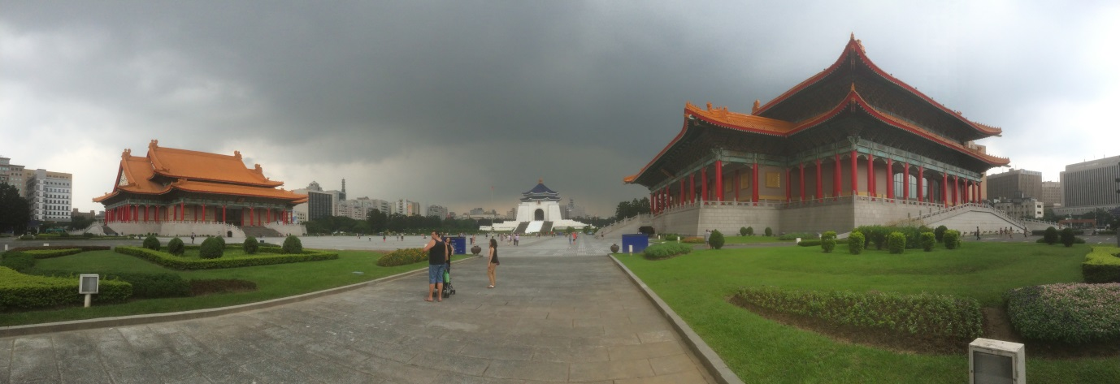

Liberty Square in Taipei (Source: Carlo Castelli)

Often irresistible land pressure in inner cities and a more pronounced pursue of density as a key factor to the viability and sustainability of our cities have also eaten into the availability of land and contributed to the reduction of the size of public space in modern urban developments.

Of course the recent events connected to the financial crisis of the major international markets brought along an additional urge for austerity that somehow pushed towards the same direction. Public spending is under scrutiny and often reduced, affecting the quantity and quality of public space provided by civic authorities.

Other two factors play a major role into the affordability of public space. Planning institutions are under pressure for staff and resources with subsequent limited capacity to manage the city-making process and inadequate skillsets and knowledge prevent them to negotiate effectively more public space. Secondly, the overall service provision expected within the framework of welfare systems such as healthcare and housing take often priority over public space.

Some exceptions are noticeable though. For instance, the Queen Elizabeth Olympic Park created in London in occasion of the London 2012 Olympics represents a clear example that it is still possible to create public spaces of ambitious scale; it is of ‘the same size as Hyde Park and Kensington Gardens combined and the biggest new park to open in London for a century (Vasagar, 2012). A similar case is represented by the High Line Park in New York, a linear park more than 2 kilometres long opened in two phases between 2009 and 2011 and re-using and dismissed rail track of the New York Central Railroad.

These are often the result of the strong competition amongst cities to attract the global elite and relocate on their shores. The case of the Queen Elizabeth Olympic Park is also the result of a clever use of the funds derived from the organisation of big sporting events such as the Olympics. The strategy behind has been based on the design of a legacy mode well in advance of the games in order to utilise the event almost as an ‘accident’ towards the ultimate objective of regenerating a part of the city.

It is interesting to note that both cases are actually examples of regeneration or re-use of either neglected parts of the inner city as for London or obsolete pieces of infrastructure as in New York. It is also noteworthy that public spaces are one of the main assets cities invest in to attract new citizens - somehow confirming the thinking that public spaces are intrinsically embedded into the essence and imagery of our cities.

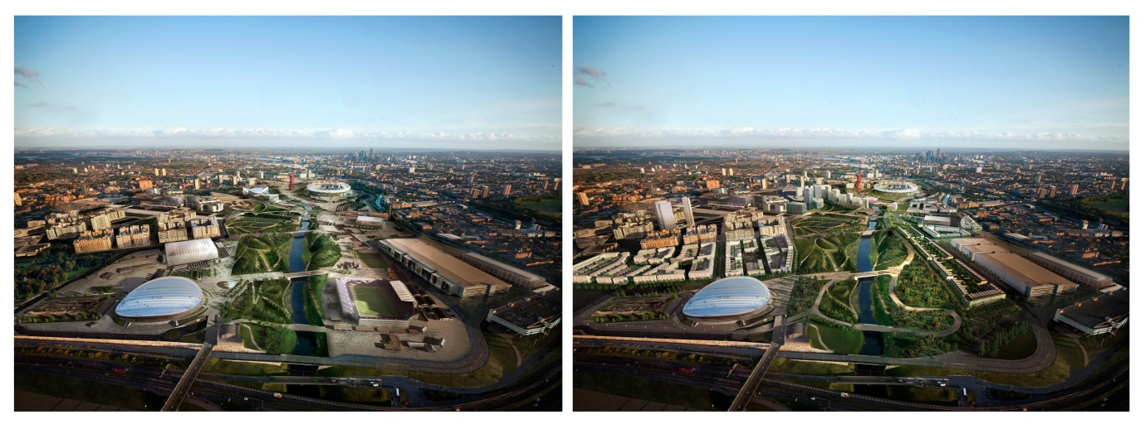

Queen Elizabeth Park in London – Games and Legacy mode (Source: AECOM)

Overall, the sheer scale of public projects created in representation of a political system is out of the equation and only some exceptions are possible in the name of the race for highest positions in city-rankings and press coverage that cities are forced to pursue to remain well marked in the global competitiveness map.

*A diffused public space network*

What this paper is trying to address is a kind of diffused network of public spaces that can really enhance the liveability of our neighbourhoods and uplift the quality of our cities.

This is the public space that suffers more from the dynamics that have been outlined earlier on. This is the public space we want to understand whether cities can still afford or not. It is the public space that does not hit the front pages of the magazines but are the ones which can have a real impact on the quality of our cities.

Public initiative – again because of the limited resources I mentioned before – is very rare nowadays. The ball is generally in the court of the private realm, with public authorities generally acting as enablers or more often as mere approvers of the development’s compliance to local planning regulations: a pure box-ticking exercise.

The choice nowadays would seem to be bouncing between the need of ‘making things happen’ through a laissez-faire system that allows for fairly limited concessions to the public sphere - at least in terms of ownership – or the paralysis. New developments are increasingly characterised by top-down processes where the public authority can only act as a counterpart with significant diminished negotiating power. This is also due to the limited level of resources for local authorities that makes them unable to cope with the complexities and ramifications of the dynamics of city-making, very often of legal nature but in many cases purely relative to planning and urban design quality they fail to impress to the outcome of the process.

Yet many examples of new developments have proved incredibly successful for the creation of vibrant places, in spite of a highly privatised character of the urban fabric, at least in mature economies

**What is public space?**

London is one the most successful and yet most privatised urban agglomerates in the world. There are many lessons to be learnt from this apparently simple statement. One is that public space and public spaces do not need necessarily to be fully publicly owned and managed in order to offer at least some of the functions that public spaces are supposed to perform for our societies.

The overall political, social and economic context is shifting towards an acceptance of the privatization of public space due to the aforementioned reasons such as limited resources, prevailing economic models that tend to limit the presence of public intervention and a more individualistic set of priorities in the production and use of (public) space.

At the same time, a more individualistic society puts less pressure on the production of public space and more on the creation of often privatised amenities combined with outlets of consumption.

*But what is public space?*

In order to understand whether we do have less public space, of less quality and whether we miss it or not, we need to define what public space is.

This is a difficult challenge since the *perception* of public space is changing and its interpretation is different in varying contexts and for different individuals.

I concur with Stephane Tonnellat (2010) that ‘in urban planning, public space has historically been described as "open space", meaning the streets, parks and recreation areas, plazas and other publicly owned and managed outdoor spaces, as opposed to the private domain of housing and work’.

The above definition though is heavily skewed towards the spatial connotations of public space and does not comprehensively capture the variety of characteristics that urban actors attribute to it. It is necessary to really understand *what we demand from public space* to really understand its value and importance.

Sennett (2002) in his ‘Fall of Public Man’ clearly defines what the issue at stake is. Not so much the decline of public space, but rather the loss of a clear definition - and ability to control and modulate - between the public and private sphere.

Sennett in his essay ‘the Public realm’ produced for the BMW Herbert Quant Foundation (2009) also interestingly defines the public realm as ‘a place where strangers meet’ and identifies ‘the difference between public and private […] in the amount of knowledge one person or group has about others; in the private realm, as in a family, one knows others well and close up, whereas in a public realm one does not; incomplete knowledge joins to anonymity in the public realm.

In a way therefore it is not public vs private but public *and* private modulated in various degrees to offer individuals and social groups the choice to share more or less of their individual sphere and a framework to express the ability to switch between one mode and the other.

Successful public spaces, being them streets or squares or any other form of spatial arrangement able to offer humans the possibility to congregate, are actually *a carefully modulated mix of public and private dimensions with many shades in between defined by permeable boundaries.*

*Public space as platform for trade and exchange*

Historically, trade and exchange have been deeply intertwined and have found the most fertile ground for mutual benefits where they were mixed in a fruitful way. The Greek Agora was the place of congregation in Greek city-states and is considered by many the archetype of the public space. It was the place where the public domain unfolded through many activities covering the entire spectrum of collective interaction, political, social and pragmatic. Trade cities around the world and their markets offer the best examples of this environment that is characterised by a strong functional vocation for commerce and business and yet provides a high level of openness and accessibility to many.

Whitechapel Market in London is a prime example: the diversified mix of retail types – from the market to high street supermarket - makes it a vibrant trading place where affordable goods and food in particular can be found, but it is also the place of encounter for many. In particular, children and women of the Bangladeshi community find it a comfortable environment for socialising. It also represents a source of access to jobs for the local community. The local mosque is closely located along with restaurants and spaces to socialise, creating that mix of activities and intensity of uses that makes it so successful.

*Public space as infrastructure*

Piazza del Campo in Siena in Italy is a great example of a highly successful and representative public space created through the celebration of the very mundane need of bringing water from a remote aquifer through aqueducts to the town centre. It is the theatre of any representation of the unity of the *comune* and its symbolic power isstill very much alive today since all the main public events and celebrations are held in the *campo,* including the famous *palio*. The Campo is framed by very private *palazzi signorili* and crowned by the *palazzo comunale* (the building physically hosting and symbolising the civic authority). Piazza del Campo represents the perfect example to consider two elements that can characterise public space.

One is the opportunity of utilising infrastructure for the creation of public space – which is particularly relevant in contemporary city-making where big infrastructural projects are often carried out with joined efforts between public and private stakeholders.

The second consideration, strictly linked to the first one, is that the creation of public spaces such as the Campo realised through the realisation of pieces of city-making infrastructure offer a strong element of symbolism linked to the celebration of the infrastructure itself and therefore of the *civitas*. This provides unifying ‘glue’ for the social connective tissue of the city and big challenges and opportunities in terms of process and engagement of the various stakeholders.

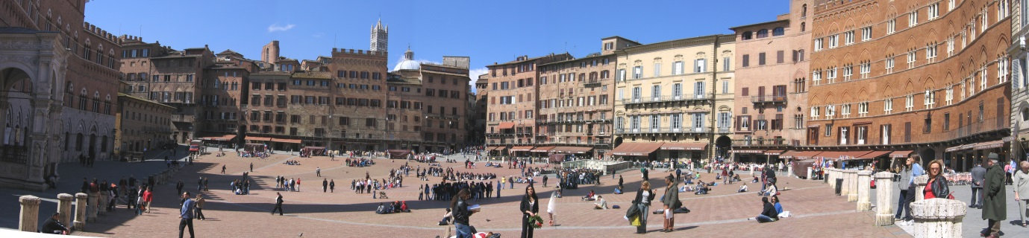

Siena Piazza del Campo: the slope to collect rainwater has proved incredibly popular as a seating device (Source: Wikipedia, @Scott Williams)

One might even push the argument to consider *public space as infrastructure* following the logic of considering it as the very essence of our cities. Particularly interesting from this point of view is the work of Jane Jacobs (1961) and her research on the streets of our cities.

On the other hand, infrastructure can nowadays be considered– and perhaps always could – public space, particularly transport systems of various nature and form.

The bus rapid transit system Transmilenio in Bogota, implemented by the mayor Enrique Penalosa, has become an inspirational precedent to support effective, affordable public transport in cities. It has managed to provide access to jobs located in the city centre to the low income population living in the periphery. An extensive network of cycling routes has contributed to the inner connectivity of the city enhancing the opportunity to improve the general health of the population.

Transmilenio and the vision of mayor Penalosa have become symbols for the city’s civic empowerment of its population and as such can be considered as public space in all regards.

In general public transport is undervalued as a form of public space. Too often stations, airports and termini are considered only from a functional point of view neglecting their potential role of place-making although more and more nowadays there are trends that contribute to change this approach.

Munich Airport has developed many activities and facilities to attract passengers and population of surrounding towns to its public realm to the point that it is becoming almost a town centre in its own right. On Sundays, when shops are closed in the city centre, numerous visitors are willing to spend time in the public spaces of the airport, also attracted by the numerous activities organised by the managing company – again public and private actors working together.

King’s Cross station or Liverpool Street in London cannot be considered only places of transit. They are indeed places of encounter with many activities contained within the stations that go beyond their original purpose.

In both cases it is that healthy mix between public and private, functional and redundant spaces that produces the vibrancy of the public realm.

*Accessibility and status*

Whilst in this paper it is advocated that not necessarily all the spaces have to be publicly owned and managed, it is also argued that a healthy component of the public realm of our cities *must be* purely public.

Going back to the objective of defining public space by defining its functions rather than its spatial appearance, it is not possible to overlook its value as that space where a multitude of urban agents can meet and engage mutually with no limitations other than those set by public law.

Unrestricted access to public space is a fundamental element that needs to be preserved. Paternoster Square is a square in the London city centre, next to one of the most prominent monument and symbols of the capital, St. Paul’s Cathedral. The square is privately owned and during the demonstrations of the Occupy movement was chosen by the movement as one of the symbols of the privatisation of public space. Tents were planted overnight and the square occupied. After confrontations between the demonstrators and the private owner of the square, the outcome, supported by legal recognition and therefore endorsed by the public authority, had been to remove the demonstrators and to close off the space to the public for a few days, producing a particularly representative turn into the debate upon whether occupiers had the right to stay or not.

This is part of a wider trend that has seen many public spaces in London and other cities globally become more and more privatised, process that caught the attention of the press too as, for instance, Vasagar (2012) explained on The Guardian and has become the focus of various reports - see Minton (2006) amongst others.

It is critical to guarantee ‘access and use of public open spaces […] as a first step toward civic empowerment and greater access to institutional and political spaces’ as recognised by the Human Settlement Indicator produced by UN Habitat in the presentation ‘Adequate Open Public Space in Cities’ held in New York City on the 25-26 February 2015.

What is public space then?

Starting from the spatial definition that so often has been the dominant assumption of urban planning theories, I tried to identify here the elements that define public space looking at the activities that take place in and the characteristics that are typical of public space in today’s cities.

Public space can be defined as an articulated and complex environment where individuals’ public and private selves co-exist and benefit from each other. It is often relevant as an outcome of pieces of infrastructure and able to combine mundane and pragmatic aspects of the urban fabric of our cities with more political and even poetic dimensions of our urbanity.

Today’s privatised, more introverted, individualistic and consumer-driven life-style can afford privately owned and managed ‘public’ spaces where trade and exchange are intertwined and serendipity, encounters and interactions can occur. Nonetheless, it is critical to maintain and preserve a certain quantum of space that is fully public, accessible to all, acting as a potential political platform and a ground for diversity.

**Can we afford public space then?**

In current planning systems, particularly in cities where land pressure is very high and other issues such as housing provision are taking their toll, the short answer is probably no, we cannot afford public space as we used to.

On the other hand, the various characteristics identified earlier on in this paper help to understand how cities would not be the same without a properly designed network of public spaces. Furthermore, strong competition amongst cities is often played out through the offer of public space of the highest quality.

In other words we *must* afford public space.

So the question is how we can afford public space.

*Public space is changing*

As we tried to analyse before, public space is changing and adapting to different economic and social trends. It is not anymore the single extensive area of green or square created and managed by the public authority but perhaps a multitude of smaller public spaces, possibly privatised, offering the choice and opportunity for consumption of goods and services.

Also, disruptive technological changes such as the internet and social networks create new forms and dimensions of public space. I am not going to analyse these here nonetheless it can be said that they are able to offer a diversified platform for socialisation that in a way is competing with public space as traditionally intended.

At the same time, access to information and exchange through the net is certainly becoming a sought after form of public space and yet another type of collaboration and synergy between public and private. The number of ‘hot-spots’ that are offered in bars and cafes at no cost is increasingly high and much appreciated by users around the world, particularly when travelling.

It has also played a major role in the development of recent political movement such as the Arab Spring although it is important to note that the modalities with which protests were mounting and have found their full expression were in public squares such as Tahrir Square in Cairo during the Egyptian revolution. Still, the squares themselves, often market places, have become symbols of political change offering a clear example of how public spaces are critical in defining the collective character of our cities.

The changes highlighted above are fully in line with the definition of public space attempted in earlier parts of this paper. A more fragmented, pragmatic and flexible network of generally smaller public spaces, often privatised and more introverted, acting as the *infrastructure of access* to the goods and services, other main larger public spaces or other forms of communications.

*Public space as infrastructure – a human right?*

In general, and looking at possible recommendations, considering public space as infrastructure of our cities is the most promising path to guarantee its affordability.

The Oxford dictionary defines infrastructure as ‘the basic physical and [organizational](http://www.oxforddictionaries.com/definition/english/organizational#organizational__2) structures and facilities (e.g. buildings, roads, power supplies) needed for the operation of a society or [enterprise](http://www.oxforddictionaries.com/definition/english/enterprise#enterprise__2): nothing in its semantic definition is in contrast with the public space as described earlier on.

In fact the assimilation of public space to infrastructure shifts its value towards the potential status of human right as some already hinted to.

“Public space is a human right” said UN Youth Envoy, Ahmad Alhendawi, “I believe that public space should follow three A’s—it must be available, accessible and acceptable.” These were his words during a side panel on “Harnessing the Potential of Public Space for Women and Youth” organized by UN Women, in collaboration with UN-Habitat, on September 18 2014 at the United Nations Headquarters.

Ms. Lakshmi Puri from UN Women added: “Affordable.”

Interesting from this point of view is the claim elaborated by David Harvey (2008) upon the right to the city and to compare the right to public space to the more extended notion he offers:

*The question of what kind of city we want cannot be divorced from that of what kind of social ties, relationship to nature, lifestyles, technologies and aesthetic values we desire. The right to the city is far more than the individual liberty to access urban resources: it is a right to change ourselves by changing the city. It is, moreover, a common rather than an individual right since this transformation inevitably depends upon the exercise of a collective power to reshape the processes of urbanization. The freedom to make and remake our cities and ourselves is, I want to argue, one of the most precious yet most neglected of our human rights.*

Public space and city infrastructure in general is of course dependent on a strong political vision and often coming from strong, democratically elected leadership to defend that vision, as some examples mentioned in this paper prove. Transmilenio in Bogota’ would not have happened without a decisive action by mayor Penalosa that cost him escorted life for quite some time. The Olympic Park in London has also been firmly in the vision of mayor Livingston before being delivered by his successor.

*Some recommendations*

From considering public space as a piece of infrastructure, and based on my experience as a practitioner, the following recommendations can be inferred:

1. A strong political vision is critical.
2. Either delivered by public or private entities or collaboration between them, provision of public space is absolutely critical to the very existence of our cities and the well-being of their citizens.
3. It should be planned strategically at very early stages of the city-making process and at various scales, including public space provision in regional and metropolitan structure plans and implementing it in more detail in local master plans. These should be used as a basis for any plan at a local scale and negotiations with private entities held by public authorities.
4. It should be planned in an integrated way, looking at the various social, physical and economic aspects and implications of the production of public space.
5. The value of carefully designed and located public space needs to be monetised in the wider context, not only from a ‘public goods’ point of view but taking into account all the positive benefits for all the stakeholders, footfall for retail for instance.
6. New ways of delivery need to be explored. Delivery of infrastructure systems in the last twenty years have been often based on Public Private Initiative schemes with mixed results.
7. A guaranteed minimum level of quality and quantity has to be defined by authorities through a consultation process that should be as inclusive as possible.
8. Stakeholder engagement strategies have to be pursued in order to trigger mechanisms of inclusion in the decision-making process. It is necessary to combine top-down (practice and expertise) and bottom-up approaches through the intensive use of collaborative workshops that can help listening to the various voices and draw effective conclusions for implementation.

**Conclusions**

The evolution of public space as a more fragmented, pragmatic modulated and flexible space of actions and interactions is offering opportunities for policy-makers, citizens and designers to understand these new trends and build cities that can support social cohesion and innovation.

Some critical points are here listed as fundamental elements for attention:

1. It is clear that – to an extent – a certain amount of privatised public space is acceptable. Much of today’s trade and exchange - and therefore encounter and communication - happen in privatised space – physical and virtual.
2. Public space is changing in quality, character and location. Transport systems for instance can be considered as public space but also technology offers new milieus to be considered as public space.
3. Only a strong political stance driving the production of public space in its various forms will generate a healthy urban environment.
4. Contemporary cities are all about the modulation, integration and individual CHOICE within some fundamental urban dichotomies - private vs public, mundane vs spiritual, fun vs functional, connected vs secluded - that is what the city is about.
5. The need to consider public space as part of the integrated infrastructure of our cities seems urgent and categories such as science, policy, practice and civil society should act in an integrated and innovative ways.
6. Embrace the less or non-ideological character of the public space – and probably our cities – and utilise more mundane opportunities such as infrastructure and trade places to provide a mature urban milieu of socialisation.

Public space must be afforded.

The conclusions and recommendations of this paper try to provide a framework to facilitate the identification of innovative ways to win the challenge.

REFERENCES

Coldwell, W. (2014, April 8) The Queen Elizabeth Olympic Park: a visitor's guide <http://www.theguardian.com/travel/2014/apr/08/queen-elizabeth-olympic-park-london>

Harvey, D. (2008). The right to the city. New Left Review 53, September-October 2008.

Jacobs, J. (1961). The death and life of Great American Cities. New York: Random House.

Minton, A. (2006). The privatisation of public space. Royal Institution of Chartered Surveyors.

Sennett, R. (2002). The fall of public man. London: Penguin Books.

Sennett, R. (2009) The Public realm.

Retrieved June 4, 2015, from <http://www.richardsennett.com/site/senn/templates/general2.aspx?pageid=16&cc=gb>

Tonnelat, S. (2010). The sociology of urban public spaces. In WANG Hongyang, SAVY Michel and ZHAI Guofang (eds.), Territorial Evolution and Planning Solution: Experiences from China and France, Paris, Atlantis Press, 2010, 1.

UN Habitat. Adequate Open Public Space in Cities - A Human Settlements Indicator for Monitoring the Post-2015 Sustainable Development Agenda. A Presentation of the UN Human Settlements Programme (UN Habitat) at the Expert Group Meeting on the Indicator framework for the post-2015 development agenda, New York City, 25-26 February 2015.

Vasagar, J. (2012, June 11). Public spaces in Britain's cities fall into private hands. Retrieved June 4, 2015, from The Guardian.

<http://www.theguardian.com/uk/2012/jun/11/granary-square-privately-owned-public-space>

<http://www.oxforddictionaries.com/definition/english/infrastructure>

UN Habitat (2014) Public space is a human right, says Youth Envoy

<http://www.un.org/youthenvoy/2014/09/public-space-human-right-says-youth-envoy/>