EPHEMERAL PUBLIC SPACES IN THE REINVENTION OF AFFECTION: THREE URBAN EXPERIENCES FROM BRAZIL

Janaina Teles Barbosa
Aveiro University- Portugal

Rui Miguel Ferreira Roda
UNISINOS University- Brazil and Aveiro University- Portugal

ABSTRACT
Brazilian cities are structured around a socio-spatial segregation that shows a strong prevalence of private spaces over public spaces. This situation creates a constant replacement of the meanings assigned to public spaces, which are turned into consumption spaces, stigmatized as risky and abandoned by the government. This paper approaches “emerging practices in design” aimed at designing sustainable cities in developing countries through the production of “utopian spaces”. These practices can be understood as living laboratories to generate social innovation. In this article it is presented the design projects developed by three Brazilian groups: “Muda”, in São Paulo; “Praias do Capibaribe”, in Recife; and “Opavivará”, in Rio de Janeiro. The data was collected during a field study though ethnographic participant observation and qualitative interviews with the project creators and citizens involved. Three aspects were analysed: participation, materialization and subjectivity. The aim of this study is to understand how these design practices can explore the feelings fostered by public urban spaces, as well, how they interfere more effectively in the city’s culture of participation. In this analysis, design is understood as a performative action that prioritizes both the social and the cultural dimensions of spaces and objects. In the closing remarks this study shows that these experiences have a character of micro practices empowering the actions of each individual involved in the collective body, finds effectiveness to arise the sense of community in the city. The grass-root nature of this approach could be seen as an obstacle for its use on a wider scale, but the efficiency of these actions in promoting deep social changes should encourage public and private urban institutions to implement policies that enhance their development.

1. INTRODUCTION
According to a recent UN report, 80% of Latin America's population lives in cities, and it is expected that the rate of urbanization in most countries will reach 90% by 2020 (UN-Habitat, 2012). This disordered growth brings great challenges for the management of cities and their sustainability. Population growth reveals itself in urban spaces through strong contrasts. In Brazil, the slums (“favelas”) and their lack of structure live side-by-side with luxury gated communities and high level technology. The scarce public spaces are found between these contrasting realities and they are often stigmatized as dangerous or replaced by semi-private consumption spaces.
The integration of people in the urban design and management process is crucial to allow finding solutions that can adjust themselves to their needs. Besides functionality people’s emotional relationships with the spaces are important for changes in the urban environment. When people are not involved in the planning process of the area where they live they do not develop emotional relationships with the spaces, which consequently turn into passageways without an identity and subject to vandalism. Fifteen years ago, Brazil created a set of measures that allowed more openness for the participation in urban design decisions. However, they are still associated with traditional participation tools that prevent a real empowerment of individuals, who are still subject to the decisions made by the political power.
Over the last two decades, we have been witnessing the emergence of collective and autonomous initiatives that strive for a recovery of public spaces based on simple and low-cost projects. In this paper we shall call these projects “emerging design practices” that can be seen as autonomous design practices that develop functional alternatives on a local scale and can also be considered as urban laboratories that suggest opportunities for a more strategic use of design. The aim of these practices is to bring changes in habits, awakening the individual’s responsibility in the collective transformation of the city through the creation of “utopian spaces”. These “utopian spaces” are temporary spaces that lead people to develop different relationships with the city. Through the creation and use of these spaces, people imagine other scenarios, which may be utopian at the time, yet possible in the future. In the Brazilian cities, these spontaneous design practices have many different shapes and expressions, some with a more artistic and temporary character, others with a more communal and resilient nature.
The analysis of these experiments has been developed by research in design through transdisciplinary approaches that open possibilities to encompass the complexity of the contemporary urban space. Design has been lead towards this issue in order to find solutions based on processes that move people, even temporarily, without an emphasis on the final product. Within this scope, design is focused on developing procedural interventions in the city, rather than on creating durable objects. These experiments are seen by Manzini (2008) as “systemic discontinuities”, which provide micro changes on a local scale. According to the author, before reaching a macro way towards a sustainable society, it is important to concentrate efforts in the many existing “local discontinuities”.
Through an approach focused on urban design plans, Kristine Samson (2012) develops an understanding of these practices as “performative actions”. As a temporary performance, design allows a procedural understanding of urban planning, which deals with the material, as well as with the immaterial aspects of space, such as the emotional relationships between people and the space that is going to be designed or transformed. This model of understanding allows urban planners to reach a deeper understanding of specific contexts, seeing both their limits and their potential.
“Emerging design practices” can be understood within the scope of design activism. Ann Thorpe (2012) provides a categorization of activist practices in design, which she identified when using unconventional methods in order to bring changes on behalf of an excluded group. Fuad-Luke (2009) presents a vision that is more focused on products, understanding activist design as design processes that give voice to new possibilities for social, institutional, environmental and/or economic changes. These two studies allow us to understand these practices better, both from a point of view that is placed outside design (social movements and autonomous practices), and from a re-direction of traditional design methods. However, in both cases, we can see design’s crucial responsibility in the solution of different social problems.
This research is approaching on the notion of design activism associated with an aesthetic action that stands on the edge of the artistic and design fields. Within this scope, Thomas Markussen (2013) defined design activism as being connected to the notion of "disruptive aesthetics", which includes projects that affect the urban space and cause different social interactions and behavioral changes. The theoretical framework developed by the author helps us to understand how design activism works and what its effects are on people’s everyday life; however, it still deals with design as a product created by someone who can interfere in the everyday life of a given public space. This approach does not deal with the co-creation aspects of design activism.
These researches allow a conceptual understanding of these practices, but they are focused on European and North-American contexts. In developing countries, such as Brazil, these experiments entail other singularities that are worth studying in a more detailed way. While in the two former contexts there is the need to create different types of public spaces, in Brazil there are more basic structural challenges, such as the lack of public spaces. Public investment is still based on conventional means and the steps taken to produce these spaces are slow. On the other hand, “emerging design practices” take on an even more activist nature in devising, occupying and creating living spaces, thus unveiling new ways to manage the city.
In addition to context-related issues that involve economic and political factors, there is a lack of culture of participation among most of the Brazilian population, which is accommodated, both to the abundance and to the lack of public spaces. This is the spatial dimension we want to deal with in this exploratory paper. How can design interfere more effectively in the city’s culture of participation? How can design create tools that foster an emotional relationship between people and the city’s public spaces?
In order to discuss these possibilities, this paper introduces a preliminary reflection on “emerging design practices” in public spaces based on three Brazilian projects: “Bolha Imobiliária”, in São Paulo, “Piscina flutuante”, in Recife, and “Cozinha coletiva”, in Rio de Janeiro. This paper is divided in three parts: General study design; Emerging design practices (description of the case studies); Finding and discussions, and the Final remarks. In the topic finding and discussions are analyzed three aspects of the initiatives: participation, materialization and subjectivity.

2. STUDY DESIGN
The data was collected through fieldwork developed in three Brazilian cities - São Paulo, Recife and Rio de Janeiro - during three weeks in October 2014. These three cities have strong social, economic and cultural dynamism, representing two different regions of the country. The data was collected in the fieldwork though ethnographic participant observation and qualitative interviews with the 7 project creators and with 15 citizens involved in one of the projects as participants. The photos used in this paper were provided by the archives of the projects. The selection of these specific projects has to do with the fact that their design practices are based in artistic methods and does not target the conventional market; they are promoted on a small-scale, involving social movements and networks of creative communities by developing partnerships with public and private institutions. A diagram was used to characterize the different stages of each project taking into account for instance qualitative aspects such as personal motivation, social engagement tactics and effects on people's daily lives.

3. “EMERGING DESIGN PRACTICES”
3.1. Bolha imobiliária- São Paulo
The design project of “Bolha imobiliária” (literally, housing bubble) was created in 2013 by “Muda” group, which are composed of three architecture students aged between 20 and 25. The group moved on to practice through temporary low-cost projects that allowed experiencing the city in a more playful and creative way. The project was developed in a very spontaneous and intuitive way and built over two days in an informal workshop. Everything was made voluntarily in collaboration with an association of recyclable material collectors and with an informal boxing academy built with materials found in dumps located on the city’s outskirts. The object was inflated for the first time on the great viaduct located in the city centre (Fig. 1), which was built very close to a series of apartment buildings causing high levels of noise and air pollution. Every Sunday, the viaduct is closed to traffic by the municipality and occupied by people who take part in artistic events and performances. The object was inflated also in various public spaces that were not usable due to the lack of green areas and urban furniture.

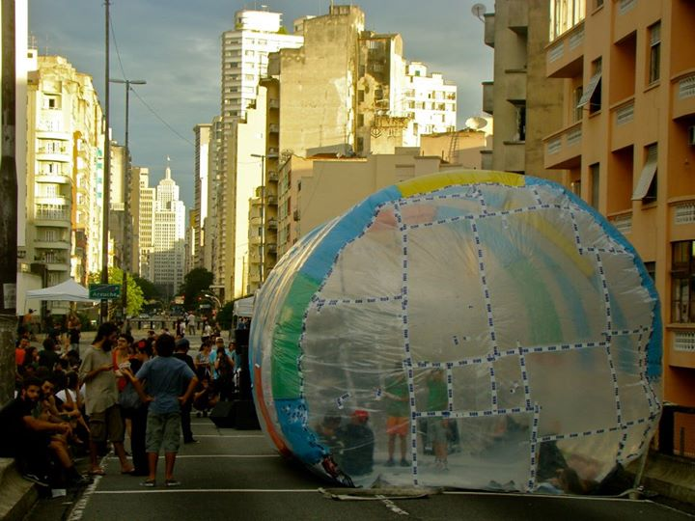
Figure 1: Housing bubble inflated in Minhocão bridge in Preliminary Arts Festival in São Paulo. Photo by “Muda” group.

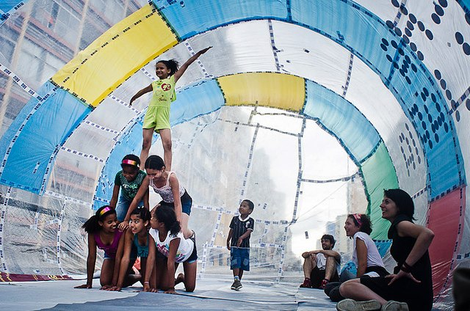
Figure 2: Children occupied the inflatable object in São Paulo. Photo by “Muda” group.

3.2. Piscina flutuante in Recife
The design project “Piscina flutuante” (literally, floating pool) was one of the interventions developed by the "Praias do Capibaribe" group, composed by around six young people from different backgrounds aged between 20 and 30. The group has been active since 2010 and is focused on performing temporary occupations along the banks of the Capibaribe river, which crosses most of the city of Recife and whose water is not suitable for human use. The interventions always took place on the first Sunday of each month and are aimed at inviting the residents to see the river as part of their lives, as a place of leisure, contemplation and mobility. The floating pool (Fig. 4 and 5) was built over ten days in 2014 and promoted intense interactions between nearly 20 people. The group developed the idea of the collective construction of temporary prototypes with the goal of triggering sensory experiences and testing the real possibilities offered by the river. In addition to the pool, the work resulted in the construction of a social area, a pool and a kitchen. All the resources were obtained through informal partnerships and voluntary work.

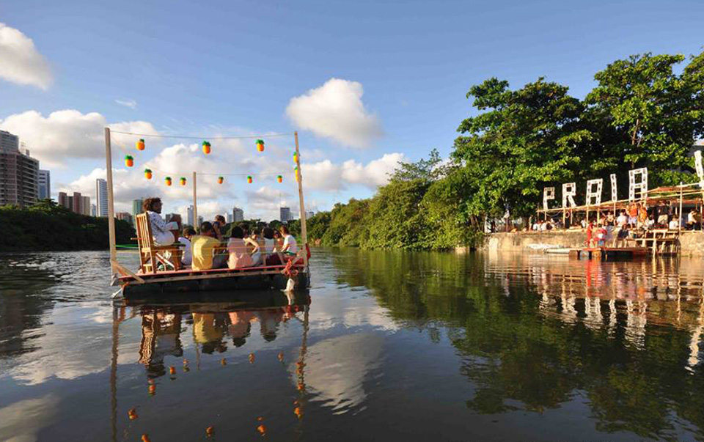
Figure 4: Floating living area collectively built on temporary intervention in Recife. Photo by “Praias do Capibaribe” group.

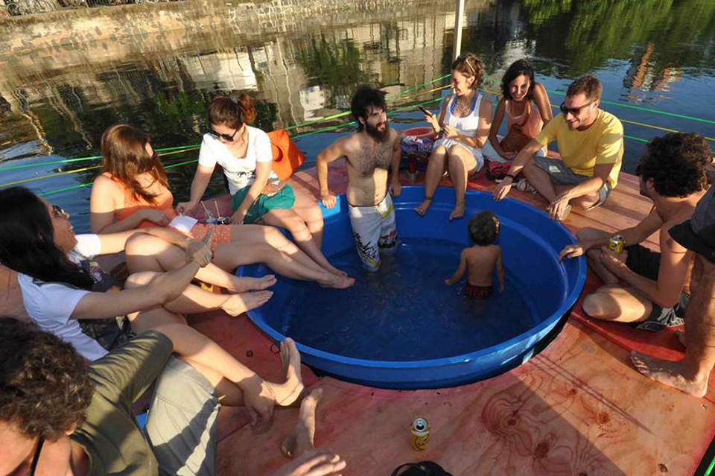
Fugure 5: Floating pool on the urban river in Recife. Photo by “Praias do Capibaribe” group.

3.3. Cozinha coletiva_ Rio de Janeiro
The design project “Cozinha coletiva” (literally, collective kitchen) was developed by the “Opavivará” group, composed on four members from different backgrounds aged between 25 and 35. The project involved assembling and using a kitchen on a public square for two months in 2012. The project was funded by the municipality through an incentive program for artistic interventions in public spaces. The kitchen had drinking fountains, sinks for washing dishes and food, a wooden oven and stove, tables, benches and beach chairs (Fig. 5). The space had also a mural for posting the activity schedule, and a weekly newspaper to record and describe the activities that had taken place. Temporarily, the group placed elements from the private, domestic atmosphere out on the public streets. This temporary kitchen built on a public square led different types of people, such as passersby, workers, tourists, researchers, students, garbage collectors, homeless people, prostitutes, residents, artists, etc. to meet each other. Around the table and while preparing food, these people shared their stories for a few moments (Fig. 6). The intervention managed to activate functions that had already been devised for that kind of public space, such as the interaction between people, relax, contemplation and leisure.

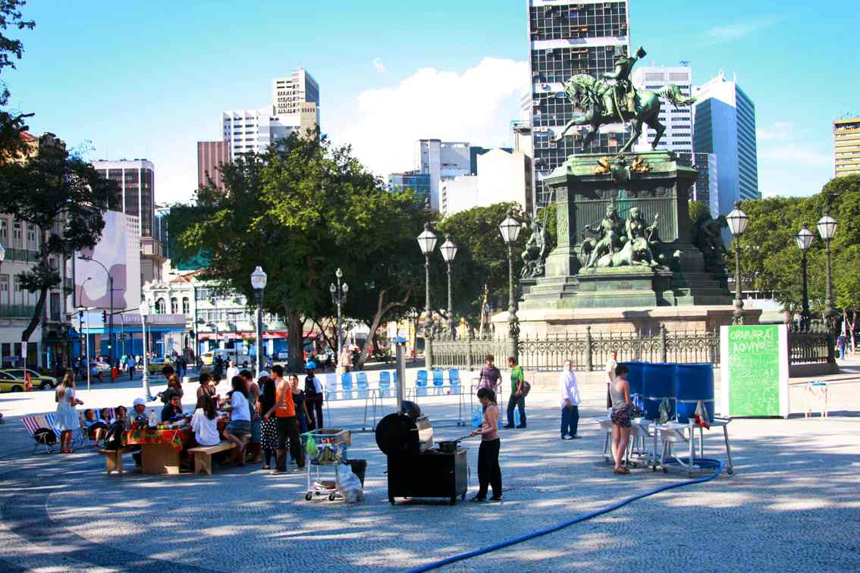
Figure 5: Collective kitchen in Tiradentes public square in Rio de Janeiro. Photo by “Opavivará” group.
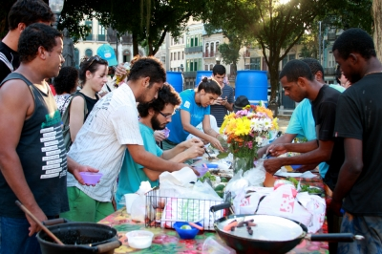
Figure 6: Collective meal in Tiradentes public square in Rio de Janeiro. Photo by “Opavivará” group.

4. FINDINGS AND DISCUSSION
In order to facilitate communication the three design projects were called project 1, 2 and 3 (Table 1). As "emerging design practices" in the Brazilian context the three initiatives propose three temporary strategies of activation and creation of public spaces. The project 1 proposed the production of a playful urban place built with reused materials. The project 2 was conducted through intensive workshops through the production of experimental prototypes for public use of in a urban river. The project 3 was carried out by bringing to the street a temporary kitchen constructed in an underutilized public space. On the Table 1 the characteristics of the three experiences are described in detail for a better comprehension of the three design projects.

Project | (1) Bolha Imobiliária  (housing bubble) | (2) Piscina flutuante  (floating pool) | (3) Cozinha coletiva  (collective kitchen)
Group | Muda | Praias do Capibaribe | Opavivará
City | São Paulo | Recife | Rio de Janeiro
Problem | Real estate speculation. | Pollution of the urban river. | Public square stigmatized as a dangerous place.
Motivation | “..we were tired of urban projects that are not put into practice...” | “..we wanted to bathe in the Capibaribe river...” | “...we wanted to feel the street as my home...”
Solution | Build a temporary social gathering atmosphere. | Create a temporary social interaction atmosphere on the river. | Create a domestic atmosphere on a public square.
What is it? | Inflatable object | Floating pool | Kitchen on a public square
Audience | Low income community and participants in the viaduct event. | People who took part in the workshop and residents. | Passersby, artists, workers, residents, other users.
Goal | Making people aware of the problem. | Test the possibilities that the river may offer to the people. | Temporarily activate a public square.
Materials | Plastic bags used in analog ventilation equipment. | Recycled wood and large-size garbage containers. | Drinking fountains, sinks for washing dishes and food, wooden stove and oven, tables and benches, beach chairs and an information mural.
Production | In collaboration with the recycled material collectors community. | During an intensive workshop with university students. | By the group.
Funding | Collaborative | Public + Collaborative | Public + Collaborative
Effects | Visual impact on the urban space, occupation made predominantly by children, temporary social interaction. | Visual impact on the urban space, sensory experiences related to the use of the urban river, emotional relationship between the people and the river. | Social interaction between the people who were using the square through the act of cooking and eating.
Table 1: Detailed description of the three design experiments in the three Brazilian cities.
The described initiatives emerged from complex problems in large cities in Brazil. The solution for these problems can´t be found in a short term because it involves political, economic and cultural factors. The motivations of the three projects came from the discomfort of people transmitted through their feeling of inability to provide solutions as common citizens. The inflatable object, the floating pool or the collective kitchen do not intend to be definitive solutions to these complex problems, but aim to present themselves as social strategies for participation to build another city. In addition to the visual impact, the interventions provoke new sensory experiences in participating individuals, which can influence the reconstruction of the sense of community in the city. The parameters presented on the Table 1 will be analyzed in the next items taking into account three aspects developed by the design process: participation, materialization, subjectivity. These three aspects help to clarify the steps taken in the three initiatives in which the peoples’ participation is closely related to the production of subjectivity of urban spaces. The materialization in this process is nothing more than a way for the two other processes to be made possible.

4.1. Participation
During the participatory process we realized that the project creators were proposing a dynamic approach that allowed the constant involvement of co-creators. The participation process related to the collective process of construction of the “utopian spaces”, involves the following stages (Figure. 7):
1. Wishing: Motivated by a problem that they are involved, a small group of people wishes to transform an urban space;
2. Sharing: This group mobilizes more people to think about simple and cheap solutions;
3. Imagining: The group grows and collectively idealizes a temporary project;
4. Experimenting: The group creates temporary spaces that are collectively tested.

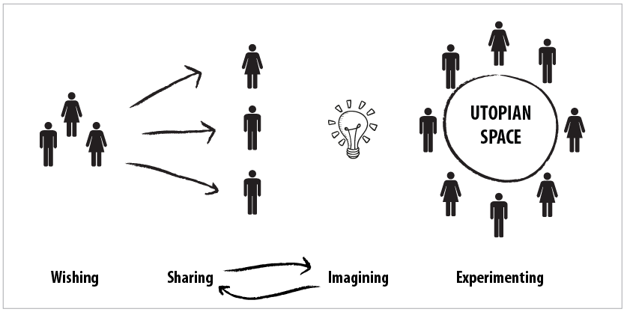
Figure 7: Stages of participation involves the production of a "utopian space".

The visualization presented on Figure 7 aims to better understand the process of participation in the production of "utopian spaces" in the three studied experiences. The steps sharing and imagining have no definitive order, coming before or after the sequence, or even both dialoguing during the production process. Marcela, one of the members of the creative group of project 1 (Table 1) mentioned "the participation was held in a very spontaneous way, we had the idea and shared it to friends through social networks and in informal ways. We intended to discuss collaboratively how we would make the project viable". In this case, the idea came before, but the creative process of construction of the object was shared collectively. The same observation can be applied to the project 2 (Table 1). According to Julien, one of the creators, "the roles of the people involved were not pre-established in the project because the potential of each one has been being discovered during the process." In project 3 (Table 1), the group creates a situation to facilitate the participation of different people through food preparation and collective meals.
It is understood in design field that this participation process is directed to producing a more active citizenship. The three analyzed “emerging design practices” present themselves as simple actions that invite the citizens to take part of the creation of the city. The satisfaction of the involved people in these processes is not related to a desire for consumption, but associated to their participation in a collective action towards a common good. According to the situationist “dérive” (Debord, 2004) these three projects allow experimenting and acting on the real city, even if only temporarily. Design gained an activist role, working as a “performative act” (Samson, 2012), acting on the limits between aesthetics and politics (Markussen, 2013). The aesthetic approach related to design processes includes projects such as those presented in this article evoking the power that each individual involved in a social collective. These aesthetics did not aim at overthrowing the institutional power, but rather to create trading channels, giving rise to new processes of participation and identities. In this context, aesthetics is recognized as a “poietic” activity (Carlsson, 2012). So far, the process of idealization and production of these shapes involves the active participation of individuals in the generation of meanings.
4.2. Materialization
On the three studied "emerging design practice" processes what is the most important is not to achieve a final product as an object or a space designed conventionally. What matters in these projects are the experiences of every individual in their relationship with the collective. The “emerging design practices” are based on diffuse knowledge and individual motivations aimed for the common good. They are experimental and collaborative practices whose starting points are the experiences lived by people and materialized by them. The stages of the materialization are focused on “empathy” which is the first stage of a conventional design project development (Hasso Plattner Institute of Design, 2015). Empathy is the foundation of a design process focused on the human being that involves observation, involvement and experiments. “Utopian spaces” work as catalysts for this process, involving the other parts in an integrated way (Figure. 8).
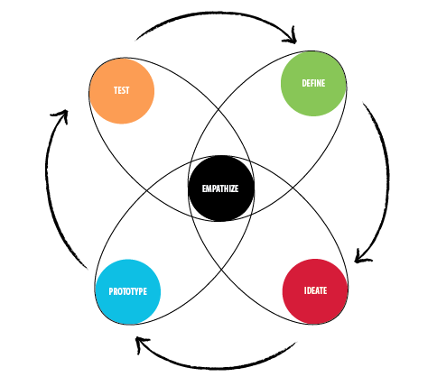
Figure 8: Phases of design process in emerging practices.
The “materialization” is the stage of “experimentation” in the three projects. These processes allow creating new meanings between the people involved in the experiments and the interfered spaces. The materialization plays an important role in the realization of a collective will, temporarily involving the construction of new intervention artifacts, the new use of industrialized materials and the creation of new collective situations. The support of the three initiatives involves collaborative temporary funding along with partnerships with public institutions and restricted to the artistic field, besides voluntary work (Table 1). This situation reveals a weakness of these projects as they do not allow a necessary sustainability to develop longer and comprehensive interventions in public spaces.

4.3. Subjectivity
This topic is linked with the effectiveness of the studied initiatives. These design processes allow creating new meanings between the people involved in the experiments and the interfered spaces. Thus, the effects are related with the perceptual dimension of people with various forms of inhabiting the city. From this point of view, the aesthetic of the “utopian spaces” is based on human relationships, presenting the potential to interfere in the relational sphere (Bourriad, 1998). The utopia of a new city integrated in the collective imagination is related to the production processes of subjectivities. The subjective relationships between the individual and the world are closely connected to the socially-built collective imagination, based on norms and rules that allow accommodating the social order. In this context, the analyzed spaces aim to develop new “micro-political” and “micro-social” practices that tend to modify and reinvent ways of being amidst couples, families, urban context, work contexts, etc (Gatarri’s, 2000).

5. FINAL REMARKS
This work focuses on the specificity and the role of “emerging design practices” in the production of “utopian spaces” in the Brazilian context based on field data collected in three large cities. We analyzed three relevant aspects for an understanding of these practices: participation, materialization and subjectivity. The “participation” is related to the creation of situations, which revealed that the active participation of individuals in the promoted actions is closely connected to real urban experiments. In “materialization” it is observed that the analyzed practices are focused on “empathy”. Finally, the “subjectivity” is related to the effects of these new practices which cause a mental impact on the city in terms of the social behavioral change process.
This research shows that these experiences have a character of micro-practices empowering citizens to claim for alternative and resilient cities. Considering the complexity of the urban environments in the Brazilian context, the presented practices rebuild emotional ties between people and public spaces. However, these experiences were still observed in a small scale not involving the diversity of the urban community. Thus, there is a risk for these initiatives to be exposed to the economy that can use it for private benefits through for instance "green washing" strategies in their invisible market interests. The improvement of these creative methods can result in future design tools with a potential to multiple effects towards more solid and resilient experiences in a local scale, involving a larger diversity of citizens. In a further scenario these practices can also be integrated in official programs creating a new bridge between citizens, urban planners and policy makers.
ACKNOWLEDGEMENTS
This research was funded by the Coordenação de Aperfeiçoamento de Pessoal de Nível Superior (Capes), fundação do Ministério da Educação (MEC)- Brazil.
REFERENCES
Bourriad, N. (1998). Relational Aesthetic. Paris, FR: Les Presses du reel.
Carlsson, A. (2010). The Aesthetic and the Poietic Elements of Information Design Information. Paper presented at Visualisation (IV), 2010 14th International Conference (pp. 450-454). Retrieved from http://ieeexplore.ieee.org/xpl/login.jsp?tp=&arnumber=5571189&url=http%3A%2F%2Fieeexplore.ieee.org%2Fxpls%2Fabs_all.jsp%3Farnumber%3D5571189
Fuad-luke, A. (2009). Design Activism: Beautiful Strangeness for a Sustainable World. London, EN: Earthscan
Hasso Plattner Institute of Design, Stanford University, d.school: “Bootcamp Bootleg”. Retrieved from http://dschool.stanford.edu/use-our-methods/>, 07.03.2015
Guattari, F. (2000). The Three Ecologies (translated by I. Pindar and P. Sutton). London, EN: Athlone Press.
Debord G. Debord and the Situationist International. Text and Documents. 2002-2004. Ed. Mc.Donough. Cambridge, EN: MIT Press.
Manzini, E. (2008). Design para inovação social e sustentabilidade. Comunidades criativas, organizações colaborativas e novas redes projetuais. Rio de Janeiro, BR: UFRJ.
Markussen, T. (2013). The Disruptive Aesthetics of Design Activism: Enacting Design Between Art and Politics, in Design Issues, 29 (1).
ONU-Habitat. Naciones Unidas. (2002). Estado de las Ciudades de América Latina y el Caribe, Rumbo a Una Nueva Transición Urbana. Programa de las Naciones Unidas para los Asentamientos Humanos. Retrieved from http://estaticog1.globo.com/2012/08/21/Estado-de-las-Ciudades-de-America-Latina-y-el-Caribe-2012.pdf
Samson, K. (2010). From master planning to processual strategies. In Kiib H. (Eds.), Performative Urban Design (pp. 217-227). Aalborg, DK: Aalborg University Press.
Thorpe, A. (2012). Architecture & Design versus Consumerism. How design activism confronts growth. New York, NY: Earthscan.

