CEPT University
Contribution of Street Vendor in making Streets 'Public'
Prithvi Deore | Saumya Lathia
Data collection : Prithvi Deore, Saumya Lathia, Anjali Chaudhari, Vaidehi Gohil

Abstract
It is believed that places create memory and nothing is more memorable than the vibrancy of busy streets or the peace at a park bench or the excitement of bumping into someone at a public square. Public spaces leave an impact on every individual knowingly or unknowingly. Public places ideally in any urban fabric, are the true reflection of the diversity the fabric holds and thus act as “the heart” of that fabric.
It is said that streets among all, are the most public! Streets since history have held huge importance and have always been the activity generators of any place. Streets have always served as social hubs and have been great platforms of interaction, exchange and social inclusion. Thus streets have been engines of economic activities and prosperity. Today, in almost all Indian cities, the glory of the streets is diluting day by day due to the dominance of vehicular movements.
The street vendors make the streets more vibrant by increasing activities, safer through ensuring inflow of people and inclusive in its true sense by allowing people from different backgrounds to participate in the exchange of goods and services. Vendors respond to different type of streets in different ways through density of vendors, time and duration of operation and service provided. The study attempts to highlight these patterns and understand their relation with the streets in the city of Ahmedabad which is the fourth largest population of vendors in India and a culture that celebrates coming together as communities. Thus, public spaces become a necessity here. The study tries to bring out various interactions that these vendors have with the streets and the land use around and how does that contribute in making our streets as more equitable and pleasant public spaces.

Contents
Abstract 1
Introduction 4
Streets and Street Vendors - their relationship with different types of streets 5
Cluster, streets, market v/s street types 6
Mobile stationery v/s street type 8
Vendors v/s Sidewalks 8
Vendors v/s Trees 10
Area covered by vendors v/s streets 10
Land use cases 13
Residential- a neighborhood in Sabarmati Ward 13
Brief introduction: 13
Basic demography: 13
Relationship with land use: 14
Commercial- C.G. Road 15
Basic demography: 15
Relationship with land use: 16
Institutional- Street along CEPT University 17
Basic demography: 17
Relationship with land use: 18
Recreational – A neighbourhood park in Vasna 19
Basic demography: 19
Relationship with land use: 20
Exception – Street Markets of Law Garden 21
Basic demography: 21
Relationship with land use: 22
Conclusion 23
Bibliography 23

Map 1: West Zone 5
Map 3: Clusters and Street Market 7
Map 2: Mobile and Stationary Vendors 9
Map 4: Street vendors in Sabarmati neighbourhood 13
Map 5: Street vendors in commercial area-CG Road 15
Map 6: Street vendors in Institutional Zone - CEPT University 17
Map 7: Street vendors around a neighbourhood park 19
Map 8: Street market of Law Garden 21

Table 1: Length and % of Street 5
Table 2 : Number of Street Vendors 5
Table 3: No. of vendors-clusters, street markets, plot markets 6
Table 4: No. of Mobile and Stationary Street vendors 8
Table 5: Sidewalk percentage coverage 8
Table 6: No. of vendors v/s Sidewalk 8
Table 7: Relation between trees and vendors 10

Figure 1: Local street section 10
Figure 2: Collector Street section 11
Figure 3: Sub arterial street section 11
Figure 4: Arterial Street section 12
Figure 5: Street vendors at street junction 14
Figure 6: Street vendor in low income group area 14
Figure 7: Small scale shops of street vendors serving all employees 16
Figure 8: Food vans serving shoppers and students Figure 9: Vehicular street transformed to market 18
Figure 11: High influx of people 20
Figure 10: Edge of gated park transformed 20
Figure 13: Woman selling traditional wear Figure 12: Street market at night 22

Introduction
“Public space is all around us, a vital part of everyday urban life: the streets we pass through on the way to school or work, the places where children play, or where we encounter nature and wildlife; the local parks in which we enjoy sports, walk the dog and sit at lunchtime; or simply somewhere quiet to get away for a moment from the bustle of a busy daily life.” Public places ideally in any urban fabric, are the true reflection of the diversity the fabric holds and thus act as “the heart” of that fabric. Public spaces leave a huge impact in every individual’s as well as every society’s way and quality of life. Thus good public spaces become a cultural, social, environmental and economical necessity for any society to offer a better quality of life.
Since history, streets have been the most “public” of all as they have always served as social hubs and have been great platforms of interaction, exchange and social inclusion. Streets are places where our socio-economic divides dilute and the feeling of being “citizens” strengthens. In India, streets always have held great importance in the lifestyle of people. From the celebration of India winning the cricket match, to playing cricket, from enjoying shopping to celebrating weddings (during precession), from eating and socializing to living, all our activities take place on our streets. Our culture celebrates the spirit of coming on to the streets for almost everything!
Since the street markets play an important role in adding more color and enthusiasm to this spirit, all our cities are incomplete without them. Thus their presence is usually very also associated to the identity of the city itself like the Sarojini market in Delhi, Manek Chowk or “Ravivaari” in Ahmedabad . Ahmedabad in particular has a strong culture of street markets consisting of a wide variety of goods/ items sold. From traditional clothes at Law garden, to beautiful flowers in Jamalpur, to jewellery in Rani No Hajiro, contemporary clothes at Nehrunagar to lots of “khaugallis” the city is full of opportunities and options for lively and pleasant public spaces and even an alternate “nightlife”.
The West zone is taken as the site for the street and street vendors study. It is chosen based on the lack of studies available on the newer development of the city where vending is contemporary in nature and is very different from traditional vending. This Zone was hence taken to study the trends related to the streets which are predominantly focusing on vehicular movement yet play an important role as public space. This is further studied and understood by taking distinct cases of different typologies of vendor agglomeration. Apart from this, case studies of markets are taken to understand the relation between land use, street vendors and influx of people.
The research started with extensive literature study to understand the scenario of the city and street vending in the city and India. The whole zone was surveyed wherein the vendors were marked on the locations and their type - mobile or stationary, items sold, etc. These were marked in GIS and spatially analysed in relation with the street network of the zone. The markets were surveyed where all the vendors were marked and observed all along the days in four time slots. The influx of people were counted and then analysed based on gender, age and income groups. Land use was noted through observation, previous studies done by the University students as well as the Development Plan of the city.

Streets and Street Vendors - their relationship with different types of streets
There are different types of streets in the West zone of the city. Each street type performs specific function.
- Arterial - wide streets focusing on fast vehicular movement connecting one important part of the city to other.
- Sub arterial - wide streets with fast vehicular movement serving the immediate land use and as feeders to the arterial street
- Collector - streets serving the neighbourhood areas, small commercial areas, etc and as feeders to the sub arterial
- Local - Streets serving the residential neighbourhoods and its surroundings.
These streets are modes for transit and space for the street vendors where they interact with the people. The following results are drawn to understand the relation between the street type and density of vendors.
Map 1: West Zone
 | Arterial | Sub-Arterial | Collector | Local
Length of street (in km) | 43 | 79 | 68 | 153
%age of total length | 12% | 23% | 20% | 45%
Table 1: Length and % of Street
 | Arterial | Sub-arterial | Collector | Local
No. of Vendors | 332 | 772 | 1211 | 1036
Table 2 : Number of Street Vendors
In the West Zone, the road distribution according to the length is as shown in the table. The maximum is 45% of locals-which are of varying quality connecting the neighbourhoods within as well as with collector roads and the surrounding areas. The minimum is 12% of arterial roads which connect various parts of city to each other. These major are mostly part of the rings of the city's street network. We see maximum vendors on Collector roads which form only 20% of the street length. This is because of comparatively higher pedestrian accessibility leading to better contact with customers using the streets. These streets are usually narrow and have slower pace of vehicular movement making movement of pedestrian as well as vendors easier on streets.
Similar to collector streets, local street provide lesser vehicular movement but these streets too have lesser number of pedestrian movement over the time of the day. For example, these streets are only used by the residents hence making the customers base for vendors lesser. Therefore, we observe that though the number of vendors are high but the ratio of vendors to street is lowest. Also, it is important to note that sub-arterial streets have lesser vendors as compared to collectors mostly due to the policies which have allocated these streets under 'model roads' preventing vendors to do their business on them.

Cluster, streets, market v/s street types

No. of Vendors | Arterial | Sub-arterial | Collector | Local
Individuals/cluster | 249 | 569 | 640 | 625
Street markets | 83 | 168 | 378 | 346
Markets | 0 | 35 | 193 | 65
Total | 332 | 772 | 1211 | 1036
Table 3: No. of vendors-clusters, street markets, plot markets
- Cluster, Street market, markets :-
We see that highest number of street vendors as clusters are in collectors and local. The junctions usually have these kind of clusters. They serve the immediate surrounding areas and hence also have that kind of commodities like tea, tailor, pan, pasti, snacks, etc.
Maximum vendors are through clusters on street then street markets then space markets.: Maximum vendors are in clusters contributing much more to the streets. These have lower density of vendors as compared to the street markets and the space markets. Followed by these are the street markets which have higher contribution to the streets because of the high density. Also, these markets usually serve larger areas. These tend to form city level markets where vendors as well as customers come from different parts of the city.
It is important to note that the street vendors ensure that the services are available to all. The vendors are spread across at various places- from low income group areas to high income group areas.
Also, as discussed above, most of the vendors tend to locate near the junctions. The street vendors by attracting people (and locating near the places where market is available) make streets especially junctions livelier and public.
Also it is important to note that the site taken is not the oldest part of the city. This site shows different characteristics from the traditional vending. Traditional vending are mostly stationary, and located in form of historical markets.

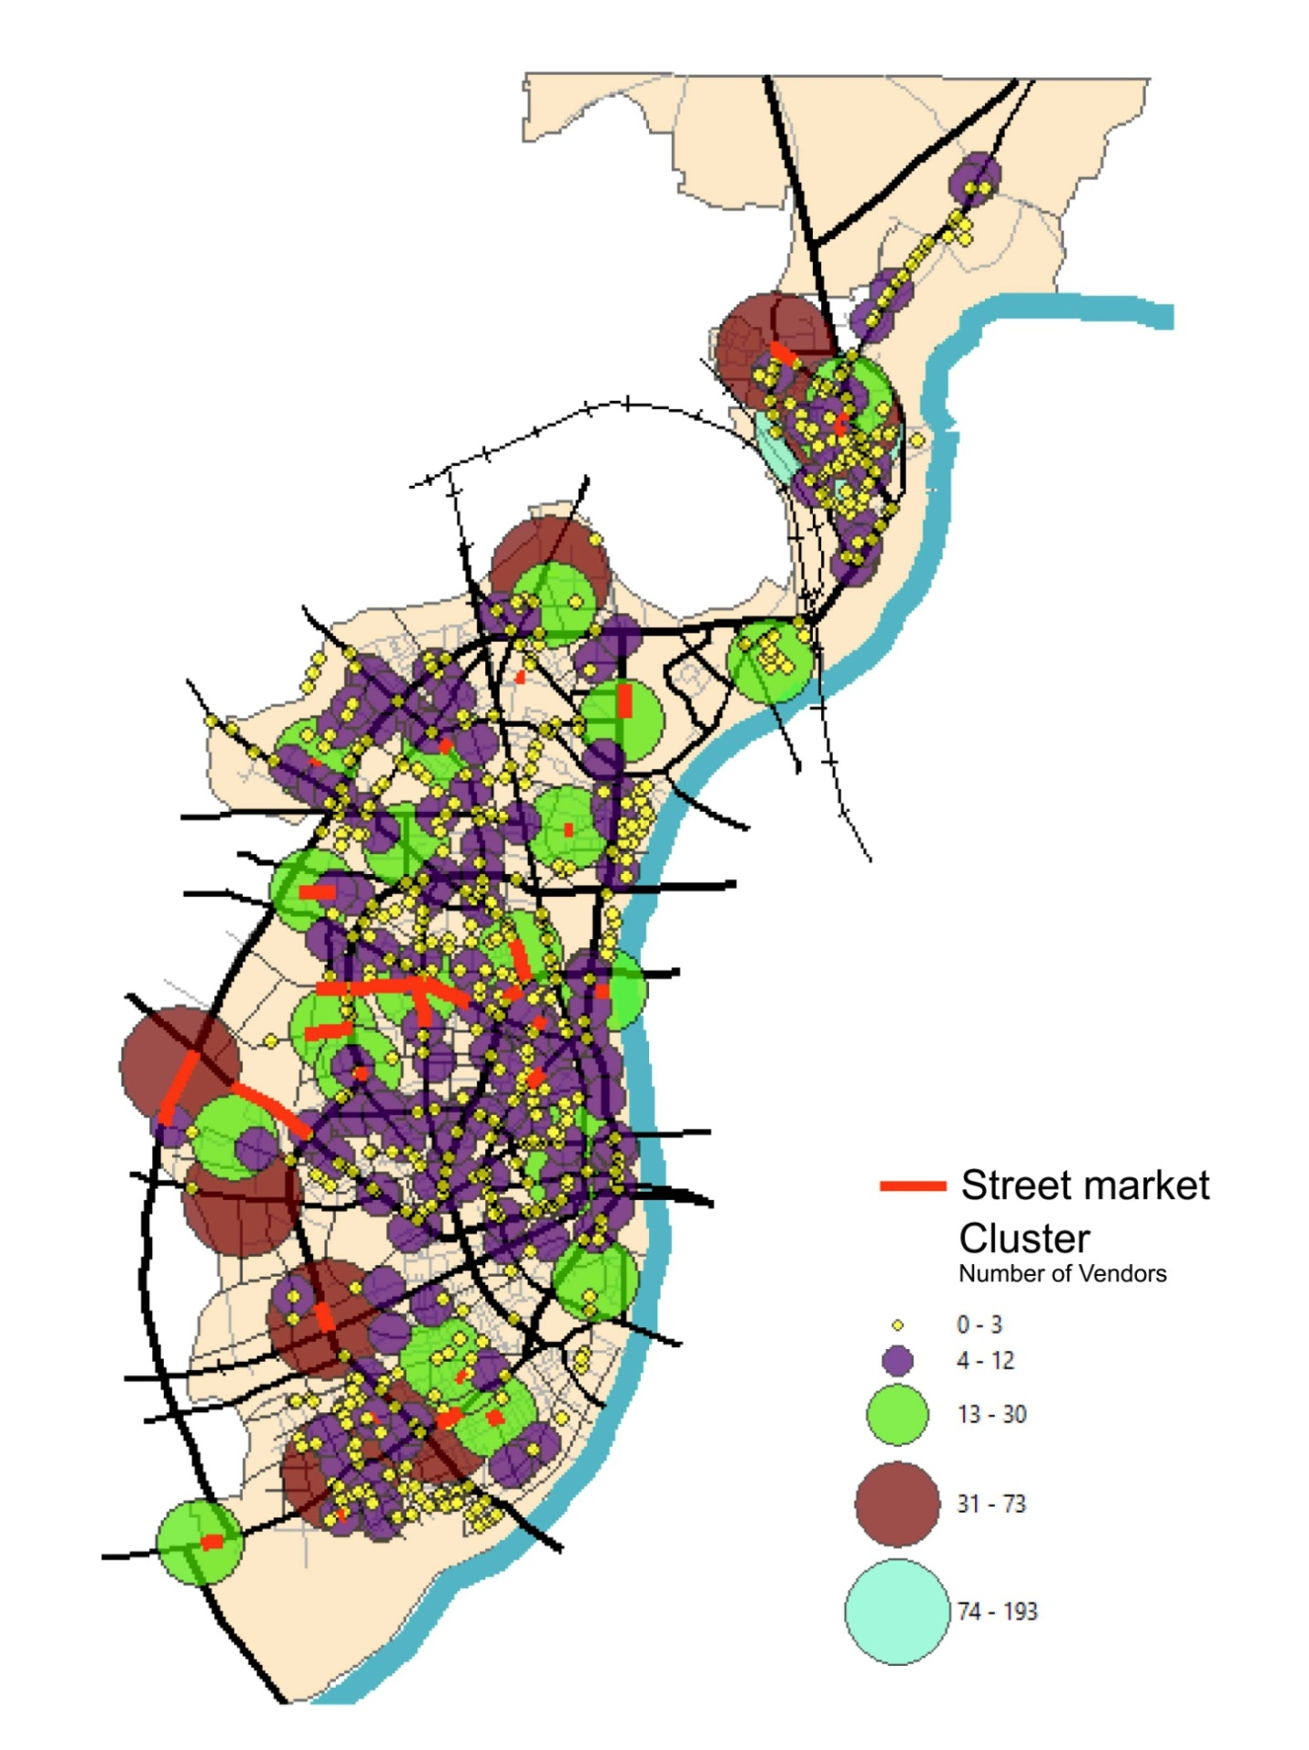 Map 3: Clusters and Street Market

Mobile stationery v/s street type

 | Arterial | Sub arterial | Collector | Local
mobile | 20 | 70 | 133 | 120
stationary | 326 | 804 | 687 | 740
Table 4: No. of Mobile and Stationary Street vendors
Mobile vendors in the zone are 12% of the sample. We observe that highest mobile to total vendor percentage is on the collector street closely followed by the local street. This is because most of the mobile vendors tend to serve the residential areas. The mobile vendors serving the residential areas are convenience for customers as they get the commodities and services at their door step.

Vendors v/s Sidewalks
Narrow, no, wide

SIDEWALK %age | Arterial | Sub-Arterial | Collector | Local
None | 0% | 33% | 38% | 55%
Narrow | 20% | 46% | 39% | 43%
Wide | 80% | 22% | 23% | 2%
Table 5: Sidewalk percentage coverage
 | Street type
Sidewalk |  | Arterial | Sub arterial | Collector | Local
 | None | 0 | 55 | 94 | 112
 | Narrow | 24 | 115 | 116 | 90
 | Wide | 75 | 40 | 53 | 9
 | Total | 99 | 210 | 263 | 211
Table 6: No. of vendors v/s Sidewalk
Sidewalks are as a pedestrian movement corridor on streets but in Ahmedabad the sidewalks are a formality wherein the pedestrian movement is not constraint to the sidewalks.
Most of the vendors use the sidewalks to locate as these provide security from vehicular traffic as well as attract safe space for customers and vendors alike.

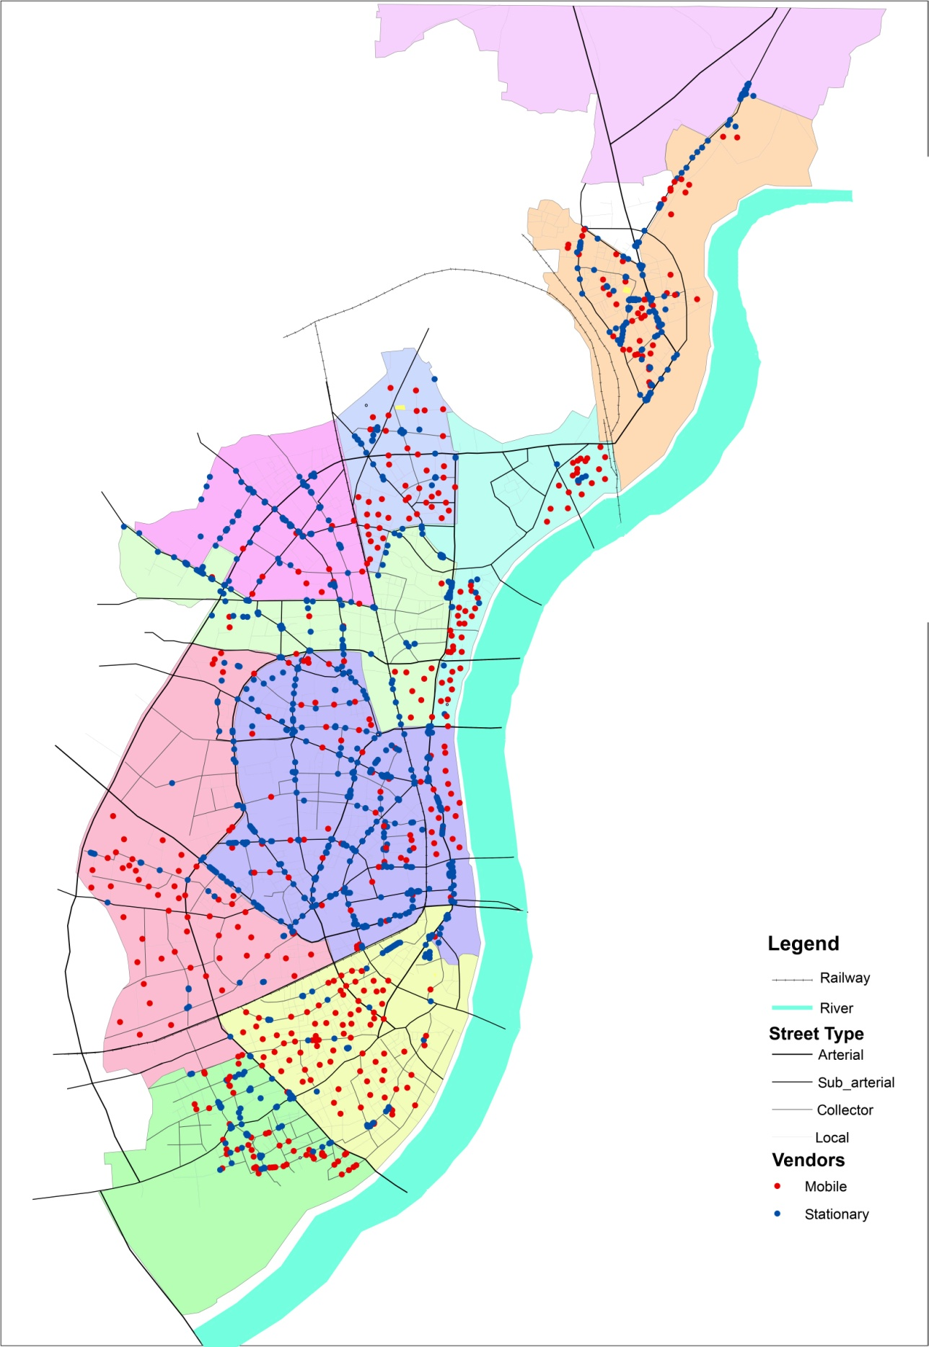
Map 2: Mobile and Stationary Vendors

Vendors v/s Trees
Ahmedabad is one of the cities with less tree cover. It is less than 12% for the city and for some areas even less than 1%. Since street vendors do not have proper infrastructure in form of shade they depend on the tree cover. Substantial percentage of street vendors seek the tree shade and take cover. These are especially important during the mornings and afternoons. It is very important to note that only 33% of the arterial are covered with the trees. Similarly, 28% of sub-arterial and 30% of collector streets are covered with trees. Hence, these small numbers become significant keeping in mid the percentage of coverage by shade. The trees are a protection from the harsh weather and exposure to Ahmedabad heat.
 | Arterial | Sub-arterial | Collector | Local
% of vendors under trees | 13% | 21% | 27% | 29%
Table 7: Relation between trees and vendors

Area covered by vendors v/s streets
We see that the local streets have the junctions as the most important place where the vendors locate. Also, there are vendors which are mobile in nature moving mostly on the local and collector streets.
Coming to the collector streets, these attract a lot of vendors because of high number of customer these have due to higher pedestrian movement. Sub arterial are for fast moving traffic hence lesser number of vendors are usually seen here as compared to the collector. Similarly, arterial have the least number of street vendors.
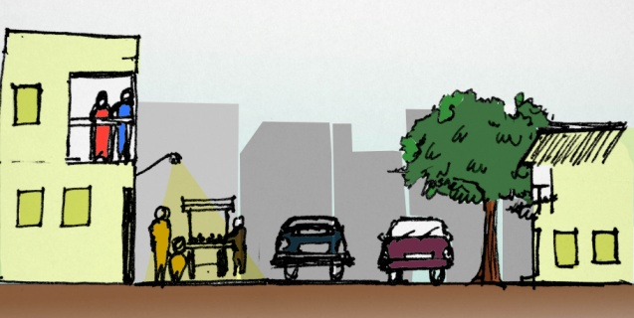
Figure 1: Local street section
Local streets are usually narrow and varies drastically according to the land use and income groups around. These serve the neighbourhoods around and have vendors which are mobile in nature or stationary vendors locating at street junctions. The streets should facilitate the needs of street vendors. They can have a safe and shaded part on street for standing as well as movement. Junctions should especially have space provision for the vendors.
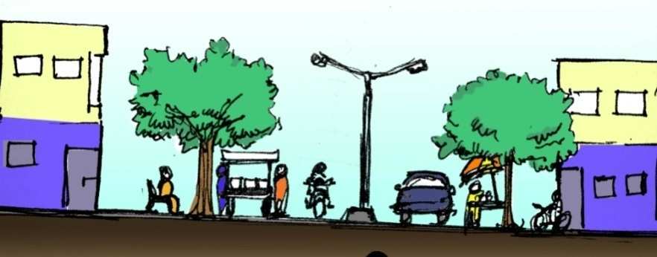
Figure 2: Collector Street section
Collector streets attract most street vendors in this zone. Hence, the street sections should assist the street vendors for movement as well as locating as stationary. These too should be shaded and have enough space for public for movement. The areas should also be lighted well as here vendors stay for longer duration that is till late evenings. The streets can become much more interactive if apart from these seating facility and green buffers are provided.

Figure 3: Sub arterial street section
Sub arterial streets support vehicular movement much more than collector and local streets. Hence, it becomes difficult for street vendors to be included in the process of forming the streets. But because of the high number of people percentage on these roads the vendors are interested in locating here. Hence, a specific zone should be provided which is shaded and have proper facilities.

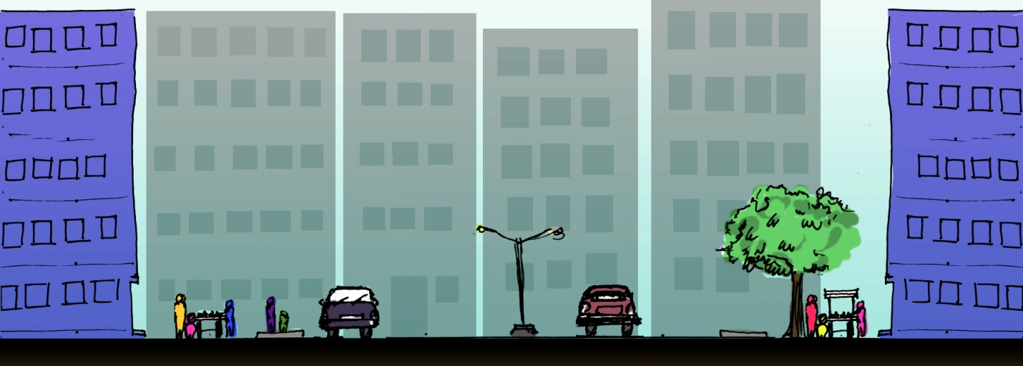
Figure 4: Arterial Street section
Arterial streets are important in for vendors in terms of opportunities provided by the better infrastructure. But the high mobility makes it difficult for the vendors to succeed. Hence provided zones with proper time slots to increase the pedestrian movement and street vendors movement is important.

Land use cases

Residential- a neighborhood in Sabarmati Ward

Brief introduction:
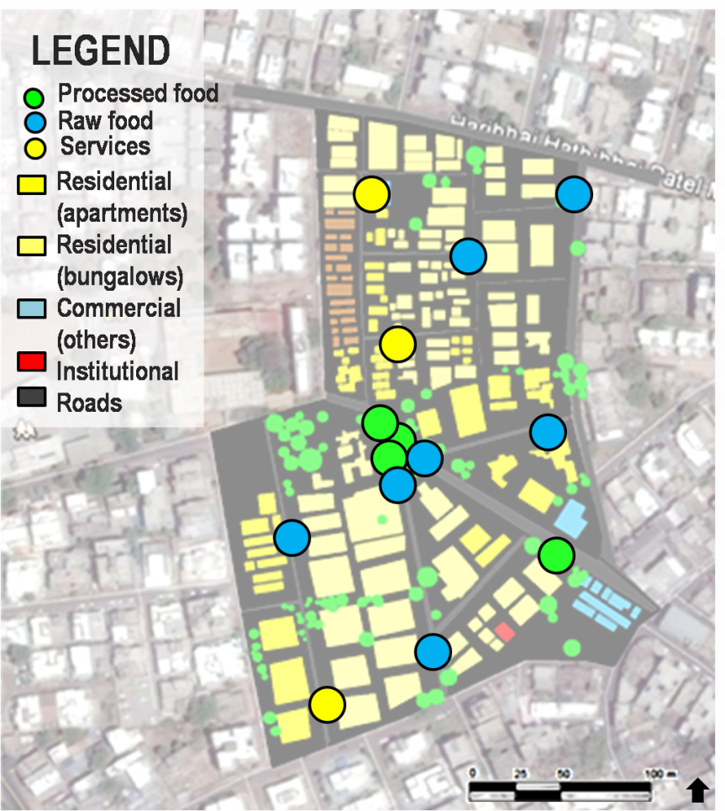
The Sabarmati ward is one of the oldest wards of western Ahmedabad. Along railway line that cuts across the ward is the Railway Colony of Sabarmati, one of the first housing colonies in the area. The area is pre dominantly residential with main roads being mostly mixed use. The ward has many slums and squatter settlements and mainly consists of lower and middle income group. There are very few dedicated open spaces in the entire ward and the quality of these spaces is appalling as they’re clogged with solid waste. Thus here the streets act as breathing places in the dense fabric where people come out to! There are three major street markets along the vertically mixed use roads.
Map 4: Street vendors in Sabarmati neighbourhood

Basic demography:
Total No. Of vendors- 14
Male –female ratio- 1:0.3
Nature of vending:-
Mobile – 46%, Stationary- 64%
Goods/services sold:

No. of people served – 638 HH
Income group – 79% LIG, 19% MIG, 2% HIG
Gender - 67% Females, 33% Male

Relationship with land use:
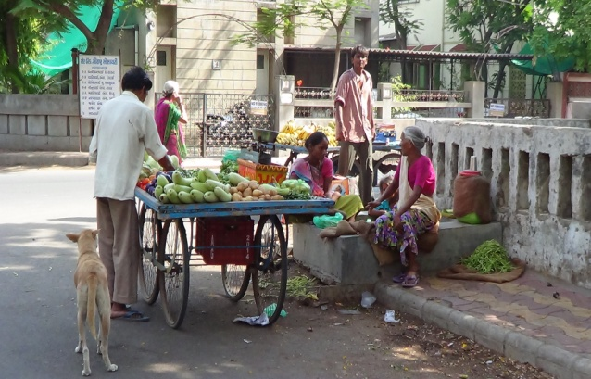
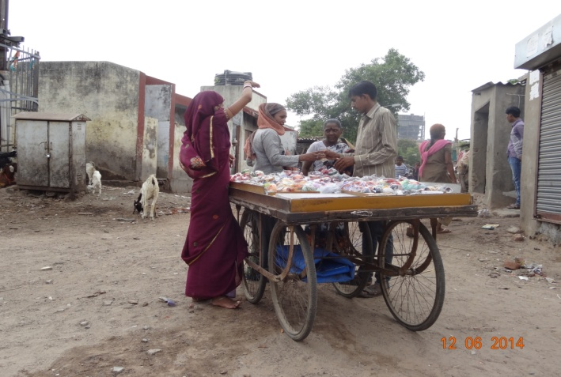
The case taken to explain the response of vendors to the land-use is a mix neighbourhood having more than 60% LIG population and around 25% MIG population with little land under commercial and institution. It mainly consists of local streets. Thus the vendors here sell mostly raw food like fruits and vegetables (daily needed items) and around 35% of the vendors are mobile in nature. Among the stationary vendors, majority of them sell processed food like tea, lemonade, snacks or pan. These stationary vendors are located on junctions of these local roads which have more visibility and market potential while these mobile vendors go around the streets in the neighbourhood selling raw food and providing services like collection of pasti (old newspaper), oil tins, etc. The mobile vendors moving along the street are an opportunity for the people to socialize. Since there is no dedicated open space within the neighbourhood, usually when these shaak-bhaji walas (vegetable vendors) go around, they give women who come to buy the fruits or vegetable a chance to stand and chat for a while. Thus these vendors act as an important element of making those otherwise inactive local roads “public” for the amount of time they are around. And since these mobile vendors go from building to building throughout the day, they keep contributing in making some or the other street more active. Stationary vendors often are points for interaction across neighborhoods as they are located on the junctions. The kitli culture being very popular in Ahmedabad, the pan and the chai stalls are the best places for people to have their conversations. The stationary vendors selling perishable item (food items) are often joints where people meet. Manjuben a resident from the neighborhood said “Sangeetaben, Komalben, Megha (ladies living in the same building) and I often walk to the crossroad to buy vegetables and chat over.” Another resident (who lived in a bungalow) said “I and Paulomiben, who lives in the opposite apartment bump into each other lot of times at the crossroad while buying fruits/vegetables.” Thus these vendors provide opportunity to people from different income groups, who otherwise pass over, to stop and interact. The mobile vendors who provide services often visit these neighborhoods in the afternoon. Hence when people come onto the streets to give them the pasti, empty oil containers, etc they are the reason that there is some activity going on the otherwise dead streets in the afternoon. Other than this, the neighborhood is also less active in the night. But these pan-walas give people the reason to come out onto the streets and interact. Thus these vendors ensure extended hours of activity on the streets making them more important and an absolutely necessary element of their daily life!
Figure 5: Street vendors at street junction
Figure 6: Street vendor in low income group area

Commercial- C.G. Road
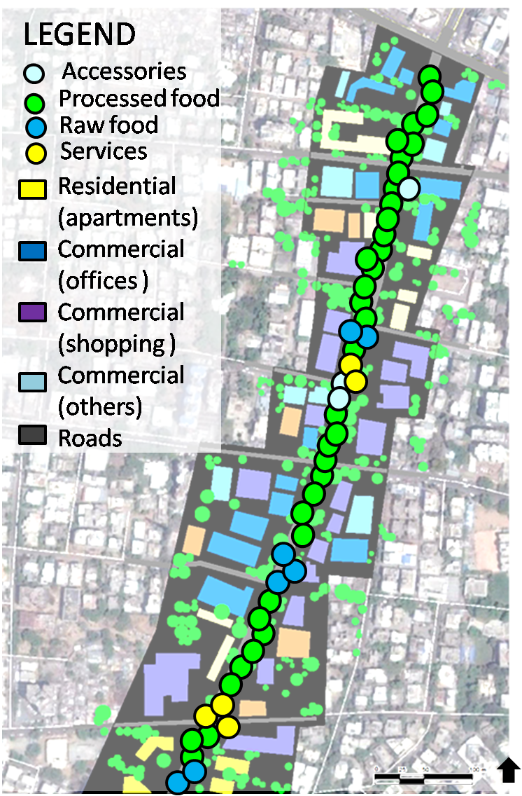
Chimanlal Girdharlal road is one of the most popular places in the city currently! What makes any place extremely popular is the sentiments and memories attached to it. For all Amdavadis, CG road is the place one can relate to Diwali celebration. During Diwali, all the buildings of CG road are beautifully lit with colourful lights and crackers, and the entire city is found on the street enjoying decoration and the celebration.

Basic demography:
Total No. Of vendors- 78
Male –female ratio- 1:0.2
Nature of vending:-
Mobile – 2.5%, Stationary- 97.5%
Goods/services sold:

No. of people served – 4800
Income group – 13% LIG, 63% MIG, 25% HIG
Gender - 67% Females, 33% Males

Map 5: Street vendors in commercial area-CG Road

Relationship with land use:
The area formerly planned for residential use is presently one of the major commercial centres of the city (Sanghvi, 2004). Situated in the Navrangpura ward, C.G. Road thrives with a vibrant range of commercial activity. There is predominantly high end residential and mixed use development adjoining the commercial stretch. The area being highly popular and important receives a huge influx of people daily. However like any other Indian street it is dominated by motorised traffic. Owing to its popularity and significance in the city, it has been a part of various place- making initiatives like “Raahgiri”. Raahgiri promotes safe walking and cycling around the city in order to “reclaim” the streets for its people. The transformation of the stretch due to the initiatives had been largely covered by media. “The stretch of CG Road — from Panchvati to Swastik Crossroads — which is known for its traffic snarls and loud blare of car horns, was transformed into a happening park of sorts as the young and old came together at the crack of dawn to participate in a number of fun activities or simply to socialize.” (Patel, 2014)
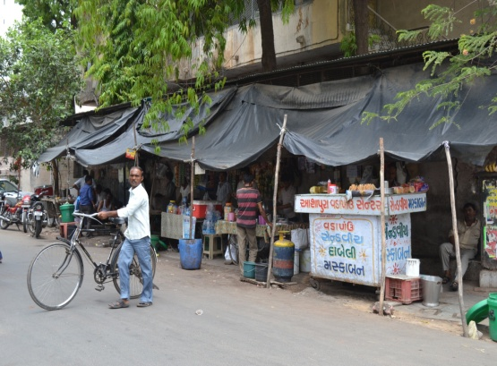
The stretch being predominantly commercial (around 95%) has a network of major roads around it. Approximately 60% of the vendors are located at the major junctions while the rest are located near the malls and offices. These vendors mainly sell processed food like snacks, tea/coffee, lemonade, juices, fast food, etc. Some other vendors are into selling accessories, shoes or cycle/bike repairing. The pattern observed in this commercial stretch was very different from the residential neighbourhood of Sabarmati. In Sabarmati, 35% vendors were mobile in nature and the stationary vendors were scattered while in this case the percentage of mobile vendors was less than 2 and the stationary vendors were highly agglomerated. This indicated that the vendors in the residential area are slightly more dispersed and more mobile to cover a larger population while in the commercial areas, agglomeration fetches them more market.
The vendors which sell processed food often serve the white collar workers as well as the blue collar workers. In CG road, the employees of the corporate offices and grand shopping malls usually order tea/snacks form these vendors or go to their stalls during their breaks. Similarly, the watchmen, cleaners, other service providers usually go to these vendors for having their lunch (which costs them around Rs. 20-30). Thus this range of items sold by the street vendors get them more market but also indirectly make the streets slightly more equitable. Other than that, the street is generally dominated by motorised traffic, but the presence of the vendors and the spillover of the activities on the road which often creates “traffic issues”, also ensure the movement of pedestrian, which in itself is a way of making the street more equitable.
Figure 7: Small scale shops of street vendors serving all employees

Institutional- Street along CEPT University
The street beginning from the campus of CEPT University and stretching up to the campus of H.L. College is famous for street food and clothes. The street is located in the Navrangpura ward which is widely known for its institutes and commerce. Owing to the relatively higher share of institutional and commercial land use (about _% and _% respectively) Navrangpura ward has more trees and open spaces compared to other wards in the West zone. Yet these open spaces are either gated and have a specific type of user group or are used at a specific period of day, making them less active throughout the day. Since the ward receives a huge share of floating population, the need of public spaces becomes even more crucial. Thus there are some distinct streets in the ward which are multipurpose, more “public” and active through most of the day

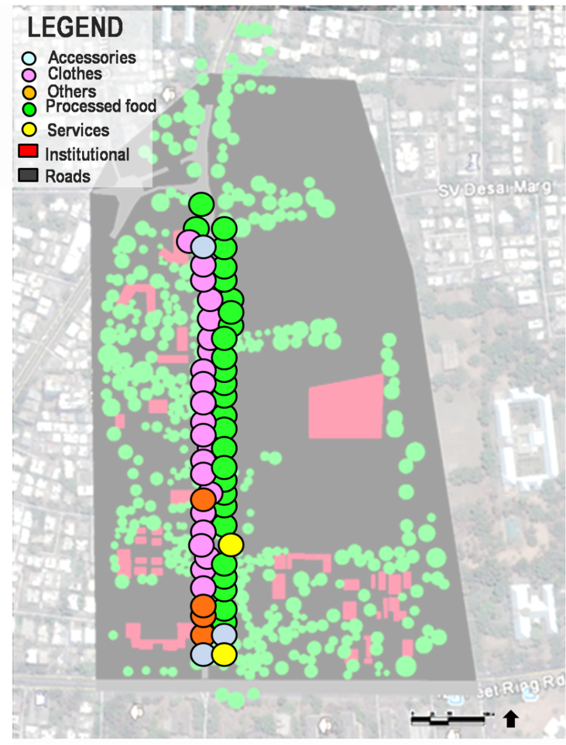
Basic demography:
Total No. Of vendors- 67
Male –female ratio- 1:0
Nature of vending:-
Stationary- 100%
Goods/services sold:

Influx of people– 5500
Income group – 13% LIG, 56% MIG, 32% HIG
Gender - 54% Females, 46% Male
Map 6: Street vendors in Institutional Zone - CEPT University

Relationship with land use:
The land use around the street is mainly institutional. The street market continues through the entire street. On one side of the street (adjacent to the CEPT University) there are vendors selling mainly processed food (around 53%) throughout, while on the other side of the street the vendors sell clothes and accessories in the evening. During the day, the students of all the colleges around come to this street market for snacks and beverages, while in the evening market of clothes welcomes the entire city to walk along and shop. During the nights the student of CEPT University who usually work late night and all the other people in the area, who want some late night munch are seen on this street enjoying the food. This street along with complimenting the land use is an excellent example of how with the intensity of activities and usage, the character of a space keeps changing throughout the day. It is believed that when the edges of any street are made up of plain, long institutional walls, those streets act as convenient places for many anti social activities during the non- peak hours, making it “unsafe”. But these street markets extend the hours and intensity of activities along the entire stretch not only making them safe but also vibrant.
In the morning the street is mostly used for circulation of motorised traffic, but pedestrian movements start increasing gradually till when its completely dominated by pedestrians in the night. Thus these street markets make the street more equitable by giving the pedestrians a reason to walk along (even though there is no adequate provision for pedestrian safety) and by moderating the age groups and income groups divide. These street markets are vital elements of the “culture” built around the idea of “enjoying the street”. Owing to the significance and popularity of these street markets, this stretch has been a part of many place making initiatives recently like.
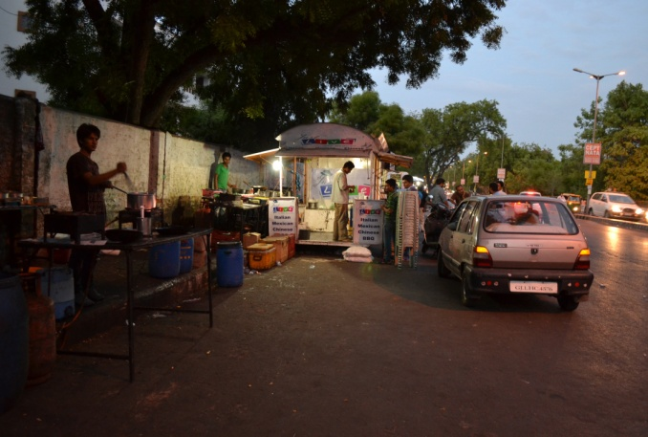
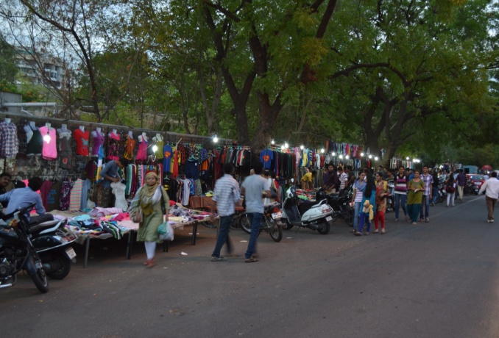
Figure 8: Food vans serving shoppers and students Figure 9: Vehicular street transformed to market

Recreational – A neighbourhood park in Vasna

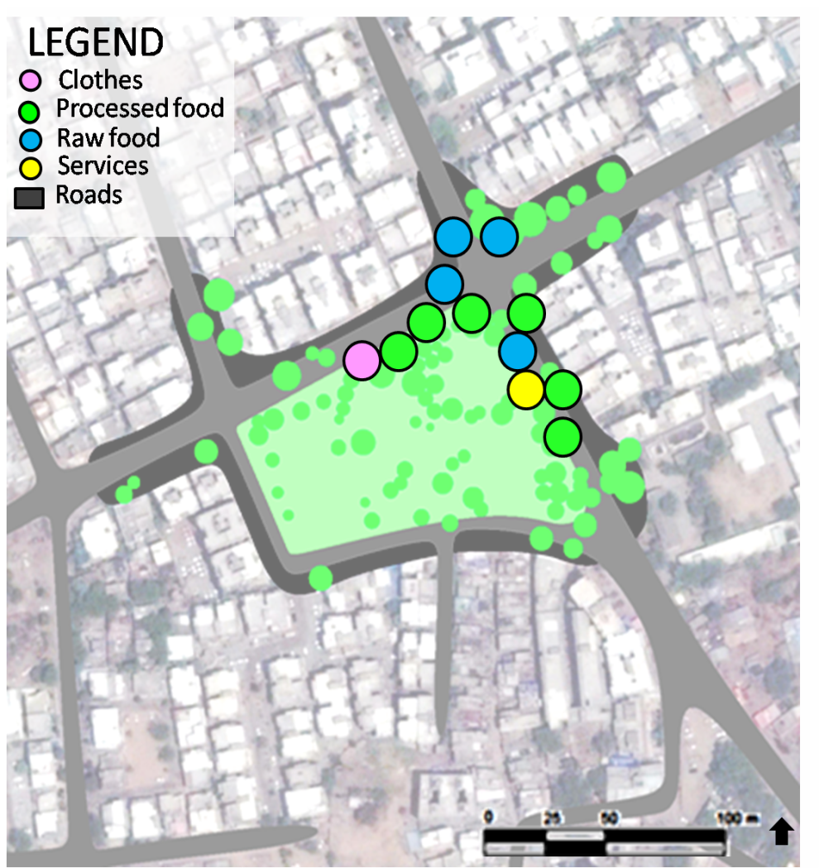
The Vasna ward is one of the oldest high end residential areas of western Ahmedabad. The predominant landuse of the ward is residential and the predominant community is Jain. The ward is virtually divided from the centre into two halves having absolutely contrasting character. One half of the ward has high end residential while the other half has three major slums of Ahmedabad and other squatter settlements (together consisting 29% population of the entire ward on 10% land). Around 23% of the wards land is vacant or under floodplains leaving barely 2-3% land under dedicated open spaces. These spaces are located strategically such that these are accessible to all income groups. The quality of these open spaces is fairly good. However the quantity of the open spaces is highly inadequate for a population of around 1 lakh, making these small neighbourhood spaces even necessary and important.
Map 7: Street vendors around a neighbourhood park

Basic demography:
Total No. Of vendors- 12
Male –female ratio- 1:0.2
Nature of vending: Stationary- 100%
Goods/services sold:

Influx of people– 345 daily
Income group – 43% LIG, 27% MIG, 35% HIG, 15% EWS
Gender - 56% Females, 44% Male
Age group – 39% kids, youth- 17%, senior citizen- 44%

Relationship with land use:
The case selected is a neighbourhood park surrounded by a mix of typologies and income groups to understand if open spaces can dilute the socio- economic divides. This park is relatively smaller in scale compared to some of the other parks in the ward that are located near high end residential areas. The land use around the park is mainly residential but the nature of vending is very different to that of the residential neighbourhood in Sabarmati. Here due to the park, around 54% people are engaged in selling processed food, other 16% is engaged in providing services and selling clothes and accessories. The percentage of people selling raw food is around 30% whereas in Sabarmati it was over 50%. This is mainly because the target group of these vendors- the people coming to the park, are more likely to buy item other than raw food.
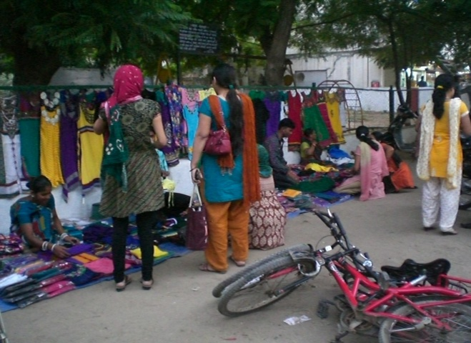
During the morning the people who come for exercising and jogging usually have juices and snacks at these stalls. In the afternoon the labourers and blue collar workers in the surrounding who have their lunch under the shade of the trees in this park and then have a nap, often have their tea/ pan from the same vendors. While in the evening the ladies who bring their toddlers to play in the park and the senior citizens who come to the park also have their juices/tea and snacks from these vendors. Hence they create platforms that are accessible to all income groups and age groups. Apart from this, the vendors located on the footpath adjoining the park and their activities, make these sidewalks a great transitional space between the street-full of motorised traffic and the park-full of people. This in a way makes these sidewalks truly public unlike the street (along it) or the gated park besides it!
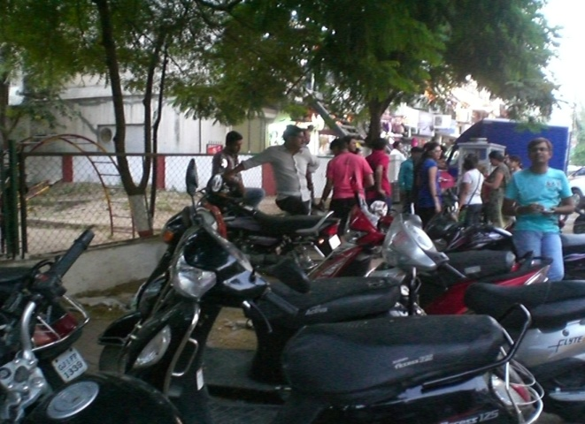
Figure 10: Edge of gated park transformed
Figure 11: High influx of people

Exception – Street Markets of Law Garden
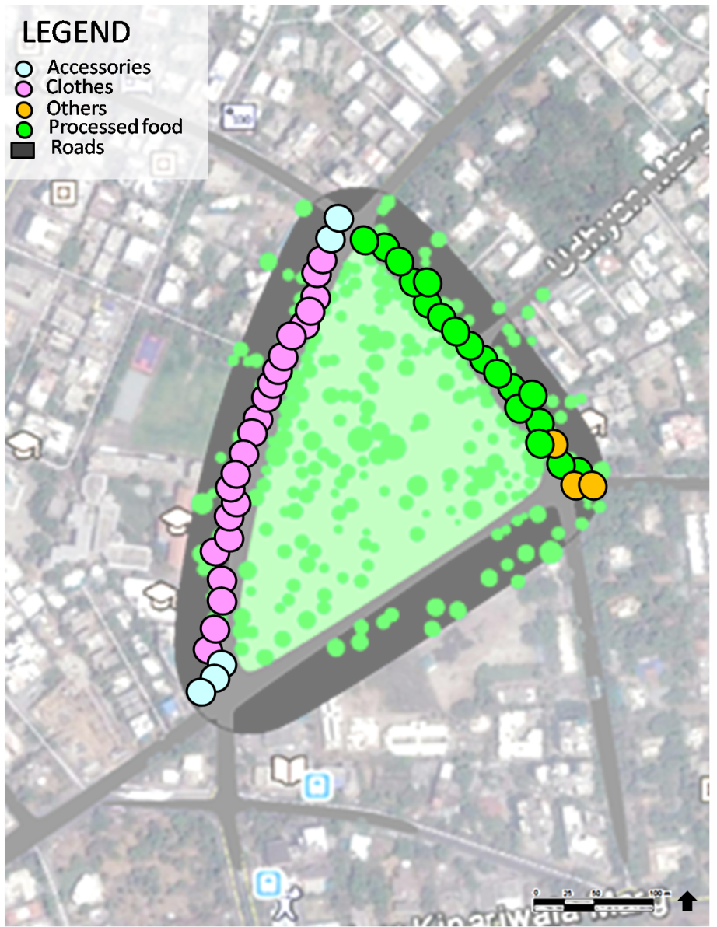
Situated in the Navrangpura ward, Law garden is one of the most celebrated areas in the city. The garden which earlier gained popularity due to the Law College nearby (after which it is named) now is synonymous with street shopping of traditional clothes. The street food of Law garden is equally famous. This area thrived due to the activities of the adjoining land uses (institutional and commercial) and hence had these vibrant street markets along its edges. These markets were then removed from the street due to mobility issues and traffic congestion. At that point, the otherwise extremely popular garden had been completely abandoned by the people and there were lot of efforts and initiatives to bring back the street markets. As a result of this the street markets were reclaimed and were among the few organised street markets of the city. This garden is a classic case of how a public space can be successful or dead due to its multiple interdependent components.
Map 8: Street market of Law Garden

Basic demography:
Total No. Of vendors- 225
Male –female ratio- 1:0.6
Nature of vending: Stationary- 100%
Goods/services sold:

Influx of people– 345 daily
Income group – 33% LIG, 27% MIG, 45% HIG, 17% EWS
Gender - 53% Females, 47% Male
Age group – 19% kids, youth- 57%, senior citizen- 44%

Relationship with land use:
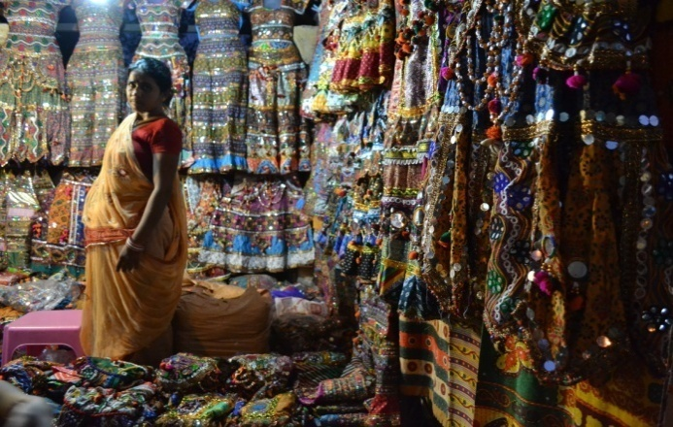
Generally it is the vendors that respond to land use and the character of streets around them but in some cases, the vendors agglomerate and from strong markets which then drive the entire area’s image and activities. Law Garden is one of those rare cases. It has institutional land use around and does have about 36% vendors engaged in selling processed food, but what Amdavadis associate it with is Navratri. Thus what has driven the image of this area is the street market of traditional clothes which wasn’t much depended on the land use around. People from all over the city come to the street to shop and eat. When these street markets were removed initially, the people were so attached to the market that they started feeling that without those street markets, the garden does not hold any attraction, and thus stopped going to the garden. Now these markets had initially come up because law garden, as a park was what was driving that area and received good influx of people daily throughout the day. But gradually it was these markets that started building a new colourful image for the area. Thus a lot of times it is the attachment of people towards a public space which makes it more than just a place, that attachment is exactly what turns it into a “culture” or lifestyle. Law Garden hence is that one place which may not have all the elements of any “successful” public space life adequate infrastructure, various options for sitting and walking, overlap of activities, etc, yet it undoubtedly is one of the most celebrated “public” spaces in the city currently.
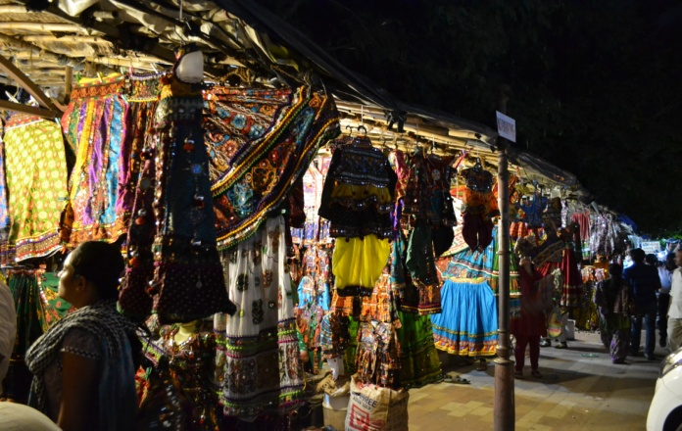
Figure 13: Woman selling traditional wear Figure 12: Street market at night

Conclusion
Street vendors being part of informal economy hold great importance in developing nations. But at the same time they are excluded in the process of development and ignored in cities. The interaction of street vendors with the street is in relation with the type of streets. The streets are important in determining the nature of vendors - mobile or stationary as well as the way they 'arrange' themselves and form markets. Street elements like tree shade and sidewalk also become an important determinant for street vendors location. Their contribution to economy is through serving the residents by providing required goods and services. But, apart from the direct contribution to the cities they play an important role in making streets active and safe public spaces. Street vendors make gated parks public and become a transition between the parks and the street. The streets which give much more importance to vehicular movement become pedestrian encouraging zones because of the street vendors. Street vendors provide a platform where people from different income groups, age groups, communities and gender can come and buy. They are the 'eyes on the streets'. They are people attracting magnets. They make the streets a place where people become more important than vehicles.

Bibliography

Ganesh, J., & Pandya, Y. (. (2010). Informal market development along netaji marg, law garden, Ahmedabad. Ahmedabad, Gujarat, India: CEPT University.
Mahadevia, D., Brown, A., Lyons, M., Vyas, S., Jajoo, K., & Mishra, A. (2013). Street Vendors in Ahmedabad: Status, Contribution and Challenges. Ahmedabad: Working Paper No. 20, Centre for Urban Equity, CEPT University.
Mahadevia, D., Vyas, S., & Mishra, A. (2014). Informal Economy Monitoring Study: Street Vendors in Ahmedabad, India. Manchester: WIEGO.
Raval, B. (2001). Multiple Work Status of Women in the Informal. Ahmedabad: SEWA.
The Street Vendors Act. (2014). THE STREET VENDORS (PROTECTION OF LIVELIHOOD AND REGULATION OF STREET VENDING) ACT . Government of India.
Sanghvi, A. S. (2004). Development and maintenance of public garden : a case study of Western Ahmedabad. Ahmedabad : CEPT University.
Patel, A. (2014, November 23). Ahmedabad street livens up with Raahgiri. Retrieved May 14, 2015, from Times Of India, Ahmedabad:
http://timesofindia.indiatimes.com/entertainment/events/ahmedabad/Raahgiri-Day-Ahmedabad-street-livens-up-with-Raahgiri/articleshow/45257690.cms?
Mahadevia, Darshini, Alison Brown, Suchita Vyas, Tejas Patel, Self Employed Women’sAssociation (SEWA). Inclusive Design for Street Vendors in India. Centre for Urban Equity, CEPT University, Ahmedabad.
Bhowmik, S. K. (2003). Hawkers and the Urban Informal Sector: A Study of Street Vending in Seven Cities. Prepared for . Delhi: National Association of Street Vendors of India (NASVI).
Bhowmik, S. K., & Saha, D. (2012). Street Vending in Ten Cities in India. Delhi: NASVI.
Ganesh, J., & Pandya, Y. (. (2010). Informal market development along netaji marg, law garden, Ahmedabad. Ahmedabad, Gujarat, India: CEPT University.
Mahadevia, D., Brown, A., Lyons, M., Vyas, S., Jajoo, K., & Mishra, A. (2013). Street Vendors in Ahmedabad: Status, Contribution and Challenges. Ahmedabad: Working Paper No. 20, Centre for Urban Equity, CEPT University.
Mahadevia, D., Vyas, S., & Mishra, A. (2014). Informal Economy Monitoring Study: Street Vendors in Ahmedabad, India. Manchester: WIEGO.
Raval, B. (2001). Multiple Work Status of Women in the Informal. Ahmedabad: SEWA.
Sanghvi, Ajaykumar S; Ray, Chandranath N. (Guide) 2004, Development and maintenance of public garden : a case study of Western Ahmedabad.

The Value of Public Space How high quality parks and public spaces create economic, social and environmental value, CABE space.
The Sunday market of Ahmedabad originally situated on the banks of river Sabarmati- famous for its antique items.
Khau refers to food and gallis mean streets, meaning streets famous for its food.
There were predominantly 4 type of spatial agglomeration observed- a market (polygonal), a street (linear), cluster (highly concentrated points) and neighborhoods (sparsely concentrated points).
Narrow refers to sidewalks which are less than 1.5 m in width while wide refers to sidewalks more than 1.5 m in width.
Refers to the culture where people come on to the streets for their tea and light snack to the stalls called kitli. Kitli also refers to the vessel in which tea/coffee is prepared!
Focused group discussions with the residents.
The Hindu festival of lights held in the period October to November. It is particularly associated with Lakshmi, the goddess of prosperity, and marks the beginning of the financial year in India.
Sanghvi, A. S. (2004). Development and maintenance of public garden : a case study of Western Ahmedabad. Ahmedabad : CEPT University.
Patel, A. (2014, November 23). Ahmedabad street livens up with Raahgiri. Retrieved May 14, 2015, from Times Of India, Ahmedabad: http://timesofindia.indiatimes.com/entertainment/events/ahmedabad/Raahgiri-Day-Ahmedabad-street-livens-up-with-Raahgiri/articleshow/45257690.cms?
The 9 day long gujarati festival of folk dance usually falls in September- October.

