Johannesburg City Parks and Zoo Public Dialogue Series

Towards an urban approach for liveable and safe public spaces and parks for Johannesburg

**Peter Gotsch, Ayanda Roji, Blanca Calvo, Itzel Obregon[1]**

# Introduction

Twenty years after the end of apartheid South Africa remains a very unsafe and unequal society. The country's cities in particular, while accommodating a continuously increasing share of the population, are still highly fragmented and feature enormous inequalities. Public open spaces and parks are crucial components for integration and social cohesion and a sound quality of life.

The quality and the safety of public open spaces is an area of significant concern for Johannesburg City Parks and Zoo (JCPZ) – the entity that deals with parks and public spaces – due to the significant levels of crime within South Africa, and within the City of Johannesburg (COJ). Crime and fear of crime destroy the quality of life of Johannesburg's inhabitants while diminishing their freedom of movement, reducing their participation in public life and reducing the effectiveness of socio-economic development. In the context the Johannesburg City Park is developing the Johannesburg Public Space Safety Plan (JPSSP) which will form component of the Joburg City Safety Strategy (JCSS )[2].

The JCPZ acknowledges that issues expressed through public open spaces become a manifestation of fragile social and community systems; therefore issues of crime and violence in public open spaces cannot be addressed through law enforcement alone. Any intervention aimed addressing public space safety must be holistic in its approach, addressing the social issues occurring within the communities surrounding them. JCPZ recognises that its capacity in crime prevention is limited, however the municipal entity will invest in public space safety through well-informed planning, design, management and maintenance of parks and other public spaces in accordance with its mandate." (JCPZ in February 2014)

This paper seeks to contribute to JCPZ's efforts in preparing the ground for the formulation of an urban approach for safer parks and public spaces for Johannesburg (and beyond), which will be part of a follow-up mission. Generally the paper seeks to raise awareness on the pertinence of public space is general, as it elaborates on the relevance of public spaces and urban safety as basic human needs and as common societal goods.

The paper has six main sections: 1) The first part elaborates on the relevance of public space and safety and discusses the role of public spaces in regulatory contexts, such as the National Development Plan 2030; 2) The second section illuminates the main drivers and trends in urban development and in safety in South Africa; 3) From a normative perspective, the third section describes the functions and principles of open public space, putting forward an urban approach to safer and more inclusive cities; 4) The fourth part delineates several national and international model practices on parks and public spaces; 5) The fifth and concluding section provides recommendations some focal areas for intervention and summarises the key success factors of developing safer public open spaces in Johannesburg. Throughout the paper paragraphs marked by an "" point to relevant implications for planning more and safer public spaces and parks in the context of Johannesburg.

# Relevance

## Why public space

When discussing the quality of life in cities, it is important to ask how contemporary urban environments are produced and by whom and whether public spaces play the role of social glue, or whether they are a means of separation and fear.

It is interesting to observe that often the urban settings that are perceived as chaotic and problematic, and that planners and officials don't aim for, such as the African street intersection and market (figure 1), are characterised by mixed use, complexity, density, and heterogeneity. In contrast many of the urban spaces that are planned in order to control the supposed chaos, such as the suburban township in figure 2, tend to be highly monotonous and 'controlled' and thus allowing only for a limited range of uses and adaptations. The first sort of urban spaces tend to be generated by multiple users. In contrast specialised institutions, such as planning departments or private developers, generate the second type. In many instances planners and officials aim at 100% risk free environments and in this process they loose track the holistic and integrated urban qualities such as access, mixed use, diversity, density and social qualities. While institutions and private developers more and more steer the development of urban spaces today, cities are made up of commoditised spaces and land markets. In this situation the shared value of public spaces, common resources, public goods and common identities tends to vanish. In South Africa institutions of the private sector together with those of a paternalistic post-apartheid state dominate the production of urban space and in many instances civil society tends to be left behind.

In this situation the government in partnership with academic institutions, civil society organisations and social movements is in a critical position to challenge the mainstream and to develop alternative development paths towards a more inclusive and sustainable future and towards cities for all that provide accessibility and that facilitate integration. Various alternative movements and good practices – e.g. on the right to the city, or on place making, on green parking, on community management and neighbourhood parks, participatory planning, urban farming, etc. – exist at national and international scales. We need to learn from them, to adapt these to the South African context and scale up and mainstream their approaches.

## Arguments against public space

There are various arguments against public space that are generally valid. It's economic, social and cultural value is difficult to measure and qualify. Therefore sceptics of public space would say that it is:

* An extra that is only viable in rich cities;
* A typical feature of European cities;
* Too dangerous;
* Only an ideal and not existing in reality, as public space is always owned by someone;
* A thing of the past and not appropriate for 21st Century cities which are dominated by media spaces and where all private, public and economic spaces are blended.

On the other hand lovers of public space would counter that public urban space:

* Is a vital ingredient of every good city;
* Promotes tolerance and inclusion;
* Is a basic need and a public good for everyone;
* Promotes tolerance;
* Is something all people enjoy as they use and experience it and hang out there;
* Belongs to every democratic equitable society.

## Why safer public spaces?

Today international organisations and governments world-wide acknowledge that urbanisation is a motor of development and prosperity, the role of public spaces and the function of safety within this process is still not sufficiently understood and so remains largely neglected.

Indeed, safety is a core quality of public spaces (and semi public spaces) such as streets, squares, parks and transit terminals. Absent safety has a severe impact on the quality of life of people and the prosperity of a city. Poor safety and lacking, or dysfunctional, public spaces and fear constrain the daily lives of millions of city dwellers around the globe. In many instances public life occurs during daylight hours only. Open spaces are used for movement from A to B only and communities lack cohesion and trust. In this situation administrations are inefficient and businesses cannot unfold their potentials. On the other hand, in cases when safety is as abundant such as in Western Europe, people stop being conscious about its relevance as basic need and as a public good. The topic is only appreciated if it poses a day-to-day problem.

The situation in South Africa is particularly problematic as it is among the countries with the highest levels of violent crime worldwide with extraordinary levels of murder, rape and youth related crime. Urban safety is perceived as the top three problems across class and racial divides in South Africa (Parnell and Pieterse 2010).

Most of the stakeholders that are part of urban development processes have not been able to understand the character of urban safety as a public good that is produced by a multiplex of factors that are also context specific and so the concept is lacking in most laws and regulations. Instead conventional methods of crime prevention based on control policing and criminal justice continue to play a central role. (Gotsch 2013) Likewise most institutions tend to perceive public spaces more as risk factors than as solutions.

* As we agree that public urban spaces are a central ingredient of good cities, we need to ask how good public spaces and parks are made and which qualities they need.

## Public space and safety in regulatory frameworks: E.g. National Development Plan 2030

*"In 2030, people living in South Africa feel safe and have no fear of crime. They feel safe at home, at school and at work, and they enjoy a community life free of fear. ...Women walk freely in the streets and children play safely outside..." (NDP 2030 2012: Ch12).*

Various programmes and policies of the South African government reflect an impressive self-diagnosis; they are aware of most of the key challenges related to societal and spatial development, including public spaces and safety issues, and contain a high level of self-criticism.

E.g. The South African "National Development Plan 2030: Our future - Make it work" provides an excellent analysis of the trends and problems in regard to the country's urban development. At the same time it underlines our diagnosis that the role of public spaces has been neglected.

*"Despite slower urbanisation than in other parts of Africa, another 7.8 million people will be living in South African cities in 2030 and a further 6 million by 2050, putting pressure on municipalities to deliver services." (Republic of South Africa 2012, 266)*

*"South Africa's towns and cities are highly fragmented, imposing high costs on households and the economy. ...overall, little progress has been made in reversing apartheid geography." (Republic of South Africa 2012, 266)*

*"Despite efforts to transform South Africa’s urban areas, many housing projects do not create efficient urban spaces." (Republic of South Africa 2012, 269)*

*"One of the consequences of weak spatial governance is that spatial planning has tended to follow patterns set up by private-sector investment. While the private sector has a role to play, the overall pattern of spatial development should be shaped by the long-term public interest." (Republic of South Africa 2012, 275)*

* The quotes at hand demonstrate that the national level policies also include clear goals of achieving integration and social cohesion. The problems are clearly identified and the goals are obviously defined. On the other hand, detailed and realistic roadmaps towards the achievement of the goals seem to be missing. A spatial component of and social cohesion is missing.

Strategic Priority 7: Build cohesive, caring and sustainable communities

*"Social cohesion broadly defined as that which gives members of a society the capacity to cooperate in ways that create the possibility for positive change is important if we are to achieve development success. However, inequalities of condition (wealth, income, education, health), and inequality of opportunity and a general absence in society of being part of a common enterprise, facing shared challenges and belonging to the same democracy with a shared destiny, is placing severe stress and strain on social cohesion."   
(The Presidency of the Republic of South Africa (MTSF) 2009, 22)*

Notably the NDP 2030 is also discussing five overall principles for spatial development namely: spatial justice, spatial sustainability, spatial resilience, spatial quality, and spatial efficiency.

Among others the section on spatial justice demands that:

*"The historic policy of confining particular groups to limited space, as in ghettoisation and segregation, and the unfair allocation of public resources between areas, must be reversed to ensure that the needs of the poor are addressed first rather than last."*

And the part on spatial quality stipulates that:

*"The aesthetic and functional features of housing and the built environment need to be improved to create liveable, vibrant and valued places that allow for access and inclusion of people with disabilities."*

* However, further specifications on the role of public spaces could play in the process of spatial justice and spatial quality are lacking.

It is also illustrative that none of the 76 development indicators of the Medium Term Strategic Framework 2009-2014 designates a role for public spaces. (The Presidency of the Republic of South Africa (MTSF) 2009, 46) (According to this list of indicators a city without public spaces is perfectly possible).

* The analysis of national level strategies and policies brings to the fore that none of these elaborates on the role of the urban public sphere and public spaces. Moreover, the impression is that individual rights account for more than collective rights and that the protection of greater social values and public goods at urban and national levels tend to be lacking.

However, some recent policies, such as the Integrated Urban Development Framework (a national level urban development policy, which is being elaborated upon at the moment) are working with the notion that urbanisation has not only many problems but also many opportunities and energies that need to be harnessed and used towards sustainable urban development (Department of Cooperative Governence and Traditional Affairs 2013).

A highly promising programme with a high potential impact on public spaces is also the Neighbourhood Development Programme of the National Treasury. Due to its massive investment scale of 10bn Rand over a period of 10 years in about 100 projects, the programme is expected to trigger a significant transformation of South Africa's urban fabric. The NDPG:

"... supports neighbourhood development projects that provide community infrastructure and create the platform for private sector development and that improve the quality of life of residents in targeted areas" (National Treasury, Republic of South Africa. 2010)

* While neither the IUDF, nor the NDPG specifically operate with open spaces and urban parks, the core stakeholders involved in the implementation of these programmes, such as local governments, including the JCPZ, should play an active role in the implementation of these programmes and promote the development of the urban public domain through these mechanisms.

The main challenge South Africa's government is facing is characterised by a stark delivery gap between the local level of government (districts, municipalities, towns, metros) and the services that the population receives. This delivery gap arises because at the moment local governments are still under capacitated and weak. Moreover a local culture of participation needs to be cultivated.

* Therefore an approach to empowerment towards active citizenship and the development of democratic leadership is needed. This also needs to be taken into account when developing parks and public spaces.

## Implications

* Based on the paragraph describing the relevance and the regulatory context of above, agencies engaged in the development of urban public spaces and parks Johannesburg should:
* Promote safety is a core quality of public spaces;
* Contribute to a better understanding to the relevance of public spaces and the function of safety as vital components of quality of life and prosperity;
* Convince crucial stakeholders from government, civil society and the private sector that urban public space is a core ingredient of sustainable and equitable cities;
* Encourage all stakeholders that are part of urban development processes to understand urban public spaces and urban safety as indispensable public goods and lobby for the inclusion of public urban space and urban safety into comprehensive development plans and frameworks at national, provincial and local levels;
* Play an active role in the implementation of core government programmes and promote the development of the urban public domain through all public planning mechanisms;
* Contribute to the development of realistic roadmaps towards the achievement of spatial component of and social cohesion;
* Advance components of a participation in any larger program, framework, policy which deals with of parks, public spaces and safety aspects.

# Context of urban development and urban safety in South Africa

In order to develop alternative visions and paths for the future, including visions and concepts for public spaces and parks, it is essential to know the main challenges and trends that shape urban development, low-income housing, and grassroots and community initiatives in South Africa in the upcoming decades. And because urban safety is a key issue of concern, it is also essential to understand the key drivers and trends related to urban safety in South Africa.

## South African urban pathways and trends

The following urban trends and pathways are instrumental in order to understand the status quo of South African cities today:

* Urbanisation and concentration: It is evident that urbanisation rates in South Africa will further increase in the next decades and that populations will concentrate in large cities. (Turok 2012). The Johannesburg/Gauteng region grew by 23% between 2001 and 2011. By 2020 more than one third of the country's population will be living here (Gauteng City Region Observatory 2012).[3]
* Regionalisation: The large cities with several millions inhabitants are increasingly becoming multiplex regions. Here the orientation to one centre gives way to multiple, and often specialised nodes. The dimension of urban landscapes and regional parks becomes important in this context. As fast growing peripheries become the key sites of new urbanisation the transition between city and the open landscape becomes another key issue.
* Exclusion, fragmentation and segregation, and persisting apartheid patterns: South Africa features the highest rates of economic polarisation in the world, and spatial and economic disparities are increasing. The country's cities epitomise this trend. The legacy of apartheid is still evident in the spatial environment. A majority of people continue to live far from job opportunities, services and facilities, and usually in ‘dormitory’ type residential areas. Urban spaces are dominated by architectures of fear (highly segregated and monofunctional land uses, housing enclaves, walls, surveillance devises).  
  Most South African Metropolises feature GINI indexes higher than 0.7. This widely exceeds the UN's civil unrest alert benchmarks of a GINI coefficient of 0.4 (UN-Habitat 2008: Global Urban Observatory). (figure 3)
* Recent revival in some urban centres: After a period of crisis, neglect, abandonment and decay since the early 1990's (end of apartheid), some central business districts are experiencing a recent revival (e.g. Cape Town CBD, Newtown and Braamfontein in Johannesburg).
* Increasing densities: In contrast to many other urban agglomerations worldwide, South African cities are experiencing a relative increase of urban densities. This is mainly due to the fact that the apartheid city has been extremely segregated and dispersed (Angel 2012).
* Detached house is the ideal: Even so, the detached single family home remains the desired form of living for the majority of South African households, whether rich or poor. (This is also reflected by the Government's social housing programme (RDP) which hitherto supplied more than 2,5m houses for the poor) (Government of South Africa 2012).
* Car orientation: Likewise, the organisation of cities is based on motorised transport, e.g. private cars and taxi busses. This low-density context makes mass public transport difficult. Bicycles have a bad reputation as distances are long and bike infrastructure is lacking.
* Fear as a main motive of urban development and design: High economic inequalities, spatial segregation, low education levels, substance abuse, and discrimination of women come together with the apartheid legacy of structural violence to trigger many violent crimes. South Africa has very high murder rates and extreme rates of rape and abuse of women. In this context lack of trust and fear become major motives of urban development and design, generating architectures of security, fear and segregation. (Many communities tend to prefer "target hardening" activities and defensible architectures such as walls and fences, more CCTV cameras, security guards). (Lemanski 2004)
* Bureaucratic blockages and weak government: The legacy of apartheid promotes the expectation of a paternalistic and bureaucratic state and hinders participatory development. There is an increasing tendency towards top-down and technocratic approaches to development. Moreover, political uncertainty is on the rise.  
  The local governments of this ten-year-old state are in the midst of a decentralisation process and remain under-capacitated and weak. Corruption and political patronage are very common. Local governments have limited capacity to implement genuine participatory processes and hear and respond to voices from the community.   
  A recent shift of the government away from a `free housing` policy engenders many challenges for ensuring adequate alternatives (e.g. meaningful and democratic means for communities to secure in-situ upgrading).
* Ideology of private development: Modern South Africa has embraced a neoliberal trajectory that believes in the power of free markets, of individual property, and of privately led development. Combined with the bureaucratic and paternalistic government, the ideology of private development tends to reinforce apartheid style patterns of exclusion, discrimination and segregation, and it prevents consensus on common resources, a public sphere and a vision of a city for all. A private an investor driven urbanisation is often composed by megaprojects and enclaves of dozens and sometimes hundreds of hectares which privatise and securitize large tracts of urban land. In this context the exchange value of land and buildings dominates the social use values of the urban fabric.
* Vulnerable populations suffer most: More than half of South Africa's population is without a regular income, and the tendency to become poor is rising. In this situation the majority of the excluded and deprived population is "locked" in peripheral settlements and precarious dwellings at periurban locations, most of which are remote from services and job opportunities and other amenities of urban life. In this situation the poor are the least protected from risks such as man-made and natural disasters (e.g. fires and floods), joblessness and violent crimes. Rising numbers of violent protests can be seen as indicators of declining trust, a feeling of disempowerment, lack of a voice, and the rising frustration of the urban poor. (Alexander 2010)
* Differentiation of the poorest of the poor: As a tendency, income inequality becomes more important than ethnic inequality, and the various groups of the poor can be differentiated even further: Urban and rural poor, female poor, poor children, poor immigrants, poor elderly, poor mothers, poor homeless, poor backyard dwellers, poor slum dwellers, etc. (All these are groups which for various reasons are excluded from the mainstream economic system).

## Implications

* Because parks are a key component of a sustainable urban fabric, any good strategy seeking to develop a viable system of public urban spaces (including parks) needs to embrace the opportunities (such as increasing densities and revitalised inner cities) and problems such (such as fear, fragmentation, or privatisation) discussed above. Any strategy should seeking to nurture the opportunities will also trim down some of the problems.

## Urban Safety in South Africa

Violence and crime and fear of crime are omnipresent in the daily life of contemporary South Africans which also significantly shape the patterns of behaviour in public spaces and which have a significant impact on the design of public places and parks. The following sections outlines crime and violence in South Africa, including the main underlying drivers and trends and their dimensions. It concludes by outlining the main implications this situation has for creating safer public parks and public spaces.[4]

Among the main causes of violence in South Africa are the country's apartheid legacy and a related culture of (structural, cultural and physical) violence which is grounded on the history of brutal government, institutionalised racism, of the availability of fire arms, fragmented families and poor education systems, as well as the immense inequality and poverty (Gotsch 2013 drawing on CSVR 2010).

The drivers (causes) of violence and crime in South Africa result from a combination of factors including poverty and inequality to economic exclusion and unemployment as well as weak governance, the challenges of urbanisation and resultant poor urban design.

Violence is one of the leading causes of non-natural deaths in South Africa: 43% of all instances of injury mortalities between 2000 and 2004 are attributed to violence (Centre for the Study of Violence and Reconciliation 2010). At the same time the country maintains one of the highest per capita rates of reported rape in the world (Human Rights Watch 2011; Moffett 2006). In this situation South African social and economic inequalities converge in cities and city regions and the urban centres feature the highest levels of crime and violence.

Areas with different socio-economic and spatial characteristics tend to exhibit varying scales and types of violence. As noted by the Centre for the Study of Violence and Reconciliation, the South African urban landscape can be divided “into middle class high crime communities” and “poorer violence-prone communities”. Violence is predominantly concentrated in the low-income, under-serviced and marginalised settlement areas of South Africa's cities, for example in former township areas and the growing informal settlements. At the same time crime (e.g. property crime) converges in richer neighbourhoods and the CBDs. Thus crime and violence seem to follow patterns of spatial segregation (Lemanski 2004). Temporally, much violent crime is also experienced over the weekend period, particularly on Friday and Saturday nights, where a significant proportion of incidences are directly related to the abusive consumption of alcohol and drugs. Particularly important in understanding urban violence in South Africa, as elsewhere, is the fact that male youths are overwhelmingly represented as being both the victims and perpetrators of violence and crime (Burton 2007; Pelser 2008) .

Apart from being perpetrators of crime, the youth also act as protectors for the community. In this regard, the youth constitute the major of grassroots actors in community crime prevention initiatives

* The spatial and temporal characteristics of crime and violence patterns in South African Cities highlight the necessity to consider socio-spatial as well as socio-economic aspects of urban life in formulating an integrated development plan that promotes urban safety.

Public spaces in South African cities[5] suffer from unequal service delivery and the prevalence of lawless behaviours that often also lead to vandalism and theft of public infrastructure, illegal occupation by displaced, homeless, migrants, drug and alcohol abuse, littering (including discarded drug paraphernalia), misappropriation for economic activities (e.g. informal trading, informal waste separation, drug trade, or prostitution). The misuse impacts on the day-to-day management and maintenance activities of the respective departments (such as the JCPZ) and engenders huge costs to both the City and communities who use the public spaces. The consequence of these problems means that legitimate users withdraw from using the parks, providing public spaces for criminals to overrun and repurpose.

* The Johannesburg City of Parks and Zoo (JCPZ) department acknowledges that issues expressed through public open spaces become a manifestation of fragile social and community systems; therefore issues of crime and violence in public open spaces cannot be addressed through law enforcement alone. Any intervention aimed addressing public space safety must be holistic in its approach, addressing the social issues occurring within the communities surrounding them. While the department recognises that its role in crime prevention is limited, the municipal entity will invest in public space safety through well-informed planning, design, management and maintenance of parks and other public spaces in accordance with its mandate.

## Summary and implications

Based on the evidence above, it is apparent that 1) Violence is one of the leading causes of death in South Africa; 2) Youth are heavily involved in violence as both perpetrators and victims; 3) the experiences and perpetration of violence is gendered, with women being vulnerable to specific forms of violence such as rape while young men are generally overrepresented as main perpetrators of violence; 4) The distribution of violence and crime varies across urban neighbourhoods in urban South Africa, with poorer areas more prone to violence while relatively wealthier areas are more prone to economic crimes; 5) While functional public spaces (including parks) are rare in South African Cities, the existing locations and parks suffer from various forms of misappropriation which cause considerable costs and which tend to discourage the normal user from using the public places and parks.

* The implications of the above trends and drivers of urban violence in South Africa for the design of parks and open public spaces are, among others:
* Compared to other countries, where a culture of violence is less pervasive, parks and public spaces in South Africa need a higher level of attention to safety through integrated activities of control, prevention, and pro-action. These should be developed in close collaborations with the adjacent communities and various user groups (cf. to the urban approach for safer public spaces and parks as outlined below);
* In general the administration (i.e. on national level) should consider introducing policies, which require that actors, which drive the privatisation of urban land, and which support the development of public parks and places (such as the "social obligation" which is part of the Brazilian urban statutes).
* Depending on their social context and geographic location (rich or poor, centre or periphery), parks and public spaces face specific sets of problems and potentials, challenges and opportunities. Therefore generic solutions for designing and maintaining parks and open spaces need to be tailored to the respective conditions, case by case;
* Parks and public spaces in poor neighbourhoods (e.g. township areas and informal settlements) need particular consideration and focus, taking the special needs of the users and target groups into account;
* The aspect of safety for women and youth needs particular attention;
* Parks and public spaces (including sports facilities etc) are important spaces for youth to find room for meaningful engagement and appropriation;
* Youth are also an important target group to be included in participatory management activities.

# Principles and strategies

The following part discusses strategies towards better (and safer) public spaces and parks including the qualities of good parks and public spaces. The section firstly discusses the functions of public urban places, introduces the approach of placemaking, and sketches out an urban approach to safer public spaces and parks.

## Three purposes of public open spaces

Based on the insights of other experts such as of the German urban sociologist Bernhard Schäfers[6], public city spaces have three main purposes (slide 32). They serve as a stage for:

* The exchange of information and of goods between diverse stakeholders;
* The open representation and display of different identities, lifestyles and cultures of various population groups;
* The experience of difference, therefore promoting tolerance and conviviality.

Indeed Schäfers refers to public space as the heart of an "open society" in the sense of Karl Popper. He insists that public urban space should be not occupied by individual groups and that public space requires active and conscious citizens who know how to and who desire to act through a culture of the public. For Schäfers, as well his peers, public space is a key element of a democratic society. (Schäfers 2003)

* A modern democratic society needs public space.
* Public urban spaces should facilitate exchange, representation and the experience of differences between various population groups.

## Placemaking (and principles for open spaces)

Placemaking is a holistic strategy of conceiving, constructing and managing public spaces which is becoming popular around the globe and which is highly valid when thinking about effective and sustainable strategies for creating public spaces and parks. The role of designers and planners is to generate an open framework, which facilitates co-production and adaptation of places by various groups of users. In other words, urban places (such as streets, parks and squares) are the sum of the agglomerated behaviour and imaginations of the users.

The approach of Placemaking originated in the 1960s, based on the ideas of urban scholars and activists like Jane Jacobs (Jacobs 1961) and William H. Whyte (White 1980). These embraced the perspective of the user and promoted concepts such as walkability and design at the human scale. Today the concept is widely promoted by the planning and design offices of Jan Gehl in Copenhagen (Denmark) and the Project of Public Spaces (PPS) in New York City (United States).

Whyte (1980) writes for example that it is the social life in public spaces that is the main ingredient of the quality of life of life in cities. He promotes a design of public spaces from the bottom-up. In this context it is essential that all design needs to be based on a comprehensive understanding of peoples use and perceptions of spaces. Small urban places are “priceless,” and the city street is “the river of life... where we come together". Among the main findings of his studies of public plaza's of New York City in the late 1960s (the so called Street Life Project) was that "people attract people", that not overcrowding but under-crowding is a common problem and that the availability of places to sit in comfort is a crucial issue. Following his approach that cities should be designed for the people White also stated that the “So-called ‘undesirables’ are not the problem. It is the measures taken to combat them that is the problem.” (Cf. http://www.pps.org/reference/wwhyte/, r24.02.2014)

While describing the quality of urban life Jacobs (1961) identified 4 main generators of urban identity:

1) Mixed uses and activities;

2) Short blocks;

3) Variety of elements of altering dimension, category and form (heterogeneity);

4) Density and concentration that attracts a critical mass of people.

Among other aspects Jacobs stated that people like to live, not just be, in lively neighbourhoods. She also states that Citizens and strangers alike must enjoy safe city streets and that this security cannot be provided by the police alone but by an intricate social system (and eyes on the street), which automatically achieves this effect.

## Nine principles for urban public spaces

Based on the examinations of public urban spaces and of placemaking approach the authors identify the following 9 principles for good public open spaces: 1) mixed use; 2) adaptability, flexibility and temporary uses; 3) openness and accessibility; 4) pragmatism; 5) balance of fixed programme and free use; 6) connectedness and embeddeddness in the urban fabric; 7) comfort zones; 8) human scale; 9) 100% secure is not the solution.

1. Mixed use means that a public urban space attracts, and allows for, diverse users;
2. Adaptability and flexibility refer to the fact that a good public space (and park) should permit transitory adaptations by various users (such as flea markets, ballgames etc.), but no permanent appropriation;
3. Openness and accessibility means that the place should be open for all citizens as long as they respect the common principles;
4. Balance of fixed programme and free uses: A good public space needs few programmatic elements that attract users and that create a base for the identification with the place, but then the largest amount of the space should be neutral and open to temporary adaptations;
5. Connectedness and embeddeddness within the urban fabric is another crucial prerequisite related to the requirements of accessibility and ownership. A good public urban place is an integral element of its supporting e.g. the urban quarter and part of a networked and nested system of other public urban spaces and parks. (Cf. slides 34 and 35);
6. Comfort zones such as opportunities for non-commercial seating and for people watching are among the most crucial ingredients of successful public urban spaces;
7. Human scale refers to the need that a good public urban space needs proportions, which relate to the body and it's sensory apparatus.
8. 100% security is not the solution: 100% can only be achieved through radical control, privatisation, technologic surveillance, and exclusion compromising on most of the principles that are listed above. On the other hand 99,9% security is feasible though mechanisms of "natural surveillance" such as eyes on the street and social control
9. Pragmatism refers to the need to embrace semi-perfect solutions and incremental learning processes. A public place is rarely perfect from the start.

## Safer Cities Strategies (Multidimensional approach etc.)

The knowledge of various local and global organisations should be tapped to tackle security issues in cities (i.e. their public spaces). International organisations include the UN-Habitat Safer Cities Programme (Nairobi) with the associated Global Network for Safer Cities, the World Bank Institute (Washington) including the HIVE-Platform, the World Health Organisation Violence Prevention Alliance, the Small Arms Survey (Geneva), the International Crime Prevention Centre, and the European Forum for Urban Safety (Paris). Relevant institutions contributing to the urban safety body of knowledge in South Africa include the Centre for Scientific and Industrial Research (CSIR), (Holtmann 2010, Kruger 2005) and the Centre for the Study of Violence and Reconciliation (CSVR).

Manuals for safer urban spaces and parks have been produced by the CSIR (Kruger, Landman and Liebermann 2001) the Government of Chile (Government of Chile 2003), and the European Commission ( (European Commission 2008), and the National Recreation and Parks Association (National Recreation and Parks Association (NRPA) 2013?), among others.

The UN-Habitat Safer Cities concept is one of the pioneering models to advocate a comprehensive prevention approach; including the establishment and promotion of the multi-level networks and civil-state partnerships, required in the implementation of spatial, institutional and social prevention approaches at the local level. It focuses on city level and community based interventions.[7]

The current strategy “towards an urban approach to safer cities” reflects a fresh trend where urbanisation is not only seen as a problem but as an opportunity.[8]

The "I make my city safer - toolkit", for example (UN-Habitat 2013: Unpublished), advocates a "positive urban change towards an equitable, prosperous and sustainable city" and speaks of "turning challenges into opportunities". Safer Cities promotes a strategy "to make cities liveable places" and safe public spaces are seen as core elements of an "equitable, prosperous and sustainable" urbanisation "by nurturing the values of social cohesion and co-existence" while sustainable development need to be based on inclusive bottom-up planning, management and governance of urban areas. (Ibid: 7)

* All plans for better and safer public spaces will benefit from tapping the knowledge of local and global organisations engaged with safety issues.
* Of particular relevance is the UN-Habitat safer cities is a programme, because it addresses the nexus of urban development, public space and urban safety.
* While the envisioned programme for safer public places and parks in Johannesburg can learn from UN-Habitat's experience, it can also become a model case for UN-Habitat.

## An urban approach to safety

Urban areas in general and public spaces (and parks) in particular contain opportunities and energies within themselves to enhance the reduction of violence and crime and generate safe environments. In this context the authors of this paper recommend to embark on an “urban approach to safety.”[9]

As a matter of fact the Urban Approach to Safety combines three interlinking tiers: 1) Problem response; 2) Risk prevention; and 3) Cultivation of urban energies.

1. "Problem response" builds on appropriate, accountable and effective policing and justice mechanisms.
2. "Risk prevention" seeks to employ a multidimensional approach to violence and crime prevention in cities and communities, which is based on a set of common principles and which combines social, spatial and institutional approaches and the respective synergies.
3. "Urban energies" aim to utilize urban advantages to harness the productive dynamics of urbanization processes, e.g. to reap the urban dividend in tapping distinct social, cultural, economic urban energies. This level is proactive and opportunity based and seeks to strengthen factors of urban resilience.

## Implications

The implications of the described principles and strategies for the design of parks and open public spaces are, among others:

* All concepts and guidelines for public open spaces in Johannesburg need to take into account that that open public spaces are a key ingredients of a democratic society which promote integration and social cohesion by facilitating exchange of information, representation and experience of the 'other', and which significantly contribute to a better quality of life.
* Public urban places (streets, parks and squares) need to be seen as the sum of the agglomerated behaviour and imaginations of the users. The main aim of generating public spaces and parks therefore is to generate an open framework, which facilitates co-production and adaptation of these places by the users.
* All stakeholders creating Johannesburg's public spaces and parks should embrace approaches such as Placemaking as including the key principles of good public open spaces (whether mixed use, human scale, open programming and temporary adaptation). The strategy to promote Urbanism should become a key component towards augmenting quality of life, prosperity and peace. Hence all strategies that aim to create safer cities need to embrace principles of placemaking and urbanity. In this light an urban approach to safety needs further refinement and definition. This approach aims to combine methods of control and prevention with tactics of exploiting urbane energies and opportunities.

# Case study projects

The following section provides a short overview of six projects showcasing good practices in the generation of public spaces, parks, and in urban safety. (The authors plan to explore these, and additional examples in more depth as part of a comprehensive lessons learnt document guiding the planned guidelines for safer parks of the Johannesburg City Parks and Zoo department.)

## New York – PPS

The Project for Public Spaces, or PPS, is a "project" and an NGO that is based on the thoughts of Jane Jacobs and William H. White. Safety in this context is seen as an intrinsic ingredient of urban streets and places (see above). Founded by Fred Kent, a colleague of William H. While in 1975, the initiative is based in New York City (USA). Together with the design practice of Jan Gehl in Copenhagen, PPS is globally one of the two most important proponents of "Placemaking" today. The group became known for its successful redesign of public places in New York City such as the Bryant Park in Midtown and the Tomkins Square Park in the East Village. As nodes of crime and fear of crime, these parks had been affected by drug related crimes and the one-sided appropriation of the spaces by drug related user groups in the 1980s. Thorough analysis and behavioural mapping were essential ingredients of the success achieved in cases such as the Bryant Park. Today PPS is not only working in North America, but also in Central and Eastern Europe and in Africa. (Project for Public Space 2012)

* On our context PPS's value for better and safer parks in Johannesburg lies in the holistic approach (and various guidelines to better streets, squares, parks etc.) connecting quality of life and urban safety and the quantity of its experiences, most of which are documented on the organisation's web site. (www.pps.org)

## Medellín – City Strategy

Medellin, the second largest city of Columbia, is globally recognised for innovation in sustainable urban development. A significant part of the progress made in recent years was a comprehensive strategy for better and safer public spaces and more inclusive public services. The 2,5 Million city hosted the World Urban Forum of UN-Habitat in April 2014. Due to the city's innovative policies and programmes rates of violent crime in the city that used to be known as the crime capital of the world, drastically decreased from the early 1990 to today (e.g. murder rates decreased by 80% in this period). At the core of Medellin's efforts was an enormous development programme, which mainly focused on infrastructure and services for poor neighbourhoods and on slum upgrading. In addition to government reforms and a restructuring of international drugs trade, news forms of collaboration of communities and the local government are seen as the main factors that led to a revitalised public sphere. (Sotomayor 2013) (Patiño 2011)

* The situation of governmental decentralisation, prevailing poverty and socio spatial divides in Johannesburg implies that it will be highly relevant to elaborate on the lessons from Medellin (including participation strategies) as part of the planned international lessons learnt study.

## Cape Town – VPUU

The Violence Prevention through urban Upgrading Programme is a development programme in Khayelitsha in Cape Town in South Africa that was launched in 2005. The project is collaboration between the City of Cape Town as well as the German Development Bank KfW and the local population. The programme is regarded as extremely successful (and it is reported that crime rates have fallen up to 35%). It employs a combination of spatial, institutional strategies to develop the area and the communities. Notably the development of public spaces in combination with safe nodes (for sport, leisure, social and cultural activities, offices or shopping) is core component of the initiative (e.g. Harare Urban Park). Today the programme in Khayelitsha is in its last stage. It is planned to transfer the initiative to several other areas in Cape Town, in the province and in South Africa: E.g. the Monwabisi informal settlement in Khayelitsha is developed by the insertion of a strategic network of safe public spaces and mini parks which include playgrounds and crèches and water distribution points. Notably, instead for housing, the priority was given to open public spaces and infrastructure for the community. (VPUU n.d.) (OECD n.d.) (figure 4)

* In our context it will be interesting to further distil the lessons made by VPUU that are related to open spaces and parks in low-income settlements and in areas of social conflict, including strategies of financing and community based management. Moreover it will be interesting to learn how the integration of various components worked.

## Johannesburg – Corridors of freedom

## The project Corridors of Freedom is a current project in Johannesburg which aims to promote re-integration of the various fragmented parts of the city based on transit-oriented development. In this context extensive transport and mixed use corridors are planned. (City of Johannesburg 2013) "Mixed-use developments where residential areas, office parks, shops, schools and other public services are close together" and "Safe neighbourhoods designed for cycling and walking, with sufficient facilities and attractive street conditions" are crucial goals. (Johannesburg Development Agency n.d.) Through the project, neighbourhoods will be supported by better safe parks and public spaces with mixed use along the three Corridors namely; Turfontein, Perth Empire and Louis Botha.

## Emscher Park – Old mining dumps as a regional park

The Emscher Park is a huge linear urban park in the North-West of Germany with more then 85km in length and an area of 300sqkm (figure 5). The park was created as part of the International Built Environment Exhibition (IBA) with a main implementation phase between 1989 and 1999. It is an example the redevelopment and re-organisation of a region, defined by declining mining and steel industries, into a post-industrial urban landscape based on leisure, recreation, culture and consumption without loosing it's history and identity. The leitmotiv of art, culture and nature was successfully used to steer collaboration and consensus of more of 17 municipalities at the banks of the Emscher River. Hitherto more then 200 individual projects, such as the conversion of steel factories into concert halls and museums, or the construction of a vast interregional biking network have been implemented. (LaBelle 2011)

Another example of a large park-network is the Regionalpark Rhein Main in Frankfurt am Main in Germany. (Regionalpark RheinMain 2014) In contrast to the Emscher Park the Regionapark Rhein Main is intended to promote new ways of experiencing and perceiving modern urban, peri-urban and rural landscapes and to integrate a multiplex regional city.

* The transformation of a mining landscape is an interesting model for the Gauteng region with has it's own mining legacy, which should be explored in more detail in the planned examination of model practices.

## Kallang River re-naturalisation and Bishan Park in Singapore

An example of a successful combination of climate change mitigation measure, of river naturalisation combined with park and public space is the project of the Kallang River and Bishan Park from Singapore. The project (completed in 2011) transforms 3km of a drained river to its natural form. It uses extensive bioengineering techniques and integrates public spaces and recreational amenities with parks and playgrounds. The 55-hectare Bishan Park introduces nature back to the city and serves as a central element. The Park became one of Singapore’s most popular parks with more than 3 million visitors per year. (World Buildings Directory 2012) (figure 6)

* Of particular relevance for our context will be the elaboration of lessons of how to bring nature back to the city and how to combine environmental and social aspects such as flooding protection and community participation.

## Summary

* The six projects introduced above present important lessons for urban public spaces and parks in Johannesburg: PPS demonstrates many years of successful projects through their holistic approach of placemaking that is based on observation; the cases of VPUU in Cape Town and from the City of Medellín underline the relevance of public urban spaces for the development of poor neighbourhoods; Johannesburg's Corridors of Freedom plan puts forward an important area for intervention in the city; The Emscher Park as well as the Regionalpark from Germany showcase a culture led strategies on a regional scale; And the Kalang River project from Singapore represents a successful case to combine of social and environmental aspects.

# Conclusion – Towards an urban approach for liveable and safe public spaces and parks for Johannesburg

In general the cases above demonstrate that integrative approaches are crucial to develop liveable and safe parks and public spaces. These methods combine spatial, social, environmental, cultural, technological, political and economic aspects. Moreover, if developing public spaces and parks there is a need to examine the physical and the design quality, to refine the planned use and the range of activities, and also social cohesion and inclusion.

In this context we identify the following six (preliminary) factors that are essential to make successful parks and public places:

1. Connectivity with the city   
   (Ecosystem of parks and public spaces that are connected among each other and nested with the adjacent urban fabric)
2. Appropriate design   
   (Design that is based on a global state of the art but at the same time addresses the local needs)
3. Park governance   
   (Public urban spaces and parks need to be governed, financed and managed in a sustainable way)
4. Community engagement  
   (Parks and public spaces, in particular of they are part of residential neighbourhoods, should be developed and managed in a participatory manner and with inclusion of the weak and disadvantaged user groups)
5. Appropriate maintenance  
   (In order to remain attractive a sustainable management concept is essential. The respective solution depends on the location and significance of the parks. In the context of Johannesburg the potentials community based maintenance and management need further exploration.)
6. Overarching and coherent public space policy  
   Public agencies such as the JDPZ are crucial agents to mainstream consensus on the significance and value of public open spaces for quality of life and prosperity of a city and a society among all other stakeholders.

Public spaces are societal stages on which social issues are acted out and where a democratic society defines itself. Urban public spaces and parks need to be safe in order to fulfil this role. Government policies aimed at promoting public spaces and at ensuring safety in public open spaces should acknowledge contextual issues that necessitate the use of inclusive and cohesive approaches.

# References

Alexander, Peter. "Rebellion of the poor: South Africa's service delivery protests – a preliminary analysis. ." *Review of African Political Economy*, 2010: 25-40.

Angel, Sholomo. *Planet of Cities.* Cambridge: Lincoln Institute of Land Policy, 2012.

Brugmann, Robert. "Welcome to the urban revolution. How cities are changing the world." Toronto, 2009.

Centre for the Study of Violence and Reconciliation. "Why South Africa is so violent and what we should be doing about Johannesburg." Statement, 2010, 2010.

City of Johannesburg. "Corridors of Freedom." 2013. http://www.joburg.org.za/images/pdfs/corridors%20of%20freedom_s.pdf (accessed 03 03, 2014).

DBSA.

Department of Cooperative Governence and Traditional Affairs. "Towards an Integrated Development Framework." 2013. http://www.cogta.gov.za/index.php/documents/doc_view/1036-discussion-document-for-integrated-urban-development-framework.raw?tmpl=component (accessed 11 12, 2013).

Department of Human Settlements. "Address by the Minister of Human Settlements, Tokyo Sexwale MP, on the occasion of the Human Settlements Budget Vote." National Council of Provinces, 2010.

European Commission. "Urban Planning, Design and Management for Crime Prevention. Handbook." 2008. http://www.designforsecurity.org/uploads/files/A01_-_Handbook_English.pdf.

Gauteng City Region Observatory. "Key findings from Statistics South Africa’s 2011 National Census for Gauteng." GCRO Data Brief: No.1 2012, Johannesburg, 2012, 10.

Gotsch, Peter. "An Urban Approach to Safety and Integrated Urban Development in South Africa: Knowledge and Policy Review ." Research paper, GIZ, Pretoria, 2013.

Government of Chile. *Safe Urban Spaces. Community Management and Design Recommendations to Create Safe Urban Spaces.* Vol. 2. Santiagio de Chile, 2003.

Government of South Africa. *About SA – Human Settlement.* 09 27, 2012. http://www.info.gov.za/aboutsa/housing.htm (accessed 12 2012, 02).

Isandla Institute. "Placemaking. How to involve communities in iupgrading their informal settlements." Cape Town, 2013.

Jacobs, Jane. *Death and Life of Great American Cities.* New York: Random House, 1961.

Johannesburg Development Agency. "Building a better city." *The big idea.* n.d. http://www.jda.org.za/whatwedo/programmes/the-big-idea (accessed 03 04, 2014).

Kruger, Tinus, Karina Landman, and and Susan Liebermann. "Designing safer places: A manual for crime prevention through planning and design." South Africa: South Africa Police Service and the CSIR,, Pretoria, 2001.

LaBelle, Judith M. "Emscher Park, Germany – Expanding the Definition of a “Park”." The George Wright Society Forum. 2011. http://www.glynwood.org/files/previous/pdfs/ArticlesandPresentationsByStaff/Emscher%20Park.pdf (accessed 03 01, 2014).

Lemanski, Charlotte. "A new apartheid? The spatial implications of fear of crime in Cape Town, South Africa." *Environment and Urbanization*, 10 2004: 101-112.

National Planning Commission. "National Development Plan 2030." Pretoria, 2012.

National Recreation and Parks Association (NRPA). "Creating Safe Park Environments to Enhance Community Wellness." 2013? https://www.nrpa.org/uploadedFiles/nrpaorg/Grants_and_Partners/Recreation_and_Health/Resources/Issue_Briefs/Park-Safety.pdf (accessed 04 16, 2014).

National Treasury, Republic of South Africa. . "Neighbourhood Development Partnership Programme [NDPP]. 2010. ." Quick Facts, Pretoria, 2010.

OECD. *Violence Prevention and Empowerment in the Township of Khayelitsha, South Africa.* Poverty Reduction. OECD. n.d. http://www.oecd.org/dac/povertyreduction/48869536.pdf (accessed 04 12, 2014).

Patiño, F. "An integrated upgrading initiative by municipal authorities: A case study of Medellín." In *Building urban safety through slum upgrading*, by UN-Habitat. 2011.

Project for Public Space. "Placemaking and the furure of cities." Produced under the auspices of the UN-HABITAT Sustainable Urban Development Network (SUD-Net). 2012.

Regionalpark RheinMain. "Regionalpark RheinMain." 2014. http://www.regionalpark-rheinmain.de (accessed 03 02, 2014).

Republic of South Africa, National Planning Commisission. "National Development Plan 2030 - Our future make it work ." Pretoria, 2012.

Schäfers, Bernhard. "Ansprüche der demoktatisch verfassten Gesellschaft an den öffentliche Raum." *Informationen zu Raumentwicklung* (BBR) 1/2 (2003): pp15.

—. *Stadtsoziologie. Stadtentwicklung und Theorien – Grundlagen und Praxisfelder.* Wiesbaden, 2010.

Sotomayor, Luisa. "MEDELLIN: THE NEW CELEBRITY? | SPATIAL PLANNING IN LATIN AMERICA." Spatial Planning and Srategy TU Delft. 08 26, 2013. http://planninglatinamerica.wordpress.com/2013/08/26/medellin-the-new-celebrity/ (accessed 04 12, 2014).

The Presidency of the Republic of South Africa (MTSF). "Medium Term Strategic Framework 2009-2014. Together Doing More and Better." Pretoria, 2009.

The Presidency of the Republic of South Africa (MTSF). "Medium Term Strategis Framework 2009-2014. Together Doing More and Better." Pretoria, 2009.

The Presidency of the Republic of South Africa (O8DA). "Annexure A. For Outcome 8 Delivery Agreements: Sustainable Human Settlements and Improved Quality of Household Life." 2010. http://www.thepresidency.gov.za/pebble.asp?relid=2542 (accessed 12 12, 2013).

Turok, Ivan. "Urbanisation and Development in South Africa: Economic Imperatives, Spatial Distortions and Strategic Responses." International Institute for Environment and Development (IIED) , London, 2012.

UNCHS. "The State of the World’s Cities 2004/5: Globalization and Urban Culture." (Earthscan) 2004.

VPUU. *VPUU.* n.d. http://www.vpuu.org.za/index2.php (accessed 02 12, 2014).

White, WIlliam H. *The Social Life of Small Public Spaces.* Washington: The Conservation Foundation, 1980.

World Buildings Directory. "World Building Directory – Kallang River Bishan Park." 02 02, 2012. http://www.worldbuildingsdirectory.com/project.cfm?id=3870 (accessed 04 14, 2014).

Annexe

## Relevant typologies of projects on public spaces and parks in Johannesburg

The following annexe-lists 10 proposed areas for interventions related to public spaces and parks for Johannesburg and the adjacent Gauteng region. These need to be discussed and shortlisted prioritised as part of the follow up process of developing a lessons learn and guideline document based on this paper.

1. Neighbourhood parks

2. Playgrounds

3. Cemeteries

4. Informal public spaces

5. Ephemeral / temporary spaces

6. Inner city parks and public spaces

7. Mine dumps

8. Buffer zones and no man's lands

9. Overarching green networks (between districts and regional)

10. Public transport networks

## Success factors

The following listing comprises nice success factors are the vital components of institutional success

1. Political will & leadership
2. Favourable institutional environments and arrangements
3. Capabilities: HR & IT to capture analyse & read information
4. Dedicated budget
5. Risk management
6. Confidentiality protocols
7. Quality data available routinely & in time
8. Arrangements that goes beyond the terms of offices of politicians & associated parties
9. Ownership & championship

## Potential partners The inventory below identifies potential allies and partners which could support the work on safer parks for the JCPZ

* UN-Habitat Safer Cities Programme, Nairobi
* Global Network for Safer Cities (GNSC), Nairobi
* Public safety measure for Johannesburg (PSM), UNISA
* WHO-VPA (World Health Organisation, Violence Prevention Alliance)
* ICPC (International Crime Prevention Council)
* CPTED (Crime Prevention Through Environmental Design – Association)
* EFUS (European Forum on Urban Safety)
* Johannesburg City Safety Programme and Strategy
* Centre for Scientific and Industrial Research (CSIR)
* Centre for the Study of Violence and Reconciliation (CSVR)

# About the authors

Peter Gotsch

Prof. Dr.-Ing. Peter Gotsch is an urban researcher, planning expert and registered architect. During his 16-year career, has lectured and researched at Columbia University New York, TU-Darmstadt, the Free University Berlin, the University of Applied Sciences in Frankfurt (Main) and the Karlsruhe Institute of Technology. He has also served as an expert for bilateral and multinational organisations such as GIZ, UN-Habitat, the World Bank and Misereor and participated in more than 30 international missions.

Prof. Gotsch is co-editor of the TRIALOG journal and board member of the Network-Association of European Researchers on Urbanization in the South.  He is also a consultative member of the Global Network of Safer Cities steered by UN-Habitat and co-coordinator of the focal point on urban safety of the UN-Habitat university network UNI. His research portfolio includes community driven responses to violence in sub-Saharan Africa, strategies for the sustainable growth of Megacities, and new typologies of privately planned mega projects, among others.

Ayanda Roji

Ayanda Roji holds an MA degree in Local and Regional Development from the Institute of Social Studies at The Hague in The Netherlands. She is the General Manager of Research, Policy and Knowledge Management at the Johannesburg City Parks and Zoo in South Africa. Ms Roji’s research focus and interest is much concentrated on people centred public spaces and she is a strong advocate of new alternative practices such as co-design that support non-professional forms of knowledge.

Itzel Saida Obregon Prescott

Itzel Obregon Prescot is a graduate student at the Mundus Urbano advanced Masters Programme for International Cooperation in Urban Development at TU Darmstadt, Germany. She worked as an Urban Planner at [bb22 architekten + stadtplaner](http://de.linkedin.com/company/bb22-architekten---stadtplaner?trk=ppro_cprof) in Frankfurt am Main and at Geoffrey Payne and Associates (GPA) in London, among others.

Blanca Calvo

Blanca Calvo is a graduate of the Mundus Urbano advanced Masters Programme for International Cooperation in Urban Development at TU Darmstadt, Germany. She is currently working for the Community Organisation Resource Centre (CORC) in Johannesburg, South Africa.

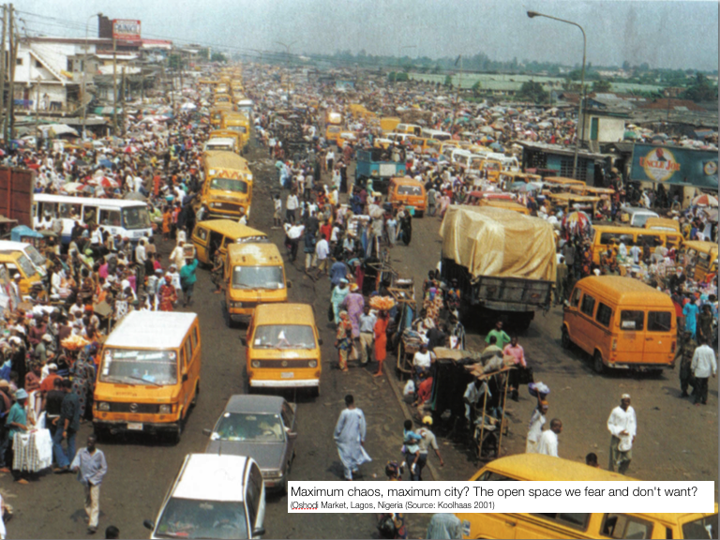

Figure 1.

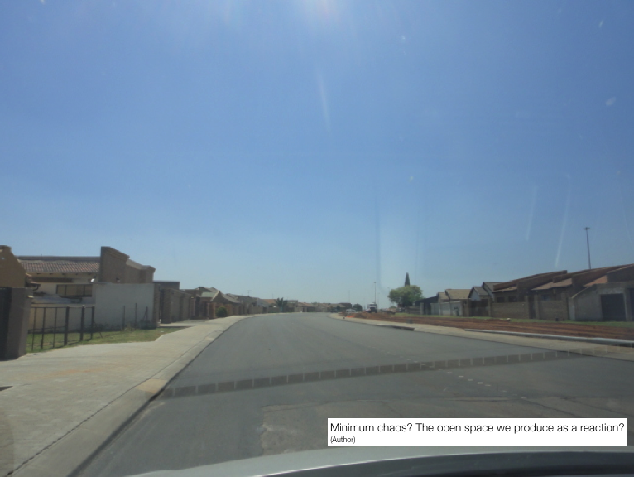

Figure 2.

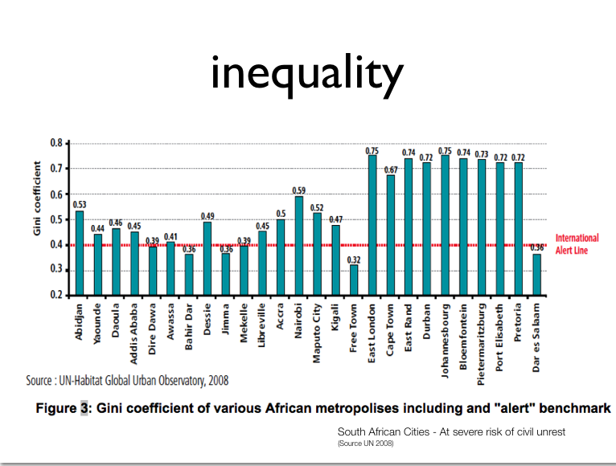

Figure 3.

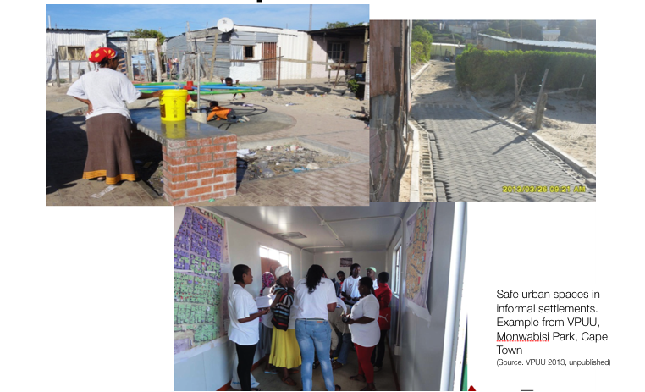

Figure 4.

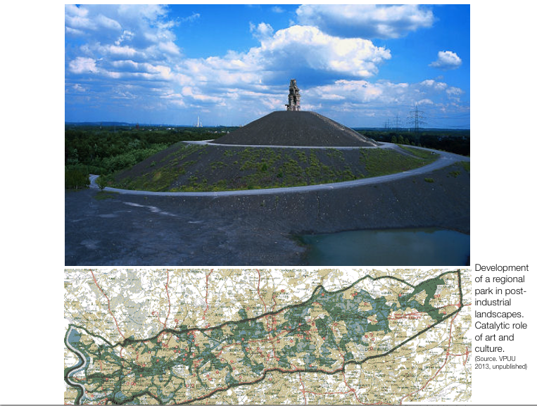

Figure 5.

1. This paper elaborates on a lecture presented by Prof. Peter Gotsch as part of the launch of the JCPZ public dialogue series "Towards an integrated strategy on urban safety in public open spaces in Johannesburg" on 21 October 2013. The dialogue series aims at creating a platform for learning and knowledge exchange between state and non-state actors.

   Dr. Peter Gotsch is Professor for International Cooperation and Urban Development at TU-Darmstadt in Germany; Ayanda Roji is General Manager: Corporate Research, Policy and Knowledge Management at Johannesburg City Parks; Blanca Calvo is an Urban Professional based in Barcelona and Johannesburg and an alumni of Mundus Urbano (TU-Darmstadt); Itzel Orregon is a 2'nd year Masters Student at Mundus Urbano in TU-Darmstadt.
2.
3. Urbanisation is a global trend. Urban Populations in emerging countries are forecasted to double in the coming 30-40 years. (Angel 2012). In 2015 the world will have 564 cities with more than one million residents (in 1995 the number was 195) (Brugmann 2009)
4. The South Africa part of this section is based on: Peter Gotsch, "An Urban Approach to Safety and Integrated Urban Development in South Africa: Knowledge and Policy Review ," Research paper, GIZ (Pretoria, 2013). The Johannesburg part is based on information obtained by the JCPZ.
5. This paragraph is based on a interview with the JCPZ department.
6. Bernhard Schäfers, *Stadtsoziologie. Stadtentwicklung und Theorien – Grundlagen und Praxisfelder* (Wiesbaden, 2010). (translated from German by the author). Schäfers largely daws on the exploration of Hans-Paul Barth's seminal work "Die moderne Großstadt" [The modern Metropolis]. (Bahrth 1969, Hamburg)
7. UN Habitat’s 2007 Global Report on Human Settlement focused on urban safety and security and emphasised the linkages of urban security with livelihood, youth development and community participation and empowerment. It has also put forward a risk management approach in dealing with insecurity.
8. The thinking is chiefly represented by Jeb Brugmann's (2009) book "Welcome to the urban revolution. How cities are changing the world" and Edward Glaeser's (2010) book " Triumph of the City: How Our Greatest Invention Makes Us Richer, Smarter, Greener, Healthier, and Happier.
9. The term originates from the UN-Habitat cities programme and awaits operationalisation.