First Contact with the Extra-Pedestrians,
Multi-level Narrative and Urban Actions for a Peaceful Invasion

Giovanni Campus
PhD Student, University of Sassari,
Department of Architecture in Alghero

Author Note
C/O Dipartimento di Architettura Design e Urbanistica, Palazzo del Pou Salit - Piazza Duomo, 6, I 07041 Alghero (SS); email: gicampus@uniss.it; mobile +39 3471560586.

First Contact with the Extra-Pedestrians,
Multi-level Narrative and Urban Actions for a Peaceful Invasion
(Figure 1) Pin with the logo of the project “ExtraPedestri”, developed in collaboration with the design course of the department of Architecture, Design and Urbanism at Alghero.
‘Extrapedestri’ is an ongoing campaign in the town of Sassari, Italy, promoted by the local municipality and developed on a project by TaMaLaCà, an all-female ‘research and action’ group of urban planners and architects from the University of Sassari.
The group’s project involves various urban actions structured around a powerful narrative: a contact with an advanced alien civilization, which has long ago abandoned the use of fossil fuels, and wants to help us to do the same.
The purpose of the campaign is not only to reduce pollution, but also to report and remove physical barriers that restrict the accessibility of urban areas and to ‘reconquer’ urban spaces for children’s play.
The purpose of this paper is twofold: to illustrate this and other campaigns and actions conducted by TaMaLaCà and the work of this group, as an inspiring model for others urban campaigns involving children, and to give some useful advice on how to design and manage a “playful urban narrative”.

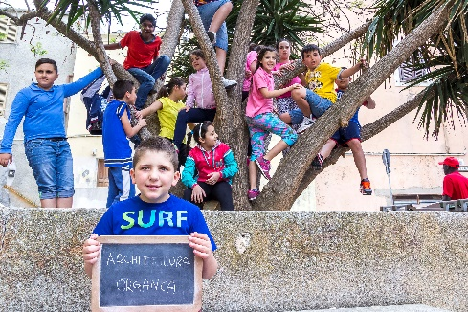
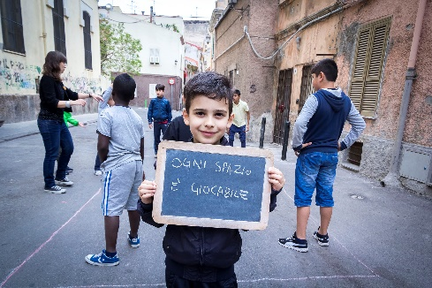
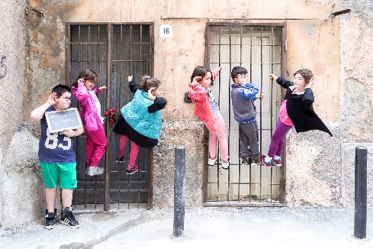
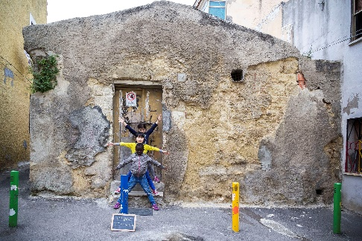
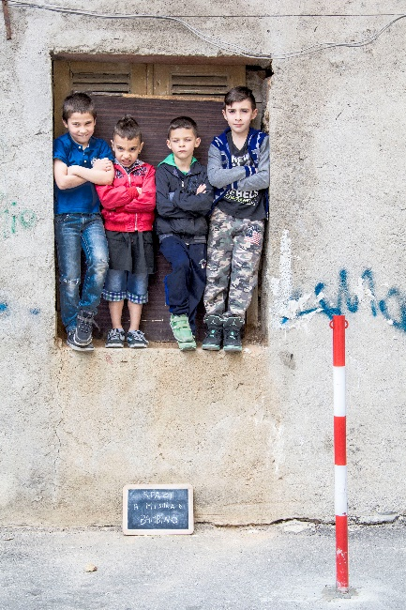
Play as a Serious Topic
(Figure 2) Urban actions realized during the Extra-Pedestrian project in the neighbourhood of San Donato. The signs read: ‘Children-measure spaces’, ‘Vitruvian Children’, ‘We are listening, listen to us’, ‘Every space is playable’ and ‘Organic architecture’. (Images courtesy Giovanni Campus)
From Johan Huizinga (Huizinga, 2009) to contemporary thinkers as Giorgio Agamben the importance of play in the construction of a culture has been pointed out. Play can be seen as the “third element”, the third motivation for human actions, being the first two the practical (or economic) and the sacred.
The toy is what belonged - once, no longer - to the realm of the sacred or of the practical-economic. But if this is true, the essence of the toy (that 'soul of the toy' which, Baudelaire tells us, is what babies vainly seek to grasp when they fidget with their toys, shake them, throw them on the ground, pull them apart and finally reduce them to shreds) is, then, an eminently historical thing: indeed it is, so to speak, the Historical in its pure state. (Agamben, 1993, pp. 71–72)
With that statement the philosopher wants to stress out the fact that historical process resides more on the ability of changing the meaning of things (and eventually changing “meanings” into “signifiers” and/or inventing new meanings for or from existing things) than on a necessitating, mechanical process going straight from causes to consequences.
Because of that, play is not only a free action, but it also speaks about freedom: the freedom of changing our environment through action.
Thus, to construct a more balanced city life we must stress on the play as a driving force for action, and recognize that the power of play is today still overlooked by planners and decision makers.
Play is a useful tool to devise and to conduct policies, projects and urban events in order to promoting urban quality of life of ‘weak’ individuals living in marginal urban areas. Contemporary city is designed and managed to meet mainly the needs of a “standard” citizen: adult, male, healthy, productive, wealthy, and (overall) car-owner. Individuals that do not match this ‘standard’ cannot exercise their own right to “use” the city: children, elderlies, women, disableds… Play can be used by these “weak” populations as a mobilization tool, in order to make them able to reclaim their own right to ‘use’ the city and to retake possession of denied public space, in a collective and constructive way. (Arras, Ghisu, Idini, & Talu, 2012)
Quentin Stevens in his 2007 book about ‘The Ludic City’ underlines the ‘non-instrumentality’ of play, citing authors from Lefebvre to Ghel, who pointed out the inherent opposition of play to instrumentality and to the issues of purpose, functionalism and productivity (Stevens, 2007).
Children in cities are the main ‘ambassadors’ of that attitude, constantly defying pre-defined functions. The ‘capability of disobedience’ that children have and might use to change the city to their advantage (and, consequently, to everyone's advantage) is one of the main reasons that lead TaMaLaCà to state that involving children in urban planning is an essential practice.
On a spatial perspective, children, have the ability of re-design, or re-invent spaces (and meanings) with the only help of their imagination. As the director of the San Donato School in Sassari told us during one of the Extra-Pedestrian actions: ‘children have the ability to transform the neglected corner of a neighbourhood in the hall of a castle, only with their presence, and their play’.

Why Children
Involving children is, first and foremost, a choice that looks to the future and it is therefore naturally oriented to sustainability. (Arras, Ghisu, Idini, & Talu, 2013) However, children are not only the inhabitants of the city of tomorrow; they are today, already, inhabitants of the city with full rights.
Focusing on children allows us also to lay the groundwork for the construction of a city more equitable and inclusive intercepting needs and aspirations of those inhabitants who, as children, are not able to fully use the city as it is today.
In the past, children used to play in the streets; today they are deprived of the opportunity to use the city and to increase their autonomy and their environmental skills. In our cities, children play and walk only inside ‘places for children’ and under strict adults’ control. Nevertheless, often children show the tendency to make the whole city playable and walkable autonomously.
Children are possibly the most disadvantaged group, with very little possibility of recognition for their citizenship and their ‘right to the city’. For their development they need to defy pre-defined functions, whereas in the modern city almost every forms pretends to follow a pre-defined (or arbitrary assigned) function. It is quite probable that the diffused hostility and the effective expulsion of children from the public spaces of modern cities is also due to their inability to use the places according only to their designed function.
We can see their tendency to ‘disobedience’ as a form of opposition they put up against those spaces and those streets, which are not capable to give an adequate answer to their need of autonomy and freedom. However, unlike many other groups of inhabitants, children lack the capability to organize themselves and therefore urban policies aiming at improving children's urban rights of accessibility and movement have to deal with that issue.
The Extra-Pedestrians project is an attempt to give structure, strength and visibility to children's action and therefore, to promote urban walkability.
Contemporary city is clearly a car-friendly city, and the car is the main adversary of children’s play in the streets (due to security issues related to moving cars) and in the squares (due to the occupation of space related to parked cars). The effects of traffic congestion on urban environment (road accidents; air, noise and aesthetic pollution; waste of time in traffic and, in particular, privatization of public spaces and soil consumption) cause a significant reduction of the urban quality of life, especially for those people who cannot or do not want to drive a car that cannot fully exercise their fundamental urban right to access and to use the public spaces and the streets.
Before the car came along, however, streets were often a common-a place of popular sociality, a play space for kids (I am old enough to remember that was where we played all the time). But that kind of common was destroyed and turned into a public space dominated by the advent of the automobile (prompting attempts by city administrations to recover some aspects of a "more civilized" common past by organizing pedestrian precincts, sidewalk cafes, bike paths, pocket parks as play spaces, and the like). But such attempts to create new kinds of urban commons can all too easily be capitalized upon. In fact they may be designed precisely with that in mind. (Harvey, 2012, p. 74)
So children, with their play, can help the contemporary city to get rid of that excess of private, moving and standing cars. Doing so, children can help all the citizens to recover their public spaces for sociality and community life. However, we need, in the first place, to help the children do that, also recognizing also at a city level and formally, their right to play (Tonucci, 2002).

Game and Narrative
Game theory emphasizes more and more the role of “narrative play”, helped in that also by gender studies. Women tend to prefer a game that is narrative; non-competitive and possibly endless (open). It seems also that men tend to adopt that kind of gameplay more than the opposite, and the game industry (specially the video-game industry) is well aware of that. As an example, we can cite the classic “Sim city” (a game, played equally by man and women, maybe not accidentally involving the construction and design of a city) and form the same producers “The Sims” and “Spore”, or the present apotheosis of games such as “Minecraft”.
Someone also thinks that we can also consider the so-called social networks as games bearing those characteristics.
In any case, part of the attractiveness of a narrative game resides in the fact that the player is able to influence the course of events, to change the story, to introduce new elements and to experiment with a basic plot and a basic set of rules. (See: Jenkins, 2004)
The more simple is the plot and the rules and the more can be the players, the more the players are, the more complexity we have to manage.
Brenda Laurel suggests that to keep control of what is more important in a narrative gameplay we have to look at the “formal cause” which is to say to the structure more than to the “content” and the outcomes of the narrative. That formal structure also refers to the “rhythm” of the story, and thus of the gameplay. (Laurel, 1993, 2009)
A good story gives you public’s attention, gets people engaged; but only a good “rhythm” – intended also in structural or architectural sense – keeps people engaged in the long run.
For the engagement of children, TaMaLaCà chooses to refer to simple science-fiction stories, very easy to understand and to share. The choice to avoid referring to local myths and legends to set the common ground reveals to be extremely safe and rewarding when working in a multicultural and multi-ethnic environment.

Multilevel Narrative
A special novelty in the Extra-Pedestrian project in the use of a more complex kind of narrative that we can call multi-level.
The timing of the various urban actions that form the campaign is partially set up in advance due to the necessary coordination with different offices of the local municipal administration and schools. As long as the main narrative goes on gaining depth and complexity, different “actors” gain the centre of the stage – groups of citizens, defined as “allies” of the alien race, and are asked to take different actions.
Also the background story is very deep, involving different characters (clearly inspired by the popular saga of Star Trek, such as the Captain Birk, commander of the spaceship, the communication officer Lieutenant Buhra or Mr. Stock, responsible for identifying allies and enemies) operating on the alien spaceship (named EP999) and in contact with planet Earth. There are also designed messengers (one of the most important is the local basketball team, and special “signs” of contact, but everything is conceived to allow every person who gets in contact to have the basic elements he or she need to understand the basic story and to interact. Who wants to go “deeper” in the story have all the elements he or she needs to do so.

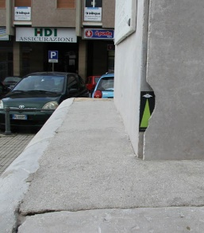
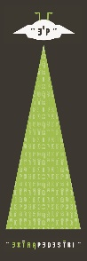
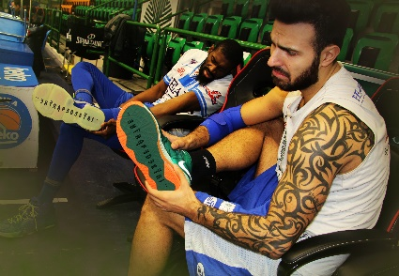
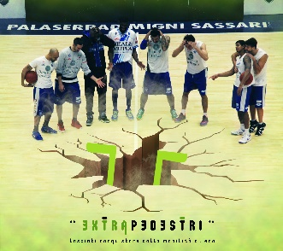
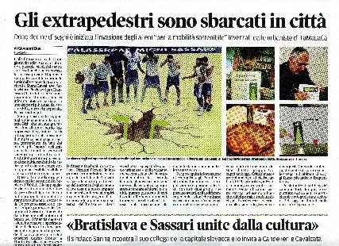
The Extra-Pedestrians Project
(Figure 3) Some of the elements of the communication campaign: stickers distributed to citizens to photograph and share online, the involvement of the local basketball team, and the local media collaboration, announcing the ‘alien invasion’. (Images courtesy TaMaLaCà)
The Extra-Pedestrians project presents an evolution in terms methodology and complexity of other previous projects form the TaMaLaCà group, briefly described below, and take into account the most important and recent international experiences and studies.
Professor Giancarlo Paba from the University of Florence has devoted much of his work to the study of the urban condition of children. Participation, for him, according also to Friedmann (1999) means “expansion of citizenship” (Paba, 2003). Expansion in the direction of more disadvantaged citizens, obviously, who can also bear the most refreshing contributions for the evolution of city-life.
Hence, in the Extra-Pedestrian project not only children, but also groups of cyclists, people with disabilities, parents driving a stroller, women, and elderly are involved as allies by the “alien race” through an effective multi-level communication campaign that mixes classic and new media.
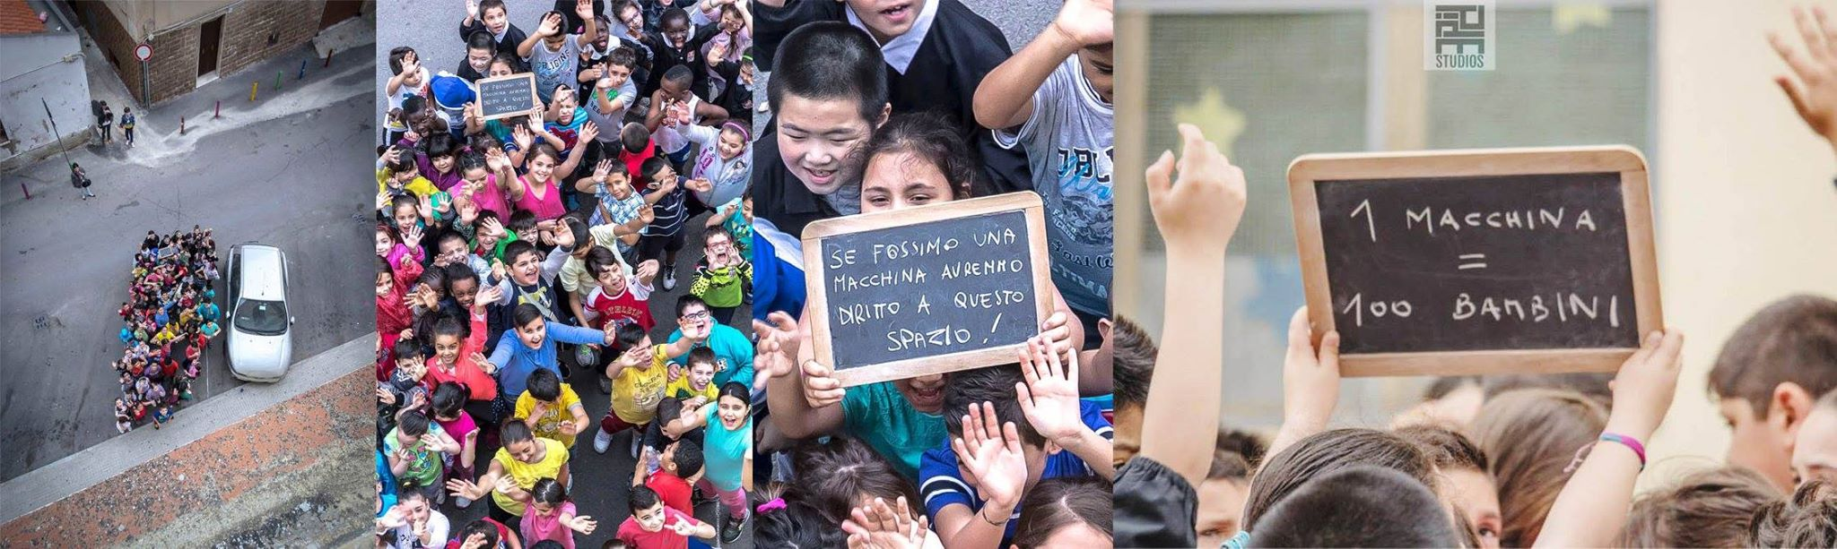
Each group has to take a specifically designed action that in addition to mobilize it requires it to spread communication and build consensus.
Figure 4: Urban action involving children from the project Extra-Pedestrians, in the city of Sassari. (Images courtesy Giovanni Campus and PIPE Studios).
As an example of action involving children, the day 15 of May 2015, the children take over a central square normally occupied by parked cars. Guided by a professional choreographer from a renowned street theatre group called Theatre en Vol, the children created coloured choreographies to restore the beauty and vitality of neglected corners of the neighbourhood (see figure 2). They also tried to show experimentally, in a provocative action, how many children can ‘fit’ into the space normally occupied by a parked car. The visual result of that action astonished in its simplicity. Almost a hundred children from the primary school can fit in that not-so-little space. On a signs that the children were holding during the action it was written: ‘If we were a car, we will have the right to that place!’ And: ‘1 car = 100 children’. (Figure 4) The question raised from that action, addressed to the neighbourhood community and the whole city population, was very simple: why the children have to play at home, while the car can occupy the street or the square? Thanks also to the power of the images produced and to the unquestionable message, that action gained a great visibility on local media, spreading consciousness in the inhabitants about the need to free the spaces for children’s play.
One of the final actions in the Extrapedestri campaign will be the temporary transformation of some parking space in that square, through a self-construction workshop, in playable spaces for children, to build consensus in the neighbourhood for the progressive and spontaneous elimination of private cars from the square near the school.
Near another school in the neighbourhood of Monte Rosello, where the problems for children are related to the cars running in the street near the school, there will be more permanent interventions aimed to invert the hierarchy of values between children and car (see figure 5).
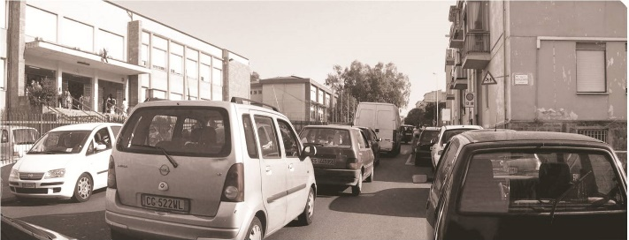
There will be also other interventions based on the use of colour to redefine and give relevance to the pedestrian paths of children to/from the school; those interventions are also briefly explained below in this paper.
Figure 5: The access to the Monte Rosello school, before (left) ad after (right, rendering). Notice evidenced pedestrian paths and the raised pedestrian crossing that allows for a more safe crossing and ‘declares’ the inversion of the hierarchy between the children and the car. (Images courtesy TaMaLaCà)
Paba in the same book cited above also recognizes the special “spatial competence” of children and declares also on that basis the right to the city also for the children, provocatively calling to a “children’s liberation war”, that in some way resonates with the idea of the “Children’s Liberation Front” conceived by TaMaLaCà in the “FLPP” project, mentioned below.

The TaMaLaCà Group and Metodology
TaMaLaCà is from 2013 an official Spinoff of the University of Sassari offering professional consulting services for the design and management of policies, projects and events geared to the promotion of the quality of urban life and the construction of an inclusive city.
It is not possible to explain briefly the richness and articulation of the work of the TaMaLaCà group that defines itself as a “laboratory of research and action”.
We will try to take account at least of the main methodologies and themes of the group referring to how TaMaLaCà identifies it (or her)self.
TaMaLaCà is a bizarre acronym from the phrase Tutta Mia La Città (The City’s All Mine) that also recalls the notes of a popular song from the late ‘60s. That playful joke wants
In a 2013 conference proceeding from the XVI National Confenece of the SIU (Società Italiana di Urbanistica - Italian Society of Urban Planners) they ironically call themselves the “suffragettes of denied urban rights” (Arras, Ghisu, Idini, & Talu, 2013) and we can tell for sure that gender awareness plays a major part in the work of TaMaLaCà.
They conceive the contemporary role of planners in western cities in relation to the necessity to ‘fine tune’ and ‘re-synchronize’ the general planning with to the specific diversity of the bodies of the multitude of different inhabitants. They are firmly convinced that the contemporary role of urban planners is to imagine, design and build forms, functions and rhythms that - accepting the multiplicity of ways and times of ‘functioning’ of various inhabitants are able to guarantee to each and every one for the full, free and effective use of the city.
As a conceptual framework they make explicit reference to the works of Amartia Sen on the capability approach as developed also by Martha Nussbaum (Nussbaum & Sen, 1993; Sen, 1992, 1999, 2009) and, at the same time to the ‘Work in Progress’ concept as defined by Accolla and the Design for All (DfA) approach (Accolla, 2009).

DfA + Capability Approach: the conceptual framework.
The original perspective of their work comes out form that particular intersection and from the attempt to bring together the two apparently distant Capability and the DfA approaches.
According to the ‘Stockholm Declaration’ Adopted on 9 May 2004, at the Annual General Meeting of the European Institute for Design and Disability in Stockholm the Design for All
Design for All is design for human diversity, social inclusion and equality. This holistic and innovative approach constitutes a creative and ethical challenge for all planners, designers, entrepreneurs, administrators and political leaders.
Design for All aims to enable all people to have equal opportunities to participate in every aspect of society. To achieve this, the built environment, everyday objects, services, culture and information – in short, everything that is designed and made by people to be used by people – must be accessible, convenient for everyone in society to use and responsive to evolving human diversity. (“The EIDD Stockholm Declaration 2004 - EIDD - DfA Europe”).
The Capability Approach, on the other hand, considers the personal well-being as a process of interaction of the person with the context, thus, goods, commodities, artefacts, cannot be used as a parameter for measuring or defining the well-being, nor they can be conceived as valuable per se. But what the Capability Approach maybe is missing is the relevance of technology, engineering, and design for capability expansion (Oosterlaken, 2009).
We will illustrate now briefly the main recurring themes and instruments that characterize the work of TaMaLaCà: the ‘micro’ size of the projects, the involvement of the citizens and the constructive use of the conflict. Being women also has a special meaning for the group (Arras, Ghisu, Idini, & Talu, 2013), as it has the choice to work as a group, a “partisan collective” (Selli, 2012). Women are enabled to create new, trust based alliances that can link local communities to political and technical decision makers.

Micro-projects.
TaMaLaCà promotes interventions of micro urban transformation to improve and extend the usability of the proximity and the quality of everyday life. The small size of the interventions is appropriate for several reasons: facilitates the attention of the project to the specific characteristics of individuals and makes possible a real involvement and participation, enables the reformulation of the project in real-time according to contraction and expansion of the demands of the people involved, to technical or political issues, and also to previously unforeseen opportunities.
Designing on a small scale makes it also easier and more relevant to designers to pay attention to design details (Gehl, 1987). The micro size low cost also makes the projects more able to get space in the local authorities’ agenda. (Arras, Cannaos, Ghisu, Idini, & Talu, 2012; Talu, 2014)

Citizens’ involvement.

Contructive use of conflict.

Other Projects

FLPP
The theme of the contact with the future (and hence of the consequences of people’s present actions) was already used in other urban initiatives by TaMaLaCà group such as “FLPP - Fronte di Liberazione dei Pizzinni Pizzoni”. That project has also been chosen to be included in the publication “Global Public Space Toolkit”, edited by UNHABITAT (Public Space Toolkit, 2015) as the 18th case study in a list of 60 urban actions chosen all over the world by an international team of experts for their effectiveness in improving the availability, quality and distribution of good public spaces. Also according to that publication
Storytelling was an extremely useful tool for showing children that their actions today could really make a difference in the future. The inhabitants – together with municipal administrators, teachers, architects and urban planners – have been ‘infected’ by the enthusiasm of children and have been encouraged the forgotten and neglected public spaces of their neighbourhood through colour, play and self-building. (Public Space Toolkit, 2015, p. 72)
The pro project also received the first prize in its category at the 2013 Biennial of European Towns and Town Planners in Cascais (Portugal).
The project “FLPP. Fronte di Liberazione dei Pizzinni Pizzoni” (Pizzinni Pizzoni Liberation Front), was in fact the first experiment to prove if playing can be used as an innovative way to teach and learn sustainability values and as a tool to claim the right to the city and to involve children and adults in a process to re-conquer their public space.
The project involved the disadvantaged neighbourhood of San Donato, in the city of Sassari (Sardinia) and aimed mainly at freeing the streets and the public spaces from parked cars, and to bring them back to pedestrians and to children’s play.
Involving inhabitants was a very difficult task, especially because the project must deal with the complexity of the problems of a disadvantaged neighbourhood.
TaMaLaCà chose to motivate and engage children and all the inhabitants through storytelling, which has been the starting point of a playfully mobilization.
The group invented a dystopian tale, taking place in the city in the year 2046. Then, after a short “teaser” campaign rising attention on the operation they delivered the dystopian tale to the children, in the form of an SOS message "from the future". All the children have accepted the challenge and have decided to help their “great grandchildren” to reach their goal: to change the future (2046) through actions that take place in the present (2012)!
The first tangible result of the project was the organisation of various urban events, during which the inhabitants of the neighbourhood - together with municipal administrators, teachers, architects and urban planners - have been "infected" by the enthusiasm of the children and have been encouraged to reconquer the "forgotten" and neglected public spaces of their neighbourhood through colour, play and self-building.
Above all, storytelling has been extremely useful for showing children that their actions in the present could really make the difference in the future: we believe this is an amazing way to talk to children about sustainability. (Arras, Ghisu, Idini, Nattivi, & Talu, 2013; Arras, Cecchini, Ghisu, Idini, & Talu, 2012; Arras, Ghisu, et al., 2012)

PortaColori
In the “PortaColori” (Colour-bearer) project, as the name suggests, TaMaLaCà explores the use of the colour as the main, fast and inexpensive instrument to change the perception, and the use, of a space.
PortaColori is a play space located in the primary school courtyard in the Monte Rosello neighbourhood of Sassari.
A participated process involving children, parents and teachers led to collective construction of the project to restore the schoolyard of the primary school. That courtyard o was always perceived and used as a public space of the neighbourhood and not simply as an area belonging only to the school. TaMaLaCà intended to devise a project that would give an efficient answer to the realistic demands and requirements of the children that arose during the participated design phase and, at the same time, would be able to support - multiplying and enriching them - the actual and present uses made of the space by the various inhabitants.
The use of colour has granted to the space a strong visual identity, reinforcing the sense of belonging to a space that everyone now knows, considers their own and regularly visits.
Colour highlights the public, “popular” character of the place, allowing it to emerge in a carefree, creative way from the widespread surrounding greyness. Furthermore, colour in this case is also an instrument of joyful contagion; it attracts glances, encourages games and free time activities and brings these back into the public space dimension of the neighbourhood.
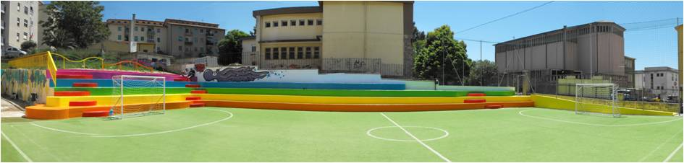
Figure 6: The space called “Portacolori” in the Monte Rosello neighbourhood of Sassari (Images courtesy TaMaLaCà).
Figure 6b: The “Portacolori”. Also the new fence of the playground is conceived as a playable space! (Images courtesy TaMaLaCà).
The transformative use of colour has been reprised in the following projects by the group and is present also in the Extrapedestri campaign, as a part of the re-design and signalling of the children’s path from home to school and back. That element of the campaign is called the “Piedibus” (from “piedi”, italian for “feet” + “bus”, as a system of public transportation). Each Piedibus route is then marked by specific colouring, which makes both the routes recognisable and highly visible as they develop and the stops and areas around them, points of meeting-communication-information characterised by “special” posters. This recognition is guaranteed by creating ad hoc signposts, route by route, constituting an initial intervention of a material, temporary nature. Devised especially for the population of boys and girls (and therefore all pedestrians), these signposts try to overthrow the consolidated hierarchical order of road uses: they are moved onto the pavement, they know the role it plays, and they creatively highlight the pedestrian crossing and invite drivers to behave more carefully. (Cfr. Arras, Ghisu, Idini, Saba, & Talu, 2014; Arras, Cannaos, et al., 2012; Selli, 2012)

References
Accolla, A. (2009). Design for all: il progetto per l’individuo reale. Milano: Angeli.
Agamben, G. (1993). Infancy and history: the destruction of experience. London ; New York: Verso.
Arras, F., Cannaos, C., Ghisu, E., Idini, P., & Talu, V. (2012). Micro-progetti di rigenerazione urbana nelle periferie: l’esperienza del Portacolori a Sassari. In Atti della VII Giornata di Studi dell’INU. Napoli.
Arras, F., Cecchini, A., Ghisu, E., Idini, P., & Talu, V. (2012). Il gioco come strumento di riconquista degli spazi pubblici negati: l’esperienza del Fronte di Liberazione dei Pizzinni Pizzoni nel rione storico di San Donato a Sassari. In Atti della VII Giornata di Studi dell’INU. Napoli.
Arras, F., Ghisu, E., Idini, P., Nattivi, L., & Talu, V. (2013). Il Fronte di Liberazione dei Pizzinni Pizzoni. Dispositivi ludici per concrete utopie. In Atti del Convegno Rebel Matters Radical Patterns. Genova.
Arras, F., Ghisu, E., Idini, P., Saba, M., & Talu, V. (2014). Rendere straordinario l’ordinario. Il colore come strumento di rivendicazione, riconquista, risiginificazione e trasformazione urbana. In E. Cicalò (Ed.), Progetto, ricerca, didattica: l’esperienza decennale di una nuova scuola di architettura (pp. 399–410). Milano, Italy; Alghero: FrancoAngeli ; Facoltà di architettura di Alghero.
Arras, F., Ghisu, E., Idini, P., & Talu, V. (2012). Riconquistare lo spazio pubblico giocando. L’esperienza del Fronte di Liberazione dei Pizzinni Pizzoni nel quartiere di San Donato a Sassari. In Atti delle Giornate Internazionali di Studio “Abitare il Futuro” II Edizione. Napoli: Clean.
Arras, F., Ghisu, E., Idini, P., & Talu, V. (2013). TaMaLaCà - Tutta Mia La Città. “Suffragette” dei diritti urbani negati. In Atti della XVI Conferenza Nazionale SIU. Napoli.
Gehl, J. (1987). Life between buildings: using public space. Washington, DC: Island Press.
Harvey, D. (2012). Rebel cities: from the right to the city to the urban revolution. New York: Verso.
Huizinga, J. (2009). Homo Ludens: a study of the play-element in culture (30. print). Boston: The Beacon Press.
Jenkins, H. (2004). Game design as Narrative Architecture. In N. Wardrip-Fruin, P. Harrigan, & M. Crumpton (Eds.), First person: new media as story, performance, and game (pp. 118–130). Cambridge, Mass.: MIT Press.
Laurel, B. (1993). Computers as theatre. Reading, Mass: Addison-Wesley Pub. Co.
Laurel, B. (2009). Designed Animism. In T. Binder, J. Löwgren, & L. Malmborg (Eds.), (Re)searching the digital Bauhaus (pp. 251–274). London: Springer.
Nussbaum, M. C., & Sen, A. (Eds.). (1993). The Quality of life. Oxford [England] : New York: Clarendon Press ; Oxford University Press.
Oosterlaken, I. (2009). Design for Development. A Capability Approach. Design Issues, 25(4), 91–102.
Paba, G. (2003). Movimenti urbani. Pratiche di costruzione sociale della città. Milano: FrancoAngeli.
Public Space Toolkit. (2015). Global Public Space Toolkit, From Global Principles to Local Policies and Practice. Nairobi: UN-Habitat.
Selli, S. (2012). Partisan Collectives as Breeding Grounds for an Active Citizenry. In Living Landscapes - Landscapes for Living Conference Proceedings.
Sen, A. (1992). Inequality reexamined (Reprint). New York: Oxford Univ. Press.
Sen, A. (1999). Development as freedom (1st. ed). New York: Knopf.
Sen, A. (2009). The idea of justice. Cambridge, Mass: Belknap Press of Harvard University Press.
Stevens, Q. (2007). The Ludic City. Exploring the Potential of Public Spaces. London; New York: Routledge.
Talu, V. (2014). Periferie al centro. Un progetto di promozione della qualità della vita urbana delle popolazioni al margine. In E. Cicalò (Ed.), Progetto, ricerca, didattica: l’esperienza decennale di una nuova scuola di architettura (pp. 361–370). Milano, Italy; Alghero: FrancoAngeli ; Facoltà di architettura di Alghero.
The EIDD Stockholm Declaration 2004 - EIDD - DfA Europe. (n.d.). Retrieved June 2, 2015, from http://dfaeurope.eu/what-is-dfa/dfa-documents/the-eidd-stockholm-declaration-2004/
Tonucci, F. (2002). Se i bambini dicono: adesso basta!. Bari: GLF editori Laterza.

