Public Space and the Problems of Practice

Professor Robert Adam

ADAM Urbanism, University of Strathclyde

Author Note

Professor Robert Adam, ADAM Urbanism, University of Strathclyde

Correspondence concerning this paper should be addressed to Professor Robert Adam, ADAM Urbanism, Old Hyde House, 75 Hyde Street, Winchester, Hampshire, SO23 7DW, United Kingdom. Email: Robert.Adam@adamarchitecture.com

**Abstract**

The provision of public open space is widely accepted as a public good and has been a requirement for a century or more in most developed nations.  The experience of providing this space in new developments should inform emerging best practice. This space is required, defined and allocated in a design process and this process has an impact on the final outcome that is not always beneficial.  An analysis of design procedures, the impact of multiple interests, confusion of function, and the problems of scale identifies inappropriate outcomes and suggests improved urban design procedures.

**NEW PUBLIC SPACE AND THE PROBLEMS OF PRACTICE**

In the early twentieth century European revulsion at the density and insanitary nature of slums led to proposals to improve the lot of impoverished and disadvantaged city dwellers. Their cramped environment was seen as a major social evil. In Britain, social reformers took slum children on organised trips to farms and villages. Followers of the Arts and Crafts movement created new working communities ennobled by hand labour and relocated to the countryside. Similar ideals affected urban design. The Garden City Movement set out to create self-contained societies based around utopian settlements interspersed with lavish, green, public spaces. The Modern Movement proposed raised dwellings above the ground in blocks and towers to open up an entire sanitised landscape of open space below and between the blocks and towers. In America, the plan of Radburn in New Jersey modified the Garden City form to an organic branching road system that pushed clusters of dwellings into parkland and this was widely adopted internationally as the ‘Radburn Plan’.In these and other ways public open space became an essential part of social and environmental reform and a virtue just by its presence.

These principles are now built into planning regulation in most developed nations. The areas regulated for public space are often considerable but vary from authority to authority. In UN-Habitat (2014) it recommends 50 percent for public use, of which 15 to 20 percent would be for open spaces. A virtue has been turned into an obligation. Plans must include large areas of public and green space which is often allocated diagrammatically through proposed new developments.

With new slums in developing nations of a scale unimagined even in the darkest days of the European industrial revolution there is the same urgent call for public space. If political, social and economic solutions to the creation of the dense illegal and informal settlements created by rapid urbanisation are found (and surely particular solutions to particular conditions will be found) the provision of public open space will almost certainly be a requirement in whatever shape the reformed urban settlements will take. This has been formalised in the *Charter of Public Space* which is specific on this issue:

In extension plans of newly urbanising cities, whose populations will double over the next 10-20 years (Africa and Asia), it is very important to guarantee sufficient amounts of well-connected and adequately proportioned public space.

(UN-Habitat [2013 paragraph 24].)

and in the UN-Habitat *Public Space in the Global Agenda for Sustainable Urban Development*:

A special focus is on cities in the Least Developed Countries, and cities with high percentages of their population living in slums and in unprivileged circumstances.

(UN-Habitat [2014, 11].)

With the experience of decades of regulated space provision in the developed nations, it would be sensible to look at how this space has been designed into major plans and learn from its successes and failures.

The first and most elementary principle is that space is not a virtue just by its presence. Large developments after the Second World War that followed the Modern Movement principles of vertically-arranged, isolated residential towers and blocks sitting above large swathes of open and green space, demonstrated with great clarity that the provision of space alone does not necessarily improve the quality of life. Indeed, they were so damaging that they created nostalgia for the social cohesion of the tight urban spaces they had replaced and spawned some of the urban design movement most prominent today.

The second principle is that space is not a stand-alone virtue. Space of any benefit to an urban area is only part of a complex system of social life, distribution of uses, roads and footpaths, planting and ecology and much more besides. The individual benefits of parkland settings at the terminal ends of branching road systems in Radburn Plans were outstripped by traffic congestion at the principal stems of these branches and the social isolation in the terminal clusters.

Public open space can be desolate in its untended openness and unpoliced landscape can be dangerous. Public squares can be barren and abused or the assembly places of antisocial gatherings. Wide streets can separate activities side to side and be places of tangible danger from moving traffic. There is clearly more to the objective of creating public space than just providing space.

**Creating Public Space as a Process**

Broad principles aside, the provision of public space finds its way from what is usually a documentary, quantitative obligation to a diagram showing the dispersion, size and disposition of space on a plan. The transition from a regulatory obligation to the disposition of space in a specific location is the first stage of a design process. This process, as a process, in all its stages, from the first diagrammatic indication of the allocation of land for public space to the on-the-ground provision of the space, has a major impact on the final design. These processes are often self-serving and have no necessary connection with the quality or practicality of the final product. The urban design process and the nature of the regulatory system often have a distinct impact on the experience of completed urban spaces on the ground. This is not always beneficial.

Before examining how the process affects the end result, we will limit aspects of public space to be discussed.

In the *Charter of Public Space* public space is given a very wide definition as ‘all places publicly owned or of public use, accessible and enjoyable by all for free and without a profit motive’ (2013, 3) and in UN-Habitat (2014) the range of typologies is very wide: in summary, it is all public and semi-private interior and exterior places to which the public may have access. This includes regular streets and footpaths, where the provision of space is either unavoidable for practical reasons, or museums or civic centres, where its public nature is defined by economics or legislation.

This paper will limit its discussion to major and minor open urban or suburban space, either planted or with hard surfaces, of a width greater than simple two-way streets with pavements. Space is taken as that area which contains little or no permanent building and is measured from the face of buildings that define its edge and includes all movement corridors within it. This paper will address these spaces according to five categories:

* parkland and open green space;
* traffic-dominated streets and boulevards;
* residual space;
* building-centred space; and
* small and large scale urban space.

The discussion will not address the provision or the improvement of public space in existing urban areas. There are distinct and well-established disciplines for the identification and design of space to serve existing communities. Community consultation has an excellent and widely published series of methodologies and there is little doubt that, in this important aspect of public space policy, the success of urban spaces is directly related to the active support and involvement of the relevant communities.

Unlike the provision of space in existing urban areas, in large urban extensions and new communities, public space is created *de novo* and without any established community. This gives greater freedom in the allocation and design of these spaces that, at first sight, would appear to be an advantage. The lack of opportunity for any direct consultation with real end-users and the freedom to set up a public space network and design with limited constraints, on the contrary, makes this much more challenging and susceptible to the influence of process over design quality.

Furthermore, the allocation and distribution of public space beyond any regulatory requirements is a process of negotiation between a range of professional and expert participants, each with a specialised interest that may concentrate more on the expert area than the over-all quality of the outcome as part of a living community. A typical master-planning team might include a highway engineer, a landscape architect, a civil engineer, and an ecologist as well as a planner, designer or master-planner. Each professional may have an equivalent bureaucrat with whom they will negotiate to achieve permission for what they propose in their area of responsibility in the plan. This complex process of negotiation, internal and external to the master-planning team, is bound to have an impact on the final design and will vary considerably according the formal and informal distribution of power and influence between all participants.

The key instrument for the planning and identification of all exterior urban space is the preparation of plans on a descending scale. Master plans for any areas above 50 hectares are usually first drawn at a paper scale or effective digital scale of between 1:25000 and 1:2000. At this scale the principal armature of streets, blocks and open spaces can only be indicated diagrammatically, but it is normal for the key decisions on the allocation, distribution and quantum of public space to be fixed at this stage. Where space is a regulatory obligation, this allocation and distribution is often checked and ratified by the relevant authorities at this scale and acquires a legal level of fixity. Any subsequent changes will be avoided in case a new decision-making and approval process is required. At a paper scale of 1:2000 a normal street 10 metres wide is 5mm wide; public spaces the size of Union Square in New York, Trafalgar Square in London and Pariser Platz in Berlin are, respectively, 120 by 70mm, 110 by 110mm, 50 by 43mm. These look very small. Intimate spaces hardly register at all.

As the planning process descends through the scales to a paper scale of 1:500, where it is possible to identify individual buildings with reasonable clarity, the spatial decisions made at these larger scales tend to be maintained. This has an impact on the design of different kinds of public space.

**Parkland and Open Green Space**

The regulatory obligation to provide open green space is usually based on the principle that green urban space in particular is good in itself and part of that merit lies in quantity. In initial use allocation, green or planted space, together with water bodies, are often represented as undifferentiated areas. Formal parks, green squares, corridors for wildlife, nature reserves and even formal recreation and sports facilities are often conflated. Parks, wildlife corridors or nature reserves, while subject to very different forms of use, might share similar and linked ecological roles. They will, however, be subject to different professional and regulatory interests, divided between ecology, landscape, leisure activity providers and, particularly in the case of surface-water drainage, civil engineers or hydrologists, all of whom will be designing and protecting quite different functional interests.

At an early stage in the design process there is often little purpose or incentive to differentiate with any or much precision precise functions as they can all be summarised and represented as planted, green, or green and blue. Large scale plans often show wide corridors of green space woven into new urban layouts, with little regard for the fine grain of their ultimate use and the differentiation that should take place as planning is taken down to a smaller scale. This lack of differentiation and quality measured by quantity creates disjointed urban plans where clusters of development are separated by parkland and open green space with little regard for their ultimate function. Fig. 1.

An early lack of distinction between the functional requirements of parks, green squares, semi-public gardens, children’s play areas, sports facilities, nature reserves and landscaped pathways can lead to poorly defined and controlled public space. Urban parks, green squares, semi-public gardens and young children’s play areas require high levels of security, management and maintenance to avoid anti-social behaviour, provide appropriate facilities and maintain surroundings of sufficient quality to attract a wide range of users (*see* below). This normally entails enclosure and, except in the case of large peripheral or central parks, close integration with built development and the proximity of users. Nature reserves and wildlife corridors are uncomfortable partners with highly maintained landscaped areas and dense occupation and, when wildlife corridors are confused with pedestrian and cycling paths, they can create unsupervised and unsafe areas.

**Traffic Dominated Streets and Boulevards**

While it is widely accepted that the dominance of the motor vehicle is undesirable and should be supressed and controlled wherever possible and a series of well-established techniques have been developed to achieve this, motor vehicles will still circulate in all modern developments. Motor vehicles will not just include cars and delivery vehicles but will also include refuse collection vehicles and fire engines. Each of these vehicle categories can come under the control of different authorities. While there has been an international concentration on the restraint of private motor vehicles and, in some cases, the size of domestic and town-centre delivery vehicles, the efficient collection of refuse and the most up-to-date fire engines are rarely subject to any such constraint. Efficient and, with an increased emphasis on recycling, more complex refuse collection is a civic cost and often leads to larger and larger and more mechanised collection. The life-saving credentials of fire rescue will trump all other considerations and no-one will wish or be permitted to restrict access to whatever size engine the fire service is using or likely to use.

Although there have been reforms in the design of highways which have given more emphasis to pedestrian use and safety than the smooth and speedy circulation of vehicles, the design of roads and pavements is still based on the role of the design to ensure safety rather than the responsibility of the individual driver or pedestrian. Increased safety is a very hard argument to resist. For all the new attitudes to vehicle movement, new roads are almost always significantly wider than well-used roads in many, particularly European and Asian, historic centres. In spatial terms, vehicle turning geometry, the separation of vehicles and people, combined with the concomitant residual space (*see* below), dominate the appearance of most urban roads.

In addition to highway engineers, other professionals and authorities can lay claim to highway land. Underground service providers for water, gas or electricity, once located in highways, are often now in dedicated strips alongside highways over which not only can there be no traffic, pedestrians or built form of any kind, but also no trees (indeed even adjacent trees can be prohibited or controlled by root restricting structures).

This combination of authorities and requirements often results in larger than necessary street widths and emergency or servicing access allowances, either rarely or never used, but which cannot (although often does) even take parked vehicles. The spatial consequences are not set by the quality of the space as a place, but by other interests.

Perhaps the most anomalous surviving highway-dominated feature, which seems for some reason to have taken on a positive identity in modern urban design, is the boulevard. The origins of the boulevard lie in nineteenth-century European urban planning. The term originates in the replacement of city walls with wide streets (the word originally meant the top of a rampart) and became a positive feature of Haussmann’s re-planning of Paris, leading to the terms ‘boulevardier’ or ‘flaneur’ for an idle stroller. The concept was exported to the USA and took on a different form, often stretching in a straight line and unrelieved for large distances as part of Jeffersonian-grid patterns which define planning in the USA to this day. In time they became a means of separating fast-moving through traffic from local traffic, with the separation usually marked with trees. It is from this source that the type seems to have spread to influence urban design internationally. Other than the planting of trees, these wide streets have little to recommend them (and should not be confused with avenues or tree-lined streets). Their width creates a distinct barrier to cross-street activity – identified as far back as 1961 by Jane Jacobs (1916-2006) as an important community function - and the ease they give to fast-moving traffic contradicts all other measures that have been developed to restrain traffic movement in urban areas. Fig. 2.

**Residual Space**

When there are generous requirements for public space in new development land such as greenfield sites, redundant industrial areas and port facilities, or land expropriated for highway improvement, highway design, utility strips, building set-backs and poorly detailed planning create substantial areas of residual land. Residual land does not originate with a designed intent to provide useable public space, but is a by-product of other planning requirements. It is sometimes called by the ironic English acronym SLOAP, ‘Space Left Over After Planning’. These spaces are often planted and included in open space calculations but, unless they have a positive use, more often than not become ill-maintained and serve no useful function. Other than superficial ‘greening’ their impact can, in aggregate, become significant and damaging to the coherence of urban areas and remove land which otherwise could be put to good use with small-scale development. Fig. 3.

**Building-Centred Space**

A particular feature of late-twentieth and early-twenty-first-century design is the stand-alone feature building or ‘iconic’ building. The origins of this phenomenon lie in global city branding and the concept has become so pervasive that local governments often specify that new buildings should be ‘iconic’, ultimately degrading the concept itself. Unlike prominent civic buildings of the past, which often commanded or addressed major civic spaces with a principal façade or façades, the contemporary iconic building is often given a three-dimensional setting so that the complete design can be seen in the round, more as a very large public sculpture rather than as an integrated city function.

Due to the size, expressive complexity and assumed significance of these frequently very expensive buildings, they are usually given major areas of surrounding space so that they can be viewed in the round and from sufficient distance to appreciate the whole structure. Often, this space has no prior urban function and, even when the buildings are auditoria or have other public assembly functions, this space far exceeds the spill-out or queuing space for full occupation. Fig. 4.

These spaces can take on an active function as useable public space but this will require a positive intention to do so and appropriate management (*see* ‘Small and Large Urban Spaces’, below) as well as a location that will attract users. As this is rarely the primary consideration of this building-centred space it will often remain as space with no useful public function, taken over by informal or antisocial activities or deserted for much of the day.

**Small and Large Urban Spaces**

Integrated urban spaces are an essential ingredient of successful urban design. They are quite different from parkland and open green space, although they may be planted and contain gardens. They include squares, public and semi-public gardens and small informal spaces.

With the descending-scale planning process described above, early identification of integrated urban spaces tends only to show major examples. This can have a significant impact on the design and distribution of these spaces. Generally, there is a strong tendency to create only large spaces and often spaces which prove to be grossly oversized for their urban function. The important network of small urban spaces, sometimes little more than 15 or so metres square (called ‘vest-pocket parks’ in the USA), simply cannot be adequately represented at scales greater than 1:1000 and cannot be designed until the layout is at a scale of around 1:500.

Large urban spaces, more than about 75,000 square metres, should be judged by the first and elementary principle set out above: space is not a virtue just by its presence. Historically, large urban spaces have had national-display functions - such as the location for monuments or as parade grounds or both - or market and temporary trading functions. Nationalist displays require maintenance and policing to avoid the degeneration of the space and so the national pride they are intended to promote. Market functions have always been subject to strict civic control. Large urban spaces additionally have symbolic status as the primary space for public gathering and, as such, usually contain buildings with civic functions. These can be used for both benign and protest gatherings. Beyond these functions there are limited uses for large public spaces that are not managed parks or squares. Fig. 5.

Large spaces with no function appropriate to their size are a poor use of urban land and can have a negative rather than a positive impact, becoming little used, poorly maintained or used for antisocial purposes. Attempts to give them relevance with public art are rarely sufficient. Art is not a function but a decoration and will only make a good space better and not a bad space good. Successful large spaces are attractive destinations and are either maintained urban parks, usually enclosed and often closed at night, or have one or a series of positive and organised functions such as dedicated children’s playgrounds, occasional events and regular markets.

Integrated small spaces, less than 2,500 square metres down to 250 square metres, have an important part to play in dense urban development. They are often overlooked in the normal descending-scale planning process and, instead of being designed positively, can be little more than dressed up residual space. Successful small urban spaces perform different functions and can be roughly divided into three types: pocket parks, semi-private parks, and urban spaces. Pocket parks are most effective in mixed-use or commercial areas, where they can be used informally by passers-by and by workers in their breaks and are usually closed and secured at night. Semi-private parks function as communal gardens in dense residential areas. They need to be overlooked by surrounding dwellings, in dense areas are often fenced, (for the security of children and to avoid edge erosion and misuse) but not locked and with, as far as possible, discrete areas for different users (adult relaxation being incompatible with infant play). Urban spaces traditionally occur at and open up street intersections and can accommodate semi-public uses that rely on footfall such as cafes and may contain limited planting or a few trees. While they may be places to linger or rest, most regular users pass through them on foot and seek the most direct route from one side to another. Direct routes will be taken unless there are major obstacles and should be facilitated and if all corners are not on a thoroughfare or do not contain a public use they will be neglected.

**Methodologies for Useful Urban Public Space**

It is by no means inevitable that the urban design process will create unused or unusable public space. It is not predictable how public space will be used in large new developments. There are, nonetheless, as outlined above, aspects of urban design as a process that avoid or by-pass the functional usefulness of public space and so its effectiveness for the community for which it is intended. Some of these are hard to change, such as the safety culture of highway engineering, the civic economics of refuse collection, or the design of fire engines. Some of them, however, can be countered by recognition of the problem.

The dynamics of the masterplanning team and its regulatory equivalent has a significant influence. This is hard to control and can relate to nothing more than the attitude of the landowners, developers or politicians or the authority given to and leadership qualities of the master planner as an individual.

Most elementary is the commitment of all members of the team to the quality of the place as a whole, over and above their specialist interests. This may seem to be quite obvious but, when asked to define their roles, specialist members of teams often only cite objectives in relation to their discipline. A common vision for the completed and occupied place, written and agreed collectively, is a good means of concentrating the objectives of the team.

In relation to new public space, all space should be specifically identified with an established function: nature reserve, wildlife corridor, wild parkland, urban parkland, sports uses, civic squares (usually only one), green squares, urban squares, pocket parks, semi-private gardens, urban spaces. No public space should have an indeterminate use. Instead of a descending-scale planning process, design should oscillate between scales on all critical areas. At an early stage, each function should be given a size specifically appropriate to its function at an early stage and size-to-function and urban setting should be compared with local and successful examples. If highway or other interests create unavoidable residual space, if at all possible that space should be aggregated or incorporated into one of the established functions at the appropriate size. Important new buildings should be integrated into the urban fabric and their spatial setting be one or more of the established place-functions at a size appropriate to the place-function, not the building.

Public space should always be appropriately located. Evenly spaced public spaces across new areas, although apparently equitable, are an inadequate planning provision. Public space should always be accessible and, unless there is a specific and powerful destination activity, such as sports or specialist events, or a function where residential use should be limited, such as nature reserves, significant public space hand as always and should always be in the places where access is easy. In particular, civic squares, urban squares and urban spaces should be at locally central locations. In a complex urban layout this is not always apparent. The centrality of spaces and intersections can be tested with mathematical network analysis. PLACE LOGIC is an appropriate analysis tool which will take an existing plan or a new plan and, at different scales, provide a clear indication of which areas are most central and well-connected as well as which streets will be most active. This data can test different options and be adjusted to take into account obstacles or specify movement type. The same analysis can be taken down to the scale of the single space and the movement patterns across the space be anticipated to facilitate the design of the space. Figs. 6 & 7.

**Conclusion**

While public space is unquestionably an essential part of all urban development, its supply and success are not to be measured by quantity but by appropriateness. In new urban areas or settlements, where there is no established community, the planning of urban space is undertaken by teams of professionals and experts and controlled by regulatory authorities. This planning is a process and the process has an influence on the end result, which is not always benign.

The initial allocation of public space with large scale diagrams tends to over-simplify the functional requirements of individual places and sets out over-sized areas. Various authorities with control over highway design enlarge streets and intersections beyond any other useful purpose. These enlarged junctions and other planning conventions produce significant areas of residual space. The fashion for iconic buildings has created large spaces with the sole purpose of viewing the building. All space should be given a defined use or series of uses and be of a size appropriate to its urban function. No public space should have an indeterminate use or a size for its use that cannot be established by precedent or detailed analysis. The location of civic and integrated public space should be located in well-connected intersections.

**REFERENCES**

UN-Habitat, INU and other partners (adopted in Rome, final session of the II Biennial of Public Space, 18 May 2013) *The Charter of Public Space.* <http://www.biennalespaziopubblico.it/wp-content/uploads/2013/11/CHARTER-OF-PUBLIC-SPACE_June-2013_pdf-.pdf>

UN-Habitat (2014) *Public Space in the Global Agenda for Sustainable Urban Development. The “Global Public Space Toolkit”*, United Nations Human Settlements Programme (UN-Habitat). http://www.urbangateway.org/sites/default/ugfiles/Global_Toolkit_for_Public_Space.pdf

PLACE LOGIC http://www.placelogic.org.uk

**FIGURES**

Fig.1: A typical master plan at a paper scale of 1:25000 showing the distribution of all green uses in a unified format.

(June 2012) *West Corby Sustainable Urban Extension*. Topic Paper 4. Delivery Issues. 3. http://www.westcorby.com/docs/tp4.pdf

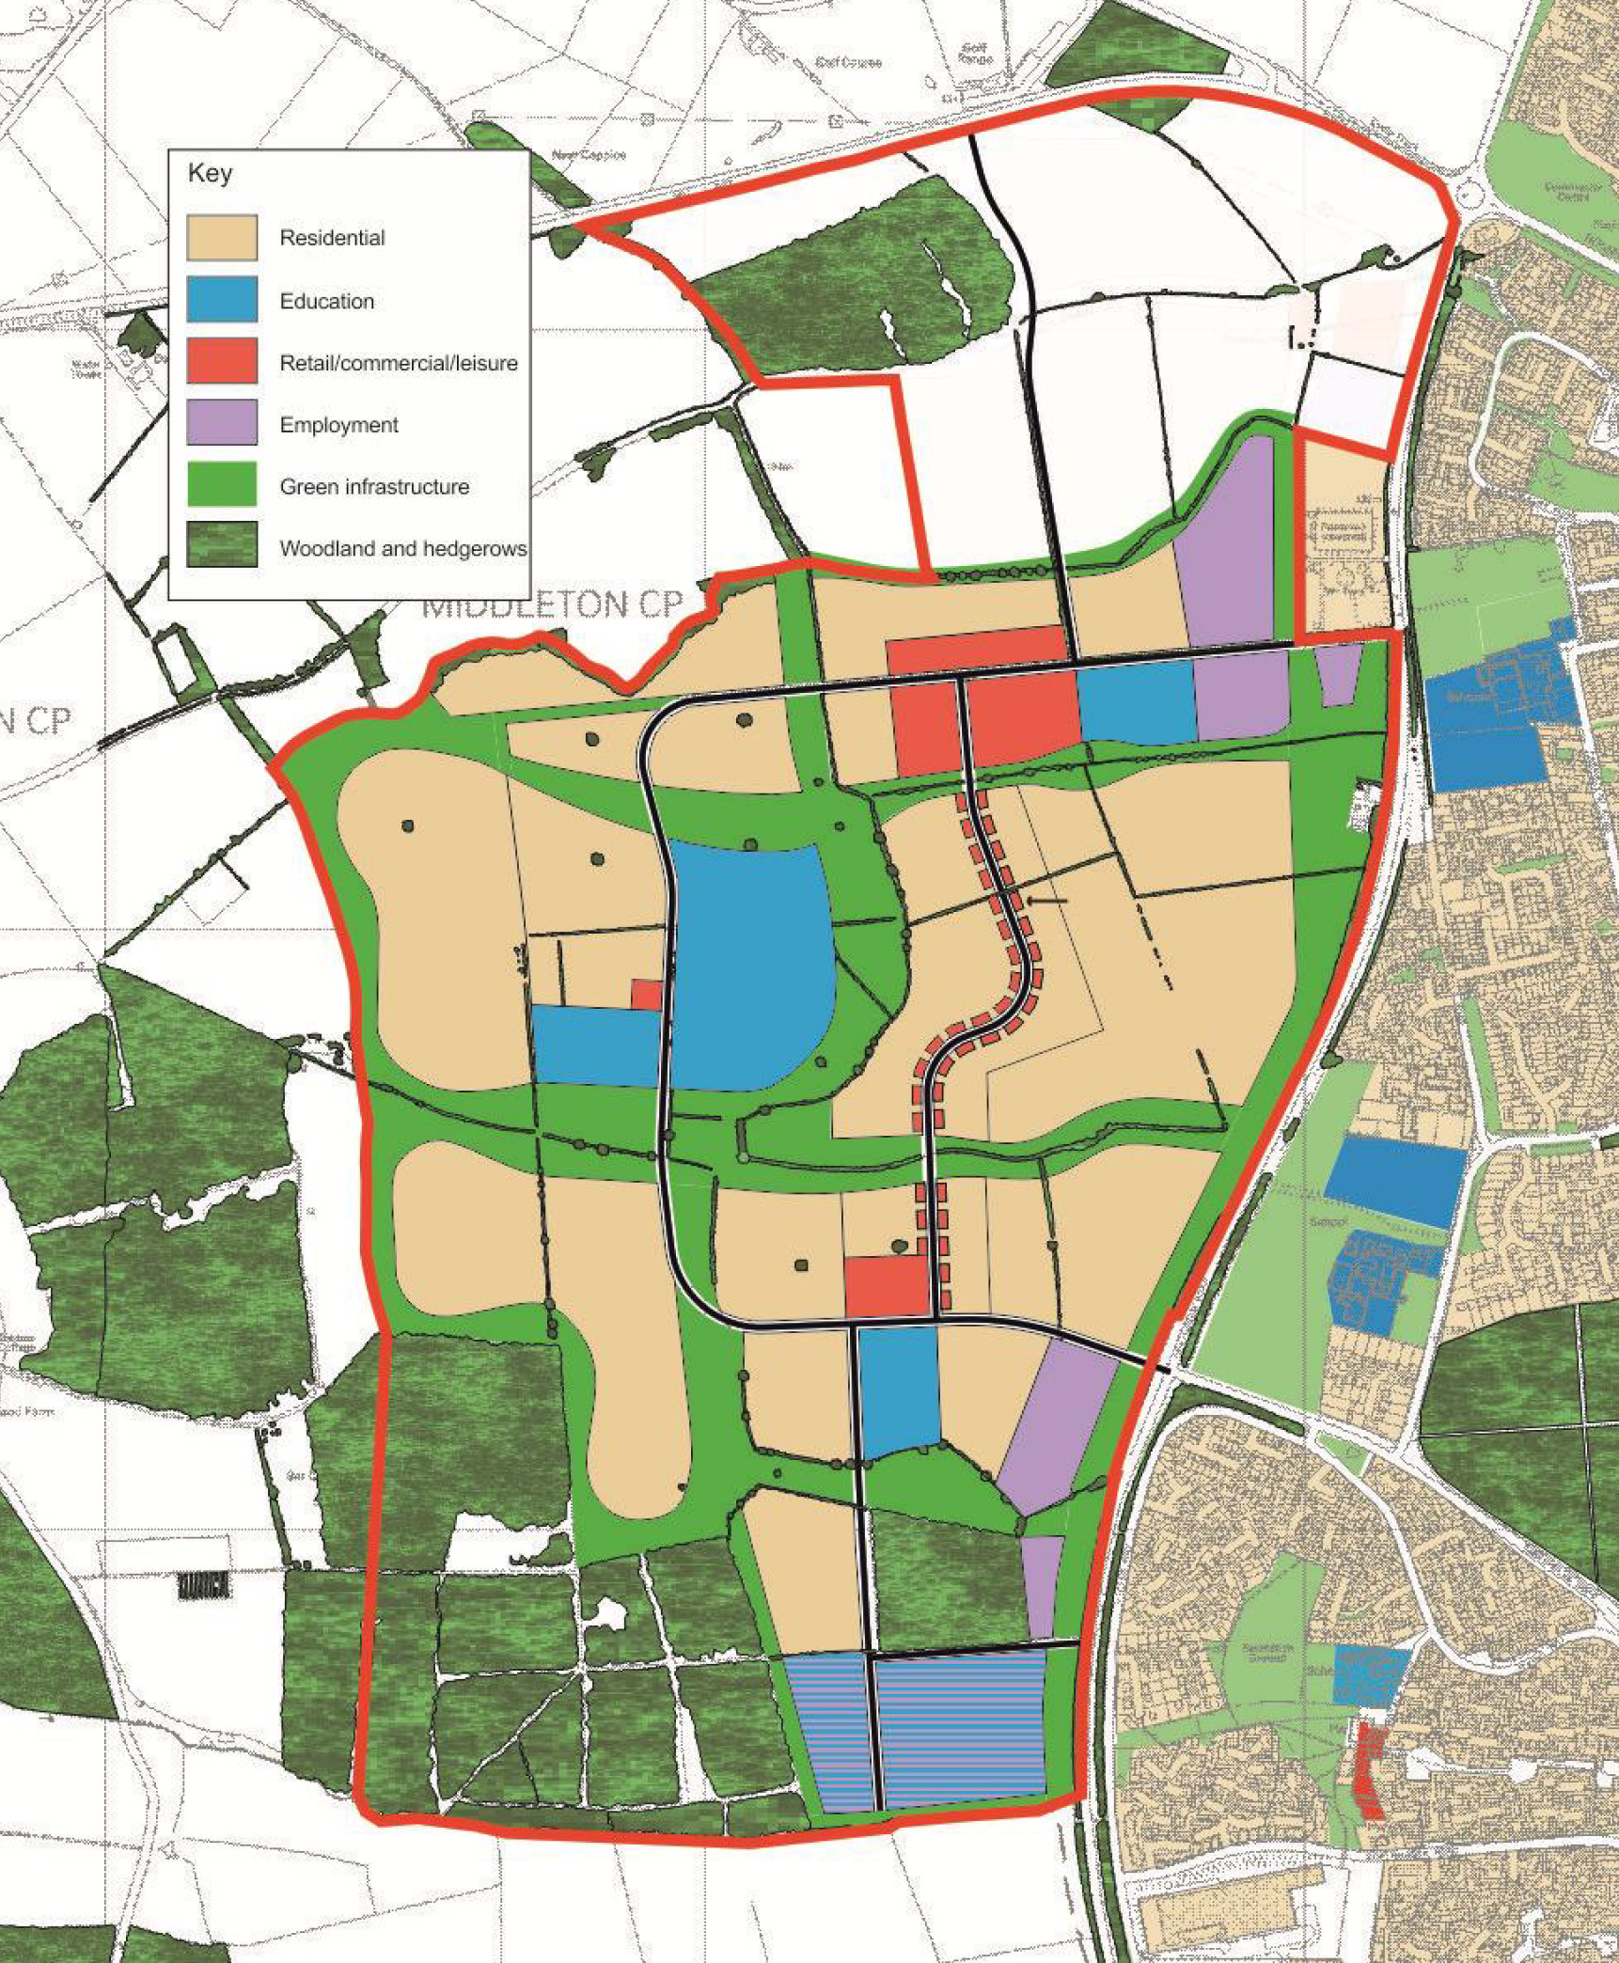

Fig. 2. Boulevard, Hunchun, China, illustrated in UN-Habitat (2014) *Public Space in the Global Agenda for Sustainable Urban Development. The “Global Public Space Toolkit”*, United Nations Human Settlements Programme (UN-Habitat), 20. http://www.urbangateway.org/sites/default/ugfiles/Global_Toolkit_for_Public_Space.pdf

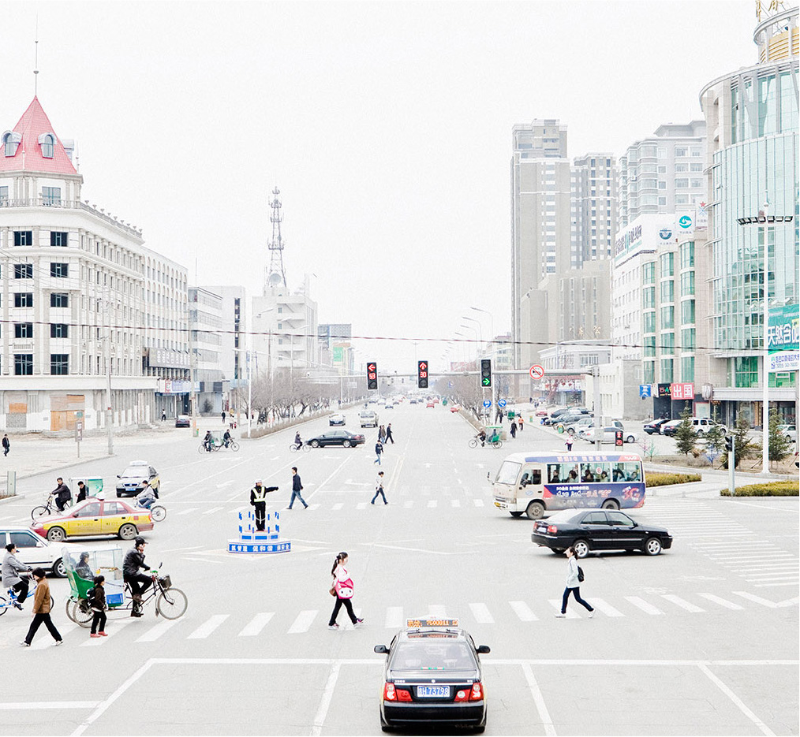

Fig. 3. Typical urban residual space

Cooper BMW – Reading, Kings Meadow Road, Reading, Berkshire.

Author’s photograph.

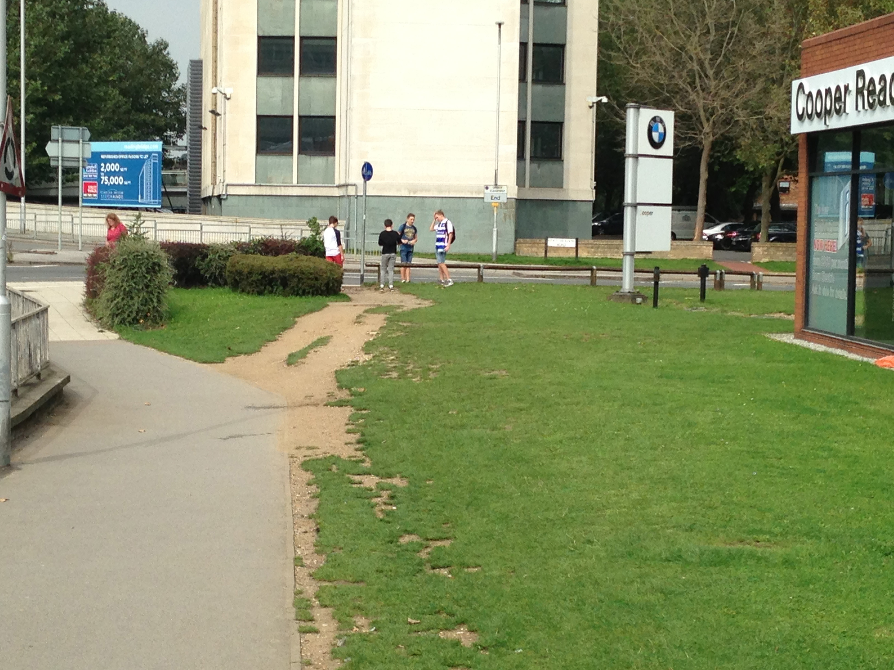

Fig. 4. City of Arts and Sciences, Valencia. Building-Centred Space.

Author’s Photograph.

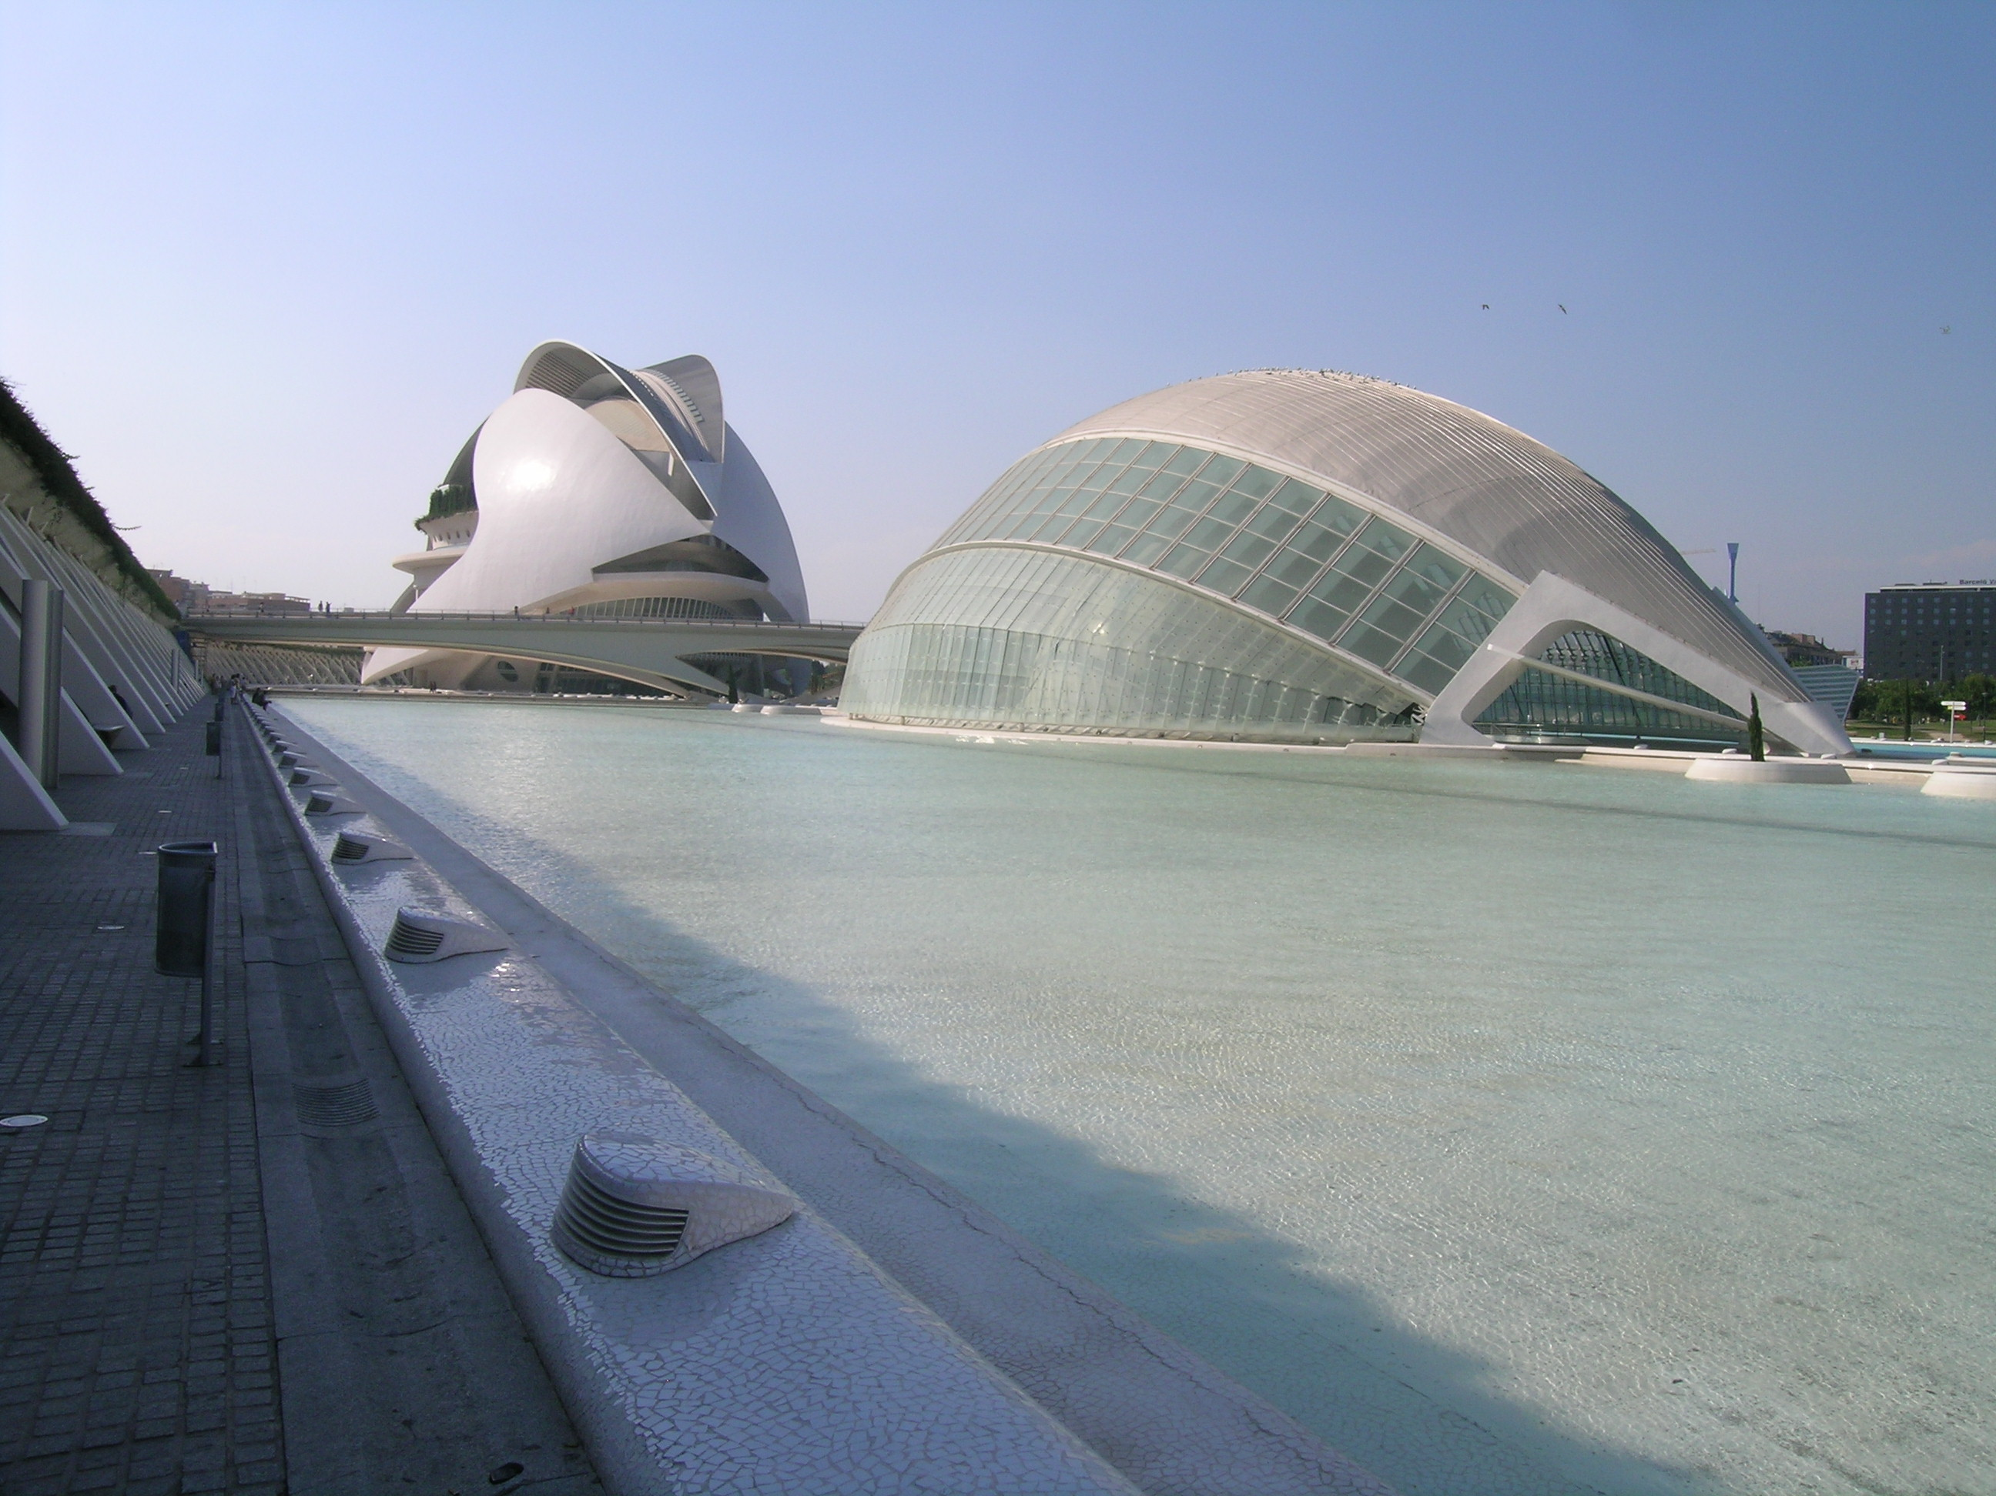

Fig. 5. Schouwburgplein, Rotterdam. A large space looking for a function.

Author’s photograph.

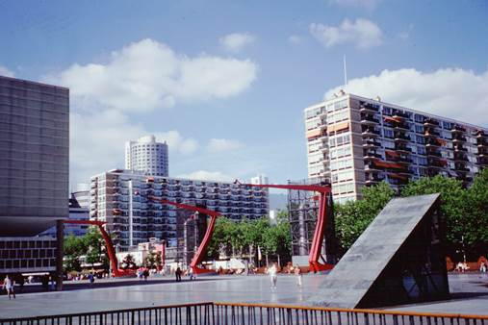

Fig. 6. PLACE LOGIC: Place Connectivity analysis identifying most effective location for central public space in a new development.

© ADAM Urbanism

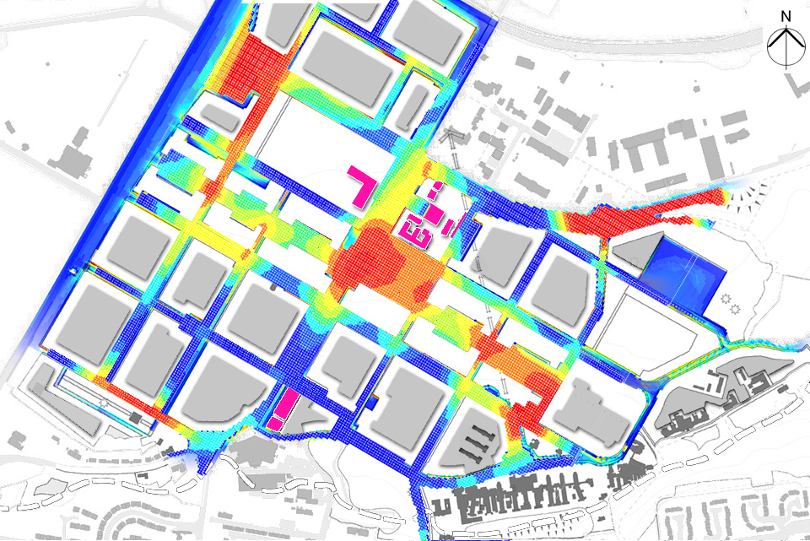

Red is most connected, blue is least connected.

Fig. 7. PLACE LOGIC: Street Activity analysis showing the strongest pedestrian flow patterns in a large public space in a new development.

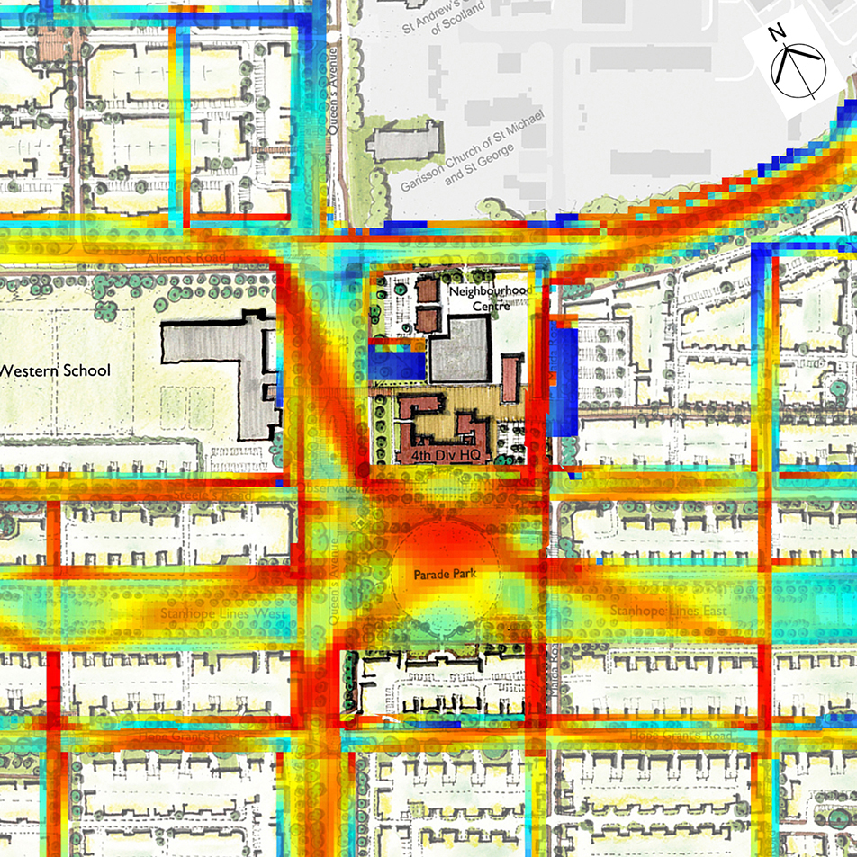© ADAM Urbanism

Red is strongest, blue is weakest.