The Reconstructed Public Places in Sacred Cities
The Case of Al Madinah AlMunwwarah Civic Centers, Saudi Arabia

By:

Dr. Galal Abada Dr. Talal Al Raddadi
Associate Professor of Architecture and Urban Design, Associate Professor of Architecture,
Ain Shams University ASU, Cairo King Saud University, KSU, Riyadh
Advisor, Madinah Development Authority Secretary General, Madinah Development Authority
galal.abada@gmail.com talraddadi@mda.gov.sa

Abstract
The discussion of the relationship between the sacred and the city ought to address the evolving transformations in holy cities today. Over the past few decades, many historical sacred city exemplifies a new hyper-inflated urban conditions, perhaps driven by its exceptional roles, character and its associated development attributes. In general, such changes has been reshaped by the insertion of a massive wave of buildings that have introduced on immense scale new elements of changing needs, commercialism, and modernization into the sacred city’s historic fabric. As public spaces in the sacred cities have been a crucial component for sacred cities for centuries, they have critically transforming their form, structure, functions, and traditional significance and distorting their historic sense of place. Recently, many notable experiences have been introduced to restore the spirit of public space in sacred space and revitalize their missing livability. Madinah, Saudi Arabia, is a good example of a sacred city in transformations and attempts for serious restoring of their identity within the wider context of the city in transformation. This paper will explore the impact of intensive and growing development on public spaces in the sacred city and will critically review some of the current interventions of (re)shaping public spaces in the city. The paper will shed light on the current transformation and the future of place and placemaking in that significant cultural context and within a rapid development process and highly dynamic conditions.

Keywords: Sacred city, Spirit of Place, Madinah, Placemaking, Urban identity.

- Background: Sacred Cities and Historic Places: Continuity and Change
There are many religious, symbolic, and spiritual references have provoked historic sites and sacred places that considered as manifestations of belief systems. This paper looks at the intersection of religious context and placemaking in a particular cultural context. Therefore, it draws on several fields of studies: cultural and history, urban design and placemaking, architecture history, and the history of public space in the city of Madinah. Over the past few decades, literature on Islamic religious space remains very limited, in spite of the growing importance and development of urban conservation approaches, development studies, and placemaking projects within the discipline of urbanism. Part of this scarcity of literature is due to the lack of studies on contemporary urban conditions in Muslim cities and the absence of research of the relationships between religion and public space. Part of the difficult nature of this kind of studies is that the observed factors of effect of religious identity over urban space—i.e. belief, personal devotion, or awareness of the sacred—are problematic to be evaluated or measured. However, the subject is complex and multiform and calls for serious research on religion and place.

Sacred sites are special places where various layers of reality exists, from the material to the spiritual plane can mirror one another through the chain of references and analogies implied in the relationships between macrocosm and microcosm (Bianca 1995). Therefore, public places in sacred sites are the places in which the world manifests itself in its real form. Public places in this context are characterized by their established connections between the visible and the invisible, tangible and intangible, the quantifiable and the qualitative, the temporary and the timeless. Hence, places in sacred cities can be seen as the surviving engines of identity and sense of place, as they convey the inner dimensions, the soul and spirit of places. Nevertheless, the need for spiritual and emotional content as implicit or explicit motives of urban identity.
Sacred places in Islam, like in the Holy Makkah and Radiant Medinah, are important Islam's sacred places in Islamic history and also important holy destinations to present-day Muslims. Makkah has the most sacred place in Islam is the Ka'ba (the holy mosque built around a black stone built by Abraham according to Muslim tradition). Makkah was designated as the holy city of Islam and the direction (Qibla) in which all Muslims should offer their prayers. Medina (or Medinah), the "City of the Prophet, was the destination of the Prophet Muhammad’s migration from Mecca in 622 and it was there that he spent the last decade of his life. It is from this point on that the Muslim community became a state as well as a community. It is, accordingly, it is considered the second most holy city of Islam. Nasr (2001) examines the complex origins and rich legacy of the religious symbolisms attached to the sacred sites and their spiritual importance. According to certain major religious traditions, the sacred city was likened to the body and modelled after it. As such the city was a confluence of the physical, the psychological, the emotive, the intellectual, and the spiritual. For example, Makkah is the supreme spiritual city of Islam in which the Ka'bah at the heart of the city corresponds to the human heart. Although much of the historic city of Makkah and Madinah have been destroyed through successive urban renewal projects, their center survives, as spiritual heart, the heart of the city, the heart of the Islamic universe, and the human heart.
Bianca (2001) points out that traditional cultures understood how various layers of reality-material and spiritual and essential-coincide. He asserted that sacred places cannot and should not be dissociated from their mundane environments. Bianca (2001) argues that historic cities are an underestimated cultural asset. In societies in which religious traditions are strong, historic cities can be seen as the surviving engines of cultural identity and creative diversity. AlShuaibi (2001) examines the impact of transformations of sacred sites in historic cities of Saudi Arabia with a special focus on Makkah, the holy city. He points out that the holy city has been the spiritual and physical focus for prayers and visitors even before Islam began. He contrasts the emergence of modernity in that sacred city through the physical changes, which has undergone a rapidly tremendous transformation process of its urban space.

The Spirit of Place
The spirit of place introduces the physical dimensions of the location; buildings and spaces that help define identity and sense of belonging. Lynch has argued that individuals' sense of well-being and resulting effective action depend on stable references from the past that provide a sense of continuity. Public places in sacred cities are the references that connect past, present, and future. Lynch stresses that can be "collages of time": spaces that express continuity of time as layered by natural elements, sites, and monuments. According to the ICOMOS (2008), the spirit of place is defined as the tangible (buildings, sites, landscapes, routes) and intangible elements (memories, narratives, written documents, rituals, festivals, traditional knowledge, commemorations, rituals, values, textures, colors, odors, etc.), that is to say the physical and the spiritual elements give meaning, value, and mystery to places.
The spirit of place offers a more comprehensive understanding of the living and permanent character of monuments, sites and cultural landscapes, representing their memory, vitality, continuity and spirituality. To protect the spirit of places, ICOMOS (2008) has addressed the Québec Declaration on the Preservation of the Spirit of Place in 2008. It sets strategies for the protection of the spirit of places, as following:
- The spirit of place is a continuously reconstructed process, which responds to the needs for change and continuity of communities. It can vary in time and from one culture to another.
- Spirit of place is an expression about the intangible heritage that gives a rich and complete meaning to heritage as a whole and in all conservation and restoration projects for sites, spaces, landscapes and routes.
- The inhabitants and local authorities should be made aware of the safeguarding of the spirit of place so that they are better prepared to deal with the threats of a changing world.
- Spirit of place is transmitted by people through interactive communication and the participation of the concerned communities that the spirit of place is most efficiently safeguarded, and enhanced.

- Characteristics of Public Places in Scared Cities:
In general, characteristics of public places depend upon their setting, the users and the purpose and activities of the space. According to the Project for Public Places, Inc., successful public places should perform four main functions: access and linkages; purpose and activities; comfort and image; and sociability. It is suggested that public places in this particular socio-cultural contexts should respond to the following criteria:
- Spirit of Place – places should have their own character, responding to and reinforcing distinctive identity of development, culture, and religious significance.
- Legibility – places should have a clear image, be easy to understand and easily identify the purpose of the space. They should provide recognizable routes and landmarks to help people identify and find their way around.
- Diversity – places should have variety and choice. There should be a mix of appropriate developments and uses that meet the local needs of all sectors of society.
- Adaptability – places should be capable of changing in response to economic, and social conditions.
- Access – places should be easy to move through and should be inter-connected with transport modes.
- Continuity and enclosure – public spaces should be clearly distinguished, and the continuity of building frontages should be promoted.
- Quality of the public realm– places should have attractive public spaces that work well for all users, including all cultural backgrounds, disabled and elderly people.

The Spirit of Place in Madinah

The spirit of place in Madinah is a synthesis of the presence of the Prophet Mosque, its traditional heritage, landmarks, spaces, remarkable natural landscapes, routes, and modern buildings, as well as its various intangible traditional elements; place memories, narratives, rituals, colors, odors, commemorations etc.). This set of unique elements give meaning, value, emotion and affinity to places in Madinah. The spirit of place in Madinah is therefore constructed by various aspects and possessing multiple meanings through time.

Intangible Elements of Madinah Spirit
It is suggested that the intangible elements of Madinah spirit can be divided into key three elements; as a journey in time and space, the significance of history and Madinah as a special place for tolerance, human interaction and a multi-cultures. A brief outline of the main characteristics of these elements are:

    - Madinah Places in Time, Space and Faith
Madinah’s, with its rich religious and historical heritage, and the present-day mass pilgrimage and visitors to the city, it continues to represent its special influential urban identity and spirit of place. The city’s origins and spiritual symbolism, remain for Muslims a powerful spiritual identity marker. The city is the place where the Holy Qur'an was compiled and from which the Prophet's companions establishing the Muslim community. Madinah was the seat of the first Islamic state, where from the city, Islam has been speeded to the world. The Prophet mosque derives its importance and sanctity from the fact that this represents the place where the Prophet lived, taught, administered the affairs of Islamic state, and is finally buried. The attributes of Madinah’s sacredness refer to the early history of Madinah is charged with the legacy and stories of the Prophet, and the context that formed the landscape of the Prophet’s life. Today, public places in the city are still vibrating with the teachings and ideas of Holy Prophet (PBUH) and marked by the various historical stories of the emerging of Islam. Madinah is therefore a journey-through- space and time in a sacred city that Muslims across the world revere to visit at least once in their lifetimes.

    - The Meaning of History in Madinah Places:
Madinah encompasses more than a spiritual and religious meaning, including a divinely inspired moral order4. Historically, religion and urban form have always been intertwined, and so is the case Of Madinah. The history of Madinah has been always tied to sites of worship, which are the focal point around city developed. The powerful aura of Madinah is reinforced by the striking images of thousands upon thousands of white-shrouded pilgrims during the hajj season moving in the city.
The physical manifestations of religion, spiritual signs and symbols in the Madinah have historically carried powerful meanings that transcend associations with specific sites and the landscape. Religious buildings and sites of various types, i.e. mosques, religious schools, historical routes, plazas surrounding mosques, convey how the community of Madinah perceive themselves and how they aspire to be perceived by others. Religious sites were always expressing aesthetic values charged with the symbolic meanings.

    - Places for Tolerance and Multi-cultures:
One of the most important aspects of the spirit of Madinah is its inherited willingness to welcome visitors from across the globe with hospitality, tolerance, and understanding. The city remains the destination of thousands of Muslims who come to visit the Prophet in his final resting place. The city had a rich various cultural environments in which the diverse identities of the hajj pilgrims and visitors were crucial. Hence, the most well-known attribute of its identity is its multicultural populace moving in the city, interacting with its residents, and making the city’s distinctiveness and uniqueness. Since ancient times, pilgrims would come to the city, and many stayed -- making Madinah, and still -- one of the first genuine multicultural cities. Thus, Madinah is perhaps one of the first melting pot, in the modern sense, among the world's cities. While, individuals and community engagements in civic life shape the meaning of public places in sacred cities as well. All these characteristics make Madinah a city where cultures interact and fuse, where people learn and share knowledge with each other and receive both temporal and spiritual enlightenment.

Madinah as Sanctified Heritage Places:
Historically, Madinah was a walled city with gates and typical traditional Islamic city elements, such as watchtowers, an old castle social, educational facilities, a historical railway station (welcoming trains from Istanbul), as well as religious buildings. Unfortunately, most of those elements have been demolished to give way for the expanding development that transformed the city since three decades. Consequently, the city has witnessed many transformations in terms of construction, renovations and demolition.
Nevertheless, several old buildings, structures and sites are still sound and kept as part of the city’s heritage today. Also, many of the sites of the major old city elements are still intact. Madinah has characterized by a collection of historical landmarks that had greatly contributed to the evolution of the cultural identity of the city over time.

Today, the urban heritage of Madinah is centered on four major categories:
- The Prophet’s Mosque, vast surrounding plaza, and the nearby historical mosques of the early Prophet’s followers and the site of the historical Saqqifa (an old market place/public forum).
- The few remnants of the old historic quarters of Madinah, have kept some of the traditional compact fabric, that were distinguished by the characteristic ”Hosh” pattern, a community large open courtyards belonging to a group of twenty to forty houses around it. Some quarters accommodate lavish Palms farms. Madinah quarters were enjoying specific public space patterns, a mixed-use character, and having commercial spines. Spinal streets hosted extended shops and craftsmen workshops and traditional services, giving the city its architectural uniqueness. The distinctive architecture of the surrounding buildings with series of intricate ”Roshans” facades -- a sort of enclosed balconies and latticed shutters of fine old woodwork on the upper floors -- to provide not only beauty but also protection from the sun.
- Sacred sites outside the center are of high significance, directly associated with the events that took place during the prophet’s life and his early followers. Major sites include: Qubaa Mosque site, Uhud Battle site, Al Ahzab Battle Area/Seven Mosques, Al Qiblatain Mosque and the Miqat Areas.
- The natural landscape of Madinah, composed mainly of the surrounding mountains, plateaus, and thee major Wadies (valleys), are running through the city from north to the south, the sites of two major inactive volcanoes in the east and the west of Madinah. Mountains such as Jabal Ayr and Jabal Sala’ provides natural beauty, value, and cultural importance. In addition, Jabal Uhud has a sacred special religious significance.

- Continuity and Change in Madinah Public Places:
Madinah has experienced tremendous changes in its form, structure, functions and identity since its establishment about Fourteen centuries ago. The enormous increase of numbers of visitors (about three million Muslims who travel each year to the holy city from around the world), to the sacred city over decades provoked by the expansion of the Prophet Mosque and plaza, the unprecedented growing in the number of visitors accommodation/hotels and the corresponding rise in vehicular traffic that have had all immense pressure on the historical city fabric. This has been resulted in the successive large scale demolitions and rebuilding of the old city central areas and the expansion of the small city into a large metropolis between 1950s and 1990s. This substantial change was due to the remarkable increase of visitors that represents an absolute unavoidable necessity at that time, and had to be accepted to a certain extent. Urban transformation in the past four decades widely promoted regularized block patterns to provide straight roads, regularized street widths, and large intersections, all of which are helpful in managing vehicular traffic.

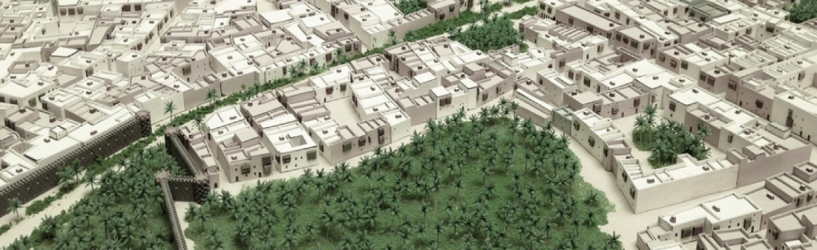
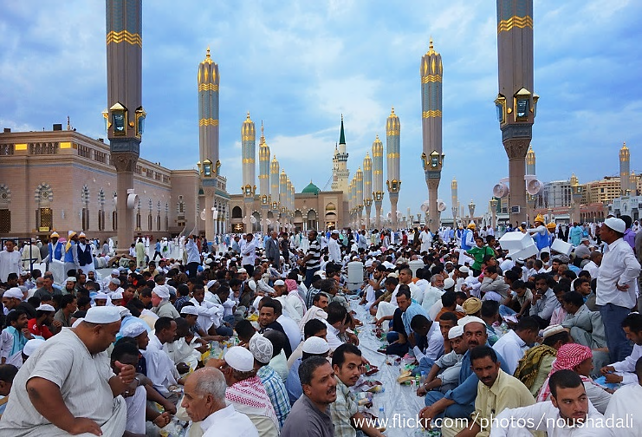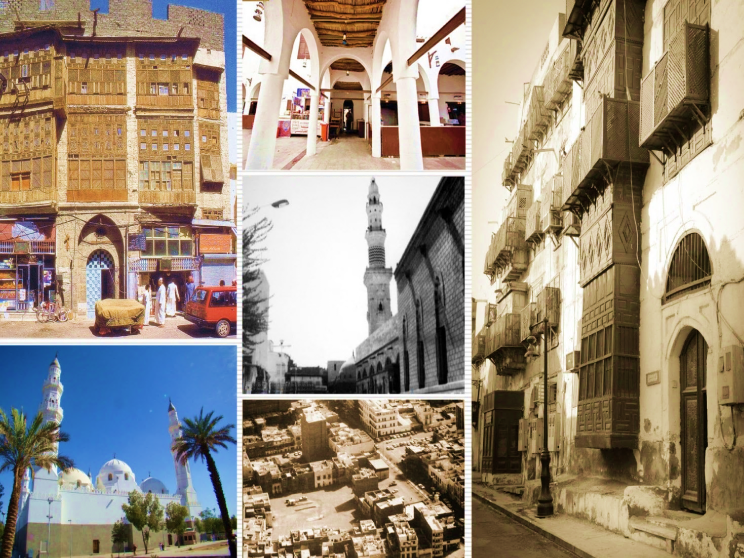
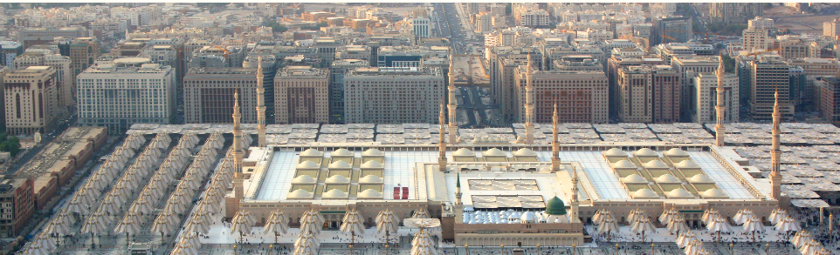
Figure 1. Some of Madinah Public Places in the past and at present (Top: part of a model for the old Madinah showing its past traditional urban tissue. Middle left: The Prophet mosque plaza during the month of Ramadan. Middle right: various images representing Madinah traditional architecture. Below: the Prophet Mosque, the surrounding Plaza and the surrounding buildings and corridor. (All images courtesy MMDA 2014).

Nevertheless, contemporary Madinah today is distinguished by its hyper-identity, following the observations of Rem Koolhaas in “The Generic City”, as there is a tendency to exaggerate and to amplify whatever feature can be found in any given local condition. The contemporary realities of the Madinah, one can observe a similar evolution in process: historical buildings are replaced by immense new developments that are in contrast to the city’s hyper-identity as a sacred site. The city becomes, however, an unusual instance that define a continuing distinct identity. There is the contradiction between its the spiritual heritages and contemporary form; its centralizing pull for Muslims or its intense effect on individuals’ experience of the sacred over the present mass culture of its infrastructure. There is no identity of place more definitive, or at the same time, as effectually indeterminate. Consequently, within this context, the role sacred space did play needs to be recognized, so the challenge of public places to maintain cultural identity under the current urban conditions can be better understood.

- Characteristics of the Major Madinah Public Places
Historically, Madinah’s urban fabric has been irregular and humble in scale and urban pattern. Many streets were discontinuous and not necessarily straight. This pattern was useful for providing small private enclaves, security against outside intruders, and shade at street level in many locations. Household privacy is highly valued in Madinah and there is a notable hierarchy where private spaces interface with public spaces (e.g., building façades, ground-level activities, and building entrances).
The Madinah Central Area and the Plaza around the Prophet’s Mosque has been dominating Madinah Central area. The Central Area has a clear hierarchy of streets with multiple well-defined connections to the Plaza of the Prophet’s Mosque. Significant historic mosques and sites around the Prophet’s Mosque are located within a modern development fabric. The Plaza, with its graceful mechanical canopies that offer shade during peak sun conditions, is both beautiful and functional. The public realm surrounding the Prophet’s Mosque demonstrates how to successfully address challenges associated with spatial needs, pedestrian comfort, accessibility, and amenities.
There is a straightforward system of minor streets that addresses site access and delivery vehicles. These minor streets mimic the historic fine grain block/street patterns and narrow shopping alleys. Despite a fairly dense concentration of buildings, there is a good balance of public and private space, with good sidewalks for pedestrians in most areas. Public spaces throughout Madinah are used for many purposes, such as gathering and socializing, commerce, and praying five times per day.

The Place (re)making in Madinah,
The place(re)making in Madinah, is seen as a processes where the art of making places for people, the connections between visitors and residents, the intangible elements of the spirit of place, and sacred places, as well as between movement and urban form, nature and the built fabric, are all interwoven to make a successful place. In addition, the concept of the spirit of a space is a unique and fundamental for envisioning the identity of the contemporary Madinah. Public places in sacred places of Madinah mediate between religious concepts and symbols and materialize religion, in a way or another, in the public space, the extent to which places in Madinah express how spiritual character may impact on and shape public space.
In general, public places in Madinah can be characterized by their capacity to provide ‘sights’ and ‘sites’, offering many possibilities for the reconstruction of public places and for restoring its spirit of place. Sights’ refers to the design of public place and aesthetic formation of place as such (e.g. the use of the particular landscape element). Symbolically, such places are sights that makes place identity obviously tangible and visible. While ‘sites’ refers to the spatial arrangements and social activities in the public place. Such places are sites where people practice and perform their identities. Both ‘sights’ and ‘sites’ are often overlap and interconnect to communicate a various spatial experience and meanings.
Conceived as such, public places in Madinah impacts upon the (re)structuring of urban space, thus requiring an approach that combines material-aesthetic, spatial, and semiotic-communicative concepts and methods. Public space in this particular context materializes religions –making the invisible visible. The reconstruction of place identity in Madinah is a significant issue to protect places ensuring its heritage significance, sustaining the individuality and distinctiveness. Madinah place-based identity refers to ideas about Madinah places, its identity and the meaning and significance of places for their inhabitants and users.
Thus, the process of place (re)making in Madinah is a kind of design process involving observation, discourse analysis and mapping a range of physical elements as a way of working with place identity to transform existing places and regenerate its local urban character.

Madinah Civic Places Program: Balancing Redevelopment, Revitalization and Regeneration
AL Madinah Al Munwwarah Development Authority MMDA has addressed a long term program to revitalize and regenerate the major civic places of the sacred city. The program is based on the recommendations of the Comprehensive Plan of Madinah 2030 (MMDA 2011). The program intends to revitalize, regenerate and redeveloped the major these public places based on (re)creating and sustaining a balance between conservation activities of the spirit of Madinah sacred public places and the responsive development intervention of the surroundings within a changing urban conditions.
The intended interventions approach is based on the redefinition of the urban fabric in the concerned sites and thinking behind developing public spaces beyond the conventional improvements of the public space, to address urban wider livability issues, such as incorporating innovative functions and activities, including exhibition spaces, shops, and an open-air gathering places, the linkage with the expanding public pedestrian spines, and to emphasize the place identity and collective memory.

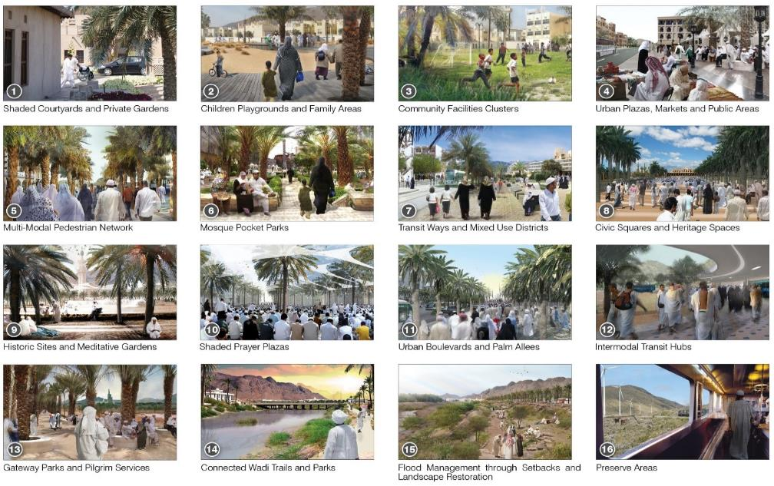
Figure 2. Part of the urban design strategy for the redevelopment of Madinah Public spaces. Source: Madinah Comprehensive Plan 2011, Volume #13, Architectural and Urban Design Guidelines, Madinah Development Authority MMDA).
1-Shaded Courtyards and Gardens | 2- Playgrounds/ Family Areas | 3- Community Facilities Clusters | 44- Plazas, Markets/ Public Areas
5- Multi-Modal Pedestrian Network | 6- Mosque Pocket Parks | 7- Transit Ways/ Mixed Use | 88-Civic Squares/ Heritage Spaces
9- Historic Sites/ Meditative Gardens | 10- Shaded Prayer Plazas | 11- Urban Boulevards/Palm Allees | 112- Intermodal Transit Hubs

The programme include the revitalization and the regeneration of the following sacred sites:
- Qubaa Mosque and site: that has a historic importance as the first place where the Prophet landed in the outskirts of Madinah and stayed after having migrated from Makkah.
- Al Ahzab Battle Area/Seven Mosques: where the battle of Al Ahzab took place and a defensive strategy, of dug a trench, to control the advance of the invading Al Ahzab army. The Noble Quran has quoted the event of the Al Ahzab Battle as a historic event strengthened the position of the community at that time.
- Al Qiblatain Mosque Area has a great religious significance as it was the place where the Qibla has been shifted toward Makkah instead of Jerusalem, as mentioned in the Quran. The mosque was built during the Prophet's time and went through many changes over history.
- The Uhud Battle Area: a historic place, where the famous Battle of Uhud took place at the southern side of the Uhud Mountain in the third Hijra (emigration) year. This battle is not only famous in Islamic history but also recited in Qur'an to be remembered forever.
- Miqat Area (Zul-Hulifa Mosque) site: owes its significance to the fact that the Prophet used to stay here on his way to Makkah for performing hajj or Ummrah.

Three interventions of ongoing projects are represented here to illustrate part of the major approaches for the reconstruction of the civic places of Madinah, and restoring of its sense of place. The cases are: Qubaa Civic Center, Al Khandaq/Seven Mosques area, and Al Qiblatain Civic Center. The adopted approaches include: the redevelopment/conservation approach, the revitalization approach, and the regeneration.

8.1. Redevelopment/Conservation:
This approach involves the clearance of the site, due to large scale deteriorated conditions, and the demolition of the existing building, which include removal of existing occupants. It is particularly suitable for transforming deteriorated areas into a positive and dynamic image of the city. Urban redevelopment is required to be integrated with the surrounding urban fabric by ensuring continuity in conservation of historic sites, improving public realm, providing green spaces and integrated fully with transit facilities and with high quality pedestrian environment. While, conservation is particularly suitable for buildings or sites with historical value, dealing with the inherent image and identity, in which they can be experienced.

  - Revitalization:
Revitalization includes upgrading and improvement of the existing sites and buildings in order to rejuvenate and gives a new lease of life to the building or the site. It is based on preserving, repairing, and restoring existing neighborhoods. It also include the provision of some key buildings and the promotion of socio-economic facilities to attract visitors, to respond to the needs for the residents, and to generate revenue.

  - Regeneration:
Urban regeneration, as defined by Roberts & Sykes (2008), the comprehensive and integrated vision and action which leads to the resolution of urban problems and which seeks to bring about a lasting improvement in the economic, physical, social and environmental condition of an area that has been subject to change. Thus, urban regeneration is a multi-faceted and complex process which should not be viewed merely as a physical, but as a sociological, cultural, economic and political matter as well (Couch, 1990).

Qubaa Civic Center Project: a Combined Redevelopment/Conservation Intervention
The site of the Quba Mosque is the sacred and historical spot where the Prophet Mohammed (PBUH) built, on the first day of his emigration to Madinah. The Mosque area is located to the south-western side of the city within the location of the old Qubaa village that is famous for palm tree farms, vineyards, and where fruit and vegetables are grown. Qubaa Mosque is referred to in the Noble Quran (Surat Al-Tawbah 108) "There is a mosque whose foundation was laid from the first day on piety; it is more worthy of the standing forth (for prayer) therein. The original mosque has been renovated and rebuilt on several occasions throughout over history. The urban fabric of the area, however, is largely irregular and spontaneous due to the mingling of traditional and modern masterplanning. The traditional fabric relies heavily on narrow winding alleys that are pedestrian oriented. The rapid development of the areas surrounding the Mosque over the past three decades resulted in the loss of many elements of its character, and led to the deterioration of its urban environments.

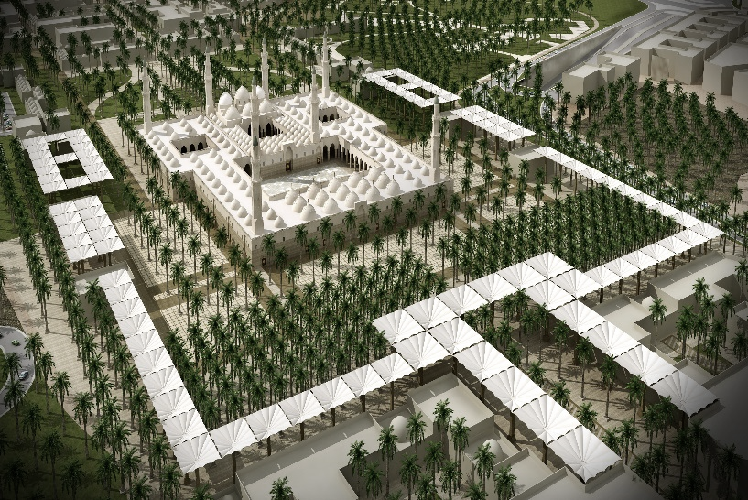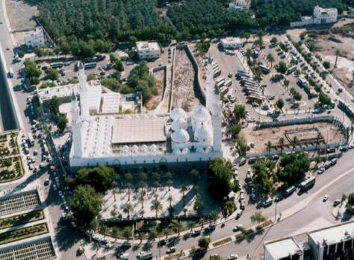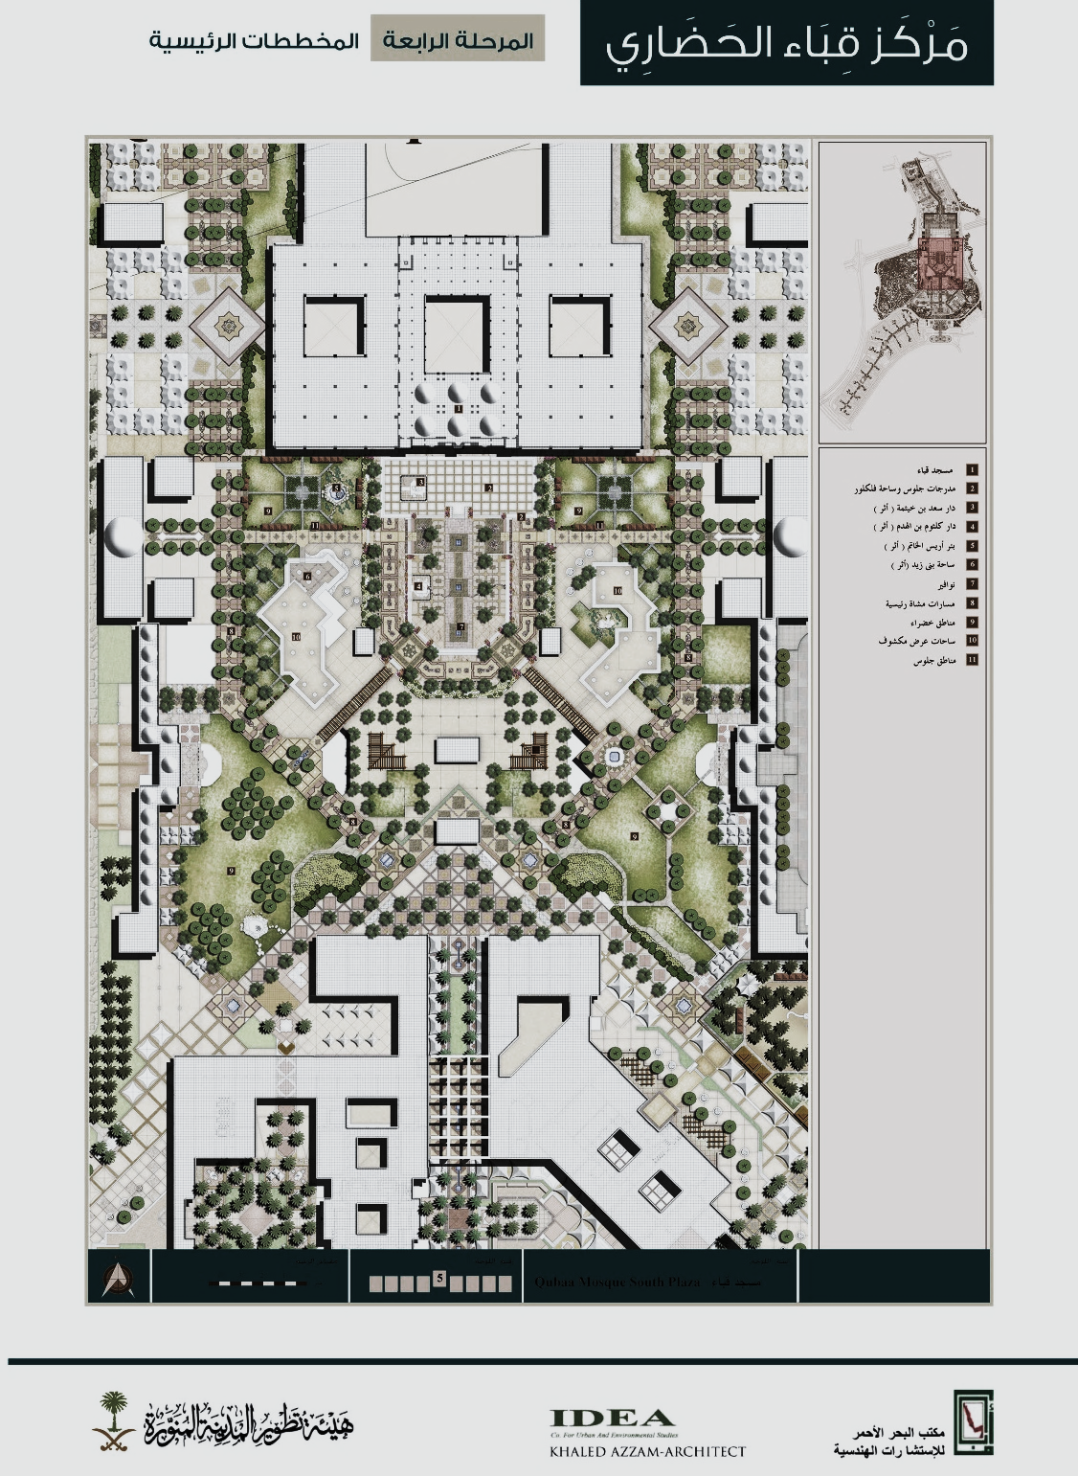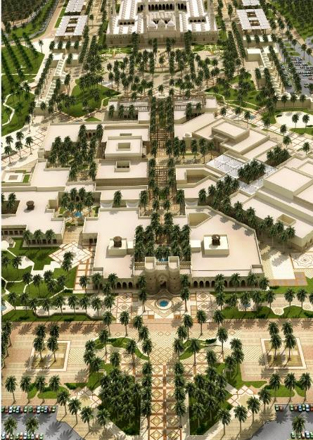
Figure 3. Part of the Design concept for Qubaa Civic Center project. (Top left: The proposed Qubaa Expansion and its relationship with the surrounding plazas, Top Right: the existing Qubaa Mosque and its surroundings. Below left: the Masterplan of the civic center and the surroundings spaces routes, buildings and small plazas (Designed by Khaled Azzam/IDEA Consultants (courtesy of Madinah Development Authority MMDA 2013).

The vision of the Qubaa Civic Center (see Fig. 3) is to establish a religious, cultural, social, and tourist hub that offers a diversity of services, for the visitors and inhabitants of Madinah, through the creation of buildings and public spaces within s sensitive spatial framework. This shall take place with supporting the urban vibrancy, and through creating active public spaces, and pathways. The Civic Center is intended to be a liveable urban node encompassing the necessary activities and needs for visitors and residents, achieving consistency and harmony between the mosque and the surroundings. Gathering spaces in the Qubaa area are vital due to the fact that they are attraction sites for the visitors. These meeting points serve diverse purposes, some of which are official, such as mosques, others are organic such as parks, services and other attractions.
The propose intervention is intended to restore the historical and urban identity and to re-develop the area in a comprehensive manner, connecting it with the Prophet Mosque area through Darb Al Sunnah route (a historical path which the Prophet (PBUH) followed during his emigration journey), in a manner allowing for the continuity and fluidity of pedestrian. It seeks to re-create a unique fabric with clear delineation of public spaces, that restores the integrity of buildings and spaces. The development emphasizes the historical sense of place, the human value, and restoring traditional character and pattern (see Fig. 3).

9.1. The design concept of Qubaa public place is to:
- Leverage the sacred value of the Quba Mosque and surrounding area in order to protect area’s sanctity.
- Introduce mixed use/cultural districts and green space while providing accommodation for the visitors.
- Have a multi-modal pedestrian network with Darb Al Sunah Pedestrian Boulevard.
- Provide safe, easily accessible sidewalks, landscaping, seating areas, and other amenities.
- Encompass different types of public spaces: the Mosque Plaza, landscaping and parking areas of high-quality and aesthetically appealing, large open areas with street furniture and shading; parks, gardens; open space such as plazas, pocket parks, and an expanded plaza around the Mosque.

Analysis
In general terms, the project responds effectively to the challenging expression about spirit of Qubaa Area as a historical sacred site, while introducing a progressive redevelopment intervention of diverse activities and functions. The influential status of the project is therefore extended beyond the urban setting and civic significance to be perceived by Madinah residents and the visitors to the site. The project has positively responded to the distinctive identity of the area, combining cultural preservation with protecting religious significance.
- The significance of the sacred Qubaa Mosque context has been preserved to certain extent, introducing new element to reinforce the conservation of the imageability of the mosque and plaza.
- The project elements are strongly legible through a sequence of hierarchical scaled spaces along a consistent recognizable route. The use of diverse typological public space within an integrated spatial network makes it easier for the overall image of the area to be perceived and experienced.
- The use of different enclose qualities, a monumental scale for the mosque and the plaza, the medium and small scale enclosures provide a sense of visual variety and various space experience. Which is an added value to the overall Masterplan.
- The architectural and public space language express a simple and clear vocabulary inspired by the traditional historic architecture of the area in a simple modern formulation.
- The design provides a sense of variety and multiple choices, through a mix of appropriate developments and uses that meet the needs of visitors and residents.
- The project succeeded to provide a clearly distinguished place, reinforced by the continuity of building frontages should be promoted.

However, the project masterplan would have more successful if the development is strongly connected with the surrounding areas from the west and the south sides, in order to enable the project to spread its centrality and significance location to the surrounding areas.
Also, the opening of the project components to the Palms farms and the agriculture areas would need more stress to balance the relationship between the built civic city context and the old Qubaa village spirit to reinforce the reconstructed identity of the area at larger definition

The Revitalization of Al Khandaq/the Seven Mosques Area
Al Khandaq area is located on the western part of Jabal Salaa (Mountain) where the events of Al Ahzab Battle took place on the fifth Hijri calendar year. During the battle, Muslims were able to dig a trench (Al Khandaq) and witnessed the occurrence of many miracles at the hands of the Prophet (PPUH). The mountain within the area of the seven mosques that are actually six small mosques. Al Khandaq was located behind Jabal Salaa, providing protection to the Muslim army during the battle, while the hill protects the back of the army. It was the first time to be applied in this region. Al Khandaq area includes the seven mosques, originally were Muslim camps during the battle, at the foot of Salaa Mountain, where the Prophet had performed his prayers there. Al Khandaq and the seven mosques area is characterized by the numerous historic, natural features of important religious and significance (see Fig. 4).
Several changes took place during the increasing and intensive urban development over the past three decades. At present, the area encompasses surrounding residential quarters opposite to the farms on the south west part of the site, and surrounding the mountain from the north western direction. The course of the trench is buried under the foundations of the surrounding buildings which requires archaeological and some exploration works. Al Khandaq area suffers the conflict in urban pattern, disorganized land use and the lack of the presentation of its historic features. Public spaces are almost lost within the existing urban pattern. Historical remnants disappeared between and within several existing buildings.
The area requires a profound intervention to retrieve part of its lost memory, informing the visitors on its history and its significance. The vision of Al Khandaq Area is to (re)present the historical elements of the site and rehabilitate its surrounding areas in a compatible manner with the spirit of that sacred place. Also, it is to provide a liveable public open space for the visitors and for the residents. The intervention is to provide a series of cultural facilities: a site museums and visitor center as well as some mixed-use activities, to make it more attractive and vibrant spot. The intervention relies the connection of the area with the Prophet Mosque to the east and Al Qiblatain Mosque to the west through the development of a sensibly planned pedestrian Heritage route. The traces of the trench is the most significant feature in the area to be presented in an appropriate way highlighting the commemoration of that historical event.

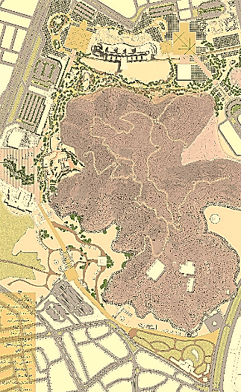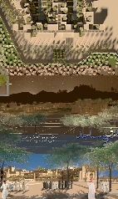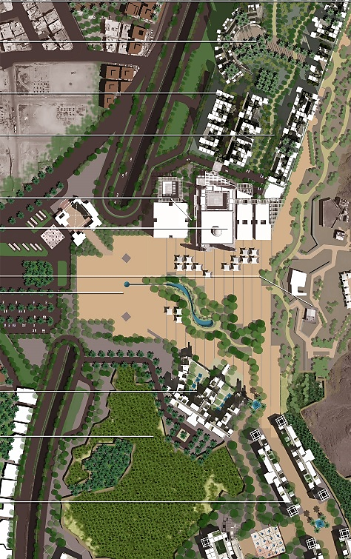
Figure 4. The design concept for the redevelopment project of Al Khandaq/Seven Mosques Area. Left: the overall master plan. Part of the large plaza in front of the mountain and the hotel buildings. Right: plan of the Entry Plaza to the site that organizes the relationship between all the site elements and directs the movement within the site as a connecting hub (Under-development design concept by the Community Development Collaborators CDC AbdelHalim. Courtesy of Madinah Development Authority MMDA 2015).

10.1. The Revitalization Concept of Al Khandaq Area Development is to:
- Promote the development of a new mixed use/cultural activities that reflects the City’s history with special attention to make the site’s historic importance readily apparent.
- Create a mixed use, mid-density corridor between Jabal Sala’ and the Al Qiblatain Mosque Area as well as a mixed use, high-density area in close proximity to the Prophet’s Mosque.
- Promote the development of a circular path around Jabal Sala’ linking the area with the Prophet’s Mosque.
- Design the landscape features to be integrated into a welcoming urban realm for both residents and visitors.
- Provide pedestrian connections to the various paths in the Seven Mosques Area, including the tunnel under Jabal Sala’ to the Prophet’s Mosque.
- Include a mix of public open spaces and facilities that respond to the needs of residents and visitors.
- Make the public square of the Seven Mosques a primary focus, where streets radiate from its center and gateways are created for the Area by provided with beautiful landscaping.
- Provide a safe and comfortable public realm with appropriate sidewalks, landscaping, and other amenities.

10.2. Analysis

The revitalization of Al Khandaq/the Seven Mosques Area is an illustrative example for dealing with a complex setting, in which the conservation of the site sacredness is mixed with the upgrading and improvement of the existing buildings, spaces and natural context in order to bring a new life to the site, and restoring its historical collective memory. It also includes the promotion of socio-economic facilities to attract visitors, to respond to the residents and the visitor’s needs.

The plan provides a strong character and create a spatial identity to the site, through the attempt to reorganize the various fragments into a unified spatial order through the circulation spine route, the desert landscape along the spine and the traces of the Khandaq (trench). This potential order would have the possibility not only to connect and the site elements into one integrate spatial system reflecting the historical and natural features, but also recreate a new outlook into the area, its image.

The project elements are clearly legible within an overall clear site image, easy to understand and easily identify from different viewpoints.

The diversity of functions, spaces, and building character contribute effectively to the site revitalization of the site providing different varieties and choices. The mix of appropriate developments and uses respond positively to the project needs and program requirements.

The accessibility to the site need to emphasize more identification of the main and the secondary routes, while mainlining the diverse possibility and the easy to move character in which the proposed spatial system provides. The interconnection with the transit station needs more accentuation.

The distinction of the spaces around and inside the site is notable. However, there is a need to enhance the enclosure at the Khandaq excavated zone, in relation to the surrounding building frontages.

Al Oiblatain Civic Center: An Integrated Regeneration Intervention
Al Qiblatain Mosque is built during the second Hijri calendar year This mosque has a special significance in the Islamic history, where the revelation had been cited to the Prophet to change Qiblah to Holy Kaaba in Makkah from the Qiblah towards Jerusalem. Since then, that mosque was renovated and reconstructed over the successive eras. Al Qiblatain Mosque area includes a residential neighborhood that is characterized by indigenous domestic patterns of densely medium-rise buildings. Approaching along the main street, the mosque is seen as a dominant visual focus and a notable landmark from long distances.
The vision of Al Qiblatain area (see Fig. 5) is to establish a Civic Center encompassing cultural, social and commercial activities in an integrated way with the expansion of Al Qiblatain Mosque. Revitalization of the surrounding area is considered. There is a need to connect the area with other nearby sacred sites though the Heritage Route.
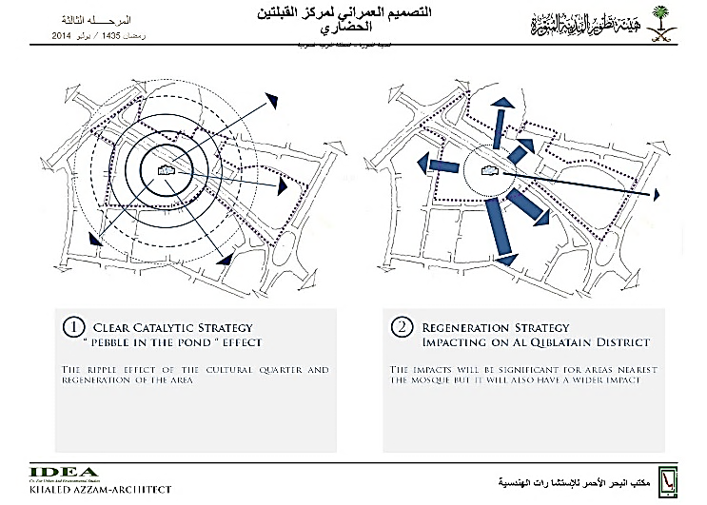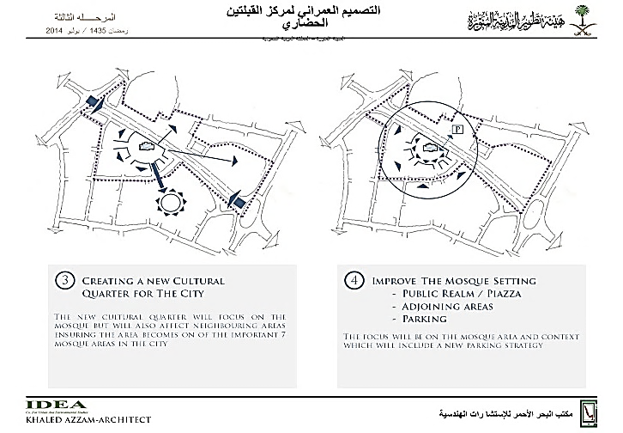

The design strategy for the site plan:
- Clear catalytic strategy “Pebble in the Pond “effect: The ripple effect of the cultural quarter and regeneration of the area.
- Regeneration Strategy Impacting on the District: The impact will be significant for The Mosque and the surroundings.
- Improve the Mosque setting: Public realm adjoining areas, parking. The focus will be on the Mosque and its context.
- Creating a new Cultural Quarter for the city: The new cultural quarter will focus on the Mosque but will also affect

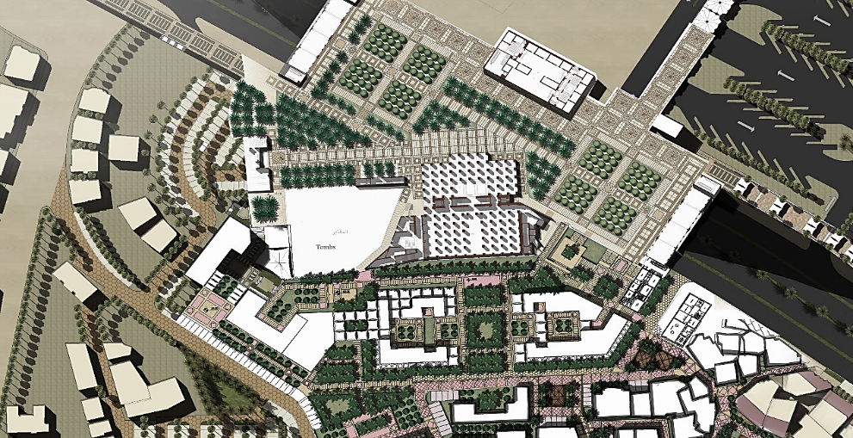
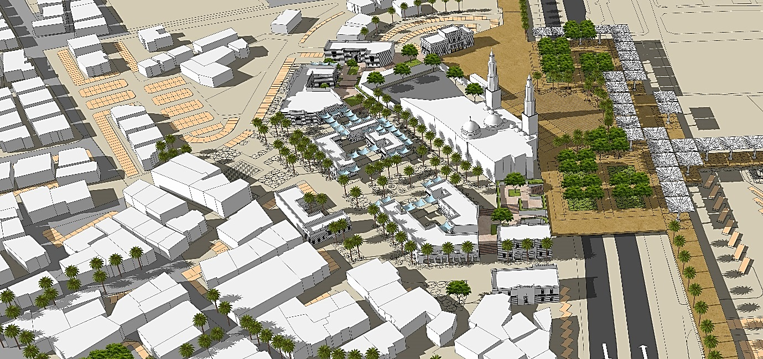

Figure 5. The design concept for Al Oiblatain Civic Center Project. Top: the design strategy for the site plan. Middle: part of the redevelopment master plan, showing the large Plaza between Al Qiblatain Mosque and the surrounding buildings. Below: an overview for the area showing the hierarchy of spaces from the large plaza to the pocket spaces, and their connectivity with the radial routs from the surrounding quarter and the main road, (Under-development design concept by the Khaled Azzam/IDEA Consultants. Courtesy of Madinah Development Authority MMDA 2015).

  - The Regeneration Concept of Al Qiblatain Civic Place is to:
- Represent the spiritual and historic character of the area through beautiful streetscaping and landscaping.
- Highlight the areas, cultural heritage, pedestrian corridor, and its value to the City’s tourism.
- Separate between the pedestrian and vehicular traffic in order to create safe, comfortable environments.
- Reinforce the Heritage Corridor as a key component of the larger pedestrian network.
- Make a clear distinction and hierarchy in scale and circulation between the private and semi-private spaces adjacent to residential and mixed use areas.
- Organize the Entry Plaza(s) with appropriate elements that are seamlessly integrated into the Plaza.
- Provide a safe and comfortable public realm with proper sidewalks design, landscaping, and amenities.

  - Analysis
The regeneration plan of Al Qiblatain Civic Place provides a good balance between the regeneration activities and the preservation of the spirit of Al Qiblatain site together with the creation of a strong urban identity and the clear linkage to the overall movement system and to the public transit.
- The different images generated by the project is clear and easy to easily to be perceived within the well-defined network of spaces and paths, as well as from a distance.
- The provision of diverse activates and uses is successful and will contribute to the vitality and vibrancy of the area when completed. The mix of new and old uses is balanced and meets the local community and the visitors to the site.
- The site plan responds to the accessibility issue to certain extent. However, a more emphasis on the separation of pedestrian and traffic will be needed in a number of locations within the site. It is to ensure that these locations are well inter-connected, especially with the transit station.
- Al Qiblatain Civic Place spaces provides a distinguished and attractive public spaces with a vibrant identity that works well for all users, including visitors of all cultural backgrounds.
- The parking be of higher quality, environmentally friendly and well placed parking area, so that an environmental-friendly parking planning can enrich the overall quality of the surroundings.

12. Conclusions
Therefore, public places in sacred sites are characterized by their established connections are seen best expression about the identity and sense of place, as they convey the spirit of places as implicit or explicit motives of urban identity. Public places in sacred cities is believed to be able to establish the value of spirituality and sanctity. Sacred public place is strongly influenced by the background and experience of religious congregations. Place are cultural space phenomenon that have been acquainted not only a religious sacredness significance, but also a historical and urban importance throughout the history. The theory of restoring the spirit of place and reconstruction of lost urban identity of a certain is a new knowledge to complement the place theory. The finding of knowledge about the relationship between place collective memory and urban open space under a process of transformation is a combined urban, cultural and spiritual strategy of making place with character and spirit. This knowledge is crucial for urban design, not only to provide a sense of strong cultural identity to places, but for the integration within with the city spatial characteristics and total image and character.
Madinah is a good example of a sacred city in restoring its religious spirit of its public places while challenging the increasing need for expansions and future growth. This paper attempted to explore the impact of intensive and growing development on public spaces within this context and will through the review and analysis of some projects in progress. The future of place and placemaking in that significant cultural context and within a rapid development process and highly dynamic conditions calls for a responsive actions that balances the development and growing needs and in the meantime protects and preserve the essence of the spiritual and human values in public places and in the city at large..

References
Ardalan, N, (1995), Places of Public Gathering in Islam, Architectural Transformation in the Islamic World. Visit: http://archnet.org/collections/57/publications/3499 (accessed on May 14, 2015)
Al-Ansari, A.Q. (1999),'Atharal-Madma al-Munawwarah. Jeddah: Daral-Manhal.
Bianca, S. (1984). "Madinah Al-Munawarah: Planning and Urban Design Concepts for the Central Area." Mimar 12, 40-46.
Bianca, S., (2000), Urban Form in the Arab World: Past and Present. London: Thames & Hudson.
Glasse, C. (2003). The New Encyclopedia of Islam. Walnut Creek, CA, USA: Rowman AltaMira.
Hague, C. and Jenkins, P. (Eds) (2005). Place identity, planning and participation, London; New York: Routledge, 2005. ISBN 0-415-26241-0 (hard cover) 0415262429 (soft cover) 0203646754
Al-Hathloul, S.A. (1996), The Arab-Muslim City: Tradition, Continuity and Change in the Physical Environment, Riyadh, Dar Al-Sahan.
Al-Husaiyyin, M. (2010), al-Madmah al-Munawwarah: Bunyatuha wa Tarkibuha al-Umram al-TaqlldT. Riyadh: Al-Turath.
ICOMOS (2008). Québec Declaration on the Preservation of the Spirit of Place, Montréal.
Al-Ka’Ki, A. A. (2011). Urban structure of Madinah: Characteristics and elements of Madinah’s urban structure. Executive Committee for the Development of Madinah’s Central Area, 59.
Koolhaas, R (1995),“The Generic City,” in S, M, L, XL, New York: Monacelli., 1239-64
Al-Madinah AlMunwwarah Development Authority MMDA (2011), The Comprehensive Plan of Madinah, prepared by MMM Group and MTA, Toronto.

Al-Madinah AlMunwwarah Development Authority MMDA (2015), AlOiblatain Civic Center: ongoing Urban Design Plan. Project volume III.

Al-Madinah AlMunwwarah Development Authority MMDA (2015), The Revitalization of Al Khandaq/the Seven Mosques Area. Urban Design Plan, Project Vol. Phase III)

Al-Madinah AlMunwwarah Development Authority MMDA (2013), Qubaa Civic Center Project: A Combined Redevelopment/Conservation Intervention, Project Vol. Phase II, III.
Al-Mahdy, O. (2013), Medina: Reviving Place Identity through Public Space unpublished Master Thesis, Waterloo, Ontario.
Makki, M. (2000),“The Impact of Urban Development on the City of Medina.” Journal of Medina Research and Studies Centre. no. 1 pp: 32-42.
Munt, H. (2014) The Holy City of Medina: Sacred Space in Early Islamic Arabia, Cambridge University Press.
Project for Public Spaces (2015). “What is Placemaking?”
http://www.pps.org/reference/what_is_placemaking/ (accessed on May 13, 2015).
Roberts, P. & Sykes, H. (2008), Urban Regeneration, A Handbook, SAGE, London.
Al-Shehri, A. (2012) Strategy for Reclaiming Al-Madinah Historic Urban Structure, a lecture at the Saudi Umran Science Society, Riyadh.
Ur Rahmaan, A., Ur Rahmaan, B. A., (2011), Preservation of Islamic Cultural and Architectural Heritage of Al-Madina Al-Munawara in Rahmaan, U., (2011),The Imperatives of Urban and Regional Planning Concepts and Case Studies from the Developing World Center for Urban, Regional, Environmental and Social-Studies (CURES) Lahore, 2011. Pp: 577-579.

Bianca S. (2001) Resources for Sustaining Cultural Identity, in Serageldin, I. Shluger, E., Martin-Brown J., Editors (2001), Historic Cities and Sacred Sites: Cultural Roots for Urban Futures, World Bank, Washington D.C.pp.:18.
Nasr, S.H. (2001), The Spirit of the Cities, in Serageldin, I. Shluger, E., Martin-Brown J., Editors (2001), Historic Cities and Sacred Sites, ibid, .pp.:13.
Bianca, S. (2001), The Spirit of the Cities, in Serageldin, I. Shluger, E., Martin-Brown J., Editors (2001), Historic Cities and Sacred Sites, ibid, .pp.:22.
AlShuaibi, A (2001), The Spirit of the Cities, in Serageldin, I. Shluger, E., Martin-Brown J., Editors (2001), Historic Cities and Sacred Sites, ibid, pp.:182.
Lynch, K. (1976) What Time Is This Place? MIT press, Cambridge/Mass.
The International Council on Monuments and Sites”ICOMOS”, (2008), Québec Declaration on the Preservation of the Spirit of Place in 2008. Visit: http://www.international.icomos.org/quebec2008/cd/symposium_en.html., accessed on 14.05.2015.
Project for Public Spaces is an influential non-profit organisation offering technical assistance, research, education, planning and design. Visit:
Project for Public Places (2000). Visit:
Ur Rahmaan, A., Ur Rahmaan, B. A., (2011), Preservation of Islamic Cultural and Architectural Heritage of Al-Madina Al-Munawara in Rahmaan, U., (2011),The Imperatives of Urban and Regional Planning Concepts and Case Studies from the Developing World Center for Urban, Regional, Environmental and Social-Studies (CURES) Lahore, 2011. pp: 577-579.
Bianca, S. Urban form in the Arab world: past and present. London: Thames & Hudson, 2000. pp: 221.
Ur Rahmaan, A., and Ur Rahmaan, B. A., (2011), Preservation of Islamic Cultural and Architectural Heritage of Al-Madina Al-Munawwara ibid. pp578.
The Melting Pot is a metaphor for a heterogeneous society becoming more homogeneous, the different elements "melting together" into a harmonious whole with a common culture. The melting-together metaphor is found in the Arabic language and it came into general usage in the United States after it was used as a metaphor describing a fusion of nationalities, cultures and ethnicities in the 1908. See: Larry A. Samovar and el. (2011). Intercultural Communication: A Reader. Cengage Learning. pp.: 97.
http://faithandform.com/feature/mecca-hyper-identity-sacred-city/, accessed on May 14, 2015.
Deprived from: The Department of the Environment, Transport & Regional Affairs (2000), By Design, Urban Design in the Planning System: Towards Better Practice, London.

